Trip Report

Traveler: Dr. Clayton Stewart (cstewart14@sky.com)

Location: Riyadh, Saudi Arabia

Dates: 7-11 December 2011

The purpose of my trip to Riyadh was to attend and present a paper at the 1st Saudi Symposium for Radar Technology (http://tangentlink.com/event/military-radar-2014/) and visit King Saud University. The conference was held at King Abdulaziz City for Science and Technology (KACST) (http://www.kacst.edu.sa/en/Pages/default.aspx). KACST is an independent scientific organization administratively reporting to the Prime Minister. KACST is both the Saudi Arabian national science agency and its national laboratories. The science agency function involves S&T policy making, data collection, funding of external research, and services such as the patent office. KACST has currently over 2500 employees. The conference was held in the KACST conference center, a modern and well-equipped facility. An external picture is shown in Figure 1.

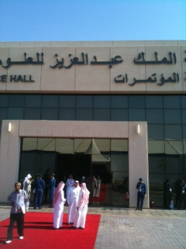

Figure 1. The KACST Conference Center

The stage for the Conference center is shown in Figure 2.

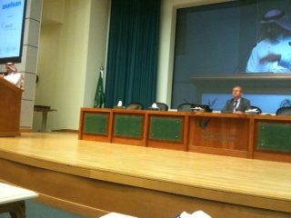

Figure 2. Stage at KACST Conference center where conference was held

The title of my paper was Operational Considerations for Passive Bistatic Radar. Prof Hugh Griffiths of UCL was a coauthor on the paper. Since they put me in the Military and Security Radars track and only gave me 20 minutes, I omitted any real technical detail and emphasized operational applications and advantages and disadvantages of PBR. The paper seemed to be well received.

The conference was generally pretty interesting. The quality of the papers varied quite significantly. The agenda for the conference is shown below in Figures 3 and 4. The papers are supposed to be available after 19 December. If anyone wants any of the papers, let me know.

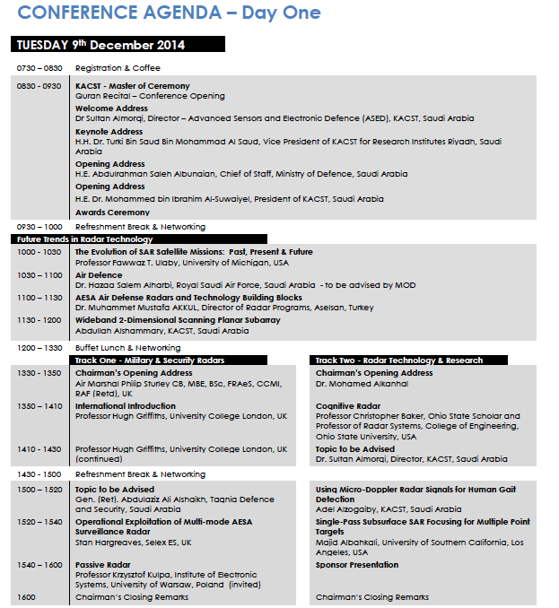

Figure 3. Conference Agenda Day 1

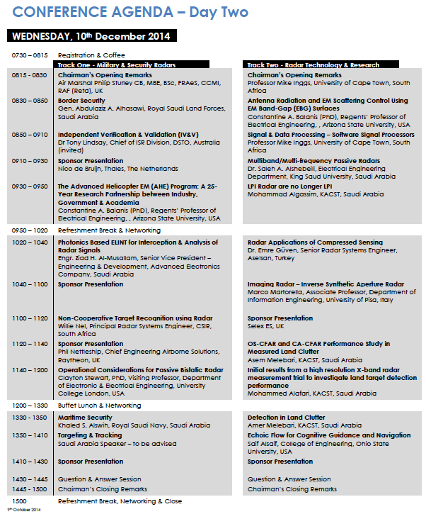
Figure 4. Conference Agenda Day 2

The conference featured an exhibit, which was pretty comprehensive. Figure 5 shows a picture of the exhibit hall.

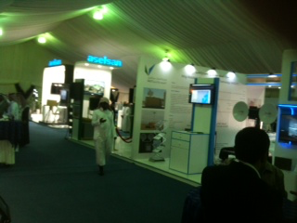

Figure 5. Conference Exhibits Hall

I was invited to visit King Saud University (KSU) (http://ksu.edu.sa/en/) while I was in Riyadh. KSU is a very large university with a student body of 65,000. Figure 6 is a picture of me in front of the School of Engineering at KSU. I was hosted by Dr. Abdelouahab Bentrcia, Lab Director of Prince Sultan Advanced Technology Research Institute (PSATRI) (http://www.psatri.org.sa/) who gave me a tour of his institute as well as the Electrical and Industrial Engineering Departments. PSATRI is primarily involved in defense electronics type of research and is funded by KACST and the Saudi Air Force. They appear to be very well funded, and the faculty seems competent and enthusiastic. The faculty appear to for the most part to have gotten their graduate educations in the US or Europe. They have state of the art lab equipment.

Figure 7 depicts some UAV’s that students in PSATRI have designed and fabricated. These projects were comprehensive and included the airframe, the payloads, the ground station, data links, the automatic flight control system, and system integration. After they have built the system, they flight test it. These are great student projects.

Figure 8 shows a large 3D printer in the labs of the Industrial Engineering Department at KSU. The airframes for the UAV’s developed in PSATRI were printed here. In addition, the industrial engineering students print automobile bodies here.

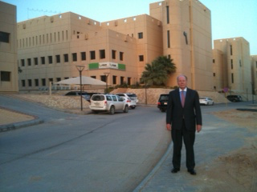

Figure 6. School of Engineering at King Saud University

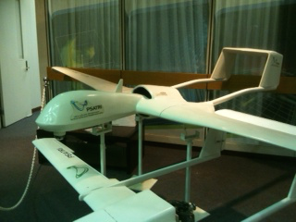

Figure 7. Student Designed and Fabricated UAV’s at KSU PSATRI

In Figure 9 the industrial engineering students at King Saud University designed and fabricated the chassis and body of this car. It's especially designed to mitigate impact with camels. There seems to be a problem particularly at night with cars at high speeds on the desert highways hitting camels. Because of the camel's long legs, on impact with a car the camel body normally ends up smashing into the passenger compartment causing serious carnage. This car is designed to have heavy bracing around the slightly smaller windshield to prevent the camel body from smashing through on impact.

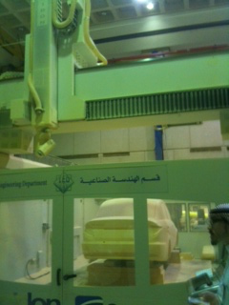

Figure 8. Large 3D Printer in Industrial Engineering Department at KSU

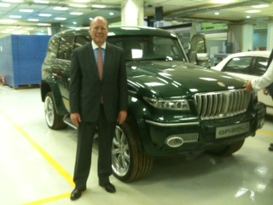

Figure 9. Automobile Chassis and Body Fabricated at KSU

