February 5, 2015 | 6:16 AM | Lynn Jolicoeur

‘The Biggest Barrier’ To Preventing Suicide: Not Talking About It

FILED UNDER: Boston, google-editors-pick, suicide-crisis-series
- E-mail
- Twitter (244)
- facebook (17760)
First in an occasional series we’re calling “Suicide: A Crisis In The Shadows“
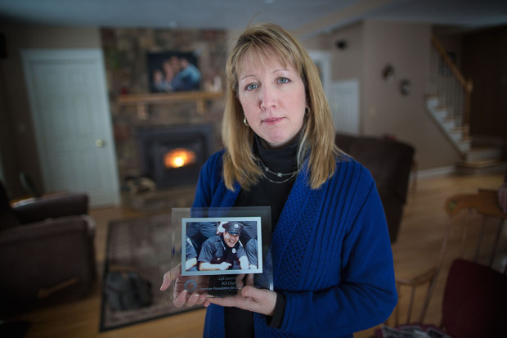
Justine Barnes holds a photo of her brother, Luke LaCaire. “I don’t hold back anymore. My brother died by suicide. My brother struggled,” Justine says. (Jesse Costa/WBUR)
BOSTON — More than two years after her son’s suicide, Susan LaCaire, of Spencer, still has a hard time opening up about it with those outside her closest circle.
“I always say we lost Luke. I never tell people how we lost Luke, unless they ask me,” LaCaire explains. “There is a stigma, and I think a lot of people look at Luke’s death as senseless. He could have lived and he chose not to.”
But the LaCaires are on a mission to bring suicide out of the shadows.
“I don’t hold back anymore. My brother died by suicide. My brother struggled,” says Justine Barnes, Luke’s sister.
“People don’t know what to say to us. They don’t know how to console us. If I told them that he had a heart attack, they’d be like, ‘Oh, I’m so sorry, that must have been so sudden.’ If you tell somebody that [your loved one] died of suicide, that wall goes up, and they don’t know how to deal with you. And then unfortunately for those of us left, that leaves you feeling even worse.”
“I don’t hold back anymore. My brother died by suicide. My brother struggled.”
– Justine Barnes
Barnes says she wishes her brother Luke, who was 35 when he died, also could have had an easier time talking with those around him about his life struggles and mental health issues. Luke was going through marital problems, and his young daughter had brain cancer. And, his sister says, when he tried to open up, some friends would tell him to toughen up.
“When my brother died, people had the nerve to come to say to me what a coward he was,” Barnes recalls. “My brother was a firefighter. My brother went to Afghanistan. My brother fought for his country. He goes into burning buildings to save people’s lives, and he’s a coward? My brother had a weak moment with a lifetime of depression.”
The LaCaires find understanding among others who’ve suffered loss through suicide, gathering at events like Worcester’s annual Out of the Darkness suicide awareness and fundraising walk.
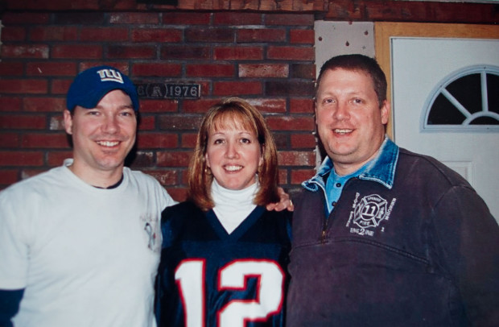
From left: Luke LaCaire, Justine Barnes and Cory LaCaire in January 2012, the last photo of the siblings together before Luke’s death in October of that year. (Courtesy)
Among the other families at the most recent walk in September was an Auburn couple that took a bold step after the suicide of their son, Paul LaRochelle III, nearly a year ago. In the 27-year-old’s death notice, the family disclosed he died by suicide.
“We wanted to make the awareness that it does happen, and it happens to many families, and it’s heartbreaking,” says Paul’s mother, Paula LaRochelle.
“We get up every morning struggling, trying to get up,” LaRochelle says. “But if by what we’re doing for Paul and representing Paul will help save one more person, just one more…”
The Inability To Talk About Suicide
But so often, suicide is hidden — in the obituaries of young people or middle-aged men who died “suddenly at home,” in the announcement by a college that a student died in his or her dorm room, or in word someone was hit on the tracks of the commuter rail.

WBUR Series: Suicide: A Crisis In The Shadows
- ‘The Biggest Barrier’ To Preventing Suicide: Not Talking About It
- ‘She Was Able To Put On A Happy Face': Big Personality Masked Pain
“The biggest barrier or the biggest cultural barrier we have to preventing suicide is not being able to talk about it,” says Jack Jordan, a clinical psychologist in Pawtucket, Rhode Island, who’s widely recognized for his expertise in counseling suicide survivors — those who’ve lost a loved one to suicide.
Jordan says that inability to talk about it often stems from shame and guilt. He’s met survivors who rarely or never talk about a suicide in their family. He recalls one woman whose father killed himself when she was a child. She went years without sharing the truth with anyone — not even her husband.
“Suicide immediately presents a choice point, which is, ‘What are we going to tell other people? What’s our narrative going to be about this?’ ” Jordan explains. “And in fact, families can have a lot of tension about that — even split sometimes, or fracture around that.”
And those decisions surrounding what to say get even more complicated when talking to children — with many parents thinking they should make up a different explanation of the loved one’s death, according to Jordan. He recommends telling the truth in age-appropriate increments, so kids aren’t filling in the blanks with confusion or self-blame.
“For that kid to think, ‘Maybe I did something. Maybe it’s because Daddy was mad at me or maybe I didn’t clean up my room.’ Sort of a child’s mind trying to make sense of this,” he says.
We need a cultural change in how we talk about suicide, Jordan says. And that has started, albeit slowly, due in large part to the survivors who do talk openly.
‘It Is A Community Problem’
Debbie DiMasi is director of grief support services at Samaritans in Boston. She’s also lost family members to suicide. (Jesse Costa/WBUR)
Debbie DiMasi is one of them. Her brother, Jeff Kinlin, died by suicide in March 2006 at the age of 46. “And my niece, who was 26, she took her life in June of 2008,” DiMasi recounts.
DiMasi is director of grief support services at Samaritans in Boston. Her family has known tremendous loss from suicide. Most recently, her daughter’s boyfriend took his life last April. DiMasi says her family didn’t feel any shame in the wake of her brother’s suicide almost nine years ago. But they were so open about it, some people didn’t know how to react.
“I think people are scared by the subject. I think everyone thinks it’s not going to happen to them,” DiMasi reflects. “And it’s at an arm’s length. And it’s not something that they want to think about or talk about.”
Many survivors are avoided or outright ignored by acquaintances. Though several of DiMasi’s friends have proved to be a wonderful support, she lost the friendship of her closest friend of 30 years after the suicides in her family, and she doesn’t know why.
Barry Feldman, a psychologist and professor at UMass Memorial Medical School whose work focuses on suicide, says society as a whole should be fighting the epidemic.
“We’re all in this together,” he says. “It is a community problem.”
Feldman believes if our government and health care leaders were talking more about suicide, the numbers would drop. He questions why there aren’t widespread public health campaigns to prevent suicide, like the campaigns aimed at safe driving.
“Things like that have really led to reducing the number of motor vehicle crashes” to the point that fatal U.S. car accidents now number fewer than suicides, Feldman points out. “So why can’t that approach, the prevention approach, work with suicide? I believe it certainly can to a large degree.”
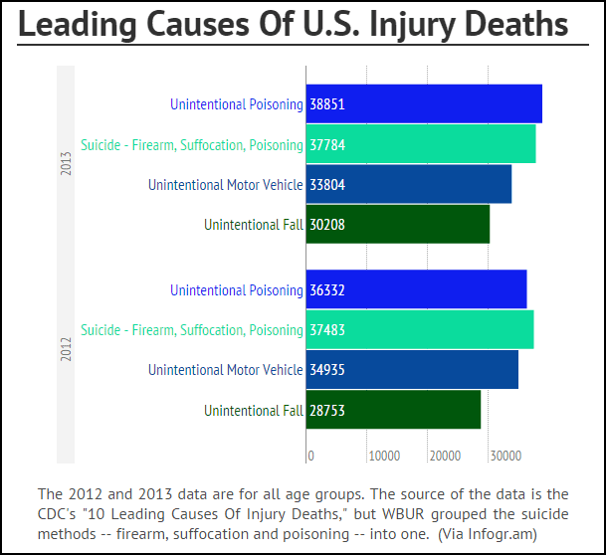
Barnes, the sister of Luke LaCaire, is already teaching prevention to her 12-year-old daughter — who was recently worried about a classmate in crisis.
“She said, ‘Mummy what do I do?’ ” Barnes recalls. ” ‘You go to the school and you tell them.’ I said, ‘You go and you tell her that you’re worried about her. And you act.’ And she goes, ‘Well, I don’t want her to be mad at me.’ And I said to her, I said, ‘You know what? I’d give anything in the world to take back what happened with Uncle Luke. Don’t put yourself in that position.’ ”
Barnes says she wishes she had taken her brother to a hospital the week before he died, when he cried about his life and his pain. But then he seemed better, and the family didn’t think he would actually hurt himself.
Mental health professionals say the first step everyone can take toward opening up the conversation and helping prevent suicide is asking any family members or friends who might be suicidal whether they’re having thoughts of killing themselves. Psychologists say asking is not going to give someone the idea or make them do it. In fact, it may be the first step toward them getting proper help and knowing people care.

