Wellness Alliance Inc.
2017
Wellness Booklet

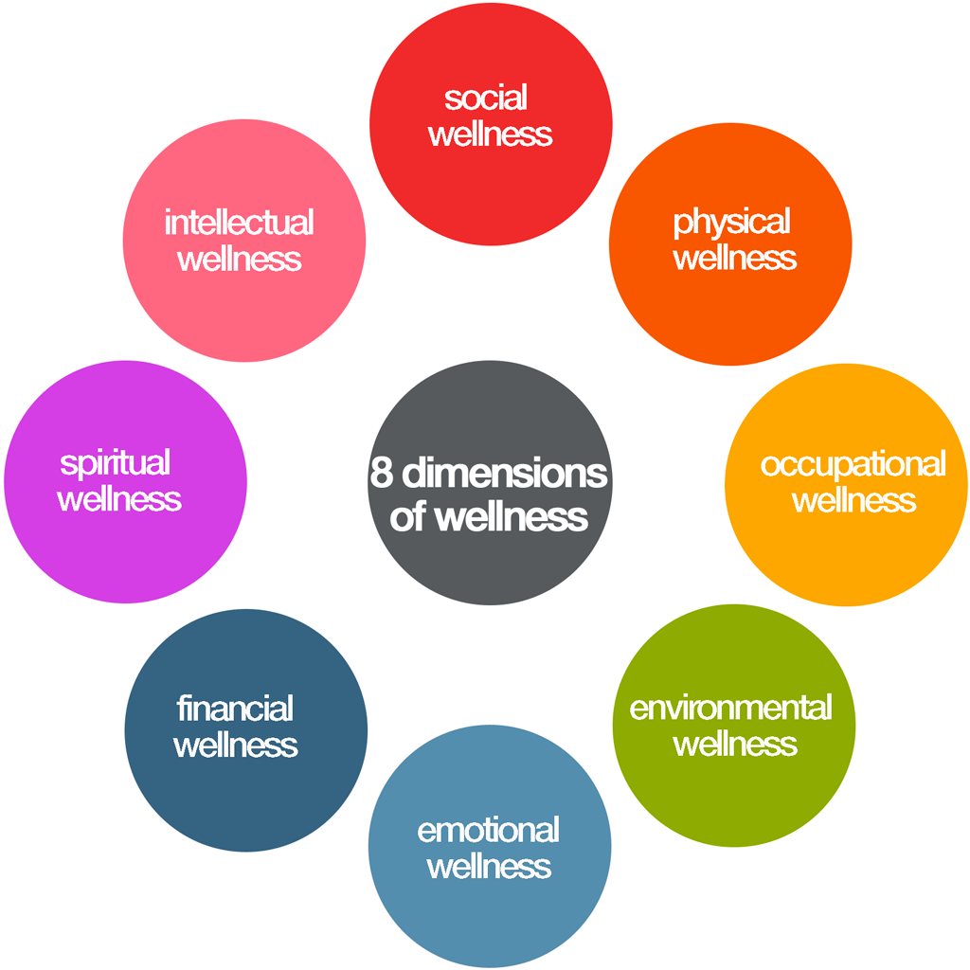
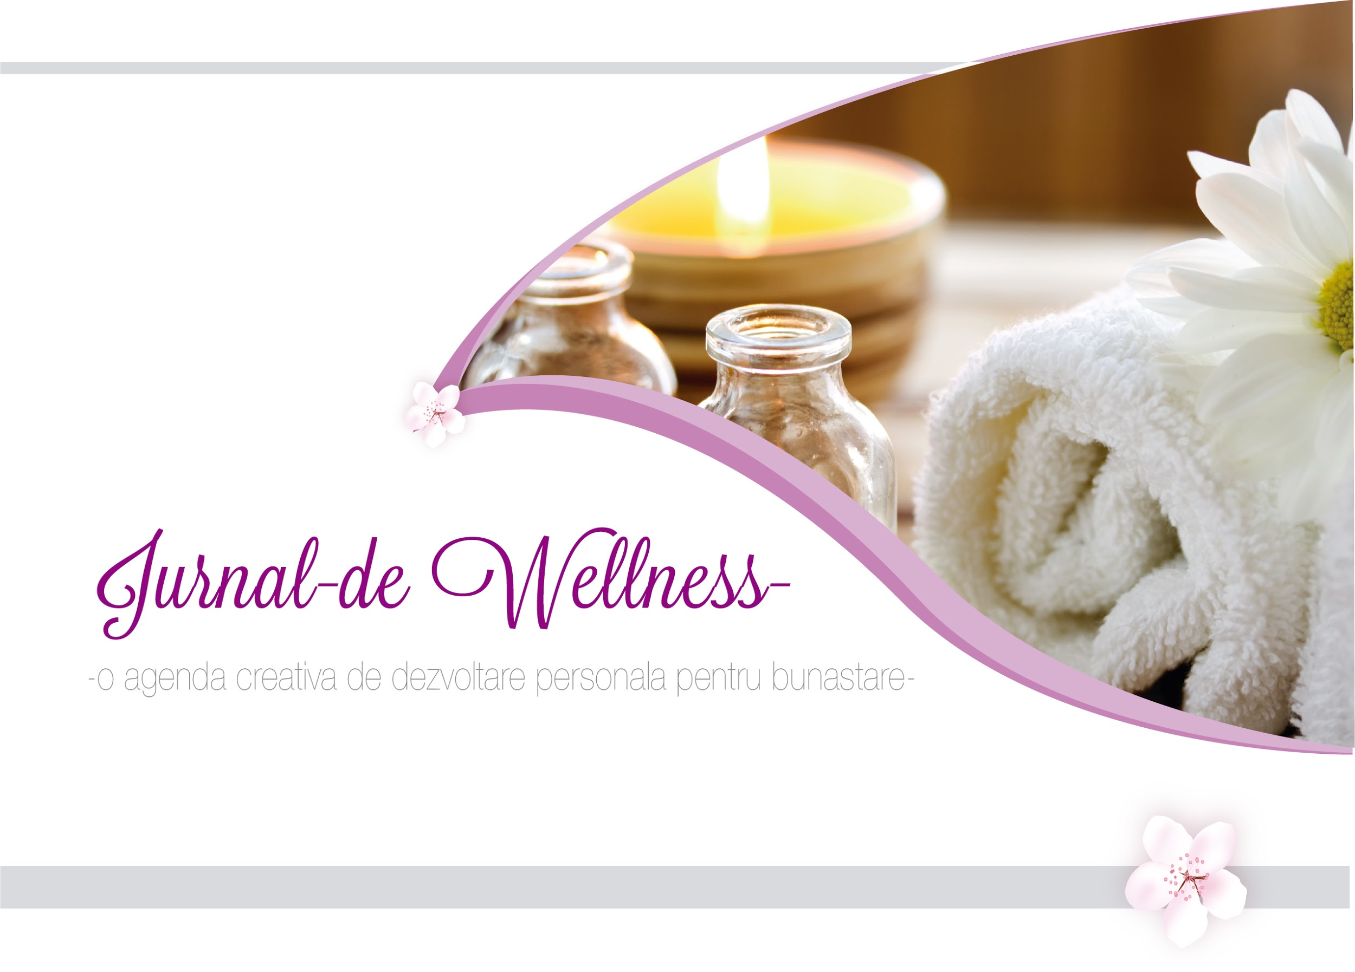

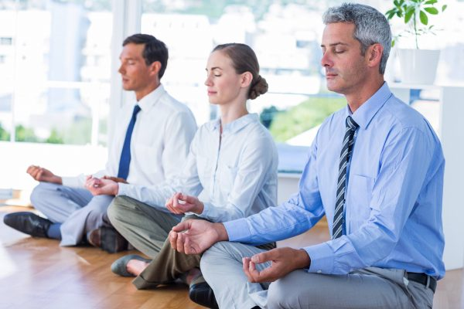
Wellness is a holistic concept and it includes a multitude of components:
Spiritual - Inspirational- Motivational, - Emotional – Psychosocial- Cultural-,
Intellectual-Physical, Environmental, Occupational, Financial and others.

For the following questions you may spontaneously think of or you may need more
time to meditate
Reflecting energizes you and inspires you to start on your wellness journey!

1. What are your Core values?
for me are: happiness, community, family, meaningful social relations, bettering the world, promoting body-mind-soul medicine
What are your valued social relationships?
For me the valued relationships are those who make me feel as family , happy ,that I belong, but as well those who assist me in my journey to better my work and the world
2.What are your personal strengths?
I am ambitious, open minded, flexible ,altruistic , intentional, creative and generous.
3.Create your Own Wellness Vision!
My wellness vision is to be generally happy and social, around people with whom I have meaningful work and activities in which I feel I can better the world I live in.
Picture it!
As Jack Canfield says , you can create a vision board with pictures of all the things you wish to achieve and look at it regularly.
What do you value most of your life?
I value human interactions, animals, nature and charitable activities
What people, resources, systems and environments can help you realize your vision?
My resources and supporting systems are those who have a similar mindset , are motivated to bring something new and at the same time charitable and serving a higher purpose to this world.
Brainstorm multiple possibilities! It is always beneficial to be open to anybody because each individual has something positive, genuine and creative to bring.
What challenges are on the way to reaching your vision?
My biggest challenge is myself - my negative perception of the circumstances and lack of capacity to surpass opposing challenges.
What wellness promoting behaviors would benefit you to adopt consistently?
I would be benefited if I would regularly go out and connect with those with similar mindset , aspirations and motivations.
What times, how and with whom?
Naturopathic oriented health providers , entrepreneurs, people who are involved in charity
Think about and design your Monthly Goals, if you hold some!
My monthly goals are around accomplishing a motivational website and researching how I involve in helping my former university and high school
Think about and design your following Weekly Wellness Goals!
Write them in a Wellness Journal or a diary!

Spiritual- Inspirational-- Motivational Wellness

Who are your inspiring figures and mentors for personal growth?
Write what inspires you about them
Use people that know you deeply and have insight to counsel you!
Create your own meaning, higher purpose, life vision and mission!
Serve the community, get involved in leadership
Empower yourself, the community, your region, your country, continent and the planet
Pray, have Hope, have faith ,belong to a fellowship
Get inspired with live events, books, online sites, CD’s, audiobooks, apps

Emotional and Mental Wellness
Surround yourself with the people you love
Spend regular time with people that bring joy and uplift you
Stay grateful for the present moment
Calm your mind to be able to discover the successful and rewarding pathway
Invest your time in the things that truly matter to you
Grow positive emotions like generosity, joy, calm, forgiveness, gratitude, happiness
Balance emotions in a daily practice
Practice Gratitude, Cultivate Hope, Be forgiving
Be mindful and Grateful –
Think of 5 positive things, persons, events and activities that bring you joy, happiness and fulfillment- you may practice this in the morning, at bed time or both
You may write about those things in a journal-
Meditate about the good traits in yourself
Reward yourself unconditionally for baby steps and progress that you have done:
I’m so proud, grateful and happy of what I’ve done…
Meditate and listen to Positive Affirmations - tapes can be found on audibles, you tube, … other audios:
I can do anything I set my mind to, I can accomplish any goal I truly want to accomplish, I love myself, I am open to more tranquility, I have a lot to be grateful for in my life, I am a great influence on others, I now provide myself with unconditional love and support, I enjoy supporting and helping other people, I use my talents to make my dreams a reality, I appreciate everything that life has to offer, I value my life, I am learning and growing every single day, I see the good within myself, my positive thoughts are now helping me improve my reality, I now focus on my opportunities, I enjoy living in the moment, I like helping and encouraging others, my genuine self is a wonderful person, gratitude fills my heart, I now welcome more prosperity into my life, It feels effortless to be happy ( audible: Positive Attitude- By Sheila Skye)
Focus on the positive aspects of a situation from the present or past
be aware of your stressors
minimize your stressors by reorienting your focus to the things that bring you joy, peace and fulfillment
Relax, meditate regularly, in the morning and evening
Mingle with people of different cultures and beliefs, celebrate the good things in them
Travel, Create , Enjoy favorite arts and hobbies

Intellectual wellness

Discover and follow your passion, align to your vision in life, values
Be curious of the world,
Increase clarity, focus, creativity,
Motivate yourself to create on your own
Create on existing frameworks
Train with experts, ( Jack Canfield, Brandon Burchard, Stephen Covey- for high performance training…)
Get coaching for peak performance
Sharpen memory like with learning a new language , a new game or a sport or hobby
Discover own signature character strengths and use them to increase your well being!
(free online Questionnaire Center at https://www.authentichappiness.sas.upenn.edu/testcenter)

Physical wellness

Eat healthy- naturally, whole foods, not processed or minimally processed, preferably organic or with no pesticides, prepared or cooked in a healthy way,
Share meals with your best friends and enjoy fellowships
Have regular meals and healthy snacks- set up reminders if you need it
Follow the guidelines of a moderate diet, rich in vegetables, beans, nuts, seeds, fruits
Eat a diet low in animal fats, salt or sugars - natural sugars are the best,
Drink enough water, flavor it with slices of fresh or frozen fruits
Sleep enough, and Wake up rested,
Dream, Take short naps, Cleanse your body, Fast,
Prepare going to bed with relaxing and enjoying activities and thoughts
Exercise your favorite sports: swimming, jogging, tennis, walking, hiking, volley, soccer, basketball, gym, cricket, …
Join a walking, hiking, volley, yoga, running, socializing group of your own or in organized environments
Create your own fitness group
Yoga is beneficial for relaxation, emotional, mental and physical well-being- Stretch- Be flexible -Practice it regularly, start once a week
Balance is important for our bodies- Do balance exercises 2 – 3 times a week – start once a week-each session of 20-30 minutes- you can use professional online yoga sites to do these exercises or join live classes
Practice low impact aerobics, strength training, isotonic exercises, isometric exercises – at home, gym or in live classes Practice low weights lifting
Experience massage and aromatherapy beneficial for relaxation
Go for Annual screenings: Annual wellness exam, Annual Obgyn exam, Annual STD (sexually transmitted) screening,
Have Safe sexual practices, learn your patterns and see what are the factors that predispose you to risky situations,
Have an Annual Skin exam by a professional (for sun, malign lesions)- Watch for new lesions on the skin
Have an Eye exam as needed, diabetic patients need to have the eye exam annually
Self-check your breasts for lumps and abnormal lesions on a regular basis, Self-check your testicles for lumps and abnormal lesions on a regular basis, have a Regular Mammogram
Screen for colon cancer, diabetes, as recommended,
Have an annual dental exam to early treat any cavities
Heal addictions such as excessive drinking, smoking, illicit drugs, … with Support groups, prayer, meditation, fellowships, counseling, service for community, volunteering, leadership
Join smoking cessation classes in your area organized by the main hospitals or use free smoking cessation support such as quitlinenc.com
Environmental wellness
Protect yourself, your family, community, region, state, country continent, planet against toxins and chemicals in foods, soil, water, air;
Educate yourself about protecting the environment, do not pollute others,
Grow your own food, buy from locals who don’t use pesticides, minimize buying processed foods that have chemicals, preservatives and colorants, buy fresh, local, organic;
Support the health protecting and organic industry
Become aware of GMO’s (practically not found in organic foods), be aware of chemicals in detergents, soaps, Favor cosmetics, soaps and detergents that are biodegradable and have mostly natural ingredients
Protect against high amount of medical radiation- inquire always about the necessity of imaging and ask your doctor for the least needed radiative investigation
Filter the water, air, Protect against dust, fumes, toxic inhalants and smoke, do not pollute the air, use environmentally friendly cars and equipment,
Protect against peak hours- intense solar radiation,
Protect against loud noises
Read EWG 2016 Shopper Guide to Pesticides in Produce: https://www.ewg.org/foodnews/summary.php
The Clean Fifteen™EWG's Clean Fifteen™ list of produce least likely to hold pesticide residues consists of avocados, sweet corn, pineapples, cabbage, frozen sweet peas, onions, asparagus, mangoes, papayas, kiwis, eggplant, honeydew melon, grapefruit, cantaloupe, and cauliflower. All the others are more polluted with pesticides so it is better if we buy them from locals who do not use those pesticides or who grow organic.

Occupational wellness
Use the weekends and after work time for relaxation,
Take breaks and take vacation time,
Choose a job that protects your body and health, physically, emotionally and psychologically and that has implemented rules for occupational protection
Protect yourself against lifting heavy weights- Use equipment instead
Protect against loud noises, air pollution, solar radiation by using professional and protective equipment- Work early mornings and late afternoons in high heat and solar radiation seasons, have long lunch breaks during peak hours of heat and solar radiation, use protective clothing for skin protection with long sleeves, big hats
Wear professional earphones while working in high noises
Use safety equipment against falls- safety belt and a helmet
Do not use machines that have strong vibrations
Protect against dust by wearing a mask that filters the air
Per OSHA recommendations, protect yourself against lifting heavy weights, bending, reaching overhead, pushing and pulling heavy loads, working in awkward body postures and performing the same or similar tasks repetitively
Exposure to these activities, increase risk for musculoskeletal disorders ( MSD’s) such as : Carpal tunnel syndrome, Tendinitis,Rotator cuff injuries (affects the shoulder),Epicondylitis (affects the elbow),Trigger finger, Muscle strains and low back injuries.
A cashier who overuses his wrists by rotating movements , needs to wear a protective splint
Employers are responsible for providing a safe and healthful workplace for their workers.
For the office work, respect the desk ergonomics, use ergonomic mouse pad.
If you think your job is unsafe or if you have questions, contact OSHA at 1-800-321-OSHA (6742).
For other worker protection information, such as Workers' Rights, Employer Responsibilities, and other services OSHA offers, visit OSHA's Workers' page.
Work related MSDs are among the most frequently reported causes of lost or restricted work time.
BLS( Bureau of Labor Statistics) defines musculoskeletal disorders (MSDs) to include cases where the nature of the injury or illness is pinched nerve; herniated disc; meniscus tear; sprains, strains, tears; hernia (traumatic and nontraumatic); pain, swelling, and numbness; carpal or tarsal tunnel syndrome; Raynaud's syndrome or phenomenon; musculoskeletal system and connective tissue diseases and disorders, when the event or exposure leading to the injury or illness is overexertion and bodily reaction, unspecified; overexertion involving outside sources; repetitive motion involving micro-tasks; other and multiple exertions or bodily reactions; and rubbed, abraded, or jarred by vibration.

Financial wellness
It is beneficial if you learn :
- how to become self sustainable and at the same time to serve your own purpose and life vision,
-how to find new money making opportunities, to plan in advance, protect against losses, reduce spending
-how to buy smart, favoring quality items

Complementary naturopathic therapies

For your health, it is beneficial if you learn about the complementary naturopathic therapies and how to treat your body using its own inner healing mechanisms and strengths
Some of the complementary naturopathic therapies are : herbology, aromatherapy, homeopathy, acupuncture, Chinese medicine, Ayurveda, Functional-Integrative Medicine , Rei Ki

Assignment
What do you think would be 5-10 things / activities that will increase your wellbeing?

