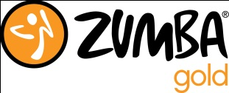
Zumba and Zumba Gold January 2020 farmingtonzumba.com
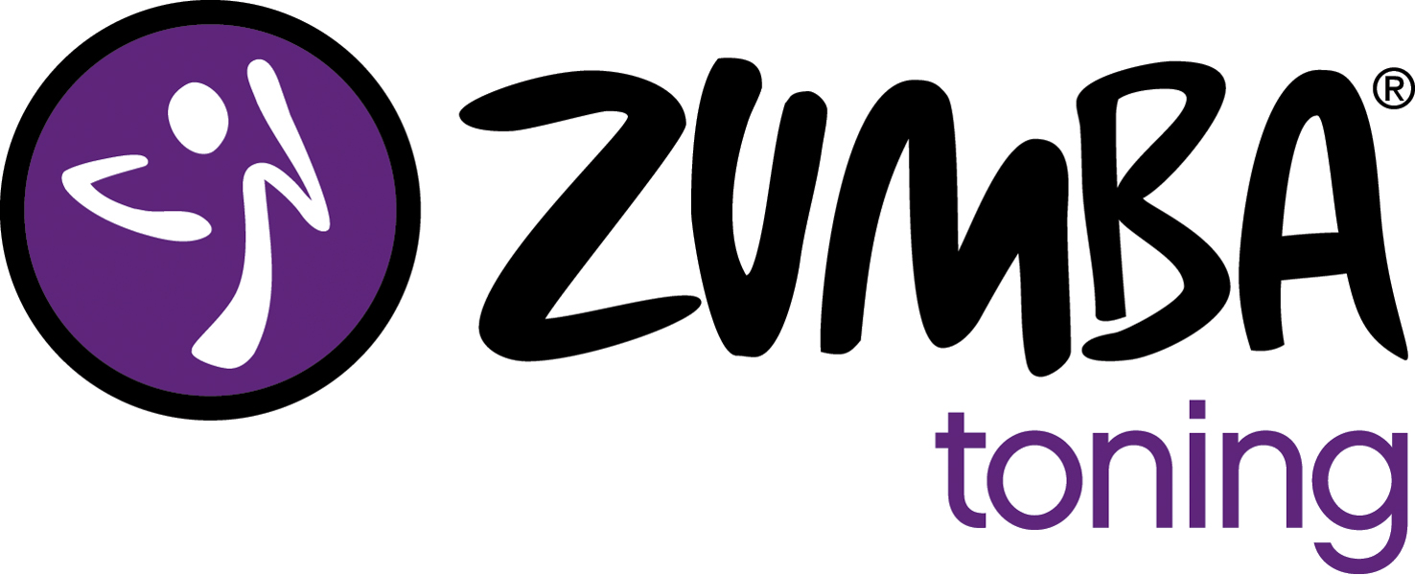
SUNDAY | MONDAY | TUESDAY | WEDNESDAY | THURSDAY | FRIDAY | SATURDAY
Fitness World is on East Pinon Hills Blvd (behind Dickey’s BBQ).  Rec Center is located at 1101 Fairground Rd  For pricing info see farmingtonzumba.com |  |  | 1 Zumba  Fitness World 6-7pm | 2 Zumba  Fitness World 6-7pm | 3  Fitness World 6-7pm | 4 Zumba  Fitness World 9-10am  GOLD  Rec Center 10-11am
5 | 6 Zumba Fitness World 6-7pm | 7Zumba  Fitness World 6-7pm  GOLD  RC 6:30-7:30pm | 8 Zumba  Fitness World 6-7pm | 9 Zumba  Fitness World 6-7pm | 10 Zumba  Fitness World 6-7pm | 11 Zumba  Fitness World 9-10am  GOLD  Rec Center 10-11am
12 | 13 Zumba  Fitness World 6-7pm | 14 Zumba  Fitness World 6-7pm  GOLD  RC 6:30-7:30pm | 15 Zumba  Fitness World 6-7pm | 16 Zumba  Fitness World 6-7pm | 17  Fitness World 6-7pm | 18Zumba Fitness World 9-10am  GOLD  Rec Center 10-11am
19 | 20 Zumba  Fitness World 6-7pm | 21Zumba  Fitness World 6-7pm  GOLD  RC 6:30-7:30pm | 22 Zumba  Fitness World 6-7pm | 23 Zumba  Fitness World 6-7pm | 24  Fitness World 6-7pm | 25 Zumba  Fitness World 9-10am  GOLD  Rec Center 10-11am
26 | 27 Zumba  Fitness World 6-7pm | 28 Zumba  Fitness World 6-7pm  No Gold Class | 29 Zumba  Fitness World 6-7pm | 30 Zumba  Fitness World 6-7pm | 31  Fitness World 6-7pm
Zumba®, Zumba Gold®, Zumba® Toning, Zumba ® Gold-Toning and the Zumba Fitness logos are trademarks of Zumba Fitness, LLC, used under license.

