Full Spa Day:
- Toy/Small (up to 20lbs) $35.00+
- Medium (21lb – 40lb) $45.00+
- Large (41lb – 60lb) $55.00+
- Extra Large (60lb+) $60.00+
- Cat Groom $50.00+
Full Spa Day Include: Hair Cut, Nails, Ears, Bath, Blow Dry, & Brush Out

Express Spa Day:
- Toy/Small (up to 20lb) $30.00+
- Medium (21lb – 40lb) $35.00+
- Large (41lb – 60lb) $45.00+
- Extra Large (60lb+) $55.00+
- Cat Groom $50.00+
Express Spa Day Includes: Bath, Brush Out while Drying, Nails, & Ears

Extras
- Dog Pawdicure $5.00
- Cat Pawdicure $10.00
- Ear Cleaning/Hair Removal $5.00
- Dental Cleaning $10.00
- Weekly Brushing $10.00
- De-matting $17.00+
- De-shedding Treatment $10.00
- Sanitary Trim $5.00
- Getting your pet accustom to grooming $5.00
- How to brush your pet $10.00
- Flea treatment & Comb $15.00
- Monthly Flea Prevention $15.00
- Flea Clean up $20.00
- Feather Extensions $10.00
- Airbrushing $10.00
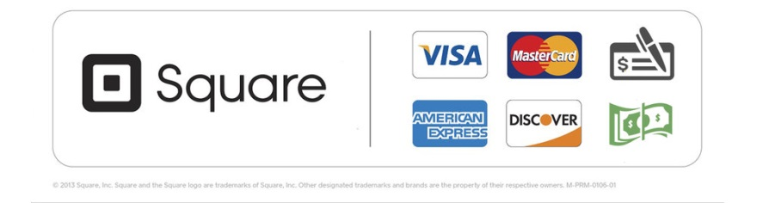
Rustic Paws accepts:

