The Destruction of the Ocean’s Environment due to Cruise Ships: Contributing to Ocean Pollution
Courtney Johnston
George Mason University
May 8th, 2017

Introduction
Cruise ships are very popular among those who wish to travel the world. These cruise ships are huge vessels that can transport hundreds or even thousands of people across the globe. Many people enjoy them because they are a vacation that is on the sea, and they can include games, rides, pools, spas, shopping, music, festivals, and so much more. Because of this they are used constantly and there are always cruise ships out on the water. Cruise ships are meant to be enjoyable and pleasant, however that is not the case with everyone and everything. Cruise ships create a dangerous effect on the ocean in terms of pollution. This pollution is dangerous for the environment above the water, such as the atmosphere and the surrounding land, and it is also very dangerous for the environment below the water, all of the marine life.
Background
Cruise ships are in constant use and are going to be sailing the seas for a very long time. Going on cruises has become very popular and very common among the public. Because taking a cruise is so popular the ships are actually becoming bigger in size to carry more people. “The number of people taking cruises will reach nearly twenty-one million by 2010” (Hardman, 2003). That was seven years ago, and that could mean that the total number of people has increased. The bigger the cruise ship, the more pollution that will be created, and this is a danger for the ocean’s environment. “These boats go to some of the most beautiful places on the planet, places that are already struggling with all kinds of pollution from development” (Hardman, 2003). This is a problem because places that are already suffering from pollution and health effects because of that pollution are becoming even more affected from the cruise ships that travel nearby. Pollution has an effect on everybody and everything within the surrounding areas of the pollution. Cruise ships are a huge contributor to the ocean’s pollution and there are health consequences that come along with this problem.
Health Implications
There are many health implications that are associated with ocean pollution. “The wide-scale dumping of waste leads to extensive accumulation of marine debris in the ocean and is therefore one of the most detrimental threats to marine life” (Leous, 2005). All types of pollution are a danger to all living organisms; humans, animals, and plants. When it comes to animals, they cannot tell the difference between trash and food. They will eat anything and this includes waste that people throw away. This waste is causing harm to the animals on land and in the ocean. In the ocean it is harder to clean up trash than it is on land. In the water trash can float away and be carried away by the waves and people may not be able to clean it up, while on land the trash tends to just lay in one spot making it easier to clean and to notice. Examples of marine debris include plastics, cigarettes, six-pack rings, bottles, cans, plastic bags, fishing lines, automobiles, and many more (Leous, 2005). All of these have an impact of marine life. “Marine debris is a classic ‘tragedy of the commons’ environmental problem” (Leous, 2005). This means that people discard their trash and their waste into the ocean, or any waterways, because they believe that it does not have any effect on them (Leous, 2005). However, this is not true. Anywhere that there is trash and waste that is being discard improperly can have an effect on humans, as well as animals. This is especially true for plastics and animals. Animals tend to get caught up in plastics, such as plastic bags or plastic rings, and this can cause harm or even death to the animal (Leous, 2005). Without proper waste management, on cruise ships and on land, the trash that is being discarded is ending up in the ocean causing major threats to animals and marine life. “As the amount of debris in the oceans has increased, so has the cost of properly disposing of such waste” (Leous, 2005). Proper waste management systems need to be placed and regulations need to be created to try and help the overall pollution that is infected the marine ecosystem.
Methodology
People have been studying the relationship between cruise ships and ocean pollution for decades. There are always new information that is being produced that describes how cruise ships are negatively affecting the ocean and its marine life. There have been many policies and regulations that have been passed and are currently trying to be passed. There have also been internationals conventions that discuss this global issue and, “such international agreements have been fairly successful in forging international consensus on the marine debris issue by defining the problem and assigning rights and responsibilities for addressing marine debris” (Leous, 2005). International conventions are important because they discuss the particular matter in-depth and they try to find reasonable solutions to the problems. “The way in which nations exercise their political interests and allocate resources will ultimately decide if marine debris will continue to threaten our oceans, economies, and future” (Leous, 2005). Since ocean pollution is an international issue there can be many problems that can arise between countries. These are important to overcome in order to find positive solutions to the ocean pollution problems. Without combined effort and agreement issues cannot be settled and agreed upon, which means the issue continues to be pushed back. The disagreements need to be dealt with effectively and efficiently in order to help eliminate ocean pollution overall, or at least as much of the ocean pollution as possible. With the ongoing conventions and the processing of regulations, cruise ships are still polluting the ocean with trash, waste, and chemicals. “Successfully addressing marine debris depends on managing its sources, movement, and impacts” (Health Reference Series, 2016). The way to eliminate pollution is to locate the source and to try and stop the source from polluting the ocean. Also, it is important to know exactly how that type of pollution is affecting the ocean and what the health consequences are of that pollution source. “EPA works to prevent, control, and reduce sources and movement of pollution that may become marine debris” (Health Reference Series, 2016). Companies and agencies are working constantly to try and come up with policies and regulations that stop ocean pollution from occurring.
First Supporting Case/Example
There are many examples and cases that demonstrate the affect that cruise ships have on ocean pollution. One example is the dumping of sewage into the ocean off of the cruise ships. Five major waste streams that are excreted from cruise ships are “graywater, sewage, oily bilge water, hazardous waster, and garbage” (Priesnitz, 2001). All of this sewage and trash that is being dumped into the ocean is causing harm and damage to any of the animals and plants that happen to consume the trash. The trash and waste is damaging the living things around the ships, but that trash also travels to various places deeper within the ocean and this can change the marine ecosystem. It can change it because animals may be eating the trash when it is not supposed to and the eating of that trash can result in death for that animal. If too many animals end of consuming the waste then that can change the ecosystem because the consuming can end up endangering the animals. “In the course of a one-week cruise, a ship will dump hundreds of thousands of tons of waste directly into the sea” (Priesnitz, 2001). All of that waste turns into pollution, and all of that pollution has to end up somewhere. That somewhere happens to be the innocent animals that are eating the waste and dying. “Graywater from showers and other drains can contain detergents and pesticides that can cause oxygen depletion in marine environments” (Priesnitz, 2001). Not only is waste a problem, but so are the chemicals that are being drained into the ocean from the cruise ships. These chemicals are dangerous for humans, meaning they can be even more dangerous on the animals and plants, the ecosystem as a whole, in the ocean. Chemicals are a major pollution problem on land as well. People tend to pour left over chemicals down the drain and those chemicals can end up in the water treatment facilities where they may not be treated completely from the water. This creates health problems for the people who drink the contaminated water. This is the same for the marine environment. If the living organisms in the water consume the contaminated water then they too will become sick and it may possibly result in death. Studies that have been conducted in Alaska report that “shocking levels of pollutants coming from cruise ships, including fecal coliform bacteria in amounts that exceeded U.S. standards by nearly 100,000 times” (Priesnitz, 2001). 100,000 times the normal amount is a number that is way to high for the levels to be safe. All of these chemicals are having a drastic impact of the marine environment. The high levels of pollution are causing harm and damage that cannot be undone. “In the United States, from 1993 to 1998, cruise ships were involved in over 100 detected cases of illegal discharges, and paid more than $30 million in fines” (Priesnitz, 2001). Cruise ship companies had to pay a fine to cover the cost of the damage that was already created from the cruise ship. It is easier to not have waste eliminated from the ship into the ocean and it makes the overall environment healthier if there was less trash and waste being dumped into the ocean. The only way to stop the spread of these chemicals is to have more rules and regulations created that can help to eliminate the pollution, especially out of the marine environment.
Second Supporting Case/Example
Another create example of the effect cruise ships have on the ocean, is the case between the cruise ship industry and Alaska. “Broad-based concerns about pollution from cruise ships arose after Holland America Line in 1998 and Royal Caribbean International in 1999 pleaded guilty to criminal charges of dumping oily wastes and other hazardous chemicals in the Inside Passage” (Klein, 2002). The Inside Passage is a waterway that is located in Alaska and cruise ships travel there frequently. Since there is so many cruise ships that travel within the Passage there is also a lot of pollution that affects the water in the waterway. Cruise ships are known for dumping waste and chemicals in the ocean as they travel. Royal Caribbean International and Holland America Line both had to pay fines for this illegal dumping, as well as the Royal Caribbean International having to pay an additional $5.5 million fines (Klein, 2002). All of this dumping of wastes and chemicals are illegal and are creating a damaging effect on the ocean and are creating a bigger pollution problem. These effects that are happening to the ocean are irreversible. Once those chemicals are drained into the water they cannot be cleaned up, or even if they can be cleaned they cannot be cleaned completely. Chemicals are hazardous and animals are consuming them and plants are absorbing them, making a change in the ecosystem. “Seventy-nine of 80 ships’ effluent had levels of fecal coliform or total suspended solids that would be illegal on land – up to 100,00 times the federal standard” (Klein, 2002). This was mentioned before from another cruise ship waste dumping. This shows that cruise ships are dumping wastes and trash that are dangerous even for on land dumping. If it is not safe for on land dumping then it is definitely not safe for the ocean. “The Environmental Protection Agency had cited six cruise ship companies (involving 13 ships) for air pollution violations in the 1999 season” (Klein, 2002). Air pollution is also a problem with cruise ships because of the amount of gases that they emit from the ship. These gases and smoke go directly into the air and the water creating problems with pollution. Overall, pollution is a huge problem with cruise ships and they create pollution from the smoke and gases, and also from the dumping of hazardous wastes and chemicals into the water.
Analysis
Cruise ships have an effect on the ocean, and the air, with the pollution that is produced from these ships. The pollution can include air pollution, such as the smoke that is emitted from the ships, and the pollution that goes directly goes into the ocean itself. This pollution can include the trash, waste, and chemicals that get dumped into the water from illegal dumping. The illegal dumping is more common than people think and this is unacceptable. It harms the animals and all of the living things that are within the cruise ships travel. When they consume the pollution they can possibly die. This can have an overall effect on the ecosystem now and in the future. This is especially true with the chemicals that are spilled from the ships. Chemicals are dangerous for humans and for animals alike. Animals do not know what is contaminated and what is safe to consume, and they eat the contamination and they become affected. Cruise ships are fined with thousands of dollars for these dumping. This is important because it is a consequence, however it is not enough to stop the pollution completely. There needs to be rules and regulations from the cruise ship companies to create a safer and cleaner type of cruise ship. With regulations there will be less pollution that is emitted and this will have a positive benefit on the ocean. Laws should also be passed for cruise ship companies to follow. These laws should be about cruise ship companies creating ships that follow certain regulations that emit less pollution. If the ship does not follow the law then it should not be allowed to be used on the ocean. There should also be inspections for the cruise ships to eliminate and decrease the amount of pollution that is coming from the actual ship, such as smoke that goes into the air and the water. Creating better, cleaner, and safer cruise ships in the future is very important in trying to decrease pollution and decrease the affect that the pollution and cruise ships have on the ocean ecosystem.
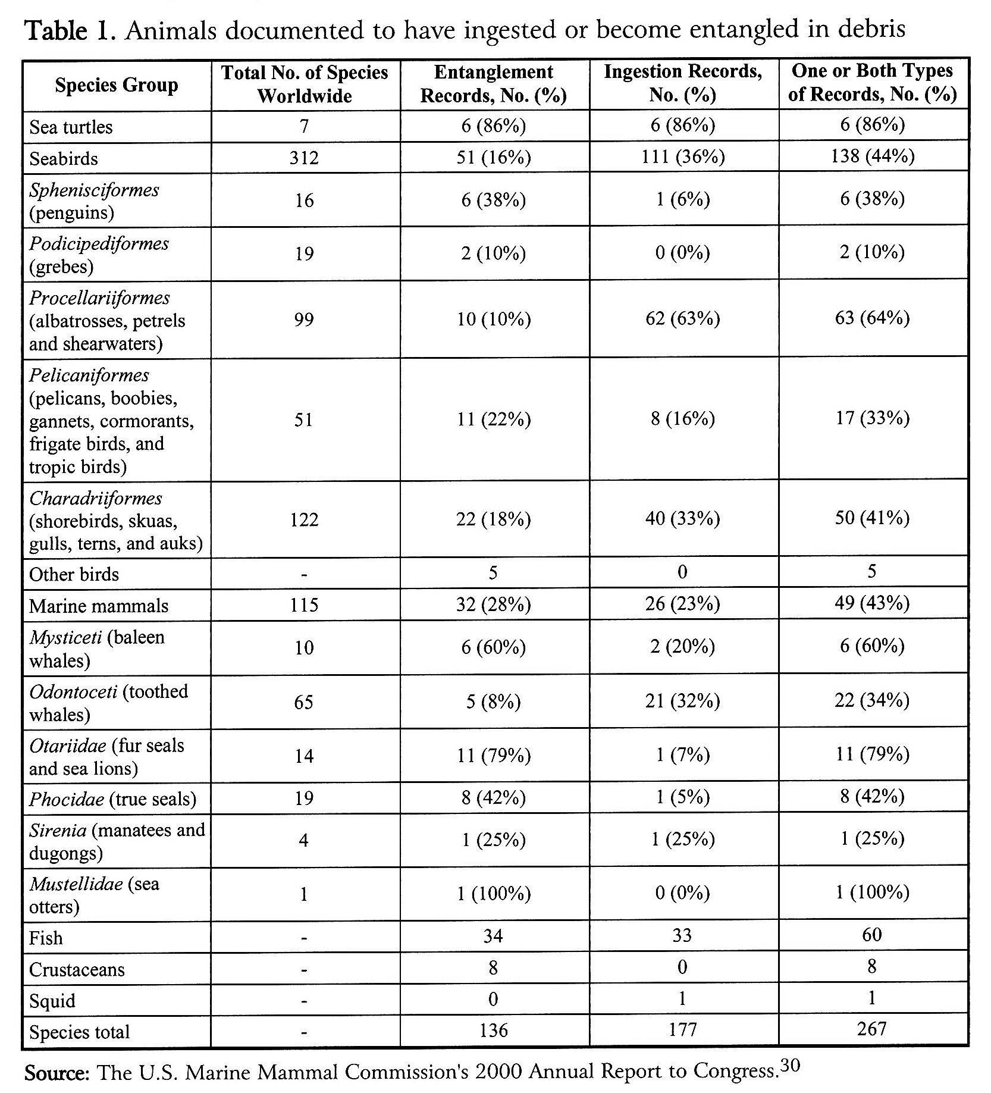(Leous, 2005).
Solutions
Many solutions can be made for the problem of the ocean’s pollution due to cruise ships. One solution can be to try and eliminate as much of the pollution as possible. The cruise ships should try and create fewer waster products and to try recycling within the ship. There should be recycling regulations on the ship so that everyone can follow along. This will create less waste, creating less pollution. Even if the ship must carry the recycled material back to land before disposing it. it can help to eliminate some of the waste that is produced. Another solution can be to “push for corporate responsibility” (Klein, 2002). This means creating public information campaigns and boycotts that can be presented by the public to the cruise line companies (Klein, 2002). Involving the public is very important. In order to create a change people need to know what the issue is, become informed, and they need to know why the issue is a concern. Letting the public become involved allows the issue to become a topic of discussion and this can lead to more attention. Making it a public issue will allow for more people and companies to become involved in order to create a positive change. Another solution is for there to be “a need for greater international, national, and local regulatory efforts” (Klein, 2002). Rules and regulations can help to prevent pollution from the cruise ships or at least try and decrease the amount of pollution that is being created by cruise ships. Regulations are a step in the right direction in changing the course of the future for cruise ships. “Collaborating and co-operating with organizations and groups beyond local and national boundaries can strengthen the impact of local public action” (Klein, 2002). Allowing the problem of cruise ships on ocean pollution to become a global topic of discussion can allow the public to be informed and to create a change.
Conclusion
Cruise ships play a large role in the ocean’s pollution. This creates dangerous and detrimental environments for humans, as well as marine life. Pollution is a global problem and cruise ships are only making the problem worse. They create waste by throwing the garbage from the ships out into the sea, and they harm the living environment that is located directly below the ship. People enjoy going on cruises because they can have fun while on the ocean, they can play games, go swimming, be entertained. This is only making an already serious issue become even more serious because of the growing sizes of the cruise ships. More and more people want to go on cruise ships and that means there will be more pollution created that will end up damaging the ocean. The public needs to become informed and learn about the dangers and the consequences that cruise ships have on the ocean. Creating more attention will allow this problem to become globally known. The more people that become involved, the better chance that there is to create a solution for this problem. Regulations need to be made and laws need to be formed to create boundaries between cruise ships and the ocean. A small effort is important in trying to create a bigger solution to help change the future.

References
Hardman, C. (2003). Cutting a course of pollution. Americas, 55(4). Retrieved from
http://search.proquest.com.mutex.gmu.edu/pqrl/docview/235266464/6773D23BB754B5FPQ/1?accountid=14541
Health Reference Series (4th ed.): Environmental Health Sourcebook. (2016). Detroit, MI:
Omnigraphics.
Klein, R. A. (2002). Left in its wake. Alternatives Journal, 28(4). Retrieved from
http://search.proquest.com/pqrl/docview/218770001/4E5D2F15BD8842BDPQ/2?accountid=14541
Leous, J. P., Parry, N. B. (2005). Who is responsible fore marine debris? The international
politics of cleaning our oceans, 59(1). Retrieved from
http://search.proquest.com/pqrl/docview/220715584/4E5D2F15BD8842BDPQ/8?accountid=14541
Priesnitz, W. (2001). Cleaning up cruise ships. Natural Life, 81. Retrieved from
http://search.proquest.com/pqrl/docview/213035839/CA9380A0E46F4296PQ/1?accountid=14541

