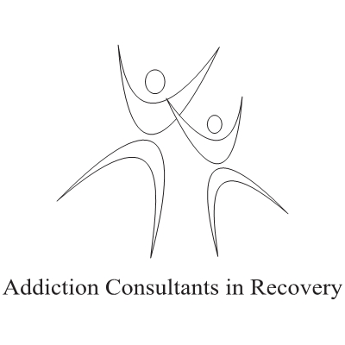

Addiction Training for Helping Professionals: Introduction to Substance Use Disorders (SUDs) ©.

At the end of this training your staff will:
#1. Appreciate that moderate to severe Substance Use Disorders are a disease that the person cannot control.
#2. Understand the three main parts of Substance Use Disorders.
- Emotional
- Physical
- Psychological
#3. Understand an important trend useful for professionals working with SUDs.
#4. Learn and understand subtle and obvious signs demonstrated by clients with a SUD.
#5. Clearly understand what a “Bottom” is for a person with a SUD.
#6. Be introduced to the DSM V criteria for SUDs.
#7. Have a chance to talk with an Addict/ Alcoholic in long term Recovery from a SUD.
#8. Be introduced to strategies for working with clients who have a SUD.
#9. Have a resource to call for further information.
Time for delivery: 3 hours (may vary slightly depending on group size and questions.)

To book your Substance Use Disorder Training or for a quote contact:

Julian Toy H.S.C. R.S.S.W. Substance Abuse Professional
Direct Line: 905-866-7301
Web: www.myaddictionexperts.com
E-Mail: juliantoy@myaddictionexperts.com

© 2014 Julian Toy

