Women of God Ministries

Go and Sow
Women Conference
April 23-24, 2010
__________________________________________
Powerful and Anointed Guest Speakers
Evangelist Victoria Newbill Minister Kira Crawford
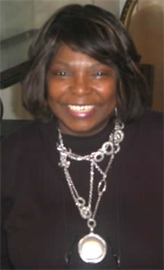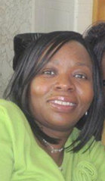

Workshop Speakers
Pastor Norma Cruz-Hayes
Sister Carolyn Smith  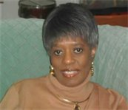 | 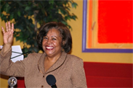  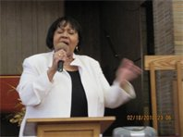  Evangelist Velma Draper

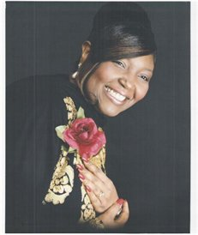
Guest Solo New Gospel
Recording Artist
Salena Siner

Praise Dancers
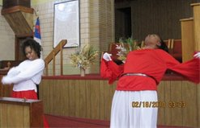
Anointed With Victory

Regina Chisholm-Dancer of Praise
