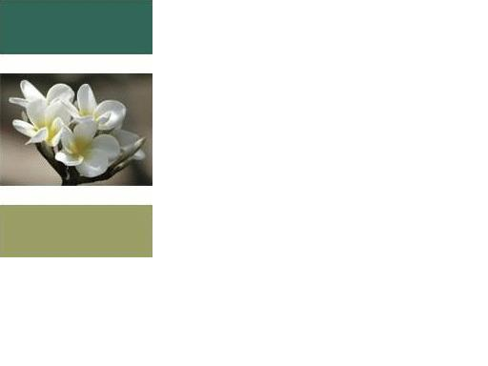

“I am thankful for and send light and love to…”

I am not going to finish this statement right now, it is up to you. This is an interactive thing. You can finish this statement with whatever you like. You can end it with the name of a person, title of a book, the fact that your needs are met, a possession that you have or a favorite moment. What I usually insert are the events, people, and everything that touches my life. I will even insert things that I am trying to create in my life. I also finish this statement with things that I may have perceived as bad or negative. For example: I might insert being unemployed or my least favorite meal or having a person in my life I disagree with.
Weather or not you choose to respond, to this blog, with some of the things you would finish this statement with is up to you. I will suggest however that you try to commit this statement to memory and use at least once a day. If are using it with more than one thing I suggest that you repeat the opening of this statement for each thing.
Example: I am thankful for and send light and love to my wife.
I am thankful for and send light and love to my daughter.
These are just 2 examples you can go on and on. In these examples I could have substituted the word, family, but I found being very specific works better.
If you try my recommendation take note of how you feel during and after this exercise. You may find you feel lighter or even happier. Don’t worry about how long your list is sometimes the longer the better, but if it short that is okay also.
I am going to keep it short this week. I look forward to hearing your comments or questions. Please let me know your experience if you try this. If it is personal and you want to share with only me your confidence is kept by sending me a message. “I am thankful for and send light and love to all who read this.”
Peace, Love, and Light,
David

