As a certified BodyTalk practitioner who has been practicing for more than a decade, Brenda has found it beneficial to promote Max Products because having used them herself and having seen the effects of these products on her own energy levels and those of her family, she fully believes in the amazing results from having Glutathione levels raised. These products have been the result of years of extensive research and are worthwhile investing in.

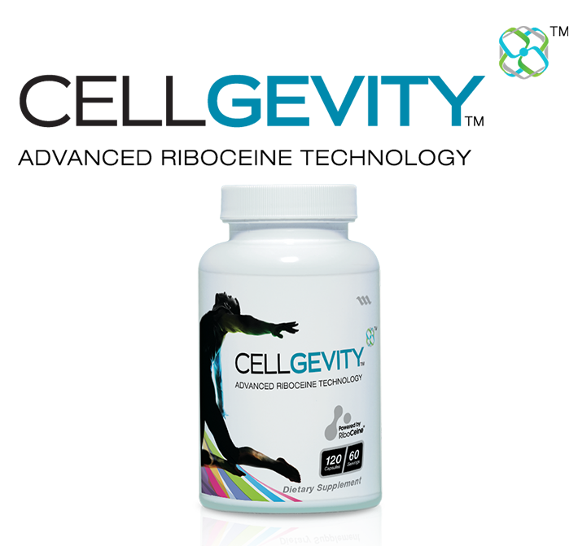

Cellgevity ACTIVE offers Youth, Vitality, Energy, better sleep, better endurance, better recovery, better protein synthesis and better nutrient metabolism just to name a few of the benefits of boosting Glutathione. Cellgevity ACTIVE is the pre-supplement supplement.
Cellgevity ACTIVE is made up of two unique components that when you combine them provide your body with optimum levels of glutathione.
Cellgevity ACTIVE is beneficial for everyone, it is responsible for so much more than just boosting your glutathione levels by up to 500%.
To find out more go to: http://brendap2.maxyour.life/cellgevity-active/

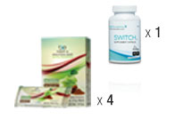

INTRODUCING THE MAX FLEX WEIGHT LOSS SYSTEM
We know that for many people maintaining a healthy lifestyle can be challenging. Work, family, long days, stress, fast food, processed food, and more can make it difficult to lose weight and enjoy a fit and healthy life.
That’s why we’ve developed the Max Flex Guide as a system that provides you with the options and support you need to see results. Our products serve as the foundation for a weight loss system where you decide which foods to eat, how intense your workouts will be, and what habits you’ll want to change the most.
To find out more go to: http://brendap2.maxyour.life/max-flex/

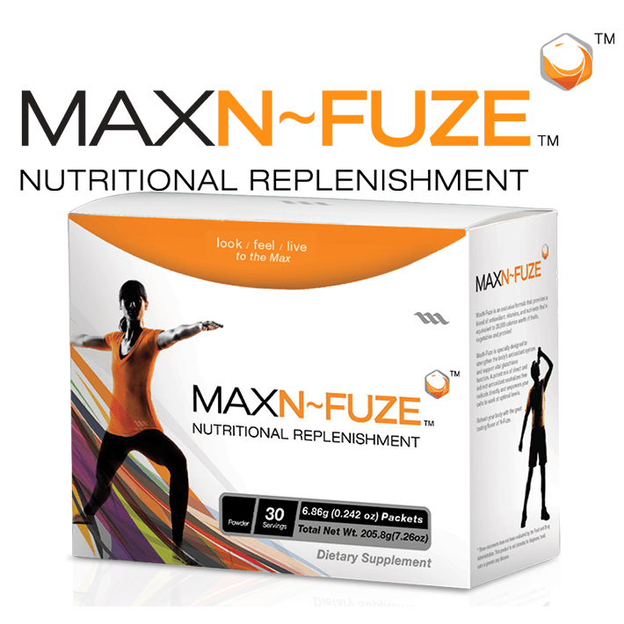

GIVE YOUR BODY THE START IT NEEDS
MaxN-Fuze is Nutritional Replenishment that’s specifically designed to provide both direct and indirect anti-oxidants along with important vitamins and nutrients. This proprietary blend works together to help support your body’s glutathione levels and defend against outside influences and attackers like free radicals, chemical toxins, and heavy metals.
Glutathione plays an integral role in recycling anti-oxidants and removing toxins, but it cant do it alone. Give your cells important nutritional and vitamin support.
MaxN-Fuze assists your cells in functioning at optimal levels. Use Max N-Fuze once a day as a stand-alone vitamin supplement or with any of Max International’s glutathione supporting products.

http://brendap2.maxyour.life/max-flex/

MAX VISIBLE SOLUTIONS

Presenting an innovative skin-care system created to give your skin the support it so desperately needs to combat the harsh conditions it encounters on a daily basis. Visible Solutions is designed by our expert research team to help your skin achieve its optimum appearance of health and vitality. Featuring four complementary ingredients that work together to help you maintain a youthful, healthy appearance, Visible Solutions is your solution for complete skin care.

http://brendap2.maxyour.life/visible-solutions/

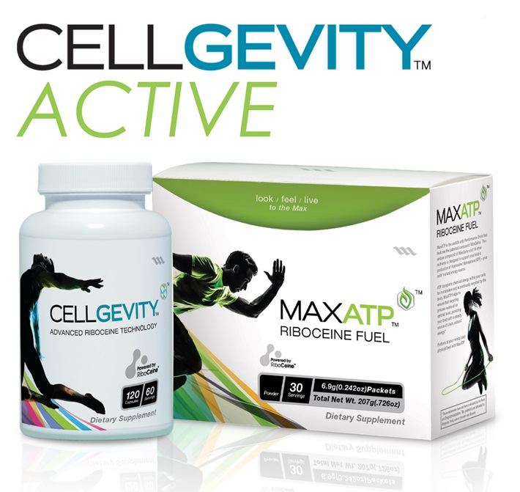

CELLGEVITY ACTIVE

ATHLETES REJOICE YOUR ULTIMATE SUPPLEMENTS ARE HERE

MAX SUPPLEMENTS BSCG CERTIFIED DRUG FREE

PRO ATHLETES AND ACTIVE INDIVIDUALS USE MAX PRODUCTS!
Even though you are most probably eating great food and getting the right amount of macros and you have fine tuned your supplement stack. Do you realise that no matter how good both your food and your supplements are there is one thing and if its not at its optimal levels, then all the great work you are doing with your lean and clean food and your supplements is not enabling your body to utilise them to their fullest. You are NOT maximising your bodies ability to utilise them for maximum performance and recovery.
Your body MUST have optimal levels of glutathione to perform at your best and recover. Glutathione is the key!
There is an amazing link between your bodies glutathione levels and all aspects of athletic performance. Max products are uniquely designed to effectively supplement your bodies production of this all-important molecule.

RAISE YOUR GLUTATHIONE LEVELS
HIGHER GLUTATHIONE LEVELS REDUCE MUSCLE INFLAMMATION AND FATIGUE

To find out more go to: http://brendap2.maxyour.life/athletes/

