
R ecognize…see…what is happening. Pause to create an opportunity for choice to arise.What is happening now, right here, in here??
“___ is like this…” “I see ___…”

A llow… Accept what is happening. Allow what is happening to happen with an open and compassionate heart.
Acceptance of what is with the recognition that it is already happening.
Can I relax here? Can I allow myself to experience this moment? Can I just myself float down this river on this raft? Can I stay here?
“Can I be with this?”; “Yes, I can be here. Yes...”;“stay…I will just stay…”

F eel what is happening. What is really happening right here, right now in this body? Can I open to the feelings and sensations as they arise? Can I hold my experience with a quality of intimacy, gentleness and compassion while saying “yes, this is what (this) feels like right now.”

T rust, release & relax. Let go of trying to control. Loosen your connection to the worries, fears and wants. Allow awareness to be your RAFT. Ride down the river of experience, noticing the ebb and flow of all things. This experience is impermanent and these feelings are not fixed or dangerous.
“This is just an experience. A thought is just a thought. A feeling is just a feeling. It is not who I am nor is it what I am.”

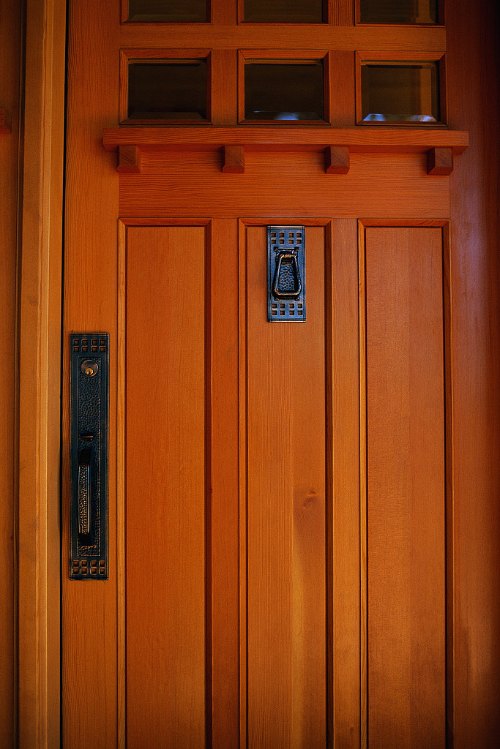

The Guest House by Rumi
This being human is a guest house.
Every morning a new arrival.
A joy, a depression, a meanness,
some momentary awareness comes
as an unexpected visitor.
Welcome and entertain them all!
Even if they're a crowd of sorrows,
who violently sweep your house
empty of its furniture,
still, treat each guest honorably.
He may be clearing you out
for some new delight.
The dark thought, the shame, the malice,
meet them at the door laughing,
and invite them in.
Be grateful for whoever comes,
because each has been sent
as a guide from beyond.

