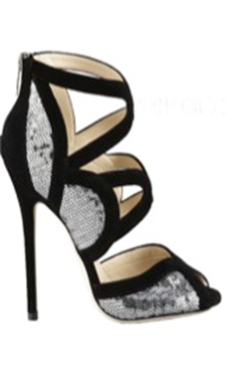
From Cinderella to Manilo Blahnik we may covet a shoe. But there is a reason why they are called ‘killer heels’. Our feet are underappreciated; but if they’re not happy we’re not happy – they’re on duty most of the day managing a balancing act between standing and walking.
Our feet are complex structures and constitute about a quarter of the roughly 200 bones in the body. On walking they absorb at least three times the load of when we’re standing and more when we are running.
Our primary shock absorbers not surprisingly translate any skeletal imbalances, through our ‘gait’ (walking or running) up into our spine. Add to that significant heels and as Dr. Casey Kerrigan in the Lancet reveals, it is not feet alone that are affected but ‘knee torque’; linking high heels to knee osteoarthritis.
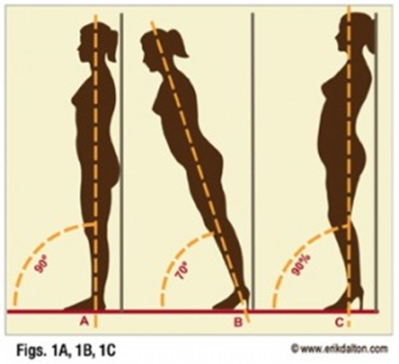
Further problems occur such as corns, hammertoes, arthritis, sprained or inflexible ankles and back problems. Eric Dalton, PhD, notes lumbar compression is a potential risk. High heels cause hyperlordosis (a deep lower back curve) altering our usual centre of gravity putting as much as 90% of our weight onto the ball of the foot compared with 40% in a lower heel.
The value of Amatsu is that it relieves the impact of killer heels, rebalances our pelvis and spine, irons out the knots and restrictions on our muscles and fascia, giving the body more mobility and lessoning the risk of these knots or restrictions leading to stiffness, niggling pain or sudden, sharp pain.

