NUMMIES, NUMMIES, NUMMIES!!

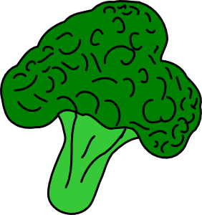GREAT FOOD TO FEED YOUR BUNNY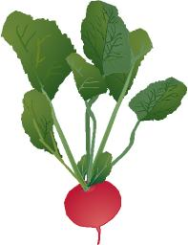

Veggies:

- GRASS HAY (MOST IMPORTANT!!): Timothy, Orchard, Bermuda, Fescue, Oat, Brome ---- NO ALFALFA **Give unlimited amounts every day**
- Parsley
- Dandelion Greens & Flowers
- Cilantro
- Spring Mix (A large container can be purchased at Whole Foods, Kroger, Publix for around $5.00)
- Yard Clover & Flowers (As long as your yard is not chemically treated)
- Endive
- Escarole
- Basil
- Bok Choy
- Brussels Sprouts
- Alfalfa Sprouts (Radish & Clover Sprouts also)
- Green Peppers
- Mint
- Oats (like dry Quaker Oats)
- Fresh Pumpkin
- Radicchio
- Dark Leaf Lettuces (Romaine or Red Leaf – NO ICEBERG)
- Watercress
- Wheat Grass
- Snow Peas
- Parsnips
- Carrot Tops
- Beet Tops

VEGGIES TO BE GIVEN IN MODERATION:

- Collards
- Spinach
- Kale
- Mustard Greens

**These are to be given no more than 1 time per week to avoid
Highness in oxalates/ goitrogens**

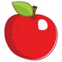 Fruit: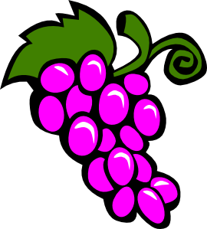

- Carrots
- Apple (NO stem or seeds)
- Banana
- Blueberries
- Melon
- Orange Slices
- Papaya
- Peach
- Pineapple (GREAT during shedding season)
- Plums
- Raspberries
- Strawberries

**Fruits should be given in moderation. Example: ¼”
thick slice of banana a day. Too much fruit can cause excessive weight gain and diarrhea**

Edible Flowers:

- Roses
- Dianthus
- Dandelion
- English Daisy
- Honeysuckle
- Violas
- Lilacs
- Red Clover
- Scented Geranium
- Pansy
- Daylily
- Nastursham
- Marigold
- Squash Blossom
- Violets
- Sweet Woodruff
- Tuberous Begoni
- Calendula

Pellets:

1/2 cup of pellets a day is all that is needed for your bunny since your bunny’s diet should be MOSTLY Hay & Dark Leafy Greens. The pellets we recommend are Oxbow Bunny Basics-T. Avoid feeding ANY pellet with seeds, corns or colorful treats as these are fattening formulas meant to fatten rabbits for slaughter.

**KEEP ALL RABBIT FOOD & HAY IN A COOL DRY PLACE**
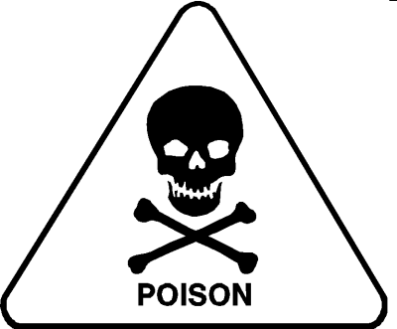

THE BIG “NO NO” FEEDING LIST

POISONOUS PLANTS:

- Apple seeds/stems
- Boxwood leaves & twigs
- Mistletoe & Berries
- Morning Glory & Seeds
- Mustard Roots
- Nightshade
- Poison Hemlock
- Poison Ivy
- Potato Greens
- Rhododendron
- Sweet Potatoes
- Tomato Leaves
- Tulips
- Wisteria (seeds & pods)

**For a COMPLETE LIST visit www.rabbit.org***

OTHER BAD STUFF:

- Chocolate (POISONOUS!!)

- Cookies
- Crackers
- Breakfast Cereals
- Bread
- Pasta
- Yogurt Drops
- Seeds of any kind
- “human treats”
- Salt licks
- Seed/Nut Treat Logs
- Vitamin Supplements
- Bird, Guinea Pig, Hamster, Gerbil, Ferret food

**There is research to suggest these items may contribute to fatal cases of enterotoxaemia, a toxic overgrowth of “bad” bacteria in the intestinal tract**

