Pixe
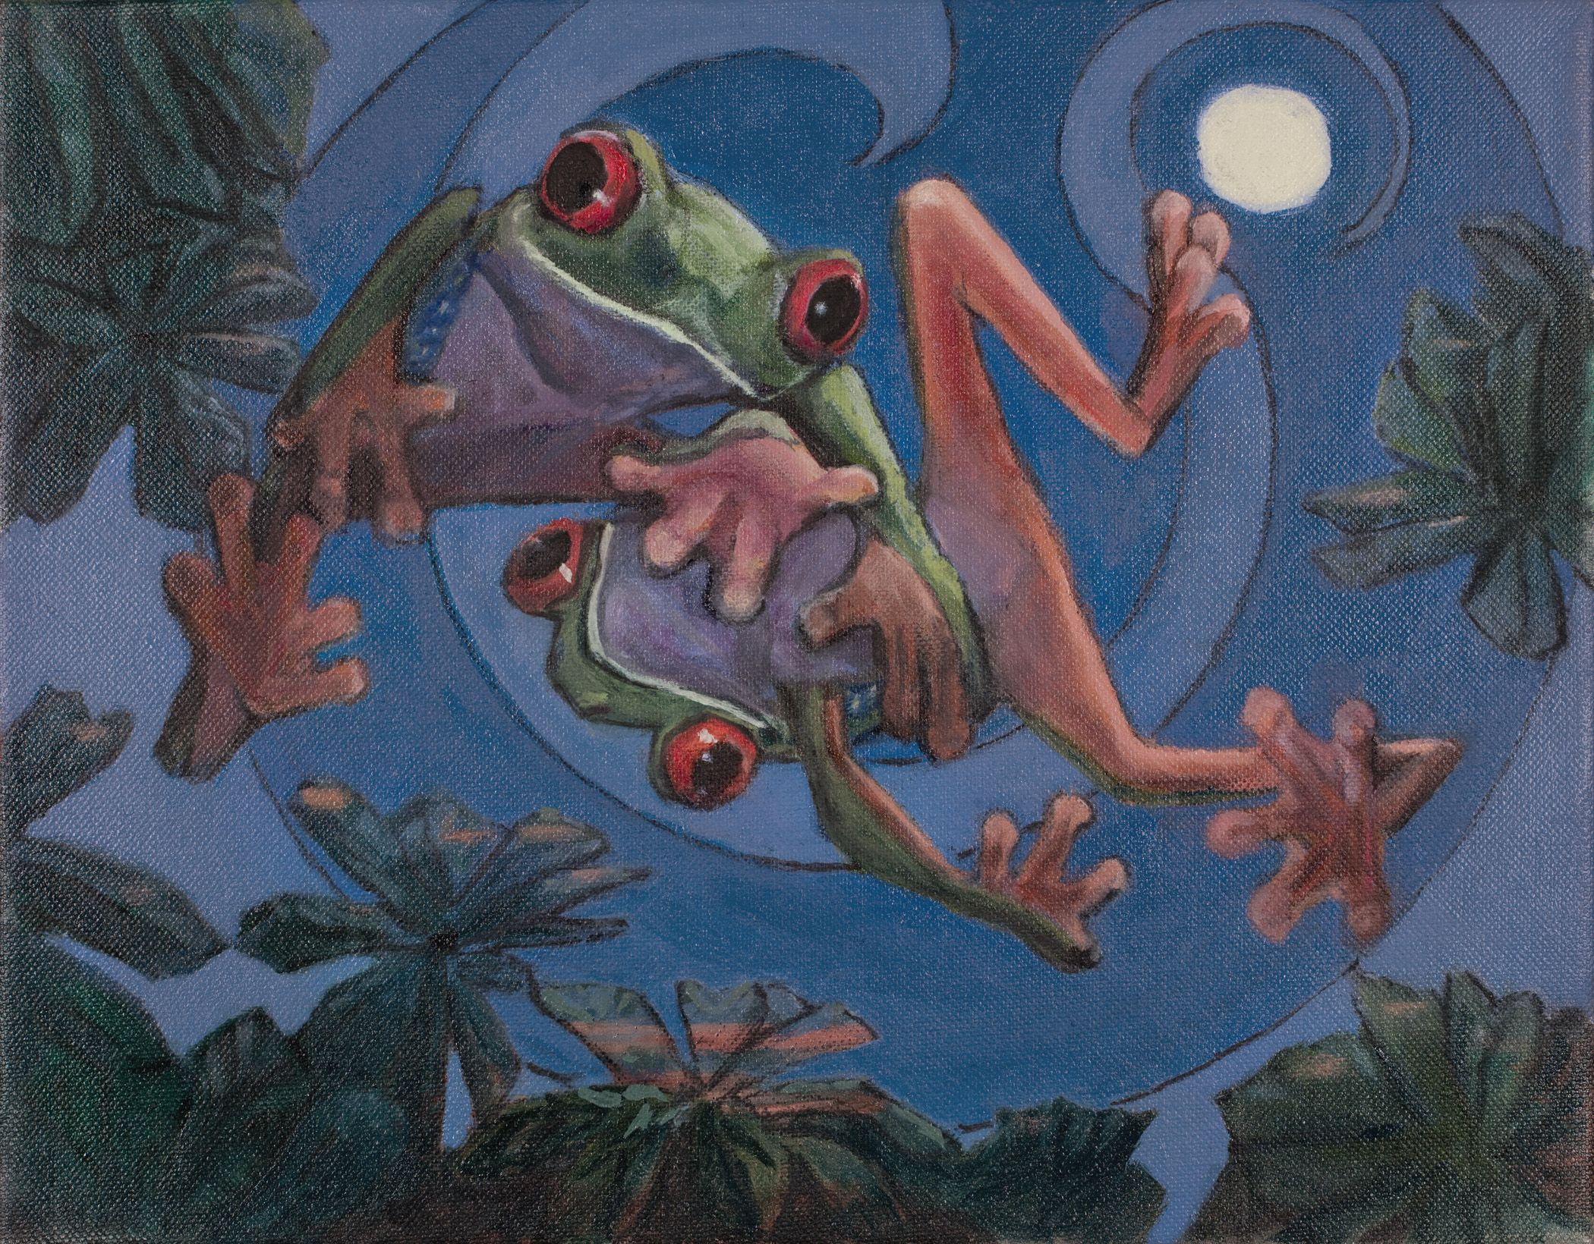
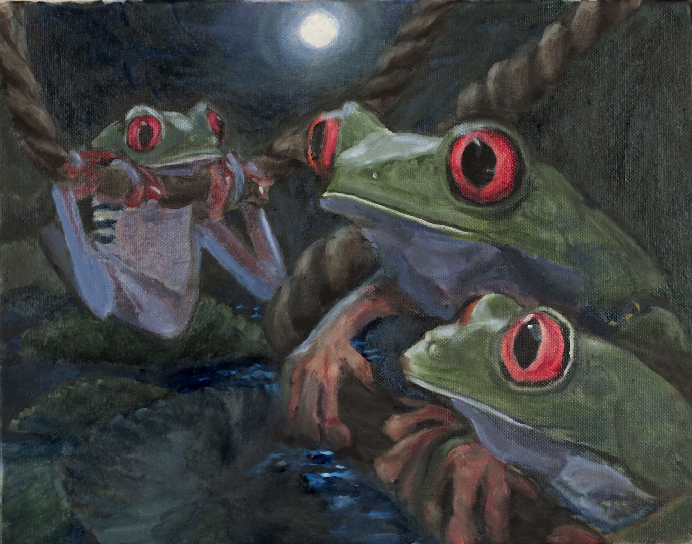
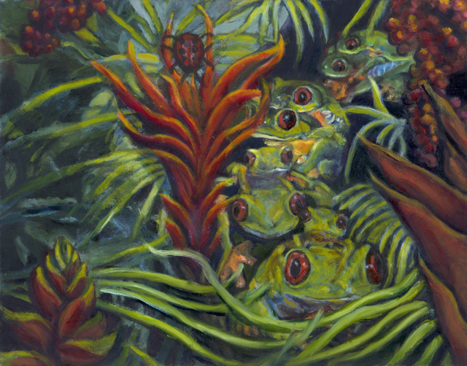
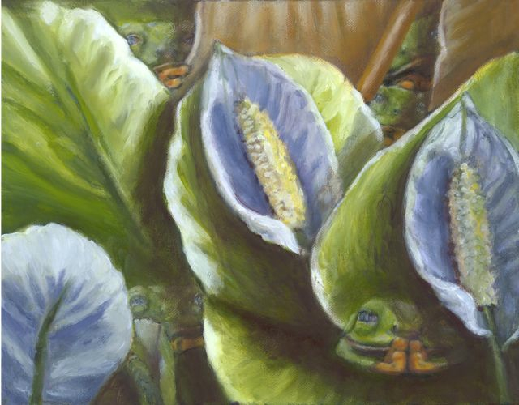
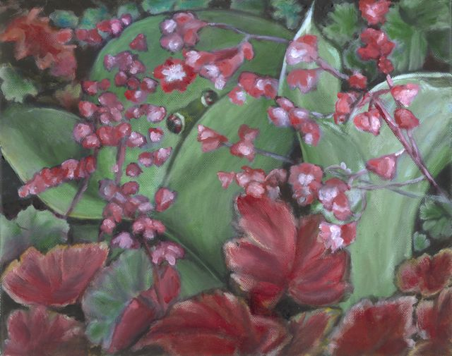
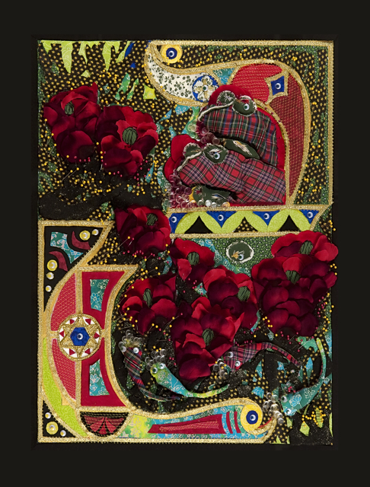
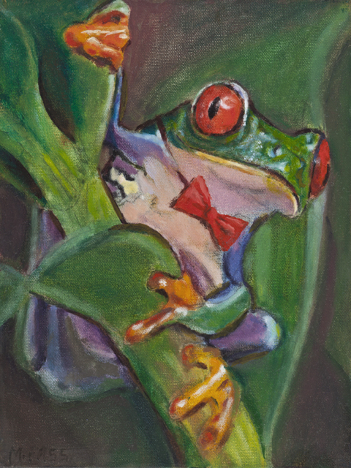
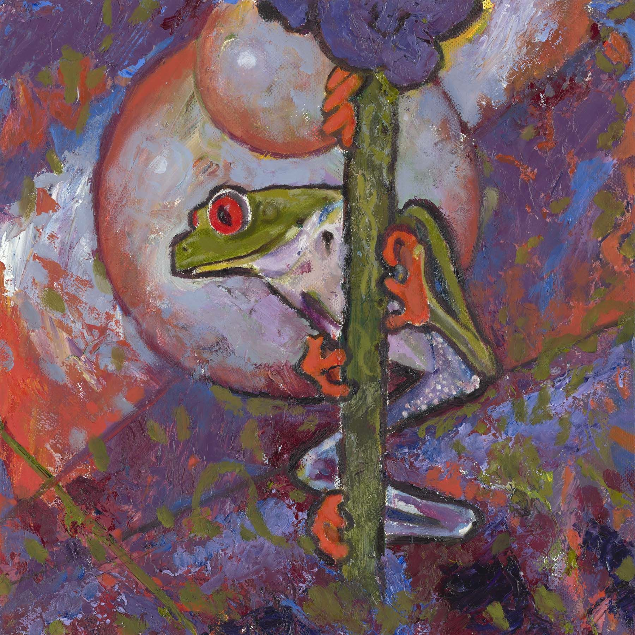
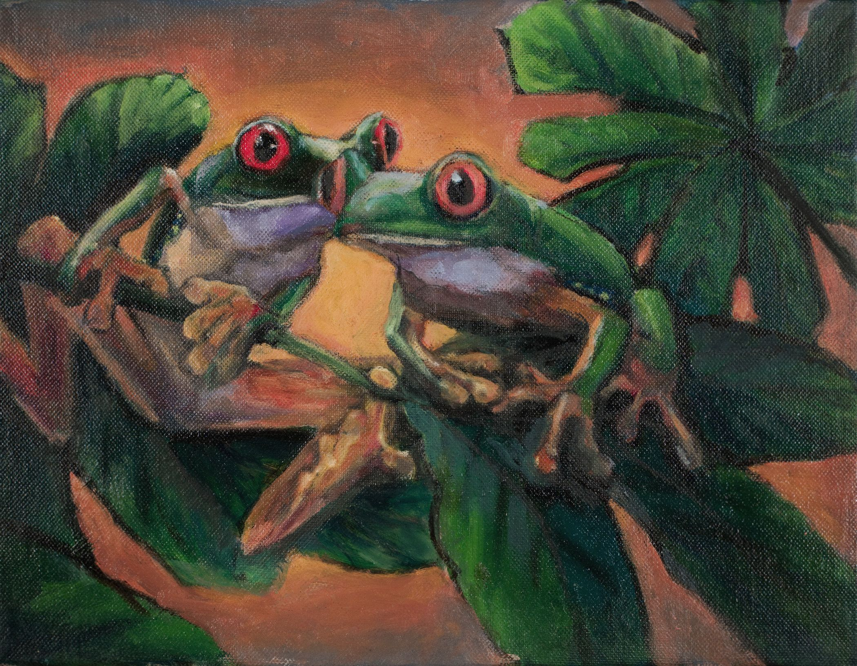
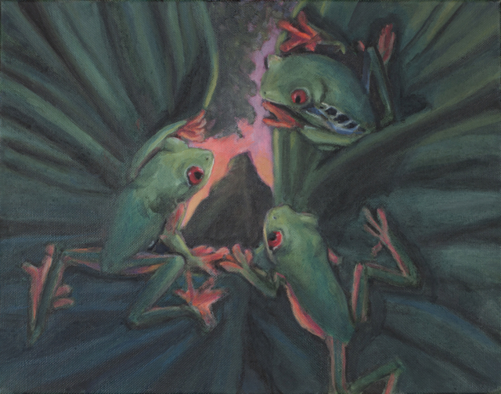
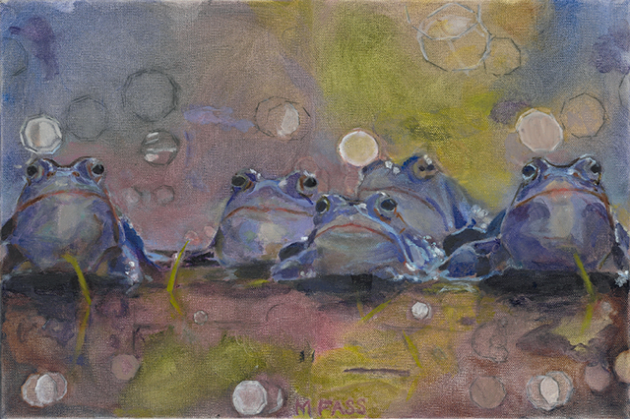
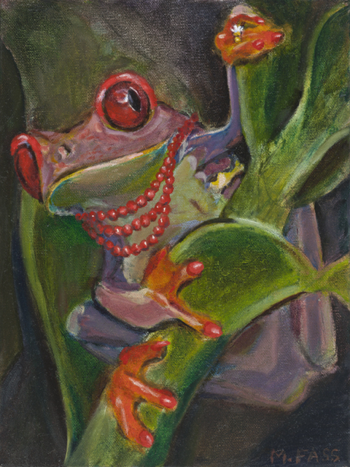
Original Paintings from Froggie Family’s First Frolic
11 x 14” Oil on Canvas Framed - $450 each
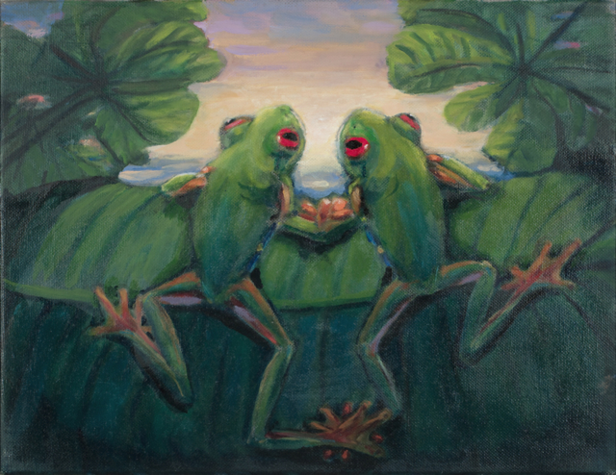
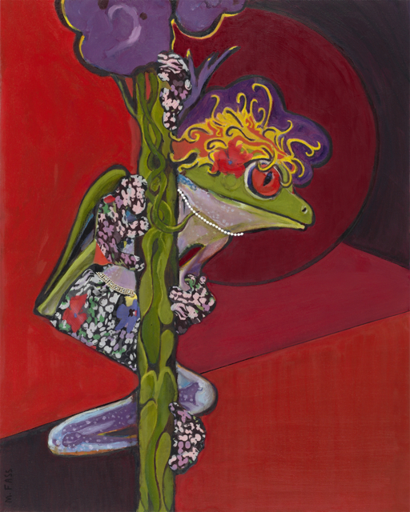
Froggy’s Dream
Oil on Canvas 10 x 12” Framed $400
Rhythm in
Blues
Oil on Canvas 18 x 12”
Framed $450
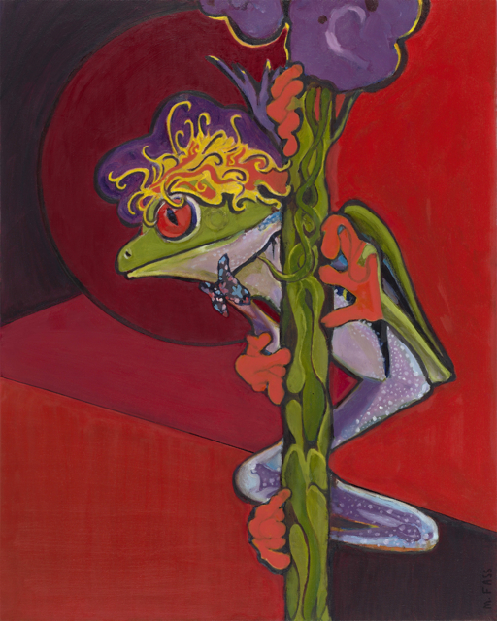
Little Froggy’s Woman
Mixed Media
25 x 27”
Framed
$1750

Beit

Mixed Media
24 x 30
Framed
$3000
Little Froggy Rockstar
Giclee
24 x 30”

Framed
$250

~ FROG PAINTINGS SOLD ~
~ MORE FROGS FOR SALE ~

