Newsletter #7

Welcome to Edition 7 of the 2019/20 LPCC newsletter.

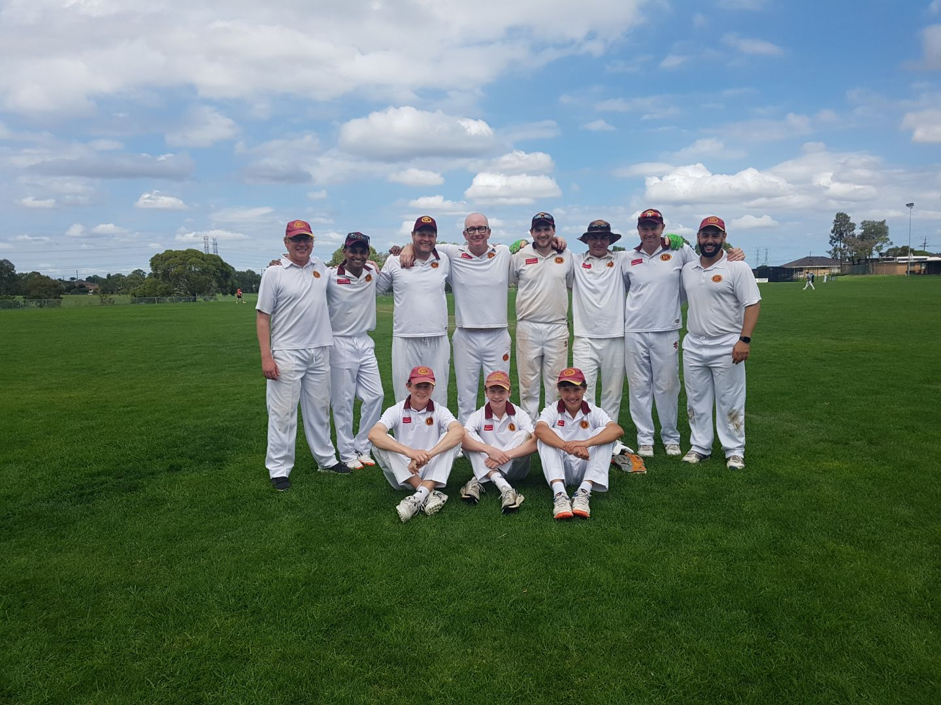

News
Season over for the senior component of the club with the 3rds (above) going down to top side Lalor on their tricky ground last weekend.

It’s a different story with the Juniors, but before we get to the cubs… the Tex Tyrrell Award was held last Thursday evening at the rooms with Assistant Coach Bill Jenkin taking the honours ahead of Sira and Gilbo. Congrats Beej! Here’s our top 10:

Bill Jenkin | 154.53
Luke Sirianni | 118.17
Brett Gilbert | 112.82
Brent Zerafa | 90.9
Max Hughes | 86.45
Max Willis | 84.62
Andy Peters | 81.44
Jimmy Carlyon | 76.92
Alex Campbell | 75
Debashis Dash | 75

Juniors
Well, we are in an exciting position this week with three junior teams in their respective Grand Finals as follows:
- U14s vs Heidelberg at Warringal Park
- U16s vs Hurstbridge/Panton Hill at Lower Eltham
- U18s vs Dennis at LPCC
If you can get along to support the boys at any of these games please do. All three semi-finals were epic wins and we’re hoping for more of the same this Wednesday and Friday.
This has been the culmination of a lot of hard work for all our junior teams and coaches with both U12s teams in the finals mix until the last week. The U10s also had an excellent season under the guidance of senior coach Brent Zerafa.
We have our junior presentation night on Friday March 20 and we’d love to see you all there. This is my chance to thank all the coaches, team managers and other parent helpers for their input throughout the season, as well as recognise the boys’ efforts.
The presentation night will start at 7pm, please arrive by 6:45pm – the club will be putting on a BBQ and the bar will be open. Please feel free to bring along your own snacks as well.
If you have any used cricket clothing or equipment that you’d like to donate, please bring it on the night and we will collect it all and distribute to someone who can use it next season.
Go Lower
Luke, Junior Coordinator

Senior results
The 1s took on Eltham in the final round one-dayer and we scored a respectable 8/165, with Sira (66), Grim (34) and Ru (29) notching their highest scores for the season. It wasn’t quite enough against our finals-bound opponents who passed us 4-down with five overs to spare.

It’s been a development year – talented youngsters in Willo, Arrow, Matt & Jim Carlyon, Lithsi & Max debuted (along with oldies Syed & AP) – and these boys will benefit greatly from the experience. We’ll take our medicine in Mash Shield and bounce back quickly!

The 2s let it slip late in the Eltham innings and were always up against it trying to chase down 2/248 in 40 overs. Chilli continued his strong late-season form with 37, well supported by Trav Lambert, who was also very consistent. Doc’s boys were often depleted throughout the year but managed to stay up in C Grade following their promotion - so very important - well done!

The 3s snuck into the finals with a powerful final round display v Banyule. Bowlers Ed Dumbrell, Occa and Rosh ripped through the opposition batting before AP, Geoff, Gilbo and Gav made light work of the chase.

A few unavailabilities didn’t help our semi-final quest v Lalor, and we only batted ten owing to a late work-related complication. A gutsy rear-guard by young guns Cal James and Luke Robertson helped us to 9/82 and when the opposition faltered to 2/2 there was a glimmer…. It wasn’t to be however and, despite a gutsy effort by Occa bowling 15 overs straight, the boys went down by 7 wickets. Congrats on a great year Gav, Charmer and team!

With skipper Geoff helping out the 3rds, Chess took over the reins and he led the way, making 53 out of 101. It wasn’t enough to defend however and 2nd placed Greensborough passed us despite good bowling by Jack Nailer, Harry Reid and Alex Preston in particular.

The club found a ripper in Geoff MacIsaac, who played beautifully while leading the boys brilliantly. Having not won a game for a couple of seasons, it was awesome to score four victories. Also cool to see so many family connections this season: Prestons, James’, Suares’, Robbo’s and Hughes’. And so gratifying to see senior debuts by Fox, Fin, Jack and Harry among others. We’re looking forward to watching these kids become our next generation of stars.

Social events
Presentation Nights
Per Luke’s report above, next Friday 20 March is the date for the Junior Pres night. We hope to be celebrating a few flags, but whatever happens in the GFs this week, it will be fantastic if all of our kids – from U10s through to 18s can come together for one last time and celebrate wonderful friendships. Get there by 6:45 – complimentary BBQ and drinks available.

The Seniors night is all booked and ready to go for 28 March at Greensborough RSL. Thanks to all who booked and paid – we’re going to have really good numbers, which is awesome. A reminder, it’s a two-course meal and drinks at bar prices.

This will be a special evening as we introduce the Lower Plenty Cricket Club ‘Hall of Fame’ and we will induct an initial three on-field legends. Who will they be?

Committee Roles
Planning has commenced for season 20/21, on and off-field.

There will be some turnover at a committee-level so we’re looking for reinforcements, particularly non-playing members… We now have position descriptions for all committee roles, so if anyone is tempted to get a little more involved in the running of the club, please contact Michael Ryan who will be happy to discuss how you can contribute.

We’d love more female participation, so if any mum’s or partners are keen, come and talk to us.
Business Partners

The LPCC thanks the following generous business partners, who have all supported us wonderfully throughout 2019/20.

We encourage all club members to continue utilising their services over winter.

Genesis Cricket Australia

