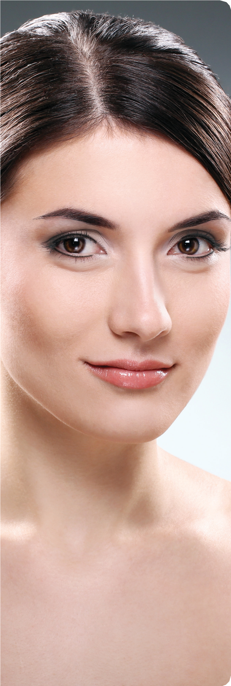

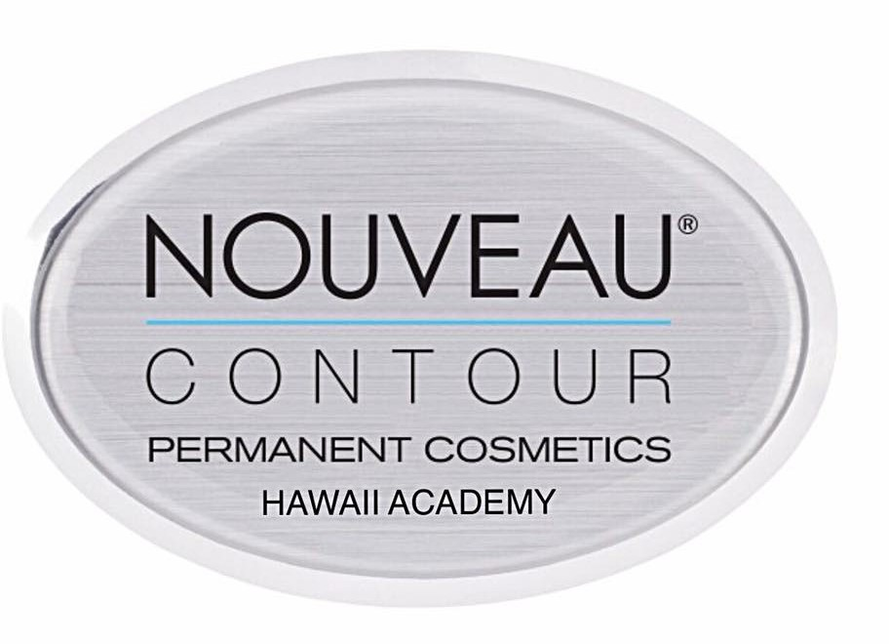

HAWAII
ACADEMY OF MICRO-PIGMENTATION

Fundamental

Training Courses

BASIC FUNDAMENTAL COURSES

The objective of Nouveau Contour Academy is to provide the highest quality education for our students. We will strive to develop you into a competent micropigmentation specialist in a safe educational environment. Our program is designed to ensure that you are prepared to meet all necessary requirements to become professional in the field of micropigmentation.

The Nouveau Contour Academy allows a maximum of 4 students per trainer in the Fundamental Training to ensure you will receive the required attention and knowledge to maximize your potential in the field of micropigmentation. You will graduate as a capable, knowledgeable, and motivated professional and will have obtained all the necessary training and experience in this area of study. Our teaching methods are designed to guide you to succeed as a talented professional.

Our trainers have worldwide experience and expertise, so you will learn from the very best trainers available. Education is the foundation of your work later. Your clients demand the best micropigmentation they can get. After you have completed the course you are assured to meet the highest requirements of you clients.

FUNDAMENTAL TRAINING
This course covers the manual text book, workbook, and practical “hands-on” model procedures. During your course training you will learn all basic techniques and fundamental elements to get you started and recognized as a true professional. Each day you will have individualized hands on training and additional homework assignments for next day’s class. The Fundamental Training consists of 4 parts:

Outlined Curriculum

1. Sterilization and Sanitation
2. Skin Anatomy
3. Facial Shapes and Brow symmetry
4. Skin Undertone
5. Color Theory
6. Pigment Theory
7. Modalities/Device
8. Application Techniques
9. Needle Configuration
10. Needle selection and identification
11. Room/Work Set Up
12. Anesthetics & Numbing Cream
13. Client Consultation
14. Note Taking & Documentation
15. Release & Consent Forms
16. State License & Insurance
17. Hands on Clinic
18. Written Exam

PART 1 – PRE-STUDY MANUAL (35 study hours)
Upon registration into the Fundament Training course, you will receive the Pre-Study Manual. The manual is intended for self-study and explains all of the basic concepts of micropigmentation, in addition to basic color theory. It is essential to properly study this book before the Fundamental Training Course can be initiated. Your pre-study manual is provided with completing registration and deposit for your class.

PART 2 – BASIC FUNDAMENTAL TRAINING
Consecutive days, 9:30AM – 3:00PM)
Fundamental Training, you will learn all the essential micropigmentation techniques, including brow symmetry (brow mapping), shaded eyebrows, natural hair stroke brows, and hybrid brows, eyeliner and lips. The training consists of theoretical training, practice training on artificial mannequin heads and practice training on models. After successfully completing the fundamental training, you receive your certificate and can immediately start perusing your career in micropigmentation.

PART 3 – HANDS ON LIVE MODEL CLINICAL TRAINING
During this training, students and teachers will have live hands-on-model(s) procedure to watch and participate in.

PART 4 -- APPRENTICESHIP PROGRAM OFFER
This program is designed to allow student to build knowledge and structural accuracy on preform procedures to sharpen skill level outlined in the post support letter issued by instructor.

That includes hands on practicum, health and safety for model and student, stretching techniques, topically applied make up design (brow mapping) and application, pigment color selection and mixing ratios, needle selection, numbing, model (client) management and after care.

The purpose of this educational apprentice program is for our graduated students to gain valuable insight and experience. Build solid relationship within client and technician base.

Nouveau Contour Hawaii is the only education center that offers this extra curriculum hands on continuing education at no cost to student. Its free!

What you get -All Materials Included
During your Fundamental Training, all products you will need for practice and procedures performed at the Academy (i.e. pigments, needles, gloves, supplies etc.) are included in the Total Class Tuition. You will also be working on synthetic skin pads and mannequin head, which will be made available for you to work with at no charge. Along with a full Micro-blading kit. All legal documents: consent and medical forms, proper after care instruction sheet, client documentation forms.

Micro-blading kit (Value $500) (included in course, yours to keep)

- Golden Ratio expert measure tool
- Straight ruler
- 15 Micro-blading needles,
- 2 Micro-blading hand tools,
- 1 Professional Micro-Pigment
- Micro-Pigment rings
- Pigment cups
- Nitrile gloves
- 6 simulated Skin pads & 6 skins for mannequin doll head
- Micro-Blading text, workbook and practice sheets
- All legal documents:
- Consent and release forms
- Medical history forms
- Proper after care instruction sheet
- Client documentation forms

These forms are all legal documents for you to use for your business. All forms are cleared by the State Board of Health, Permanent Makeup Insurance coverage clearance. All legal documents: consent and medical forms, proper after care instruction sheet, client documentation forms.

Materials included in course to use in class during your program

- Complete-Micro-Pigmentation comprehension textbook
- Handout workbook
- Skill level practice sheets
- Synthetic skin pads and mannequin head

- Gloves
- Medical Mask
- Cotton rounds
- Vaseline
- Bib
- Ink cups
- Tissue
- Pigments
- Small ruler- Caliper-
- Make up pencils (Black, Brown China marker or regular make up pencil Neutral Soft -Nude Tone & white)
- Pigment Color Chart
- Pre-Numb and Open Skin Numb agent
- Benzo Chloride antiseptic wipes
- Saline eye wipes
- Non-fragrant baby wipes/ Non- sterile gauze
- Toothpicks
- After care ointment
- Hand tool for Micro-blading/stroking
- Micro-blades- needles
- Pigments
- Micro-brushes
- Skin practice pads and sheets
- TB/HBV Sani-wipe –EPA approved
- Practice simulated skin pads
- Client Consent forms
- Medical History forms
- After Care Instruction
- Hand Mirror
- Ice Packs
- Academy's Camera- I-pad

Course Outlines

#1 FULL FACE –BROWS, EYELINER AND LIPS $6800
Micro-Blading and shading hand method and digital Machine Lining and Shading Method
11 Day Course
Digital Machine Lining and Shading Method allows you to deliver the full spectrum of Micro-Pigmentation. Correct and improve natural shape of brows with soft or dark color to fill in missing spots or darken brows for a soft make up effect. Darken the lash line to create a beautiful natural look or thicker for more dramatic look. Last but not least, lips-Rebuild the outer perimeter of an uneven or distorted lip or create a soft stubble tint to already nice lips to create a get up and go look. This is a full certification course.

Techniques the at you will learn in this course:

- Powder/full filled brow/soft to dark shading
- Micro-stroking (Micro-blading)
- Hair Simulation –Feather – brushed up brow
- Hair Simulation- 3-Dementional
- Embroidery Technique
- Digital Device and Hand Method Tapping, Shading and Blending
- Lash liner and basic eyeliner
- Lip liner and shading

#2 MICRO-BLADING AND SHADING TECHNIQUES $3800
Micro-Blading and Shading Hand Method
3 Day Course
Famous hair simulation brow techniques! This class allows you to deliver the full spectrum of Micro-blading and hand shading techniques. Micro-blade and Shade Brows and everything in-between. Correct and improve natural shape of brows with soft or dark color to fill in missing spots for a soft natural effect.
Techniques the at you will learn in this course:
      - Micro-stroking (Micro-Blading)
      - Hair Simulation –Feather – brushed up brow
      - Hair Simulation- 3-Dementional
      - Embroidery Technique
      - Hand Method Tapping, Shading

#3 BROWS ONLY: MASTERY TECHNIQUES $4800
Micro-Blading and Shading Machine and Hand Method
6-day course
Learn all brow techniques! Master Brows class allows you to deliver the full spectrum of Micro-Pigmentation for Brows only.
Micro-blade and Shade everything in-between. Correct and improve natural shape of brows with soft or dark color to fill in
missing spots or darken brows for a soft make up effect.
Techniques the at you will learn in this course:
      - Powder/full filled brow/soft to dark shading
      - Ombre Shading
      - Micro-stroking (Micro-Blading)
      - Hair Simulation –Feather – brushed up brow
      - Hair Simulation- 3-Dementional
Digital Device, Hand Method Tapping, Shading Techniques

#4 Para Medical Tattooing Therapy $6800/$3800
3D Areola and Nipple Restoration, Scar Camouflage Re-Pigmentation
4 Day Course
This is a full comprehensive training courses which is a great beginner class for the aspiring Para-Medical Technician. You will learn all the
fundamentals of basic allowing you to become a Professional Para-Medical Tattooing Specialist. Doctor’s will be calling you!

Skin re-pigmentation is a positive solution to conceal imperfections by mimicking skin and restoring confidence. Each skin imperfection and scar are as unique as the living canvas in which it resides. Each application is customized for each person to recreate the natural and unique features of the individual. Skin-regimentation, also known as camouflage tattooing, can camouflage imperfections for any skin tone.
Techniques the at you will learn in this course:
- Areola and Nipple Restoration
- Scar Camouflage Re-pigmentation
- Scar Softening/ Keloids
- Vitiligo light skin Re-Pigmentation and
- Uneven light Skin Color Restoration
REGISTRATION
Course bookings are available on a first come, first serve basis. We highly recommend booking your class as soon as possible. In order to provide you with maximum attention, attendance is limited to four students per class. Please contact our office to enroll in one of our classes. A $143.00 Registration fee is due when registering to save your spot.

- (One-Time) Registration Fee………………………………………… …. . $143 (No tax)
- TOTAL CLASS TUITION FULL FACE……………………….…….…….……...$6800
- TOTAL CLASS TUITION BROWS ONLY………………………………………$4800
- TOTAL CLASS TUITION MIRCOBLADING AND SHADING………………. $3800
- TOTAL CLASS TUITION PARA-MEDICAL TATTOOING ……………………$6200/3800 add on
- Hawaii tax not included
- Upgrade device add on and student supply kit of choice if desired

Estimated Income Chart

 | _{Procedures Per Week}
_{Fee Per Procedure} | ₁ | ₂ | ₄ | ₆ | ₁₀
_{$350} | _{$18,200} | _{$36,400} | _{$72,800} | _{$109,200} | _{$182,000}
_{$450} | _{$23,400} | _{$46,800} | _{$93,600} | _{$140,400} | _{$234,000}
_{$550} | _{$28,600} | _{$57,200} | _{$114,400} | _{$171,600} | _{$286,000}
_{$650} | _{$33,800} | _{$67,600} | _{$135,200} | _{$202,800} | _{$338,000}
 | _{Revenue = Fee X 52 Weeks}
Permanent make-up is a very profitable business for you! Join us today and start your new career. Please join the worldwide leaders of professionals to become and master Micro-Pigmentation! We are here to help you every step of the way one procedure at a time!
Nouveau Contour Hawaii Academy of Permanent Cosmetic

Meet your Instructor

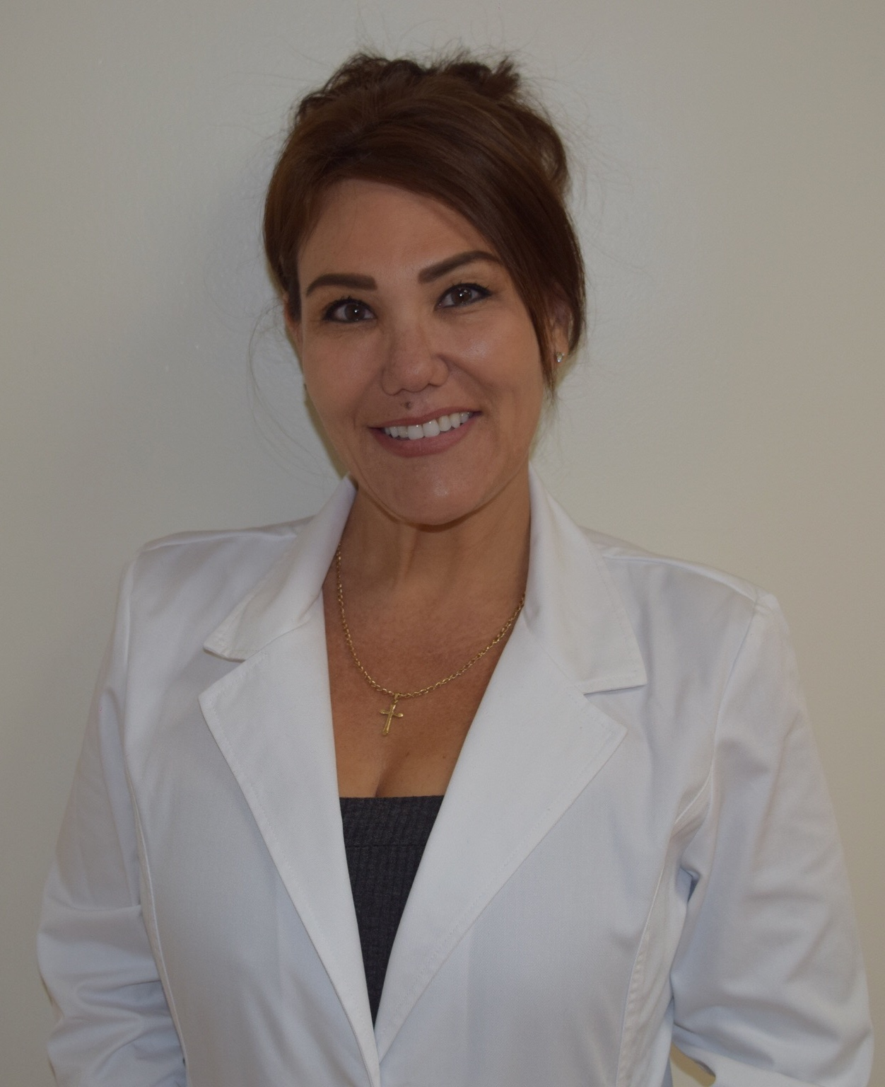
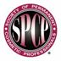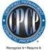

Edine Swain CPCP

- Established and operated Face It LLC & Academy in 2002
- Certified Permanent Cosmetic Professional (CPCP)
- Certified Micro-Pigmentation and Para-Medical Tattooing Therapy Specialist
- Recognized Subject Matter Expert (SME) by the SPCP
- Credited and Authorized Instructor/Educator by the Society of Permanent Cosmetic Professionals (SPCP)
- Credited Trainer and Partner of Nouveau Contour USA and Europe
- Certified in Blood Borne Pathogens (BBP) and Infection Control (IC) under OSHA & CDC Regulations
- Licensed Cosmetologist, Medical Assistant and optician

With over 25 years of experience in the Micro-Pigmentation field, Edine is devoted and passionate in instructing with the highest standards by following the guidelines within the Micro-Pigmentation professional Industry. Edine operates under OSHA, CDC and the Board of Sanitations strict guidelines, as she is a firm advocate towards permanent cosmetic and medical safety hygiene guild lines. Trained with the latest techniques, procedures and regulations, Edine attends mandated annual continuing educational courses and conventions held by the Society of Permanent Cosmetic Professionals (SPCP)ensuring that our students are receiving the most up to date information within this unique profession.

As a licensed Cosmetologist and an Aesthetics professional she understands the wants and needs of fast pace beauty industry and has worked extensively in the medical field alongside some of the top Plastic Surgeons, Dermatologist, Ophthalmologist and other outstanding surgeons and MD’s in the region for the past 25 yea

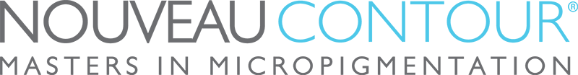
HAWAII
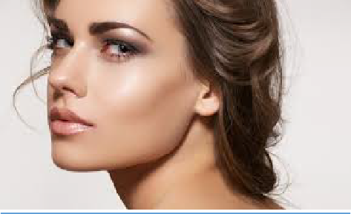
ACADEMY OF PERMANENT COSMETICS
CONTINUING EDUCATION & ADVANCED MASTER CLASSES

At the Nouveau Contour Hawaii Academy, we have Advanced Trainings available to improve your skills, learn new techniques, evolve as a professional, and offer more diverse treatments to your clients. These trainings
will broaden your knowledge, strengthen your talent and most importantly, expand your business.

BASIC FUNDAMENTAL LASHENHANCER & ENEYE LINER COURSE 2 Day- Course $2395

BASIC FUNDAMENTAL LIP LINER 2 Day- Course $2395

ADVANCE MCIROBLADING – NANO NEEDLE HAIR STROKES 1-Day Course $1195
Create the appearance of a more natural eyebrow by utilizing the newest needle configurations and 3D hair stroke techniques. Review face shape and determine the correct placement of brows.

ADVANCED FASHION POWDER BROWS 1-Day Course $1195
Fashion Powder Brows is the ultra-modern advanced technique of shaded eyebrows. Perfectly shaped lines in 1 or 2 shades that fade beautifully into each other for a soft, natural shaded brow. Once healed, Fashion Powder Brows look like a soft brow shadow behind the client’s naturally shaped brow.

ADVANCED EYELINER 1-Day Course $1195
Update your eyeliner techniques by mastering color- layering and shading. Learn ways to reduce touch ups. Find out what needle configurations are recommended for eyeliner procedures. Learn facial analysis.

ADVANCED FULL LIPS 1-Day Course $1195
Discover the correct use of color combinations, needle configurations and lip techniques for achieving excellent results with just one treatment.

COLOR CORRECTION, LIGHTENING AND PIGMENENT REMOVER 2-Day Course $2395
Learn detailed instructions on how to remove incorrect unwanted color or misplaced permanent make up. Provided color corrections to help clients that are in need. Learn how to recognize the difference between true pigment and traditional tattoo ink and how it can damage skin and so much more.

Focus Classes
ADVANCE COLOR THEORY 1-Day Course $595
Color Theory is critical to the success of your permanent cosmetics procedures. You will learn our color identification system to identify cool and warm undertones in the skin and in pigments. You can design a beautiful shape, but if the color is incorrect, your client will not be satisfied. Learn to choose the best pigment.

NEEDLES AND TECHNIQUES 1-Day Course $595
Nouveau Contour realizes it is imperative to choose the appropriate needle configuration for micro-pigmentation procedures. Our needles are especially designed to achieve the same quality throughout the entire procedure. This class will provide assurance that you understand each configuration and that you select the proper needle accordingly.

ADVANCED BROW MAPPING SYMMETRY 1-Day Course $595
Take your “eyebrow skills” to a higher level! Symmetry and shape are the key words for beautiful eyebrows. In this course, you will learn the ultimate technique to create perfect symmetric eyebrows.

VIP ONE ON ONE COACHING 1-Day Course $1195
This class is specifically designed to perfect and enhance your skills in micro-pigmentation. Bring your own models, and the instructor can evaluate technique and give suggestions as to how you can improve Your procedures.

SUCCESSFUL SALON MARKETING 1-Day Course $595
Learn how to market, advertise, and brand your permanent makeup career. It is the student’s responsibility to contact all of the state and local board of health agencies regarding the rules and regulations for practicing permanent cosmetics in their area.

COURSE INFORMATION
CLASS HOURS
Classes are daily from 9:30 am – 3:00 pm. You will have two- 15 minutes breaks and 1-hour break for lunch Occasionally, our classes run later so please be prepared to stay until the end. If you have any schedule restrictions, please let us know in advance.

DINING OPTIONS
It is very important that you feel comfortable during your week of training here. We have an assortment of Keurig coffee and tea selections, breakfast bars, snacks, bottled water, and juices that are available to
You throughout the day. We have a full-sized refrigerator and microwave available if you would like to bring your own food. Ward offers many dining options to choose from. There are many eateries within a very short walking distance from our Academy.

MODELS
For the best training experience possible, please provide your own models, If you are not able to find models, please contact our office as soon as possible and we will attempt to assist you in finding models for
your procedures. Pre-procedure materials will need to be provided to your models. Please contact our office for that information. Model attendance is not guaranteed by the Academy.

ATTIRE
We kindly ask that you wear scrubs or all black long sleeve and pant. Closed-toe shoes. If you have long hair, please make sure you have a way to pull it back. No long dangling jewelry and covered shoes.

REGISTRATION
Course bookings are available on a first come, first serve basis. We highly recommend booking your class as soon as possible. In order to provide you with maximum attention, attendance is limited to four students per class.
Please contact our office to enroll in one of our classes.

PAYMENT
Upon confirmation of your registration, you will receive the invoice for the Advanced Training of your choice. Method of payment: Cash, Check, Visa, MasterCard, Discover.

LOCATION
Nouveau Contour Hawaii Academy of Permanent Cosmetics is located on the beautiful island of Oahu.
Centrally location in the heart of the new and modern Ward Villages. Just minutes away from famous Waikiki Beach. Free daily parking.

TRAVEL AND HOTEL
You will be responsible for airfare and any miscellaneous expenses incurred, such as taxi fare, tips, food, etc. There are several hotels a short distance to the Nouveau Contour Hawaii Academy. Please contact our office for a list of recommended hotels at specially discounted rates.

