“One Short Day in the Emerald City”

Two months to go…

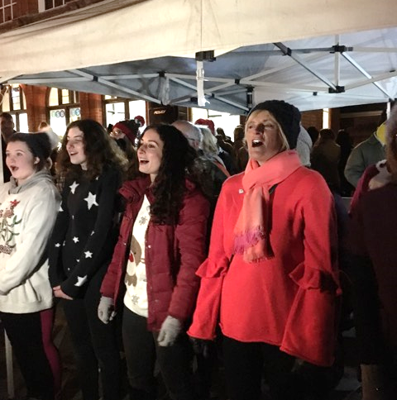
Just after the Winslow Christmas lights are switched on, the cast of The Wonderful Wizard of Oz line up ready to sing some songs from the panto. These have been the main focus of rehearsals since they started in October, with hours dedicated to learning the songs and dance moves. Director Fran says a couple of words to introduce the performance, and we are off, singing five songs from the panto and a couple of bonus Christmas songs.

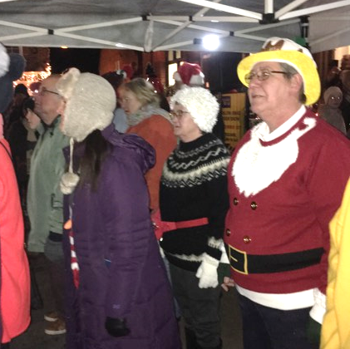
The crowd are enthusiastic, and the chilly night soon seems a little warmer as we all freestyle to the middle eight of "Ain't Nobody Here But Us Chickens". We sing through the set twice, finishing on the song that's caused the most trouble to learn "We Go Together". Those lyrics are not easy to get right! But we get most of our “Rama lama lamas” and “Changity chang shoo bops” in the right place, give the crowd a wave, and invite them all to come and join us on the 1st - 3rd February for the panto itself.
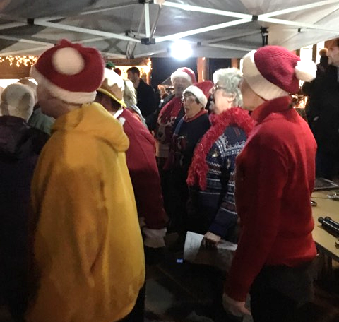
First-time director Fran has been keeping busy in the early stages of rehearsals. As well as writing the panto, choosing and choreographing the songs, and spending a great deal of time reminding us all to smile, she has run auditions and cast the principal parts. Asked a couple of rehearsals in what she thought of the cast, she was "thrilled" at the enthusiasm and how people are picking up their characters already. Phew! Fran is absolutely full of enthusiasm; here's hoping we can keep her feeling so positive as we get further through rehearsals!
It's not just the cast that will be working hard, though, and it's always good to mention the effort put in by so many people behind the scenes. Over the next few months, Fran, Yvonne, Derry and Chris will be designing, building, and painting the set. Phil will be producing the sounds, and Owen will be learning lighting cues. Julie will be managing the money, and Margaret will be finding costumes. The publicity team will be advertising the panto in as many places as possible (including blogs; tickets on sale 3rd Jan!!), and Divine Diva will be doing a great job of managing ticket sales. It would be impossible to get a panto ready for production without so many people giving up their time to make it happen! And with so many people working so hard, it's probably time to go and do my bit by learning some lines...

