Whitewater River Watershed Steering Committee Meeting
Minutes of Marth 18th, 2014

Attendees: Chelsea Tooley, Heather Wirth, Chris Fox, Ben Braeutigam, Becky Braeutigam, Lynn White, Mike Schwab, Tim Hesselbrock, Evan Divine

The meeting began at 6:00pm at the Harrison Library in Harrison, OH. After Chelsea Tooley called the meeting to order, attendees were asked to introduce themselves. Under old business, results, attendance, and reviews of the previous public meetings were discussed. Ms. Tooley also passed around summary sheets of the goals and mission statement worksheet and stakeholder concern surveys. Members noted the varied responses to the prompts.
Under New Business, committee members went to work on discussing and choosing a Whitewater River Watershed Project. The committee was shown many example logos created by the Project coordinators. Chris Fox brought up the idea of using the two different states on the logo. Many members like an upright eagle for the logo. After much discussion, the committee agreed to table choosing the logo until the next meeting. Each of the coordinators would prepare new logos with the suggested inclusions and changes for the committee to review at the next meeting.
The coordinators asked that members think about how the steering committee wanted to organize themselves, and think about who they might want to elect as committee leaders.
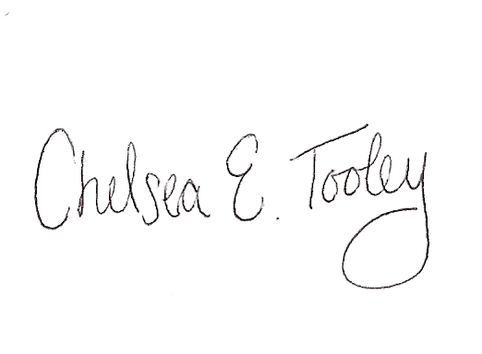
With no further business, discussion points, or concerns the meeting was adjourned. The next Steering Committee for the Whitewater River Watershed Project was set for April 17th , with further details to be announced.

Chelsea E. Tooley, Outreach Coordinator

