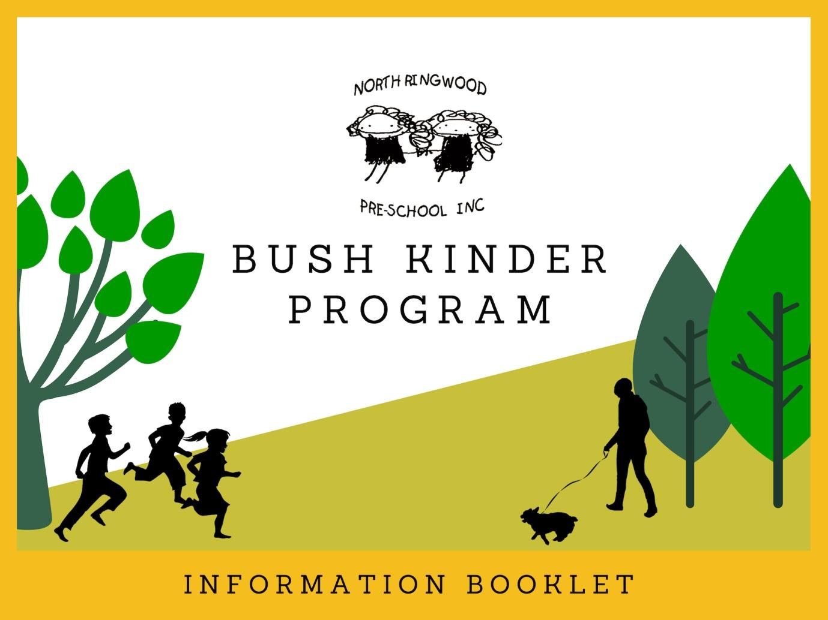

Dear Families,
Central to the philosophy at North Ringwood Pre-school is respect for the environment and the way in which we learn, connecting children with their local community and encouraging creative thinkers and problem solvers who take safe risks. There are obvious synergies between this philosophy and the principals underpinning the bush kinder program.
Originating in Scandinavia 50 years ago, 'Forest School' or 'Bush Kinder' for the Australian environment, is a play-based approach to nurture children's relationships with nature. It's an opportunity for children to explore the natural environment in an open-ended and play-based way, as such, 'no tools, no toys, no art supplies'.
We are fortunate to have Maroondah City Council permission to use an area of natural bushland and open recreational space for our bush kinder program. We also recognise the significance of Land and Country to the traditional Guardians, the Wurundjeri People. We recognise that Aboriginal people of Australia have a deep respect and spiritual relationship to this country and have lived, worked and played on this land for thousands of years before us. The elders have passed on through generations, their customs, traditions, beliefs and dreamtime. We share common values of Love, Respect and Gratitude for the Land we live, play and work on for Bush Kinder.
Children will have the opportunity to engage in a range of experiences within the natural environment through unstructured play such as climbing, balancing, investigating, storytelling and more, as well as developing critical life skills such as road safety when walking to and from the site.
In readiness for this experience, we will provide children with engaging safety-orientated development opportunities, including dog safety incursions and road safety training. Excursions will increase in duration at the bush kinder site as children become more capable and comfortable with their new surroundings and responsibilities.
Many thanks,
North Ringwood Pre-School Committee

* * * First term transition period * * *
We will be transitioning into this program during the first term as we get to know your child and your child becomes familiar with our kinder environment and their peers. We will also have incursions and education programs for the children covering topics of road, dog and snake awareness and safety to learn and practice before commencing the bush kinder program.
We'll update you via email as well as with a notice at the sign-in book once the first few weeks of term have passed regarding dates and times we will be visiting the bush kinder site through excursions. These excursions will lead up to the commencement of the bush kinder program starting on site as timetabled (page 6).
As such - bush kinder sessions for the first few weeks of term will be held at the Pre-school premises.
The following information contained in this handbook is written for when we begin the bush kinder program on site. For excursion purposes, we will be following the same practices and policies set out in this handbook, eg. children will still require appropriate clothing when visiting the site.
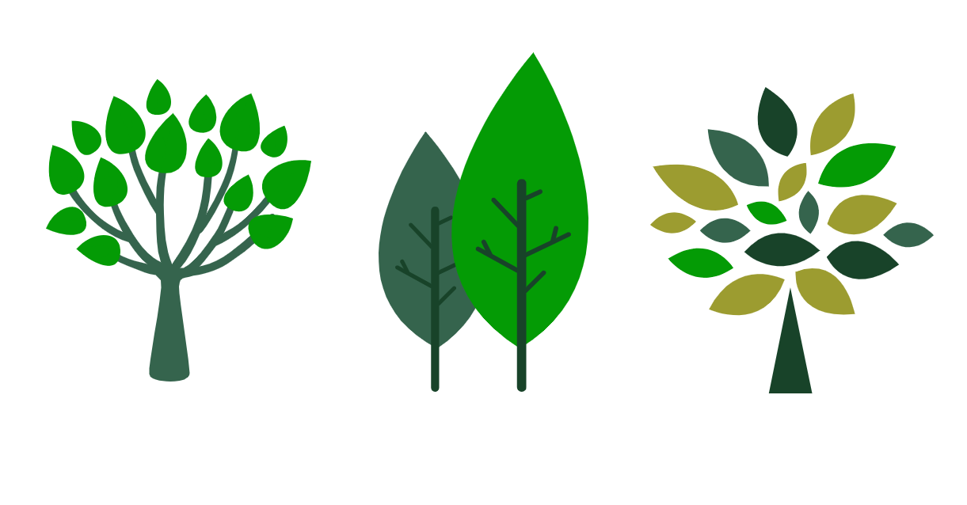
Program Outline
Following the initial transition period, bush kinder sessions will begin on site at BJ Hubbard Reserve (Evelyn Road, Ringwood North).
Educators from North Ringwood Pre-School will complete a 'site sweep' - looking for any potential hazards (eg. broken glass) and then minimize or remove them. A full Risk Assessment and Benefit can be provided upon request. Educators will then be ready to meet you and your child on site at BJ Hubbard Reserve when you arrive.
As you would for a kinder day, children are 'signed in' at the beginning of each session at the bush kinder site. The Bush Kinder leader is to be alerted to all children arriving. Once your child is signed in, we will gather into a group to:
- recap the bush kinder rules discussed during our initial excursions, adding in any new rules based on hazards, conditions, etc.
- walk the site boundaries: we will make use of existing fences, gravel pathways and vegetation to avoid areas of ecological significance, starting small - we will expand the site area as children build trust and confidence in the open space
- and recognise the traditional owners of the land, the Wurrundjeri People, with an Acknowledgement to Country lead by the educator
Children are then free to play in nature at their own pace, exploring within the boundaries set out. After a few hours immersed in nature, we will gather as a group for a snack before walking to kinder to continue on with the session.
WHY BUSH KINDER?
Research confirms a number of benefits where children spend extended periods of time outdoors, such as increased concentration and focus, provides opportunities to practice risk, develop social responsibility through a respect for the environment as a shared space, promote a sense of agency for decision making that is relevant and impacts their world and more as a result of the children's exposure and experiences. Whilst the children appear to be climbing trees or looking for insects, educators will be scaffolding this learning through discussions and affirmations, following the children's lead and encouraging further thinking and reflection as influenced by the Victorian Early Years Learning and Development Framework.
Although the indoor / outdoor program at kinder provides experiences for The Framework 'outcomes' and 'principles', through a bush kinder program children are able to experience 'real-life' play. For example, climbing across a fallen tree branch versus a fixed playground structure; or observing environmental change when visiting the site regularly. The fallen branch provides added movement, texture and can be manipulated into position where manufactured equipment cannot. Similarly, through immersion in nature, the children experience a heightened awareness of changes in weather and seasons, sharing their understandings of the environment through storytelling and investigative discovery.

Site Location
Our site is located in BJ Hubbard Reserve (Evelyn Road, Ringwood North), south of the car park. When you arrive with your child, please meet us out the front of the 7th Ringwood Scout Hall. The Scout Hall is accessible for toilet and hand washing facilities during the bush kinder session, as well as providing a shelter during emergency situations.
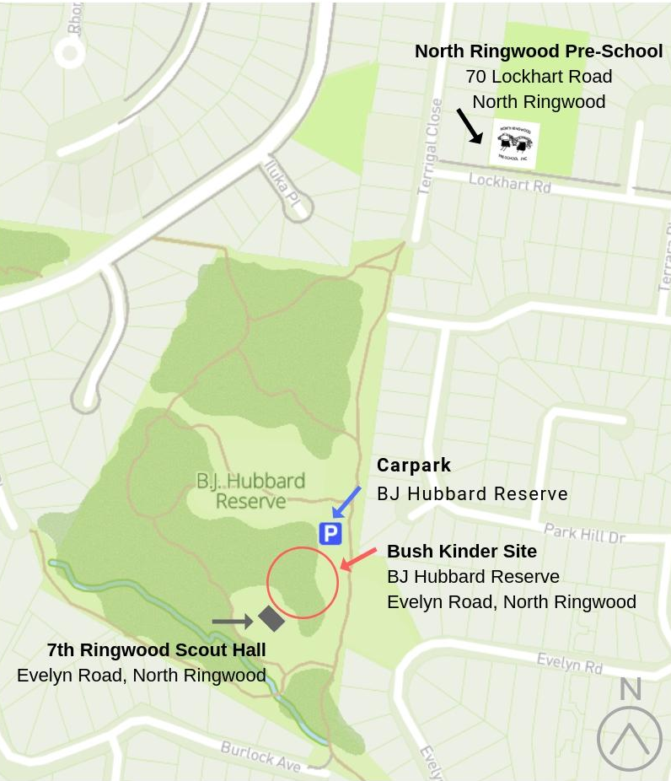
Contact details
North Ringwood Pre-School
Telephone: 9870 5418
Email: north.ringwood.kin@kindergarten.vic.gov.au

Teacher, 4YO Red Wattlebirds group: | Briony Sawtell  north.ringwood.briony@kindergarten.vic.gov.au
Teacher, 4YO Eastern Spinebills group: | Belinda Lyall  north.ringwood.belinda@kindergarten.vic.gov.au
Teacher and Bush Kinder Leader and Educational Leader: | Claire-Marie Thomas  north.ringwood.kin.claire@kindergarten.vic.gov.au
Session times
Each four year old (4-5 year old) group is offered a 15 hour per week program.
2.5 hours of this will be run at the bush kinder site, each week during the kinder term.
Bush kinder session times are as follows:
RED WATTLEBIRDS: Wednesday 8:15am - 10:45am (2.5 hours) each week
EASTERN SPINEBILLS: Thursday 8am - 10:30am (2.5 hours) each week
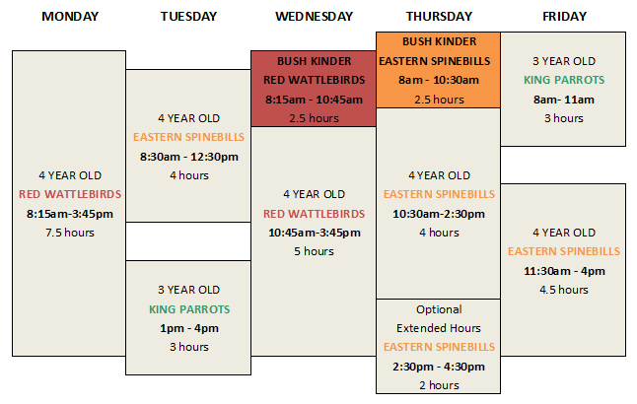
Please let educators know if you plan to drop off your child later than the session start time (above) or leave before the session finishes.
Signing in / out
As you would for a kinder day, 'sign in' your child at the beginning of each session at the bush kinder site. If you and your child are to leave bush kinder early, remember to sign out with your name, time and signature when departing.
If someone other than the persons listed on the enrolment form is to collect your child, please inform an educator and complete the required form. Educators will require proof of identity (ie. drivers licence) if they have not previously met this person.

Transportation and car parking
We will begin the bush kinder session on site at BJ Hubbard Reserve (Evelyn Road, North Ringwood) where there is limited parking in the reserve car park (access from Evelyn Road). Alternatively, park the car and enter via one of the side street entry points, enjoying a walk through the reserve before session.
To ensure the safety of the children and families, we will gather in front of the 7th Ringwood Scout Hall on site, a short walk downhill from the car park. After 2.5 hours of nature play and education, educators will accompany the children as they walk themselves and their belongings (change of clothing, drink, snack) to the Pre-School address (70 Lockhart Road, North Ringwood) via gravel walking paths and a short section of footpaths to continue on with the session.

Food / drink
Children bring their own food to kinder, including snacks, lunch and a water drink bottle. Both the snack and lunch* should be prepared as your child likes to eat it, eg. apples chopped. As we promote healthy eating throughout our program, we ask you to leave treats (sometimes food / celebration food) for home.
*For more information on snack suggestions- please refer to the Kinder Handbook.
You may wish to pack the snacks and lunch separately to make it easier for your child to distinguish between them and to ensure food is spread out over the day for maximum energy. Think 'Nude Food' - reusable containers with compartments or smaller snack pots and food without packaging, to reduce the waste that goes to landfill.
We have access to a toilet and hand washing facilities at the reserve (located inside the 7th Ringwood Scout Hall). As per our Hygiene Policy, children wash and dry their hands before eating.

Protective clothing
Similar to the kinder program, we will be playing outside in almost all weather conditions. We ask you to dress your child appropriately for the weather:
- Warm / hot temperature: sunhat, light coloured loose fitting clothing covering arms and legs, sunscreen applied, sturdy shoes (no flip flops)
- Cold / wet temperature: beanie, warm layers, waterproof jacket, rain boots or closed toe shoes, waterproof pants or suit.
We also suggest you pack a change of clothes and socks for your child in their kinder backpack as well as a carrier bag for wet/dirty clothes. A spare pair of shoes (eg trainers) to wear for the rest of kinder session if gumboots are used for bush kinder.
Apply SPF 50+ sun cream when UV index is higher than 3. Insect and mosquito repellent can also be applied.
Please also ensure an appropriate backpack is supplied that is comfortable for your child to carry. A backpack with a waist or front chest strap can help to distribute the weight more evenly and stop the straps from slipping off the shoulders.

Duty Helpers
We encourage parent helpers for both bush kinder and kinder sessions. A calendar will be located in the entrance foyer to help on specific days. Please ensure all adults sign in along with the children so there is an accurate head-count number. Job cards will be handed out to helpers when they attend a session, which include a list of duties during the bush kinder session and duties in case of an emergency. We welcome observations of children from parents during their time at Bush Kinder. These can be in the form of written notes or verbal communication.
Please note: In this environment we are actively promoting the children's decision making, confidence, persistence, imagination, curiosity, problem solving and many other skills and processes. We request that you follow the children's lead, allowing the children to be the creative drivers of their play - stepping in where necessary for safety purposes or when otherwise asked.

Attendance
If after speaking with educators you feel the bush kinder program is not for your family, you have the option to join us 2.5hours into the session at the kinder premises for the remaining session duration.

Cancellation
In the unlikely event bush kinder is cancelled due to extreme weather warnings (see Extreme Weather Policy Summary over page) families will be notified via email or SMS at short notice. The session will begin at our kinder premises (70 Lockhart Road, North Ringwood) should this occur.
If the weather becomes extreme during the session, we will shelter in the scout hall (7th Ringwood Scouts) and evacuate to the kinder building when safe to do so, as per the Extreme Weather Policy.

Medical concerns
Educators will have access to first aid kits and mobile phones on site and in the event of an incident / illness will follow the same policies and procedures that apply to the kinder premises, including notifying parents / guardians. All educators maintain a current Level 2 first aid qualification, as well as anaphylaxis and asthma management training.
Should your child have medicine that requires refrigeration, there is a refrigerator available. During enrolment and orientation, please discuss your child's requirements and medical plan with educators. Educators will then carry your child's medicine with them as contents of the emergency evacuation backpack.

Summary of Policies
EXTREME WEATHER POLICY SUMMARY:
The extreme weather policy details weather conditions that trigger the response to cancel, relocate or evacuate the bush kinder program / site. North Ringwood Pre-School educators and committee have the discretion to determine the site unsuitable for bush kinder purposes if one of the following conditions are forecast by the Bureau of Meteorology:
- Electrical storm activity / lightening
- Extreme temperature of 36 degrees celsius or greater
- Bush fires risk, total fire ban or code red day
- Flooding advice
- Wind speed of damaging winds / severe weather warning
- Extreme storm conditions and / or excessive rainfall
Should the weather become extreme during a session, or the bush kinder group are to relocate (shelter in the scout hall) or evacuate to the kinder premises (70 Lockhart Road, North Ringwood), safety of children and educators is our first priority, once settled,
educators will notify families via SMS to your emergency contact details provided.

DOG AWARENESS POLICY SUMMARY:
This policy outlines the tools used to deal with dogs off-lead that may enter the bush kinder space at BJ Hubbard Reserve; if necessary the medical responses for dog incidents and the education framework in place for children, educators and families for how to live safely with dogs.
The bush kinder site is adjacent to an off-lead dog area and as such, Committee and Council have implemented a number of initiatives for the children's safety following a thorough risk assessment. Some examples include: additional Council signage installed at entry points to the reserve advising dog owners to use the path and a lead as well as remove dog waste, our own portable signage that bush kinder is in session for the site, a letterbox drop to the surrounding neighbourhood of our planned use for the reserve as well as 'Local Laws' - Council law enforcement next year throughout session time during the transition period.
One of the main procedures children will be practicing with educators, is when a dog off lead enters the bush kinder site, to let the educators know and communicate "STOP, Dog". Children and educators then stand still, not touching the dog or making any sudden movements, whilst waiting for the owner or the dog to move away. Families can put into effect this practice at home when approached by an unfamiliar dog or dog without an owner.

SNAKE AWARENESS POLICY SUMMARY:
Unlikely as it may be, we prepare for the risk of snake's entering the bush kinder site and preventing bites similar to the dog awareness policy; using the call sign "STOP, Snake" to alert the other children and educators of a snakes presence, slowly stepping backwards to move to safety and following first aid procedures if a snake bites.
When first arriving on site, vibrations from stomping feet will alert snakes that people are present. Educators will continue to educate children that hollow logs and thick grass can be home to many creatures, they are not to be investigated without prior inspection.

ROAD SAFETY AND SAFE TRANSPORT POLICY SUMMARY:
Road safety education aligns with outcomes of the learning framework (EYLF), by assisting young children to develop skills, knowledge and behaviour to make them safer road users. We will educate children by delivering road safety messages (ie. discussion and story books) and practicing safe behaviours when transporting children for excursions and outings (eg. driveway safety).
Parents / guardians can assist by role modelling safe road use and reinforcing messages discussed at kinder such as "STOP, LOOK, LISTEN and THINK" before crossing the road with their child when out and about outside of kinder hours.
We require families to sign a detailed routine outing authorisation form before commencing any excursions. Families also have the right to refuse these activities. To ensure child safety, educators will accompany children at a minimum ratio of 1:11 (ie. no more than eleven children in the care of one educator) with a maximum of 28 children per session.

Permissions
Please refer to the printed 'Regular Outing Permission Form' located in your AGM Information Pack. We require a signed permission form before your child can commence the bush kinder program or excursions outside of the Pre-school premises.

