Monthly Challenge Checklist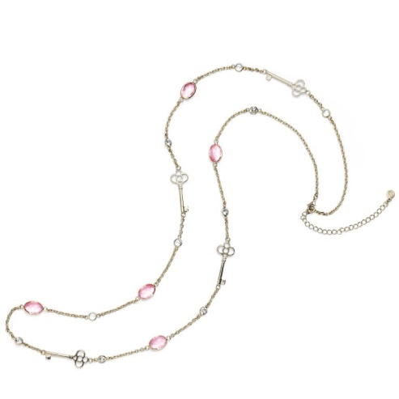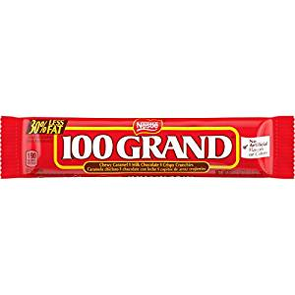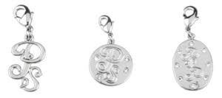

Month:

You Hold The Key Challenge ($600+ wholesale)
Total Wholesale for the month: $_____
Jewelry item earned: _____

100 Grand Sharing (10 Sharing Appointments)
Total sharing appointments: _____
Total new recruits: _____
100 Grand Sales (10 $100 Days)
How many $100 days: _____
Total wholesale for the month: $_____

Perfect Start (15 new faces): _____
Power Start (30 new faces): _____
Power Start Plus (30 new faces and 6 sharing appointments): _____

Bronze Medal (3 new team members): _____
Silver Medal (4 new team members): _____
Gold Medal (5 new team members): _____

Sapphire Star ($1800 wholesale): _____
Ruby Star ($2400 wholesale): _____
Diamond Star ($3000 wholesale): _____
Emerald Star ($3600 wholesale): _____
Pearl ($4800 wholesale): _____

