DATE: SUNDAY 9TH JANUARY 2011. TIME: 5.00 PM

LOCATION: SQUIRES CAFÉ, SHERBURN

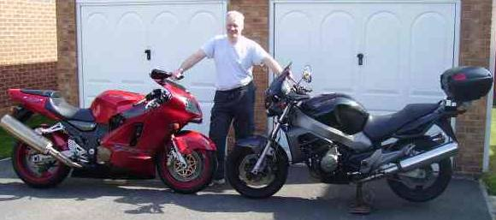
We invite you to a free suspension seminar with local suspension specialist John Sanderson of Alpha Suspension Set-Up. John attends Squires Café regularly for suspension surgeries and is well known locally for suspension set-up, based on 10 years of racing, and many more years riding, all this experience is re-enforced from his years in engineering (toolmaking).

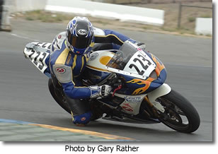
Also in attendance will be Dave Moss of Catalyst Reaction Suspension Tuning, visiting from America. Dave is known internationally for his suspension tuning for street and track bikes and video work with On The Throttle TV, a US based motorcycle focussed web TV channel. Dave has many published articles and DVDs on suspension tuning and races in Northern California with the regional club AFM. He is track-tuning bikes 150 days a year.

The seminar will last about an hour with Q & A for all attendees and will cover: -

Part I Part II

Basics -Oil and servicing
-Before you start -Improvements
-Setting SAG Tyres
-Adjusting rebound -Hard v soft
-Adjusting compression -How they affect suspension
-How they affect geometry
-How tyre pressure affect geometry

We will be using a BMW S1000RR as a demo bike to illustrate discussion points.

