2/8/08
Soul’s Journey

I was thinking about the story of Jesus during the Christmas season. I started to think of it in the context of the Radical Forgiveness “Soul’s Journey” diagram. In this diagram the earthly journey of one soul is followed. The purpose of the diagram is to send the message that every soul has a mission; therefore his life is perfect just as it is.

Too often we wonder why our lives play out the way they do. We ask, “Why me Lord? Why did this happen to me?” When we can’t make sense of our lives we feel defeated, alone, separate, and angry. The soul’s journey diagram attempts to help us understand why we go through these struggles.

Jesus’ life is a perfect example of how suffering and tragedy can have purpose in the larger view of one’s life.
Every bit of His suffering from His humble beginnings to His tragic end on the cross had purpose. Every experience created the tapestry of His life and was an integral part of the whole, creating a beautiful Spiritual picture that has endured throughout the ages.

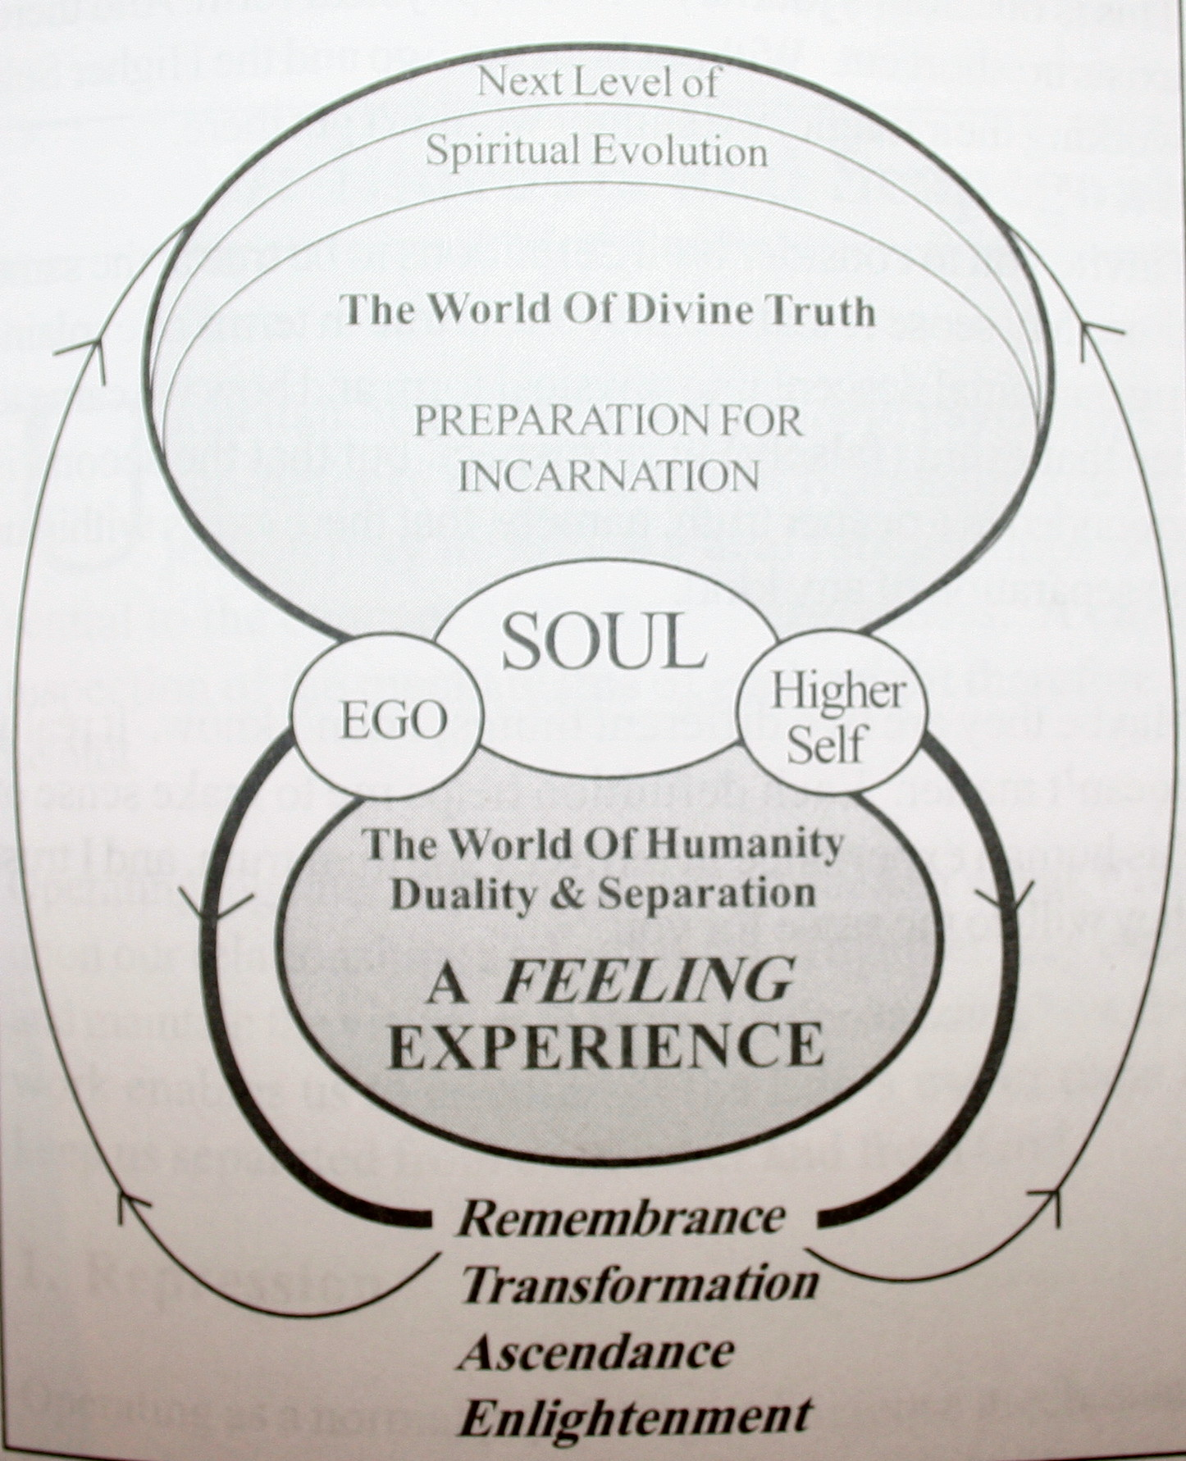

Diagram reprinted from the book “Radical Forgiveness” by Colin Tipping

The Soul’s journey diagram starts with the soul as Spirit in its purest form, light and love. Spirit resides in the World of Divine Truth. In that world there is only energy and the only known truths are Love and Oneness. Even in this perfect world of Spirit a soul may aspire to grow in his spiritual development, which is why as souls we are motivated to make a journey to earth.

The earth offers the wonderful experience of duality. In experiencing the opposite of something we come to know the opposing force in a deeply abiding way. We understand the beauty of a gorgeous, sun shining day all the more by experiencing the dreariness of a dull, rainy day. Our newly acquired human body transforms our experiences on earth into a world of feeling. We taste, touch, smell, hear and see our experiences as never before.

The earth is our giant classroom where every experience offers up a lesson. We agree before the journey starts to forget who we are and where we came from so we will exquisitely feel each of these lessons. We feel real sorrow at our losses, joy in our accomplishments. We feel passion for a new love then defeat at the destruction of that love. Our separation feels, authentic, real and complete. We have forgotten our origins so we take it all very seriously. We have forgotten our soul’s mission to understand the depth and breathe of Spiritual Oneness through our earthly experience of separation.

Just about the time we feel truly defeated we sense the nudge of a small voice whispering in our ear, “Wake up little soul! It is time to remember.” The gentle, loving voice, the voice of our Higher Self, leads us to be inexplicably drawn to enlightening seminars, books, churches and other avenues of knowledge so we can make sense of the world. If we are lucky we begin to remember who we are and that our life has a purpose. We learn that nothing is random or coincidental. Our lives including all the trials and tribulations are perfect just as they are. Enlightenment increases our vibrational energy until, having accomplished our mission; our soul is one day ready to return home.

Jesus came to earth with a mission. His mission was not for his own growth but for ours. His life unfolded moment by moment until the culmination of his crucifixion and his ascension. There is perfection in every event of His story from the birthing in a manger to His last breath on the cross. Unlike us, He never lost knowledge of Spirit. He knew where He came from and who He was. He knew what His mission was and He knew what suffering He would have to endure to accomplish this mission. Yet, at the same time He was a Spiritual being having a human experience just like all of us. So He had doubts and temptations. He felt anger and hurt. He knew the reason for Judas’ betrayal and Peter’s three time denial of Him, yet even in knowing He still felt the full force of pain each betrayal caused. How much more real our pain must feel, when we have forgotten who we really are. In His final moments He knew without doubt there was perfection even in His horrifying crucifixion and was able to proclaim, “God forgive them for they know not what they do”.

Without the knowledge of Jesus’ mission on earth this story would just be another tragic story of an innocent man who was falsely accused and sentenced to a grisly death. His story has endured because His mission was clear and it changed the world. He brought light and love to the World of Humanity so we could remember who we really are and where we came from.

There is perfection in each of our stories. Each sad or joyful story plays a part in our soul’s mission. We don’t have the wisdom or the fore knowledge to determine what that mission is, but through the story of our greatest spiritual leader, Jesus, we learn that no matter what is happening it is all perfect in the Divine sense.

A good read that explores the soul’s journey in depth is the book Courageous Souls, by Robert Schwartz. You’ll enjoy this book as a wonderful follow up to the concepts of Radical Forgiveness.

From my heart to yours…Karen Bashawaty



2550 S. Telegraph Rd, Bloomfield Hills, MI Suite 240
Join a six week group - $180
Individual Sessions - $95
Series of Three Individual Sessions - $250 save $35
Series of Six Individual Sessions - $475 – One session is free! 248-557-4006

CIRCLE CEREMONY SUCCESS!

It was a beautiful setting with tinkling fountains and floral arrangements. The lights were low and the sounds of meditative music welcomed the participants. There were twelve in all, each interested in freeing themselves of long held hurts and pain from the past. We came together in ceremony and we left united from the magical experience of Radical Forgiveness.

The Authentic Living Center, a beautiful sanctuary like place in Troy, sponsored my first Circle Ceremony. I felt honored by each person’s presence and sent out a prayer that all would get what they needed from the ceremony. The transformations unfolded in front of my eyes, pain turned into release, sorrow into gratitude, anger into surrender. With a change in perception the participants were able to let go of the past and reach for a new and improved future.

Thank you to all who captivated me with your openness and willing participation. God bless you with abundance and prosperity.

The next Circle Ceremony will be held on Tuesday evening, March 11th – 6-9p.m. at the Authentic Living Center. Please join me if possible. Register on the website www.authentic-living-center.com.

ANOTHER GROUP FORMING

I am starting another Radical Forgiveness group. The group meets once a week for six weeks. In that time we explore all the tools of Radical Forgiveness and use a different tool each week to complete forgiveness work. The group meeting time is Wednesdays from 6-8 p.m. The cost is $30 per session. The group is limited to six people total. Please email me with your interest.

BEAUTIFUL QUOTE

I will not die an unlived life. I will not live in fear of falling or catching fire. I choose to inhabit my days, to allow my living to open me, to make me less afraid, more-accessible; to loosen my heart until it becomes a wing, a torch, a promise. I choose to risk my significance, to live so that which came to me as a seed goes to the next as a blossom, and that which came to me as a blossom, goes on as a fruit. -Dawn Markova

Happy Valentine’s Day to all!

