**Grace living Personal Care Home**

**Pre-Admission Assessment**

Resident Application

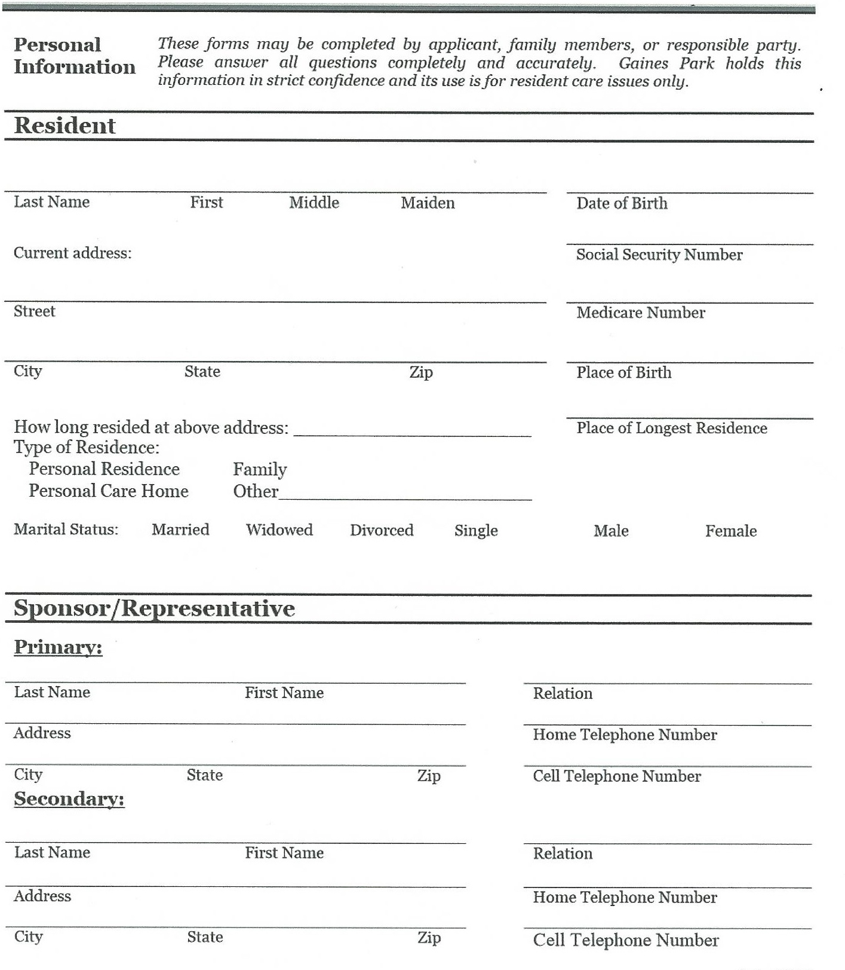

These forms may be completed by applicant, family members, or responsible party. Please answer all questions completely and accurately. Grace Living holds this information in strict confidence and its use is for resident care issues only.

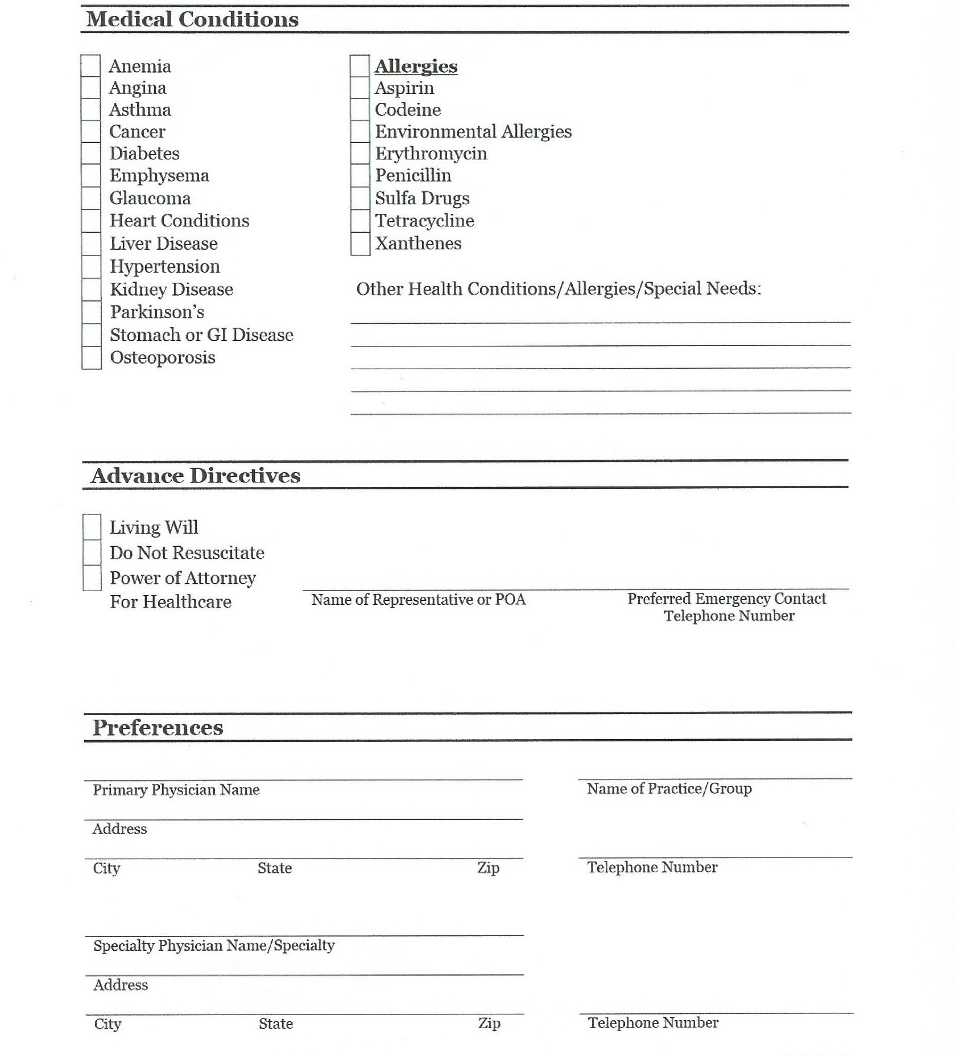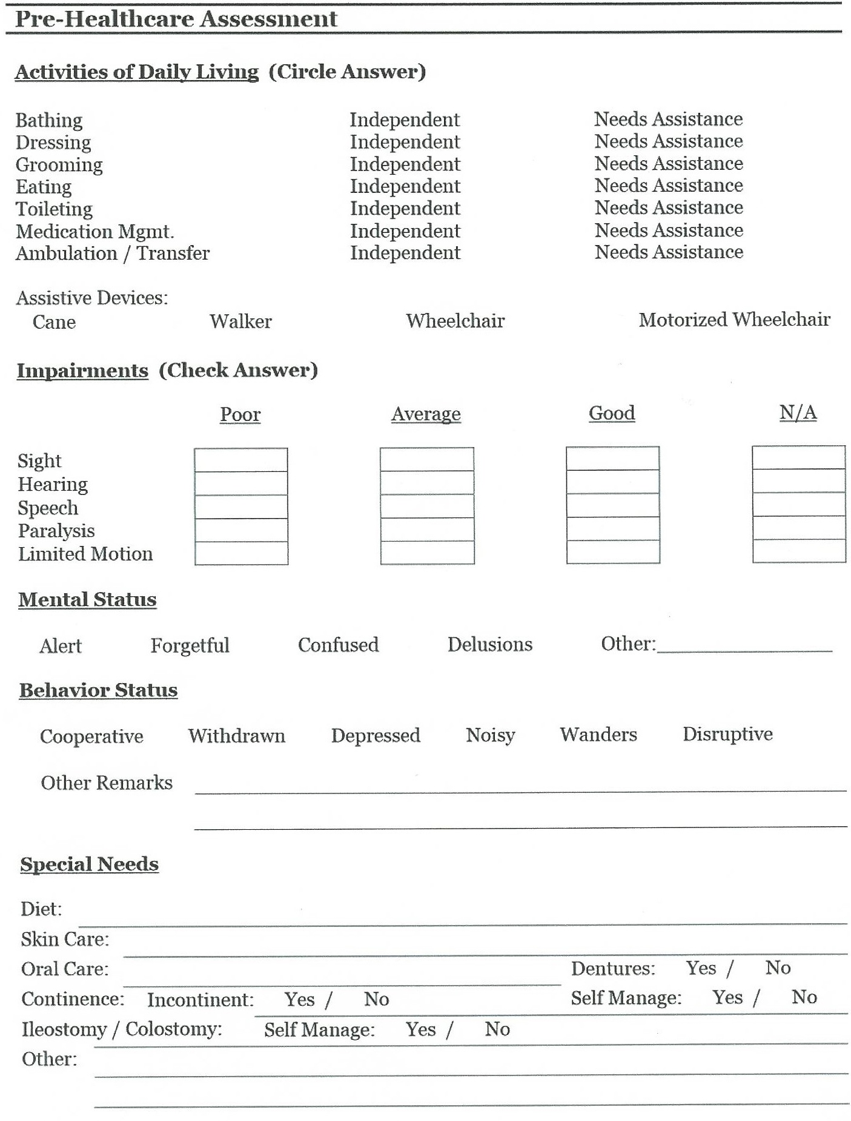  
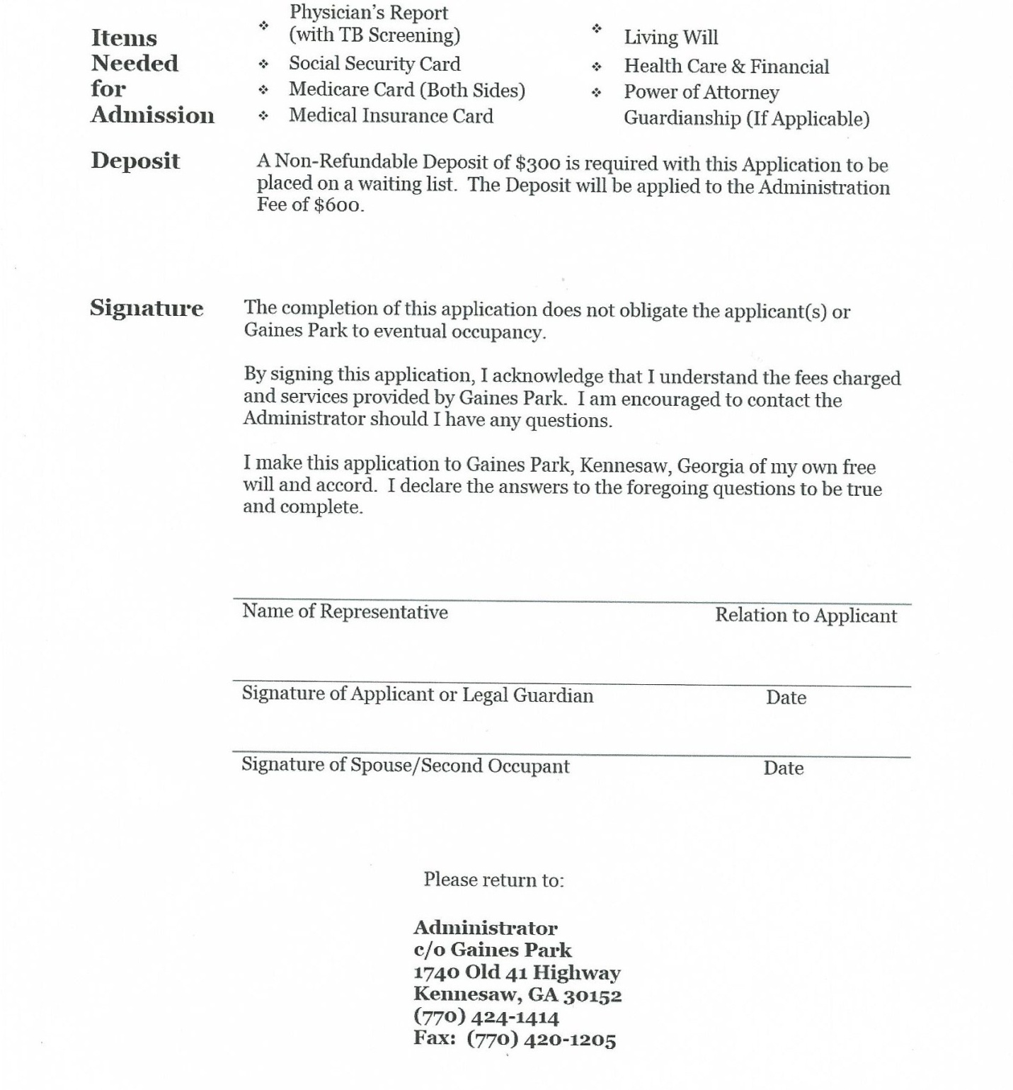

**Administrator**

**c/o Grace Living**

**2611 Summers Street**

**Kennesaw, GA 30144**

**(678) 313-4673**

**Fax: (770) 973-1821**

**The completion of this application does not obligate the applicant(s) or Grace Living to eventual occupancy**

**By signing this application, I acknowledge that I understand the fees charged and services provided by Grace Living. I am encouraged to contact the Administrator should I have any questions.**

**I make this application to Grace Living, Kennesaw, Georgia of my own free will and accord. I declare the answers to the foregoing to be true and complete.**