Helen M Schilling MD
Todd E Majeski MD

Physical Medicine and Rehabilitation
Pain Management
17320 Red Oak Drive ▪ Suite 104 ▪ Houston, Texas 77090
──────────
T: 281. 586. 0542
F: 281. 586. 0543

Medical Information about your problem for the doctor

Name: _________________________________

Date: _________________________________

What is the primary problem that brought you to this office? (5 words or less) ____________________

What is the second biggest problem facing you right now? ___________________________________

Your age: ______ Was this an injury at work? _____ YES _____ NO

Date of injury: ___________________

What was the date you last worked? ______________________

Please describe the injury or problem: ____________________________________________________
___________________________________________________________________________________
___________________________________________________________________________________
___________________________________________________________________________________
___________________________________________________________________________________

What doctors have you seen? ___________________________________________________________
___________________________________________________________________________________
___________________________________________________________________________________
___________________________________________________________________________________

What was their diagnosis? ______________________________________________________________
___________________________________________________________________________________
___________________________________________________________________________________

What special studies have you had done? (for example: CT Scans, MRI’s, etc…) __________________
___________________________________________________________________________________

If you have pain, what makes the pain worse? ______________________________________________

If you have pain, what makes the pain better? ______________________________________________
___________________________________________________________________________________
___________________________________________________________________________________

On the drawing below, please use the legend to note the kind of pain and draw on the figure the area of your problem:

(A) Aching (N) Numbness (P) Pins and Needles (B) Burning (S) Stabbing

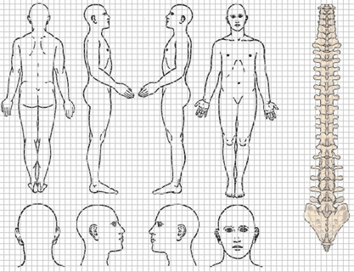

.

Have you had physical therapy in the past? If so for how long? Last time you had it? ________________________________________________________________________________________________________________________________

Did it cause a permanent improvement? ________
Temporary improvement?____________________
Make you worse?__________________________

Past medical history: Please list all medical or surgical problems you have had in the past:
___________________________________________________________________________________
___________________________________________________________________________________
___________________________________________________________________________________
___________________________________________________________________________________

Please list all medications that you are taking NOW, including dose and frequency:
1. _____________________ 5. ________________________ 9. _______________________
2. _____________________ 6. ________________________ 10. _______________________
3. _____________________ 7. ________________________ 11. _______________________
4. _____________________ 8. ________________________ 12. _______________________
For office use only below
ROS: Nl | Abnl | Findings
gen:
CV
HEENT
Eye
GI
Heme
MS
Neuro
Psych
Resp
Skin
Gu

List all drug allergies:
1. _____________________ 4. ________________________
2. _____________________ 5. ________________________
3. _____________________ 6. ________________________

Review of symptoms: Do you have any other symptoms than those previously mentioned? (sleep, etc…)
_______________________________________________________________________________________________________________________________________________________________
After you turn off the lights, TV and put your head on the pillow, how long does it take to FALL asleep? ____________________
How many times a night do you awaken? ____________ How long does it take you to return to sleep?________________

Family history: Have any of your family members had similar problems?

_______________________________________________________________
What medical problems did your mother have? ______________________________________ Your father?_________________________________________________________

We apologize for the following questions, but insurance companies request that we ask the following questions:

Do you or have you ever used street drugs? YES _____ NO _____
Have you ever abused narcotics? YES _____ NO _____
Do you smoke or did you ever smoke? YES _____ NO _____
How many years? _____ How many packs per day? _____

Social history: What was your line of work? (please describe what you did during the day)
___________________________________________________________________________________
___________________________________________________________________________________

Who lives at home with you?
___________________________________________________________________________________

Has this problem caused a problem between you and your spouse?
YES _____ NO _____

How are you supporting yourself at this point?
___________________________________________________________________________________
___________________________________________________________________________________

Are you currently getting Worker’s Compensation checks?
YES _____ NO _____

Do you have a lawsuit in progress or have you talked to an attorney?
YES _____ NO _____

For office use only: (Do not write below this line)

height_________ weight______ pain level today_______ pulse__________
________________________________________________________________________________________________________________________

PE: | NI | Abnl | Findings
cons.
eyes
ent
neck
resp
CV
chest
Abd
Gu
MS
skin
neuro
psych

(03/08/2018)

