EYFS

Enjoy Reading for Pleasure and Enjoyment
- Did you choose this book? Why?
- What did you like about the text? Why? What did you dislike about the text? Why?
- Would you read the book again? Why? Why not?
- What will you read next?
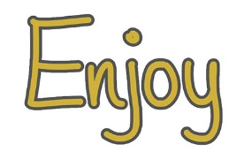
- What books do you like to read?
- Do you have a favourite book that you like to read?
- Is this a new book that you haven’t read before? Do you know anything about it already?
- Do you enjoy reading?
- What do you read at home?
- Who is your favourite author?
- Which books have you enjoyed that we have read together? And why have you enjoyed them?

Decode Word reading and decoding skills
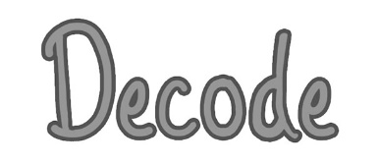
- What do you do if you are stuck on a word?
- Where do you start reading the word? Where do you look first?
- When you blend those sounds together, what word does it say? Can you tell me the word?
- Are there any clues in the word?
- Does it look like any other words you know?
- Can the pictures help you?
- Do you know what the word means or can you work out what it means (in this sentence)?
- Does the sentence make sense with that word?

Talk about the meanings of words
- What word tells you…?
- What does _______mean?
- How does this word make you feel?
- Find and copy a word that describes how…
- What word means the same as ________?
- In the story, ______ is repeated. Why?
- Draw a line to match the words to their meanings.

Find simple information
Which…? What…? How…? Where…? When…? Why…? Who…?
- Which character ______?
- Where/when does _______?
- What did _______ look like?
- Who was ______?
- Where did ________ live?
- Who are the characters in the book?
- Where in the book would you find __________?
- What happened in the story?

Talk about the order of a text
- Put the pictures from the story in order
- What happened in the story?
- What happened first?
- What happened after __________?
- What happened before ___________?
- What happened at the end?

Make simple inferences
- Why do you think _______?
- How do you know that _______?
- When do you think ________?
- Why did _________?
- How do you feel about ________?
- How does __________ feel?

Make simple predictions about a book
- What do you think will happen next?
- What do you think will happen to _______?
- Where do you think _______?

Content Domain | Examples from Recent KS1 SATs
Talk about the meanings of words
Find simple information
Talk about the order of a text
Make simple inferences
Make simple predictions about a book

Question Type | Examples from Recent KS1 SATs
Tick box

Short response

Matching

Sequencing

True or False

Other

