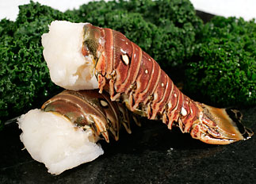

Scientific name: Panulirus spp.; Jasus spp.
Market name: Rock lobster
Common names: Spiny lobster, red spiny lobster, Warm Water lobster, Cold Water lobster

Spiny lobsters lack the large front claws of the American lobster and are prized instead for their tail meat, which accounts for 33 percent of the body weight. Some 30 species of spiny lobster are found in tropical and subtropical waters around the world.
Coldwater tails tend to be more tender and succulent than warm water, and they shrink less during cooking. Tail meat is firm, mild and sweet.

