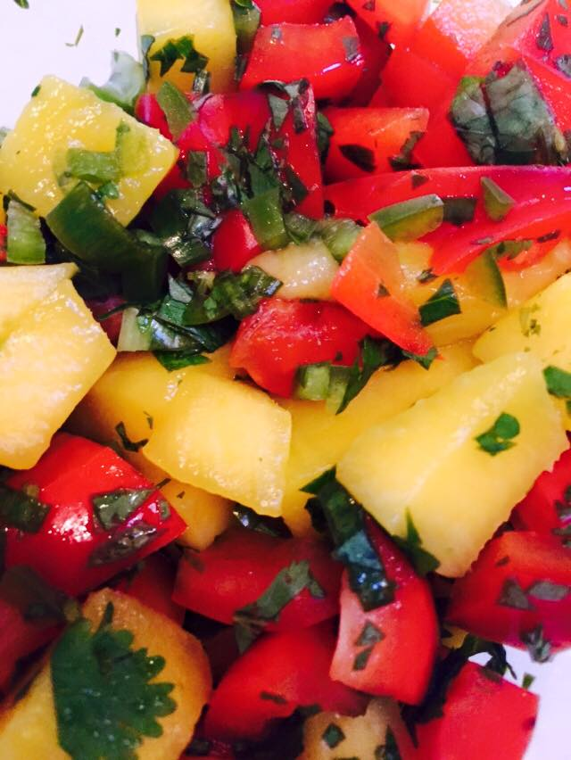

Shrimp Tacos with Mango Salsa
For the Shrimp:
1 pound of Shrimp
1/2 tsp Chili Powder
1/2 tsp Cayenne Pepper
1/2 tsp Cumin
1/2 tsp Salt
1/2 Tbsp. Oil
Combine all of the ingredients in a bowl. Add the oil to a medium size pan on medium heat. Sauté the seasoned shrimp till cooked, depending on the size of the shrimp, 4-5 minutes.
For the Mango Salsa:
1 Mango
1/4 cup Finely chopped red bell pepper
1 Green onion
2 Tbsp. Chopped cilantro
1 Jalapeno ( seeded and chopped fine)
2 Limes- Juiced
1 Lemon- Juiced
Combine all of the ingredients in a mixing bowl and let it sit at room temperature to let the flavors marinate together.
Build the tacos inside a flour tortilla and enjoy!
CHEERS!

