Seminar II: WRAP® Facilitators Training

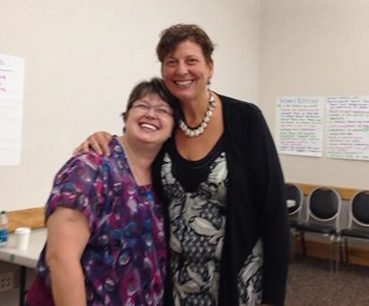

Course Description:

This course is 5 intensive days of workshops that prepares participants to facilitate WRAP® classes and equips them with the skills and materials to facilitate classes in your community and organization.

It is a follow up for people who have completed Seminar I WRAP Courses. The WRAP® Facilitators course is an experiential learning environment based on mutuality and self-determination. Participants in this course will be expected to participate in interactive learning activities and demonstrate their own experience with WRAP.

This training is appropriate for anyone who would like to lead Mental Health Recovery and WRAP® groups, work with others to develop their own WRAP and to give presentations on mental health recovery related issues to groups or organizations.

Attendees are expected to have a solid working knowledge of WRAP and share their experiential knowledge of how WRAP can work.

Before attending the seminar, it is expected that you have familiarity with the different parts of WRAP through completion of one of the following prerequisites:
- Copeland Center Correspondence Course
- 2 or 3 day Seminar I Course
- 8 or 12 week Seminar I group or workshop
- WRAP Retreat
Additionally, participants should also have and use their own WRAP, or assisted and supported another person in developing and using their WRAP. All Seminar I prerequisite course must be conducted by a WRAP® Facilitator.

Requirements for WRAP Facilitators

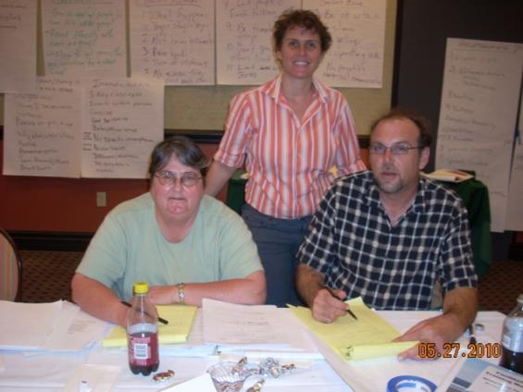

Before making a commitment to becoming a WRAP® Facilitator, you may want to know some of what will be expected of you.

When you accept the certificate that qualifies you as a WRAP® Facilitator, you will be making an explicit agreement to uphold a clear set of Values and Ethics.

Mary Ellen Copeland has been quite clear that if you don’t want to, or cannot adhere to these Values and Ethics then you cannot work with her curriculum or even present yourself as a representative of WRAP®.

These values and ethics will be made much clearer when you go through your training, but for now please understand that WRAP® Facilitators are expected to:

- Facilitate the creation and maintenance of a safe learning environment that encourages people to stretch and grow—an inspiring hope-filled place of unlimited possibilities.

- Openly share enough of your personal experience with recovery for participants to be able to relate to you as a peer and equal—someone they can trust who has “been there.”

- Make every effort to accommodate diverse human needs and different learning styles so everyone knows they are welcome and truly have a place at the table.

- Accept everyone exactly as they are right now, in all their uniqueness, without communicating any suggestion that there is any perceived need to change.

- Stand shoulder-to-shoulder with participants as true peers, just fellow humans, making sure that everyone is treated in a manner that shows that we are all equally valued.

- Treat participants with dignity, compassion, respect and unconditional high regard at all times—truly honor participants.

- Facilitate a mutual learning process that is mostly a highly interactive discussion that supports individual interpretation and discovery; rather than teach a class.

- Support real self-determination by validating all input concretely, withholding any and all judgment, and by illuminating options and choices but never giving final answers.

- Absolutely refrain from ever giving advice, counsel or recommendations, even when it is requested, and especially when you feel compelled to give them.

- Encourage participants to reflect on their own experience and to extract from it valuable lessons about what works for them and what doesn’t.

- Leave all agendas (political, religious, philosophical, treatment, personal or other) outside of the WRAP® workshop/group.

- Present Mary Ellen’s material in the clearest, simplest terms (as found in your Facilitator Manual) without modifying the material by addition or deletion.

- Share illustrative examples of how WRAP® makes a positive difference in your life and share personal insights into various elements of WRAP®, without letting your story get in the way of the group interaction or the material’s common sense simplicity.

- Follow the strictest codes of sexual conduct at all times, never behaving in a manner that might be construed as sexually suggestive, harassing or discriminatory.

- Support personal responsibility and the concept that each person is the expert on his- or herself at all times, and constantly reinforce WRAP® as voluntary self-determination.

All WRAP® facilitators struggle from time to time in the effort to live up to these expectations, and can miss the mark, but what makes us WRAP® facilitators is our dedication to the effort.

