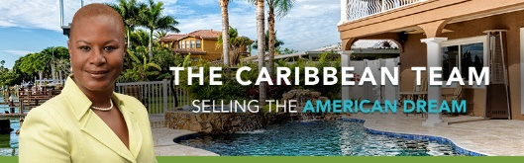

VENDOR’S LIST

INSPECTION COMPANY

AMERICAN HOME SERVICES
Christina Bowles
Office Manager
352-429-7062 (Office)
352-630-7384 (Cell)
ATKINSON HOME INSPECTION
(407) 963-3505.
HOUSE MASTER HOME INSPECTION
352-243-4553
Structural Engineer: Wayne Blocks 352.394.2590

A/C Riffles Heat & Air 352.429.8333 or 352.394.7758

Electric: South Lake Electric
B& B Bill Harper 407.466.9959
Holtz Electric Mike Holpz 352.978.7015

Plumbing: Steve Littlekin Plumbing 352.227.8599

Roof : Joe Guy, Guy Roofing Co. 352.267.6511

Handy Man - JJ Handyman 352.250.7881

Wells: All Water Services Darren Brigmond 352.394.6595

Septic Company: Robs Septic
352.462.1625
All Lake Landscape
Andrew Smith
352-405-5599

