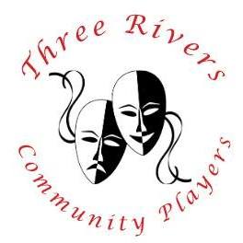
Adult Workshop and Kids Choir auditions – August 26, 5:45 – 8:30
Adult Auditions – August 27th and 28th, 6:30-8:30 Production Dates – November 1 - 2 and 8 - 10
Age 14 and up are welcome to audition for lead roles and the Adult Choir/Ensemble. School age kids 13 and younger are encouraged to audition for the Kid’s Choir
The Choir/Ensemble is a HUGE part of this show. Just about everyone will be in the Choir at some point.
Rehearsal schedule and participation requirements will be discussed at the Workshop and prior to each night of auditions. If you are cast, there will be a small participation fee. You may also be responsible for some costume pieces

VOCAL REQUIREMENTS – leads

Narrator—Soprano (or Tenor if played by male)
Joseph—Tenor
Pharaoh—Tenor/ Baritone
Jacob—Baritone
Baker—Tenor/ Baritone
Butler—Tenor/ Baritone
Brothers—Mixed male ranges
Potiphar—Baritone
Mrs. Potiphar—Alto/Mezzo
Choir Girls—Sopranos (to High C)
Choir Boys—Mixed male ranges (Low A to High A, Basses down to E)
Monday, August 26th – Adult Workshop and kids choir auditions
- Kids choir auditions will be from 5:45 to 6:45. Kids will be asked to learn a song from the show and then sing in small groups
- Adult workshop will be from 7:00 to 8:30. During the Workshop, we will provide the musical pieces that we will be using for auditions. We will also learn a dance from the show.
Tuesday and Wednesday, August 27th and 28th – Adult Auditions
- Be prepared to sing one of the selected songs from the show that best represent your range and the character you would like
- Be prepared to learn and dance a group number. We will go through it before you perform so don’t be too concerned if you don’t make the workshop

Director - Margy Eickhoff – Email: MargyEickhoff@hotmail.com, Cell 269-270-4838

