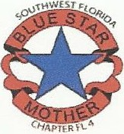

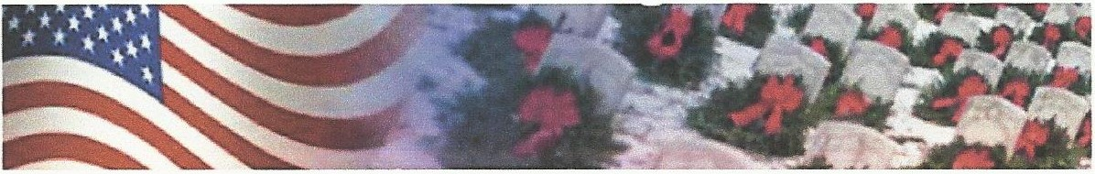
SWF Blue Star Mothers Chapter FL4 Tax ID 94-3473959
WREATH SPONSORSHIP FORM
*Sponsored wreaths are placed on the grave markers at state, national veterans cemeteries
as well as local cemeteries each December.

Orders and Payments Must Be Received No Later Than November 30, 2019
to assure December 14, 2019 delivery.

Name:------------------------
Address:-----------------------
City: _ _
State: ___ Zip: _

Phone:------------------------
EmaiI:-------------------------
Sponsoring Group ID Number: FL0053P

Cemetery Designation: Sarasota National VA Cemetery

Cemetery ID Number: FLSNCS

Sponsorship Price Quantity Total
I Individual = 1 Wreath | $15.00
Family = 4 Wreaths | $60..00
Small Business = 10 Wreaths  Wreaths | $150.00
Corporate= 100 Wreaths | $1,500.00
 |  | Grand Total
Please make checks payable to: SWF Blue Star Mothers FL4
P.O. Box 495301
Port Charlotte,FL 33949 Questions? Please call Linda @ 941-456-1920
Thank you for your Sponsorship and joining us in our mission to Remember, Honor and Teach!
Please note that all sponsorships are sent directly to the location and no wreaths are sent to the individuals
purchasing sponsorships.

