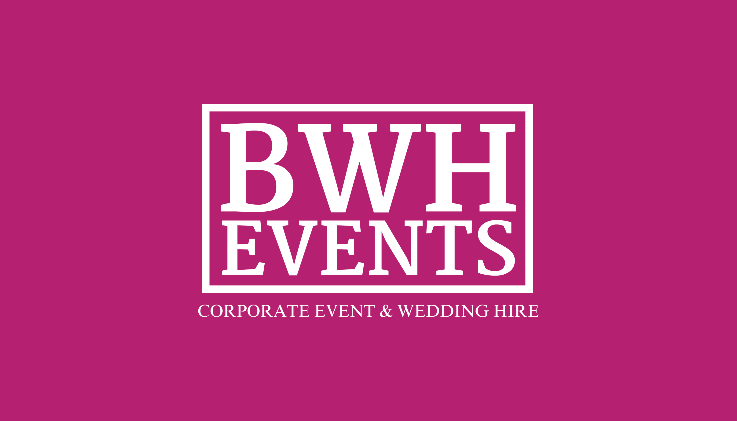
info@bwhevents.co.uk - 01189 757 959 - www.bwhevents.co.uk

At BWH EVENTS our aim is to deliver exceptional event services to discerning clients in Berkshire and the surrounding areas. We have a small team of dedicated, creative people who are always willing to take on new challenges. Our team members including florists, event staff, chefs, photographers and wedding planners.

Our custom lighting schemes, venue styling, and audio visual services are a great way to transform any space, to add atmosphere, style and impact.

One of our team would be happy to discuss your requirements and provide you with a no obligation quote. Just send over your requirements to info@bwhevents.co.uk and one of our team will be in contact.

Services
- Venue Decor
- Lighting
- Centrepieces
- Furniture
- Inflatable’s & Giant games
- Paintball and Nerf
- Bubble Football
- Table Linen
- Tableware
- Crowd Control
- Mobile Bars
- Marquee Hire
- Stage Hire
- Event Theming Props
- Catering & Catering Equipment
- DIY DJ , PA System & Dance Floor
- Photo booths
- Fun foods

© BWH EVENTS 2016
All hire services are offered subject to availability, minimum order and mileage charges.
We reserve the right to modify prices and services without prior notice. E&OE.

Décor
Category Services Price Guide
Room Decor
Bi-Stretch chair covers (black, white, ivory) £2.25 per chair including organza or satin sash of your choice
Polycotton chair covers (white) £2.75 per chair including organza or satin sash of your choice
Sashes - Organza, Satin 50p each

Finishing touches:
Gerbera chair back 60p per chair
Rose chair back 95p-£1.20 per chair
Table swaging & bows – organza £15.00 per table
Curtain covering, up to 3m high £15.00 to £25.00 per window
Curtain screen /room divider from 3m to 12m wide, up to 3m high £50.00 to £200.00
Star light curtain, (white 3m to 6m wide). £50.00 to £200.00

Aisle decor
Artificial Rose bay trees, 4ft high in pots £20.00 per pair
Hurricane vases with candles £4.00 each
Aisle Runners (21ft Ivory or Red) £45.00 each
Brown/Bronzed cross lanterns with LED candles £3.00 each
White lanterns with LED candles £4.00 each
Silver lanterns 40cm with LED candles £5.00 each
Silver Lanterns 70cm with LED candles £7.50 each

Lighting
Category Services Price Guide
Fairy Lighting
Fairy light canopy/ceiling, various designs including ceiling swags, canopies £100.00 to £395.00
Fairy light curtain £50.00 to £250.00
Fairy lights on vertical pillars from £25.00 per pillar
Fairy lights wound on high beams £25.00 to £50.00 per beam
Battery powered fairy lights (indoor/outdoor) £2.00 per set
Large 2ft mirror ball with spotlights and moving head £30.00
Mood Lighting LED up lighting (static colour) £6.50 each
LED up lighting (dynamic colour changing) £6.50 each
Room colours wash £40.00 to £200.00
Aqua, fire and flame lights £60.00 to £300.00
Disco Lighting £90.00 to £150.00 (see also DIY DJ)
Candelabras £10.00 to £100.00 (see also centre pieces)
Tea lights & Holders 50p to £1.00

Centrepieces
Category Services Price Guide
Candelabras
Candelabra 30cm, 5 arm silver candelabra £15.00 each
Candelabra 75cm 5 arm silver candelabra £18.00 each
150cm floor standing 5 arm silver candelabra £30.00 each
Candelabra 90cm Gold 5 arm candelabra £25.00 each
Decor including silk or fresh ivy, fresh flowers & crystal gem garlands from £5.00 per candelabra

Crystal Globes
60cm Crystal globes £7.50
Trio of Crystal globes, 12cm, 20cm, 25cm £20.00

Glassware
25cm Fish bowl £3.50
9cm Fish Bowl £3.50
25cm flat floating candle vase £2.00
80cm Conical vase £5.50
40cm Conical Vase £3.00
22cm Hurricane vase £3.00
60cm Martini vase £6.00
40cm x 10cm Cylinder vases £4.00
80cm Lily vase £5.50
Cylinder Vase Trio £7.50 30cm/25cm/15cm
Acrylic footed flat 19cm cylinders £3.00

Ostrich Feather Displays
Mirror base, 80cm Lily Vases, 16 feathers (choice of colours) £25.00

Lanterns
Small, Medium or Large £3.00 - £10.00
Silvers, bronze, white

Bird Cages
Mini Tea light Birdcages £1.00
Mini Tea light Birdcages £1.50
20cm Birdcages £2.50
30cm Birdcages £3.50
(Décor & Flowers available POA)

Vintage Jugs
Vintage jugs £2.00
(Décor & Flowers available POA)

Afternoon Tea Stands
Afternoon Tea Stands £3.50

Finishing Touches
Table runners (Organza) £1.00
Scatter crystals £1.00 per table
Fresh Rose Petals £1.50 per table
Tea lights 50p-£1.00
(gold, silver, clear, frosted)
Mirror Plates, 20cm, 30cm, 40cm from £1.00
(square or round)
Wood slices £2.00
Aisle Petal Displays from £20.00
Pedestals White (2) £20.00
Pedestals glass (2) £50.00
Pedestals Rustic Wooden (2) £30.00
30x30x30 glass effect cubes £10.00
Fresh Garlands from £30.00ft
Small White Urns (2) £10.00
Blossom Trees 4ft (2) £20.00
6ft Enchanted Tree £100.00
Top Table Skirts £35.00

Catering Equipment

Catering Equipment
Chafing Dishes £5.00
Ice Buckets £2.50
Bbq’s £75-£150.00
Fridges/Freezers £40.00-£150.00
Water Boiler £7.00

Table Linen

Table Cloths
54”x54” £5.25
70” x 70” £6.50
90” x 90” £8.00
108” Round £8.50
120” Round £8.95
70” x 108” £7.50
70” x 144” £8.00
54” x 54” Coloured £6.50
Napkins
White Linen £0.50
Coloured napkins £0.90

Tableware

Cutlery - All Items £0.16p (based on clean return)
Main Knives
Main Forks
Starter Knives
Starter forks
Dessert Spoons
Teaspoons
Soup spoons
Crockery-All Items £0.16p (based on clean return)
Main plates
Starter plates
Dessert Plates
Side Plates
Dessert bowls
Tea Cups
Saucers
Glassware-All Items £0.16p (based on clean return)
175ml Wine Glass
250ml Wine Glass
½ Pint Glasses
Champagne Flutes
Tumblers

Vintage Crockery

Cups and saucers £1.00
Side plates 50p
Tea pots £3.00
Milk jug & Sugar bowl £2.00
2 or 3 tier cake stands £3.50
Vintage Tea trolley £55.00

Vintage Props
Brass & Glass Tea Trolley £50.00
Singer Sewing Machine £3.00
Vintage Typewriter £3.00
Vintage Crates £3.00
Vintage Books (50) £12.00
Wooden Barrel £20.00
Bunting (Green / Yellow / Floral) £1.00 meter
Hessian & Lave decorated Jam Jars (30) £10.00
Hessian Table Runners £2.00
Vintage Suitcases (3) £10.00
Grammar phone £10.00
Chaise Lounge £20.00
A frame black board £10.00
6ftx2ft black boards £10.00
Rustic Wooden Pedestals (2) £30.00
Rustic Wooden blocks from £5.00
Mini Milk bottles (100) £25.00

9 Hole Crazy Golf Course

9 Hole portable crazy golf course, supplied with clubs, balls and score cards. £175.00

Scalextric

10ft x 5ft 4 lane Scalextric track £195.00
3 hour hire
Professional staff
All accessories included

Inflatables

Bouncy castles
12ftx15ft Turret Theme £70.00 p/day
17ftx15ft Castle/Slide Combo (beach theme) £80.00 p/day
15ftx15ft (Party Theme) £130.00 p/day
Gladiator Duel 17ftx20ft £150.00 p/day
25ft Bungee Run £225.00 p/day

Sumo Suits
Adult sumo with safety gear £95.00 p/day

Photo Booth

Photo booth £369.00
3 hour Package Includes:
Professional Staff
Unlimited Photos taken
Unlimited prints
Online viewing gallery
Prop Box
Onsite Printing for your guests
Hi- Res Cd for you of all images taken

Table Games
Table Tennis £75.00
Table Football £50.00
Air Hockey £75.00
Arcade Games £POA

Nerf Wars & Paintball

Nerf Wars – Packages from £100.00
Great Fun for all ages, Fire and shoot against your opposition in this safe environment
Hide behind barrels and Bunkers and try not to get shot!
All safety equipment supplied

Paint Ball – Packages From £100.00
Using Safe technology, with no need for CO2, Splat master is the new safe way to play paintball.
Suitable for ages 8 plus with guns that fire 50ft without the sting!
Excellent for corporate events and parties.
All Safety equipment provided.

Bubble Football

Bubble Football – Packages From £150.00
10 Player Bubble Football
Two 6 a side goals and 10 bubble suits.
Great fun for all ages.

Soft Play Packages

Soft Play - Packages from £50.00
4x4 ball pit
Happy Hoppers
Skuttle Bugs
Inflated Ladybirds
Tunnels and towers
Soft Floor Matting
Soft Play Animals

Add a bouncy castle from £50.00

Giant Garden Games

Giant Games – From £10.00
Skittles
Connect 4
Jenga
Draughts
Chess
Cannonball Drop
Croquet
Sports Day races
Tug of War
Quiots

Chocolate Fountain

Chocolate Fountain £325.00
44” Chocolate Fountain with your choice of Milk/White/Dark/Caramel chocolates
3 Hour Hire with staff
Based on up to 100 Guests
Choice of 6 dips

Triple Chocolate Fountain £295.00
3 x 18” fountains with your choice of Milk/White/Dark/Caramel chocolates
3 Hour Hire with staff
Based up to 100 Guests
Choice of 6 dips

Popcorn Machine

Popcorn machine £125.00
3 Hour Hire with staff
Popcorn for upto 100 guests
All Accessories needed

Candy Floss Machine

Candy Floss Machine £125.00
3 Hour Hire with staff
Candy Floss Machine for upto 100 guests
All Accessories needed

Frozen Slush Machine

Frozen Slush Machine £125.00 p/day
2 x 10ltr containers
Variety of flavours – Strawberry/Raspberry/Cola/Pineapple/Cherry

Sweet Cart

Sweet Cart £125.00
Fully loaded sweet cart with 10 filled vases of your choice

Ice Cream Trike

Ice Cream Trike
Supplied empty £95.00
Supplied with a selection of ice lollies £125.00
Supplied with a selection of lollies and ice cream with a serving attendant for 3 hours £195.00

Mobile Bar Hire

Mobile bar £150.00-£250.00
Choose from a contemporary wooden bar design, perfect for a summer outdoor event, or a chrome design with the option of signage or lights for a more bespoke design feature. All of our bars come fully staffed with the option of draft beers and a standard bottle drink service.

Drink Prices from:
Bottled Beers £3.00
Wines £2.50-£4.00
Spirits £2.50
Soft drinks 50p-£2.00

DIY DJ

DIY DJ £75.00-£170.00
DIY disco includes PA system, and lighting
(Suitable for playing music from client’s own laptop)
Info on use can be provided.

PA systems

PA system £55.00
Small PA system for speeches / background music including wireless microphones

Dance floors

Dance floors £295.00-£1500.00
Dance floors of all sizes
Plain, Black & White, Pea light & Disco Light

Staging

Stage Hire £45.00-£450.00
Our staging comes in 8ft x 4ft x 0.5ft sections. The stage consists of heavy black wooden sheeting fixed on top of a tubular steel framework. The sides and ends of the stage are covered with black wooden sheeting or material.

Crowd Control / Grand Entrance

Crowd Control & Entrance
Balustrades & Red velvet ropes £8.50
Red Carpet Entrance £45.00

Furniture

Chairs
White wooden folding chairs £2.50
Lime wash Chilvari chairs £3.00
Ghost Chilvari chairs £3.60
White plastic Bistro chairs £1.80
Deck Chairs £3.50
Childrens Chair £2.00
Giant Bean Bag Chair £8.00

Tables
White 5ft round Banquet table £6.00
White 3ft round plastic tables £3.00
6ft Trestle tables £6.50
Pub Style Benches £25.00
2ftx2ft childrens party table £3.00
Wooden barrel Poser Table £20.00

Marquee Hire

Mini Marquees
Heavy duty commercial 9ftx18ft £125.00
Why not join two or three to make a larger space
Suitable for 20 guests seated

Capri Marquees
28ftx38ft £225.00
Suitable for events such as weddings and parties for up to 100-120 guests seated.

Flooring. Lighting Heating can all be added at an additional fee.

Pagoda Marquee
20ftx20ft pagoda Marquee £235.00
suitable for 40-50 guests seated

Flooring. Lighting Heating can all be added at an additional fee.

Event Theming
Event Theming – POA

Theme nights are great for parties, proms, corporate events & maybe even the occasional wedding.

From James Bond, Murder Mysterys, Back to Skool, Under the Sea, Las Vegas and of course Christmas!!

We can help with a whole range of props and theme ideas, through to complete management of your event.

Please don’t hesitate to contact us today with your requirements or for further details visit the themes page on our website.

Guideline Price List
Price guidelines are based on typical installs
Minimum order levels apply
There is no VAT to pay on prices
Prices include set up at the venue and collection after the event
We do offer dry hire with client collect and return on certain items

© Berkshire Wedding & Event Hire 2009-2017

All hire services are offered subject to availability, minimum order and mileage charges.
We reserve the right to modify prices and services without prior notice. E&OE

