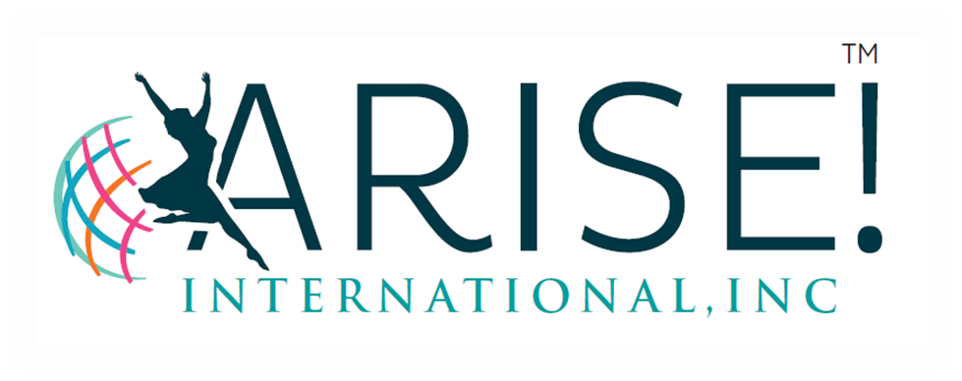
PO Box 1136
Red Oak, TX 75154
Office: 800.513.2450
FAX: 972.230.4070
Email: info@ariseintl.org
www.ariseintl.org

A PLACE OF HOPE AND HEALING

S P O N S O R S H I P L E T T E R

March 8, 2019

Dear Sponsor:

ARISE! International, Inc is a 501(c)3, non-profit organization that provides support and recovery services for adult survivors of child sexual abuse. Our mission is to help survivors heal by providing a safe and supportive environment where they are informed with truth about their past violation(s) and are empowered to move forward to live out their lives with confidence and peace.
On Tuesday, April 30, 2019 we are hosting our 17th Silent NO More! Awards Ceremony to celebrate graduates who have made the commitment to our forty five week recovery program. The recovery process is difficult however possible with dedication, the right tools and resources to promote healing. This event speaks volumes to those overcoming the effects of sexual violence and sends positive messages confirming their self worth with statements of “I matter “ and “my story matter.” Your sponsorship is greatly appreciated and needed and will help affirm the fact that there are others who care and are willing to lend a helping hand.
Here at ARISE! International, Inc we value the work we do to impact the life of survivors and the community at large. Thank you in advance for your support in allowing us to continue our mission to those suffering in silence.
Please join us for an amazing night! Feel free to contact me if you have additional questions. Deadline for sponsorships is April 24, 2019.

Sincerely,

Gwendolyn Jones

Gwendolyn Jones
President/Executive Director

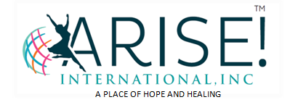

17th Silent NO More! Awards Ceremony
Tuesday, April 30, 2019
Sponsorship Levels

For your tax-deductible gift, we would like to offer the following sponsorship levels and special recognition to thank you for your support. Please review the following Sponsorship Levels. Deadline for sponsorships is April 24, 2019.

Celebrating Sponsor
$500.00 Sponsor recognition at event, logo our website, social media and 4 reserved seats

Sparkling Sponsor
$250.00 Sponsor recognition at event, social media and 2 reserved seats

Individual Tickets
$35.00 Individual Tickets (on sale April 6, 2019)

Sponsorship levels can be secured online at www.ariseintl.org.

Thank you in advance for your generosity and support of the women
we serve at ARISE! International, Inc

17th Silent NO More! Awards Ceremony
Tuesday, April 30, 2019

(Use this form if you prefer to sponsor via check)

Please select your sponsorship level:
- Celebrating Sponsor
$500.00 Sponsor recognition at event, logo our website, social media and
4 reserved seats
- Sparkling Sponsor
$250.00 Sponsor recognition at event, social media and 2 reserved seats

- Individual Tickets
$35.00 Individual Tickets

- Donation $_________

VISA/MC/DISCOVER/AMEX NUMBER: ______________________________________

EXPIRATION DATE: ______________________ SECURITY CODE: _______________

CONTACT NAME: _______________________________________________________

COMPANY: ____________________________________________________________

ADDRESS:_____________________________________________________________

CITY:___________________________ STATE: _________________ ZIP:__________

PHONE NUMBER:_______________________________________________________

EMAIL ADDRESS:_______________________________________________________

NAME: ________________________________________________________________
(as you wish it to appear in sponsorship materials)

Enclosed is my check made payable to ARISE! International for $__________________

Please mail this form with payment to:
ARISE! International, Inc
PO Box 1136
Red Oak, TX 75154

Please contact us at 800.513.2450 – EXT 1 for any questions you have.

