WESTON-ON-THE-GREEN NEIGHBOURHOOD PLAN 2018-2031
INCORPORATING EXAMINERS’ RECOMMENDATIONS

DEDICATION
This Plan encapsulates the vision for Weston-on-the-Green as expressed by its residents in 2015- 2018. We thank all participants for their views, their interest and their help in preparing this document.

The Neighbourhood Plan Steering Group.
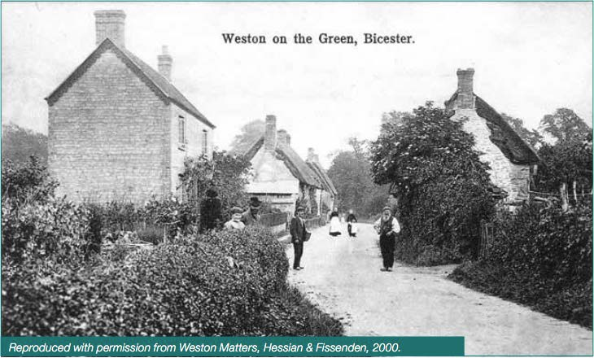

FOREWORD
Weston-on-the-Green is again a thriving village. With strong local businesses, a significant part of the population is present during the working day and the community is eager to reclaim some of the social infrastructure that has dissipated and ensure that the built and natural environments are respected and enhanced.

Against the history of a village that has been in existence since the Norman conquest, ours is a limited tenure and the Neighbourhood Plan has provided an opportunity for the village to come together, think about its future and plan to ensure that Weston is in the best possible order for those who come after us.

Throughout this exercise, the village has been conscious of the need to address social and economic issues as well as the environmental issues that are the focus of a physical plan. These themes are carried through the Introduction which describes the plan making process, Section 2: Weston-on- the-Green Today: Environment which records the baseline environmental surveys, Section 3:
Social and Economic Baseline Studies, Section 4: Concerns and Aspirations: Issues arising from the consultations where the wishes of villagers are set out, and Section 5: A Vision for Weston-on-the- Green : Objectives and Policies which details the planning policies that will form part of the Cherwell District Council Local Plan.
The policies seek to support modest, planned growth of the village while retaining the landscape setting in which the village nestles and arresting further erosion of those green spaces within the village which contribute to its character. That growth provides an opportunity to balance the existing demographic by providing market and affordable homes that will enable young families to locate or remain here as well as creating homes for those who wish to down-size. Development on the proposed sites identified in this Plan would provide for ~10% growth in housing in the village.

There are policies to enhance the heart of the village and also support the shop, post office and Memorial Village Hall which are all central to village life. Through the period of the Plan, sites will be considered for a nursery school and allotments, these needs being unmet at present. The intrusion of traffic is a continuing concern and objectives to calm traffic on the B430 and Church Road / Lane are set out as Parish Council transport objectives in support of planning policies.
Thank you to everyone who has contributed or lent support to the making of the Neighbourhood Plan

Message of support from the Parish Council
This document sets out a vision for the village of Weston on the Green. It reflects the thoughts and feelings of local people who care about the community in which they live.

They have looked and commented on housing, transport, green spaces, infrastructure and local facilities, which has led to the production of a Neighbourhood Plan which will guide the future development of the village.

We hope that residents and neighbours understand the challenges faced by the Steering Group but agree that a Neighbourhood Plan is the best option for us to shape the future of our Parish and ensure that Weston-on-the-Green continues to thrive and remains a desirable place to live, for all existing and future residents.

On behalf of the Parish Council, I would like to thank the members of the Neighbourhood Plan Steering Group and pay tribute for their work since August 2015. I would also like to thank everyone who have contributed towards the production of this document, the residents who completed questionnaires, the many who attended the consultation sessions and for the continuing support of Parish Councillors and the Parish Clerk. Without this help it would not have been possible to produce this Neighbourhood Plan.

Kate Hessian
Chair, Weston on the Green Parish Council (2015-2018)

Comment from the Chair of the Steering Group

It has been a unique challenge to be the Chair of the Neighbourhood Plan Steering Group for Weston-on-the-Green. The work started with a focused group of people and over time spread out into the community. It is the voice of the village that has been the most important part of this document. We’ve had comments from those who have lived here all of their lives to comments from the fairly new to the village. Each point of view has been important to the final document. I have learned that this is a special village, with a unique history stretching back beyond the Domesday Book. Our story encompasses an abbey, a priory, a Tudor mansion, St. Mary’s church, which has
artefacts from Norman times. We have 16th century houses, a toll road as well as a range of houses built from the 17th to the 21st century. The work of the Neighbourhood Plan team has been to honour our history whilst finding ways to grow and help meet the needs of the country. We feel we have done this within the confines of being a rural village.
A great deal is owed to the research and hard work of many members of the Steering Group. I have been most fortunate to have a team with a unique set of skills who have produced this document. This work has set an agenda for the foreseeable future and has the commitment of the Parish Council.
Finally, thank you to the people of Weston-on-the-Green who have been supportive, generous with their ideas and patient as we worked through the stages of producing such a comprehensive document.

Diane Bohm

Abbreviations/Glossary
Abbreviation | Definition
ACLP | Adopted Cherwell Local Plan
CDC | Cherwell District Council
CDCLP | Cherwell District Council Local Plan
CLP | Cherwell Local Plan
CLPP1 | Cherwell Local Plan Part 1
CTA | Conservation Target Area
ESD | Environmentally Sustainable Development
HELAA | Housing and Economic Land Availability Assessment
NPPF | National Planning Policy Framework
NPPG | National Planning Policy Guidelines
OCC | Oxfordshire County Council
RAF (Weston-on-the- Green) | Royal Air Force
SEA | Strategic Environmental Assessment
SLE | Sustainable Local Economy
SSSI | Site of Special Scientific Interest

Village confines: the area of the village defined by continuous and contiguous development forming the existing built up area of the village, excluding any curtilage beyond the built footprint of the buildings on the site (e.g. garden areas backing onto the rural landscape and outlying farms and buildings which are part of the rural countryside).
Village envelope: an extension of the ‘village confines’ that includes its landscape setting and features surrounding the built-up part of the village, i.e. fringe areas which give it an identity separate from the open countryside.

CONTENTS
Dedication 1
Foreward 2
Message of support from the Parish Council 3
Comment from the Chair of the Steering Group 4
Abbreviations/Glossary 5
LIST OF FIGURES AND TABLES 8
EXECUTIVE SUMMARY 9
. 1 INTRODUCTION 10
. 1.1 The Neighbourhood Plan: Purpose and Status 11
. 1.2 How this document is organised 11
. 1.3 Background to the Plan 12
. 1.4 Planning policy context 13
. 1.5 Relationship of the Plan to Cherwell District and Local Plans 15
. 1.6 How the Plan was made 17
. 1.7 Community engagement 21
. 2 WESTON-ON-THE-GREEN TODAY: ENVIRONMENT 22
. 2.1 Weston-on-the-Green parish boundary and setting 23
. 2.2 Historic layout and features 28
. 2.3 Pattern of development in the village 31
. 2.4 Landscape setting and green spaces 37
. 3 SOCIAL AND ECONOMIC BASELINE STUDIES 42
. 3.1 Housing 43
. 3.2 Access to/from and around the village 46
. 3.3 Employment 47
. 3.4 Current profile of the parish 47
. 3.5 Social and Economic Profile 48
. 3.6 Housing styles 49
. 3.7 Education 51

. 3.8 Community 51
4 CONCERNS AND ASPIRATIONS: ISSUES ARISING FROM THE CONSULTATIONS 53
. 4.1 Village character 54
. 4.2 Housing and Land use 55
. 4.3 Community and economy 57
. 4.4 Transport, Highways, Footpaths/ways 60

. 5 A VISION FOR WESTON-ON-THE-GREEN: OBJECTIVES AND POLICIES 61
. 5.1 Developing the policies 63
. 5.2 The Neighbourhood Plan Policies 65
Environment Policies 65
Housing and Land use Policies 70
Community Policies 73
Transport Policies 76
. 5.3 Delivery of the Plan 77
. 5.4 Monitoring 86

APPENDICES 87
. A Design Code 88
. B Statement of community engagement and consultation 95
. C Historical context for the village 102
. D Social and economic profile of Weston-on-the-Green 105
. E Community survey data 115
. F Site appraisal for Housing Development and Environmental Statement:
Area B (the Schoolfield) 128
. G Landscape setting and important internal green spaces 144
. H Characteristics of village form (morphology) 158

LIST OF FIGURES and TABLES

Figures | Title | Page
1 | Weston-on-the-Green designated Plan area | 14
2 | Homepage of Weston-on-the-Green website | 19
3 | First questionnaire survey: ‘Have your say’ | 20
4 | Aerial view of Weston from the south | 24
5 | Planning and other key designations | 25
6a,b | Conservation Target Areas | 26, 27
7 | Weston-on-the-Green late 18th century map | 29
8 | Character areas | 30
9 | Conservation Area Boundary and listed buildings | 32
10 | Key characteristics of the village | 33
11 | The junction of Church Road and the Northampton Road creates a memorable place | 34
12 | Example of building frontage set directly against  public grass verge | 35
13 | Small landmarks or ‘marker’ buildings are created  where gables front the street (Bramble Cottage) | 35
14 | Four cottages| The informal rhythm of the  elevations results from a variety in plot widths (North Lane) | 36
15 | Important and Designated Local Green Spaces | 39
16 | Habitat designations and habitat corridor | 40
17 | House sizes in the village | 43
18 | Age distribution | 44
19 | Business sites | 49
20 | Representative housing styles in the village | 51
21 | Distances to existing nursery and primary schools | 52
22 | Sites proposed in this Plan | 64
23 | An artist’s impression of the heart of the village | 73
Tables | Title
A | Outline Neighbourhood Plan timetable | 18
B | Population structure in 2011 | 48
C | Plan policies and responsibilities for their implementation | 79-85
Cover and Chapter images courtesy of R. Evans

EXECUTIVE SUMMARY
Purpose: This Plan addresses the need for housing growth, improved recreation and community facilities, design of new development, economic growth and transport for a period spanning 2017- 2031 that takes into account the character of Weston-on-the-Green (WOTG) and the villagers’ priorities.
Process: The Neighbourhood Plan (NP) group was established to develop the NP in consultation with the villagers and local businesses. The NP Steering Group focused its communication strategy on the creation of a website, mail drops, surveys, the village newsletter and periodic public meetings. A wide range of inputs was sought. Survey material was gathered and presented to the village through meetings and workshops. Responses were consolidated and analysed to identify the Proposed Sites and suggested NP Policies. Progress reports were made monthly during Steering Group meetings to which the public was invited. Reports were on the website and in the village newsletter.
NP Policies: The village consensus was to support growth in the population and housing in the village in keeping with and/or enhancing village character as found in the design code of this Plan, and to protect areas of the village that provide open natural environments for passive recreational use.
Policies are grouped into four themes:
Theme 1: Village Character and Environment → Environmental policies E1-E6
- to respect and conserve the historic form and character of the village; to conserve the village setting using previously developed land, minimizing any light pollution, keeping the pattern of the village envelope including grass verges and green spaces and enhancing biodiversity;
- .
Theme 2 Housing and land use → Housing policies H1-H7
- to deliver a measured development plan for new housing and land use that addresses the need for economic growth and of the existing and future Parish population;
Theme 3 Community and Economy → Community policies C1-C4
- to better the community by upgrading facilities and supporting local businesses;
Theme 4: Transport Highways, Footpaths/ways → Transport policies T1-T3
- to improve mobility around the village by upgrading and extending pedestrian and cycle routes and reduce the impact of traffic in the village and to reduce the isolation caused by the cessation of public transportation.
One site is proposed in the housing policies (policy H1) in this Plan to deliver 20 new homes (8% growth) by 2020: Site A (Southfield Farm) will provide 20 homes. This site has existing planning approval and at the time of drafting this Plan, building has yet to commence.

INTRODUCTION 1

1 INTRODUCTION
. 1.1 THE NEIGHBOURHOOD PLAN: PURPOSE AND STATUS The Weston-on-the-Green
Neighbourhood Plan has arisen out of the Localism Act that came into force in 2012 which aims to give local people more influence in their area. The Plan provides a vision for the future of the village and sets out clear policies to realise aspects of this vision.

. 1.2 HOW THIS DOCUMENT IS ORGANISED

. The Introduction, Section 1, outlines the founding process for the Plan. Following this are four further document sections:

Section 2. Weston-on-the-Green today – Environment: This section provides a description of the village and the surrounding parish. It defines the designated Neighbourhood Plan area as the parish boundary and summarises the key historic development pattern and features of the village which are unique and worthy of preservation.

Section 3. Weston-on-the-Green Today: Baseline Studies: This summarises the data which provide the evidence base for the plan. These studies include demography, social and

economic considerations, historical context, village character, transport and highway conditions. Detailed reports on some of these topics are reproduced in full in the appendices, which are bound separately (see Appendix C, D, E).

Section 4. Concerns and Aspirations: Issues arising from the consultations: This section reports on the issues facing Weston-on-the-Green. It draws on village meetings, questionnaires and comments gathered via the doorstep and social media. Here, villagers describe their concerns and aspirations for the village which provides a ‘brief’ for the subsequent plan-making.

Section 5. A Vision for Weston-on-the-Green: Objectives and Policies : Weston-on-the- Green residents have an overall vision for the future of the village within its parish environment. This vision includes a set of objectives that will improve the quality of life for existing and future residents, specifically addressing urgent issues such as traffic calming, new community facilities and the preservation of the rural character of the village. The Neighbourhood Plan policies set out a framework which, overlaid onto the adopted Cherwell Local Plan 2011-2031, will govern new housing development and land use in the Plan area by setting out sites for new housing numbering 20 dwellings and allow the village to develop in line with the overall vision for the future.

BACKGROUND TO THE PLAN

This Neighbourhood Plan has been prepared by the Weston-on-the-Green residents under the provision of the Localism Act of 2012 to guide the future development of Weston-on- the-Green. The Plan covers the period 2017 to 2031.

Weston-on-the-Green is an ancient village with references to a Weston Manor dating from the 11th century. The village grew over succeeding centuries until the Parish now has just over 500 residents1. The village has the unusual character of being largely contained to the western side of the B430 (the old Oxford to Northampton road) and is set in a rural landscape of crops and pasture. Two of the original farms are still operating from the village. The Plan area includes RAF Weston-on-the-Green, a former Royal Flying Corps station during WW1 which is now home to the No 1 Parachute Training School, based at Brize Norton. A

1 www.oxford.gov/districtdata/download/downloads/id/54/cherwell_census_2011_leaflet_v2.pdf

historical context for the village is presented in Appendix C.

The village is a vibrant community, which has lost some of its services but importantly has retained a small shop and post office. Due to its location within commuting range of London and the main towns and cities in Oxfordshire, house prices are high and young people and local families find it increasingly difficult to find housing in the village.

PLANNING POLICY CONTEXT

The Qualifying Body and the designated area for the Neighbourhood Plan

The Weston-on-the-Green Parish Council is the ‘qualifying body’ as defined by the Localism Act 2011. In July 2015, the Parish Council registered a Neighbourhood Area for the purposes of undertaking a Neighbourhood Plan. This was approved at the Cherwell District Council Executive meeting held on 2 November 2015.

The Weston-on-the-Green Neighbourhood Plan Area covers the civil parish and extends to the flood plain to the west, just beyond the A34 to the south, the M40 to the east (excluding Junction 9) and the Roman road of Akeman Street to the North (see Figure 1).

The Plan proposal relates solely to the Weston-on-the-Green Neighbourhood Area and no other Neighbourhood Plans relate to this neighbourhood area.

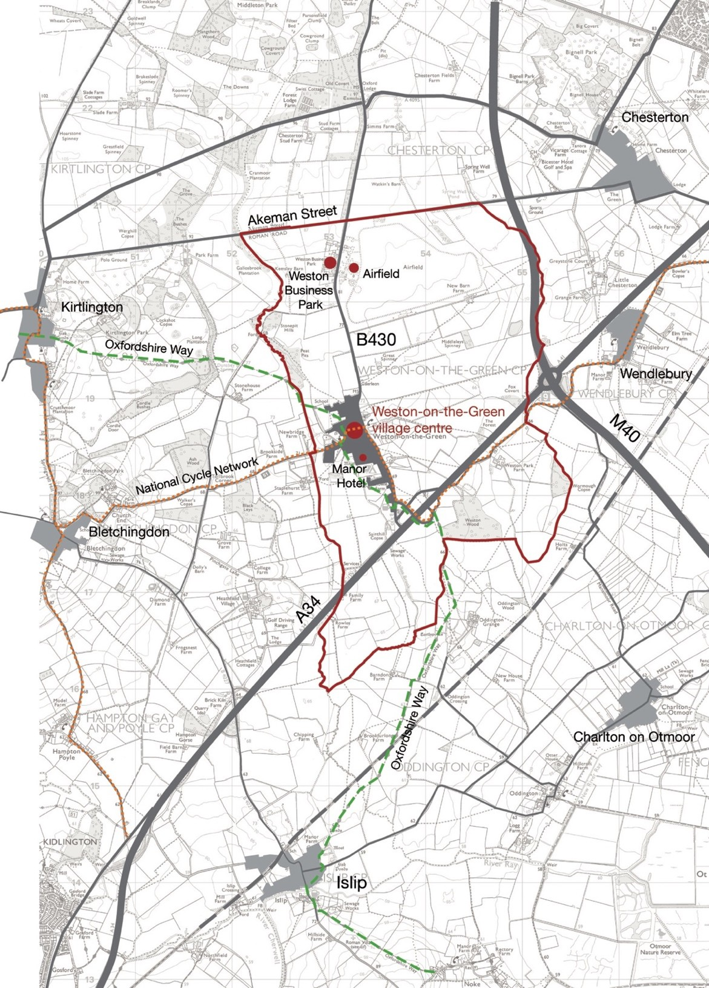

Figure 1: The designated Neighbourhood Plan area = the Weston-on-the-Green parish boundary (Crown copyright and database right 2018. Ordnance Survey)

RELATIONSHIP OF THE PLAN TO CHERWELL DISTRICT AND LOCAL PLANS

The objectives and policies presented in this Plan provide guidance to address important issues to the local community. In doing this, the Neighbourhood Plan is a key component of a broader Parish Plan that has aspirational objectives to improve the Parish and achieve a better environment in which to live. The focus of the Neighbourhood Plan is the definition of policies to guide future development within the designated area in line with these objectives.
This Neighbourhood Plan was prepared within the context of the adopted Cherwell Local Plan Part 1 2011-2031 (CLPP1), the saved policies of the adopted Cherwell Local Plan 1996 (CLP) and the former Cherwell Local Plan Part 2 (CLPP2). Policy Villages 1 of the adopted local plan identifies Weston-on-the-Green as a Category A settlement.Weston-on-the-Green is the fourth smallest of the Category A settlements. Policy Villages 2 of the adopted Local Plan 2011-2031, which seeks to distribute growth across the Rural Areas, provides for an additional 750 dwellings in Category A villages, in addition to windfall sites and planning permissions for 10 or more dwellings. As of 31st March 2017, there are 86 dwellings remaining from the Policy Villages 2 requirement. At 31st March 2018, the total number of housing completions in Weston-on-the-Green between 2011 and 2018 was 17. The number of dwellings with planning permission but not yet built equals 23 (source CDC Housing land supply update2).
The Oxford Green Belt was designated to protect the rural setting of settlements and maintain the character of the intervening countryside by restraining development pressures within the Green Belt and this is captured in policy ESD14 of the Cherwell Local Plan. The outer boundaries of the Oxford Green Belt were approved in 1975. A number of villages are washed over by the Green Belt and the villages of Bletchingdon, Merton, Murcott and Weston on the Green lie partly within and partly outside the Green Belt. The boundary of the Green Belt in Weston-on-the Green is shown in Figure 5.

To ensure that the impact on the Green Belt is minimised, priority development sites are those that lie adjacent to existing development, avoid the coalescence

2 https://www.cherwell.gov.uk/info/33/planning-policy/370/monitoring-reports/4

of settlements and otherwise have the least impact possible on the Green Belt. In the case of Weston-on-the-Green, this has resulted in disproportionate development pressure being placed on the northern half of the village which sits outside of the Green Belt. The impact of this on housing density in the village can be seen in Figure 9.

In addition, proper weight must be given to CLPP1 policies ESD13 (resist development that causes undue visual intrusion into the countryside, harm the setting of settlements or be inconsistent with local character) and ESD15 (reinforcing local distinctiveness) in considering sites which encroach on the rural periphery of the village. The very small scale of the Weston-on-the-Green settlement population currently falls below the critical mass required by the present service providers to sustain a public transport option to the village and therefore permitting any small-scale residential development in the parish would disproportionately increase car trips, thereby adding to congestion in the local area and the approaches to Bicester and Oxford. For these reasons, the pressure for large scale development in Weston-on-the-Green is reduced.
Conformity with existing planning policy:

A Neighbourhood Plan must comply with national planning policy as set out by the NPPF and support the strategic development needs set out in the Local Plan (CLPP1 and saved policies in the CLP). It must demonstrate that:

- The Plan contributes to the achievement of sustainable development;

- The Plan does not breach, and is otherwise compatible with, European policies.

A Basic Conditions Statement is provided in a separate document accompanying this Neighbourhood Plan outlining elements of conformity of this Plan with statutory requirements.

The Plan provides local detail that overlays National and Local policies and has drawn on evidence gathered and prepared for the Cherwell District Council Local Plan and new data collected from residents and businesses in the Parish of Weston-on- the-Green using surveys conducted in 2015 and 2016. It takes account of national planning practice guidelines.

HOW THE PLAN WAS MADE

The planning process was initiated by a small group of volunteers who met with the Parish Council Chairman and Parish Clerk in December 2014 to discuss the desire to develop a Neighbourhood Plan for Weston-on-the-Green.

The Parish Council agreed to support the formation of a Steering Group, made up of volunteers including Parish Council and non-Parish Council members, to collect information on the current make-up of the village and the key objectives for its future. The Steering Group activities were supported by local funds and later by a grant (Grant NPG-02207) made to the Parish Council from Cherwell District Council. The Steering Group established its Code of Conduct and appointed key roles of Chair and Treasurer. The Parish Council received reports from the Steering Group, and supported and contributed to the consultation events. The Steering Group ensured that the Plan was transparently a community effort and not driven by the Parish Council alone.

A process for developing the Neighbourhood Plan was clear from the outset and consisted of staged work:

    - base studies establishing the status quo of the village;
    - consultation on aspirations and concerns;
    - draft proposals and consultation;
    - final draft plan and consultation.

The starting point was the formation of action sub-groups, again made up of volunteers to gather information, plan and organize activities under the following headings:

Action Group 1: Community Engagement; Action Group 2: Village Form and Character; Action Group 3: Social & Economic Aspects; Action Group 4: Transportation & Highways.
A one-year action plan was created around three village events which outlined the concept of a Neighbourhood Plan to residents and developed policies based on feedback from the

community.

The Steering Group developed and launched a website (see Figure 2): http://www.wotgneighbourhoodplan.co.uk/ to engage with the community and provide information on events and progress towards the Plan.

August 2015 Inception event for volunteers
July-September 2015 | Base studies undertaken by:
 | 1. Village Form and Character team
 | 2. Social & Economic Aspects team
 | 3. Transportation & Highways team
October 2015 | 1st Event: Weston-on-the-Green: Aspirations and Concerns
 | Exhibition of base studies plus workshop/questionnaire for villagers
 | Feedback of workshop/questionnaire
 | Summary of agreed objectives
Nov-Jan2016 | Develop Plan content/options
February 2016 | 2nd Event: Neighbourhood Plan Ideas
 | Exhibition and workshops to review ideas and seek feedback
March-April 2016 | Preparation of Draft Neighbourhood Plan
September 2016 | 3rd Event: Draft Neighbourhood Plan for village consultation
 | Exhibition to seek comment on Draft Neighbourhood Plan
December 2016 | Revisions to Draft Plan and approval by Parish Council
March 2017 | Pre-submission of draft Plan to Cherwell District Council for comment
April-May 2017 | 6 week formal consultation period
May 2017 | Amendments made to the Plan
September 2017 | Submission of the Draft Plan to Cherwell District Council
Oct-Nov 2017 | CDC 6 week formal consultation period
April 2018 | Final amendments made to the Plan; all documents compiled
May 2018 | Full and final submission to Cherwell District Council
June 2018 | Examination of the Plan
October 2018 | Referendum
Table A: Outline Neighbourhood Plan timetable

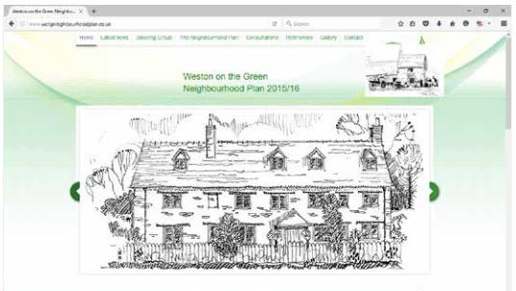

Figure 2: Homepage of the Neighbourhood Plan website: www.wotgneighbourhoodplan.co.uk

Social media (Facebook and Twitter) provided additional routes for public engagement.

Questionnaires were used to ask individuals and groups for their views and aspirations for the village; to suggest solutions for these, and ask for their help in developing policies.

At the start of the consultation process, a village-wide questionnaire was distributed to all homes and businesses (see Figure 3) and responses were used as a basis for discussions at the first Village Meeting.

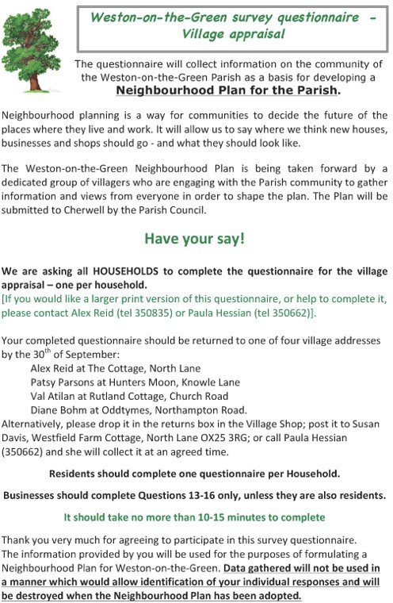
Further consultation with residents and businesses included meetings with individuals and groups representing specific concerns:

. landowners;
. young parents;
. older residents;
. children of the village;
. professionals working out of the village;
. residents of each street/lane.

Figure 3: First questionnaire survey: ‘Have your say’

Members of the Steering Group also talked with the Lead Planning Officer of Cherwell Council
and took advice as the Plan progressed. The results of such conversations and meetings were noted and helped to shape the policies in the Plan. The Steering Group, with sub- group leaders, brought together the data, material and information gathered in the research phase to prepare the first draft policy objectives. These were:

. to identify proposed sites for development;
. to understand the priority issues related to development in the village and beyond;
. to plan a phased timetable for development;
. to identify measures outside of the Neighbourhood Plan which would support the Plan policies and objectives.

Consultation meetings for the village as a whole and an analysis of the questionnaire responses identified the issues that shaped the first draft plan. Policies for the Plan were created from these and the draft Plan document was compiled. More detail of the survey and meeting processes are provided in Appendix B.

COMMUNITY ENGAGEMENT

The Community Engagement team was responsible for ensuring the whole village, including businesses, was kept informed of each stage of the development of the Neighbourhood Plan and for directing them to whom they could talk if they any had comments or concerns. The Statement of Community Engagement is detailed in Appendix B.

A concerted effort was made to reach out to those who weren’t on email and without access to the website. As well as articles published in the Weston-on-the-Green Village News, villagers were encouraged to pass on information to their neighbours. One of the main concerns of the Steering Group was that every part of the village was represented and the Community Engagement team encouraged as wide a spread of villagers as possible to join the sub-committees.

WESTON-ON-THE-GREEN TODAY:
ENVIRONMENT 2

- WESTON-ON-THE-GREEN TODAY: ENVIRONMENT

WESTON-ON-THE-GREEN PARISH BOUNDARY AND SETTING

The village of Weston-on-the-Green lies to the north-east of Oxford and halfway between Kidlington and Bicester. The south entrance to the village is just 1⁄4 mile off the A34 on the Northampton Road (B430).

Weston-on-the-Green village is immediately surrounded by agricultural land and has close proximity with woodlands and copses – Peat Pits, Weston Fen and Weston Wood which, along with the fields and crops on the village fringe, give Weston its rural feel (see Figure 4).

The name Weston refers to the position of the village in the west of the parish, “hard up
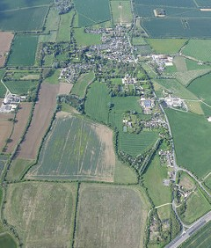
against the Bletchingdon boundary” as Weston has been described. The ‘on-the-Green’, possibly derives from the fact that the village once abutted the edge of a very large green. Weston-on- the-Green village has grown to one side of an ancient way from Oxford to Northampton, the B430 which was once a turnpike road. The village has since developed as a series of four lanes (three of which are no-through roads), on the western side of, and perpendicular to the B430. The ancient ‘green’ lies on the eastern side of the B430.

Figure 4: Aerial view of Weston-on-the-Green village from the south (Courtesy of Paul Morrison)

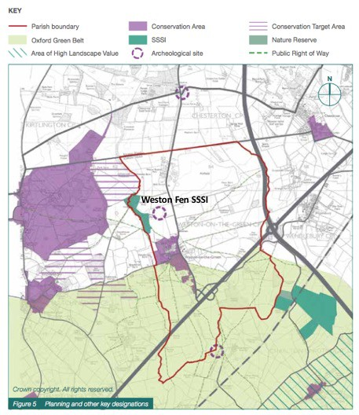

Figure 5: Planning and other key designations (Crown copyright. All rights reserved)

This layout, with the village on the western side and the green on the eastern side of the through road (B430) is unusual and highly distinctive; to the west is a compact Cherwell valley village, to the east a rural landscape of big skies and open fields where some recent development of the farms has established limited commercial and engineering services. The parish forms part of a landscape rich in historical features and field patterns including areas important for wildlife conservation (e.g. the Weston Fen SSSI and the ancient woodlands to the south of the A34; ). Two designated Conservation Target Areas (CTA) border the Neighbourhood Plan area: Kirtlington and Bletchingdon Parks and Woods CTA (Figure 6a)

to the west of the parish, and Otmoor CTA which is an extensive tract to the south-east (Figure 6b) and Weston-on-the-Green plays an important part in linking the two. Opportunities will be sought to strengthen wildlife corridors, for example the Schoolfield on the western edge of the village confines. The Schoolfield is an important green space in the village (see Appendix G, site h) that will help to establish an important link between the Weston Fen SSSI and the fields linking with rich habitats in the south (Weston wood and Otmoor CTA, Figure 6a and 6b below). Otmoor CTA includes the Wendelbury Meads and Mansmoor Closes SSSIs that lie just 3 miles from the Weston village centre. Area B requires regeneration to return it to grassland with the rich biodiversity associated with this habitat type.
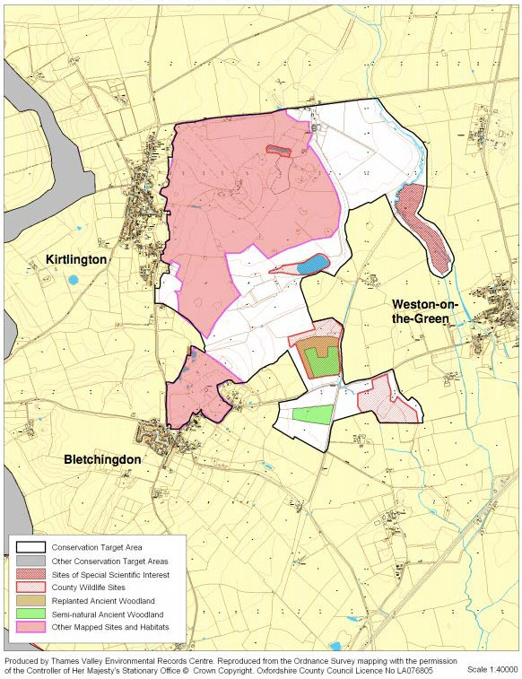
Figure 6 a): Kirtlington and Bletchingdon Parks and Woods CTA

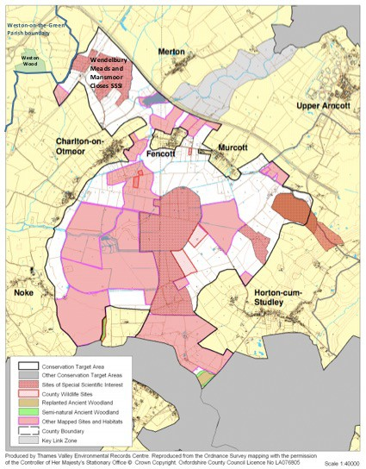

Figure 6 b): Otmoor CTA
[Figure 6a) and b): Conservation target areas bordering Weston-on-the-Green Neighbourhood Plan area. (Crown copyright. All rights reserved)]
This objective is aligned with the core principle of the National Planning Policy Framework that local plans should include strategic policies for the conservation and enhancement of the natural environment, including landscape as laid out in policy ESD10 of the Cherwell Local Plan Part 1. This includes designated landscapes but also the wider countryside3. In addition, the

3 ‘Protection and enhancement of biodiversity and the natural environment, Planning Practice Guidance 2016; https://www.gov.uk/guidance/natural-environment

Natural Environment and Rural Communities Act 2006 places a duty on all public bodies, including Parish Councils in exercising their functions, to have regard (so far as is consistent with the proper exercise of those functions) to the purpose of conserving biodiversity, including, in relation to a living organism or type of habitat, and restoring or enhancing a population or habitat. In formulating our Plan policies, we have consulted various recommended sources4 regarding environmental and habitat assessment and the Historic Environment Record which details all designated heritage assets and archaeological sites, historic buildings, landscapes and sites of local value.

HISTORIC LAYOUT AND FEATURES

The Cherwell District Council first designated the Weston-on-the-Green Conservation Area in October 2000 and a revised Conservation Area appraisal in June 2009 resulted in amendments to the Conservation Area boundary. This document details the topographical and historical features of the village, noting its unusual structure with one village street (Church Lane) and three lanes which originally served the village farms: Knowle Lane, Westlands Avenue (now redeveloped but originally serving Westfield Farm) and North Lane.

A late 18th century map of the village (see Figure 7) shows that this structure was already established by that date and has changed little since that time. Features that have remains unchanged are:

. Church of St Mary
. Dwellings around the village core (The Forge, Dower House, Walnut Tree Cottage, Willow Cottage, Hazel Cottage, Rose Cottage)
. Church Lane and its 17-19th century dwellings (Mulberry Cottage, Jubilee Cottage, Holly Cottage)
. Weston Manor
. Mill House
. North Lane

There are 33 listed structures in the village. St. Mary’s Church and Weston Manor are Grade II*, the remainder are Grade II5 (Figure 9).

4 Planning for the environment at the neighbourhood level, publication code LIT 6524; http://webarchive.nationalarchives.gov.uk/20140328084622/http://cdn.environment- agency.gov.uk/LIT_6524_7da381.pdf
5 Weston-on-the-Green Conservation Appraisal 2009, Cherwell District Council.

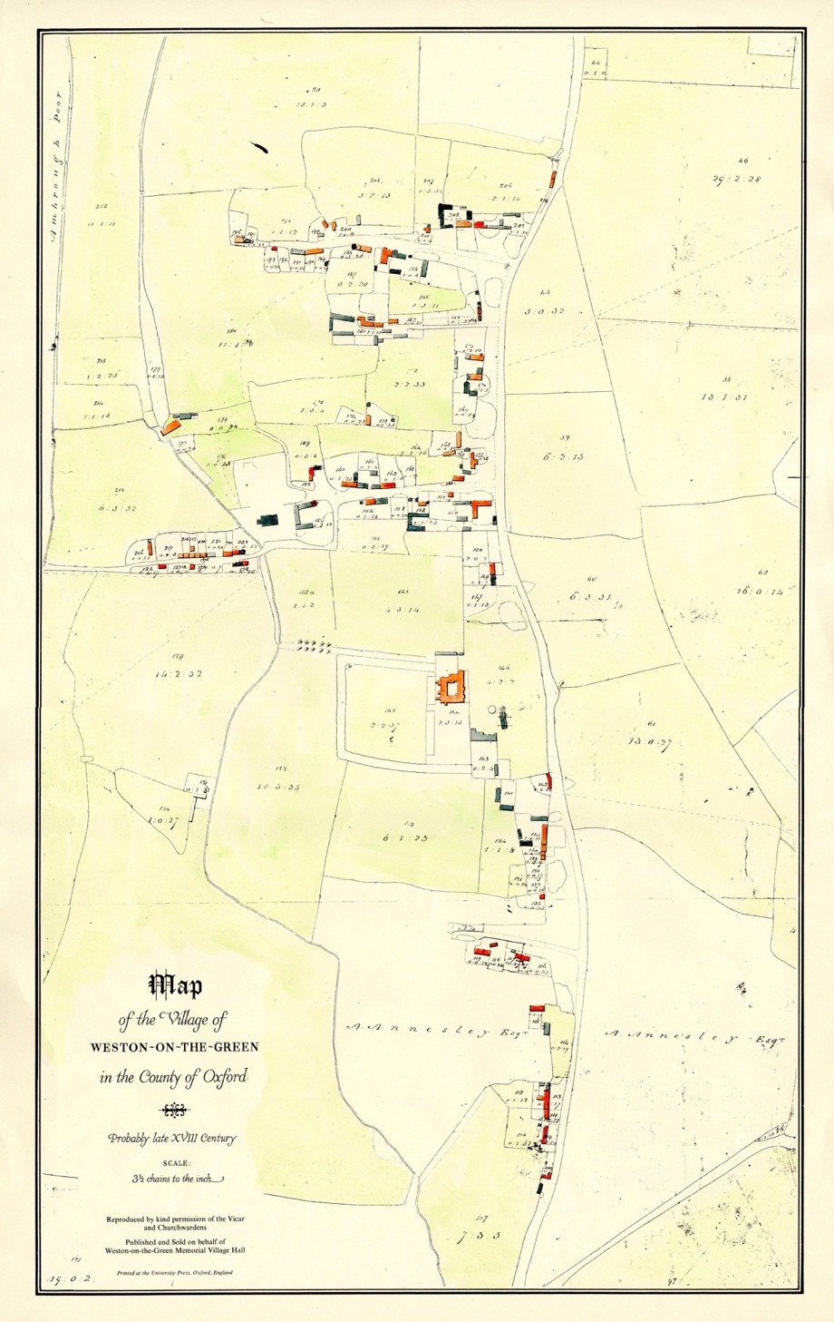

Figure 7: Weston-on-the-Green late 18th century map (reproduced from the Weston-on-the- Green archive, with kind permission of P. Hessian)

Cherwell District Council’s Conservation Area Appraisal (June 2009) identifies six ‘character areas’ which derive from the historical development of the village (Figure 8).
These are:
. The Church character area Village Core character area
. Weston Manor character area The Street character area
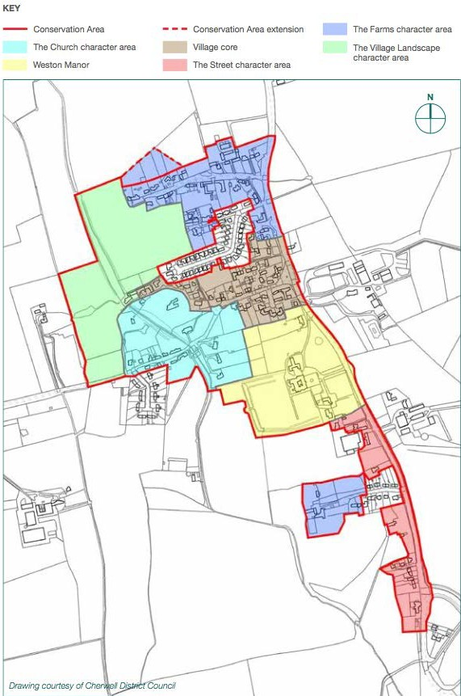
. The Farms character area The Village Landscape character area
Figure 8: Character areas (from Weston-on-the-Green Conservation Appraisal 2009)

PATTERN OF DEVELOPMENT IN THE VILLAGE

From the early ‘village confines’ pattern of the 16-17th centuries, major growth in the village has come in two forms: the addition of over 40 bungalows in the mid-1960s (which had a large impact on the village in terms of increased population and the on-traditional layout) and the smaller developments of three or more houses in groups – Knowle Lane in two phases (pre-1800 and then some further houses in the 1930s, 1940s and 1960s), Church Close (1950s), Ladygrass, CopperMill and Monk’s Walk (1973), Shepherds Close (1980s), Village Farm Court and Blacksmiths Close (1990s) and Oxford Court (2000s). Individual development of small pieces of land for dwellings e.g. along the road between the Ben Jonson and Hazel Cottage (from early 19th century through to late 20th century), conversion of redundant community buildings (e.g. school, Methodist chapel), to ‘Stoneyfield’ in North Lane (2014).
The village now has a range of building types: some of traditional vernacular style dating back to the 16-17th century whose footprint can be seen on Figure 7, the 18th century map; some could be described as ‘one off’ design; others typical of estate developments of the 1960s and later. However, on balance, the character and feel of the village has been maintained around the original ‘village confines’ layout and many of the historical features are preserved and still in use. Crucially, this collection of fairly modest dwellings grouped along one side of the main road and along four side roads, three of which are cul-de- sacs but connected by village footpaths across the ‘back’ of the village, has been maintained through the 20th century development. The key patterns of building form which characterise the village are identified on a survey drawing at Appendix I.
Figures 9 and 10 provide a summary of characteristics identified below:

Street pattern and alignment

The historic lanes are made up of long, straight segments with small deflections hiding the long distance views which are revealed as the viewer passes the point of deflection.
Dwellings located on the east-west lanes/road are no more than one or two turns (junctions) off the Northampton Road creating a highly ‘legible’ form (Figure 9). On the main road through the village (running north-south), just 21 houses border the B430, generally set well back behind deep gardens and wide verges. The remaining 90% of the village lies on the winding lanes extending west.
A number of key positive views in the village and extending into the rural borders are important assets which should be protected (see Appendix G and H for more detail). Some internal vistas could be improved, namely those cast into the once agricultural farm areas which now tend to be used for light industrial and storage purposes (Figure 10).

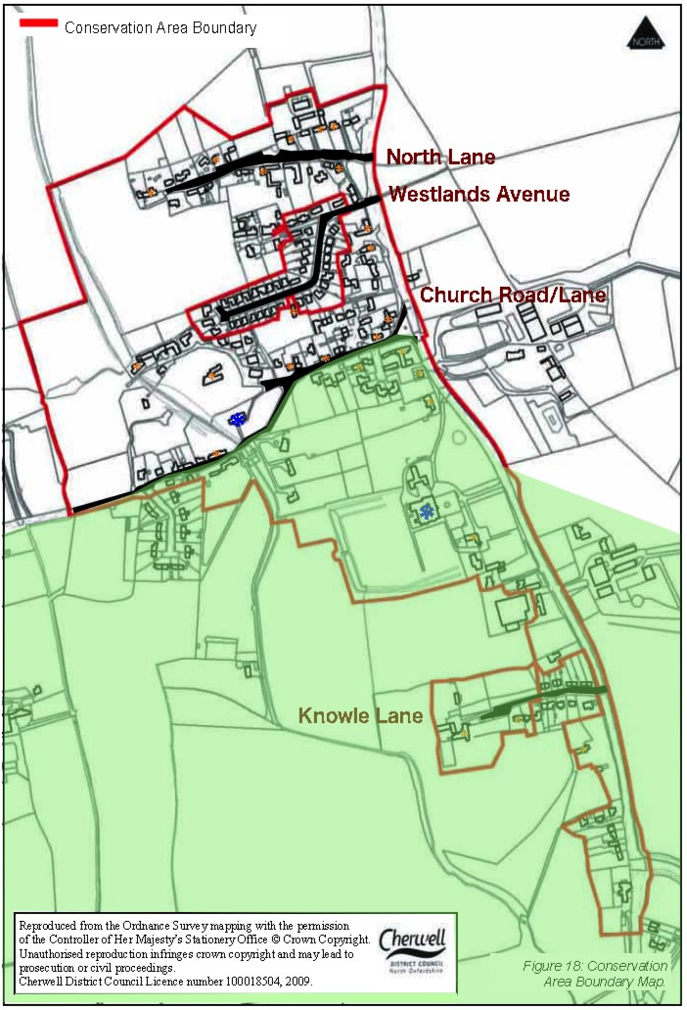

Figure 9: Conservation Area Boundary and listed buildings: Grade II (orange) except those marked in blue which are Grade II* (Courtesy of Cherwell District Council).The area in the Green Belt is shown.

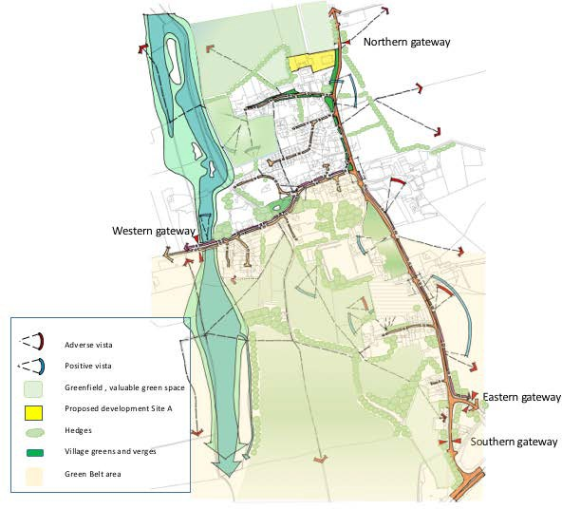

Figure 10: Key characteristics of the village showing positive and adverse vistas from viewpoints; village entry points; open spaces within the village envelope; hedgerows, verges and greens. (Map Crown copyright, all rights reserved; annotations courtesy R. Evans & S. Daenke)

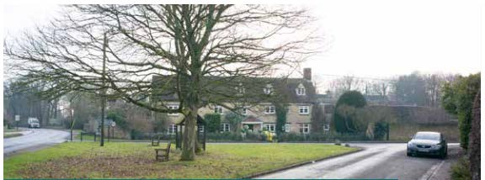

Figure 11: The junction of Church Road and the Northampton Road creates a memorable space.
    - Focalpoints
The street pattern creates focal points at the junction of Church Road and Northampton Road (Figure 11) and also the junction of Church Road / Church Lane / Mill Lane.
    - Gateways
‘Gateways’ are the visual entry points into the village: from the south at The Chequers public house, from the north at the Great Oak on the junction of North Lane and the Northampton Road, from the west on crossing the flood plain at the end of Church Lane and from the east via the A34 overpass.
    - Enclaves
Residential or business enclaves have been created from former farmyards. Such developments include Village Farm Court, Blacksmith’s Close, Oxford Court, Shepherd’s Close and are generally good design solutions to infill sites.

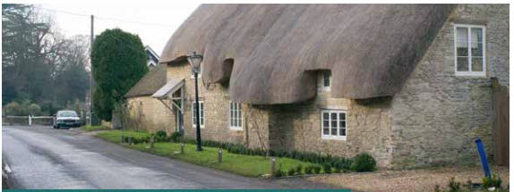

Figure 12: Example of building frontage set directly against public grass verge.

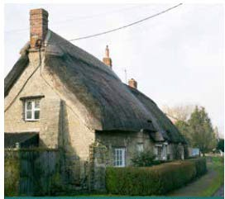
    - Building frontages and boundary walls

Most of the village housing is either built directly against a lane or verge, forming a continuous building frontage (Figure 12), or set back from the street with a low stone front boundary wall or hedge delineating the edge of the property. This combination of continuous frontages and buildings set back behind boundary walls and hedges is a key characteristic of the village (e.g. Figure 13).

Figure 13: Small landmarks or ‘marker’
buildings are created where gables front the street (Bramble cottage)

    - Landmarks and ‘marker’ buildings

The principal landmark buildings are the Church of St Mary the Virgin and Weston Manor Hotel. There is also a large number of lesser landmarks which because of their siting or a prominent gable, create memorable places within the village (e.g. Figure 13).

    - Key view and open vistas

There are a number of memorable vistas across the surrounding countryside; every lane emerging onto the Northampton Road affords such a vista over farmland to the east.
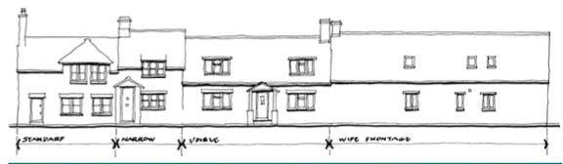

Figure 14: Four cottages – the informal rhythm of the elevations results from a variety in plot widths (North Lane)
    - Variation in plot widths
Terraces with a continuous building frontage typically have a variation in plot widths, lending an informal street frontage which expresses the character of the individual homes (e.g.
Figure 14).
    - Shallow building depths
The vernacular buildings typically have stone walls and are a single timber beam span in depth. For a given roof pitch, the ridge is therefore lower than on deep-plan buildings.
    - Roof pitches Roof pitches reflect the original roof covering: 50+ degrees for thatch, 40+ degrees for clay tile or stone slates and 35 degrees for Welsh slate.
    - Eaves heights
The eaves height of the vernacular cottages or barn conversions are typically lower than modern housing and this gives a more intimate scale compared to more recently built streets (e.g. Figure 14).
    - Materials
The predominant materials are local stone walls; tile, slate or thatch roofs and granite streetscape details. A more comprehensive list is provided in the Design Code at Appendix A.

Understanding the characteristics of the village is important in designing new development. Since much of the village is within either the Conservation Area where there are a number of listed buildings (see Figure 9) or the Green Belt (Figure 10), it is important to preserve and enhance the character of the area. There are some areas where a different approach may be appropriate – for example where there are existing detrimental views or intrusive activities there are opportunities for new development to change the character by introducing new character that has a positive impact on its surroundings.

LANDSCAPE SETTING AND GREEN SPACES

Weston-on-the-Green has a rich historic environment with 33 listed buildings, a conservation area and potential archaeological interest, and its rural character is maintained by views into the open lowland landscape on the west, north and eastern sides of the village. There is, therefore, potential for new development to have significant effects on the heritage assets within the village, depending on where the development takes place. Much is made in the Conservation Appraisal of the open verges which characterise parts of the village, mainly in the northern half. However, aside from these, the village has little public space other than the playing field on Church Lane. Therefore the preservation of the open spaces in the village, which are under threat from inappropriate development or use for parking, is important to conserve the character of the village and the rural setting beyond the boundaries.

In Weston-on-the-Green, there is a ‘potential priority habitat’ namely that part of the area known as ‘the Schoolfield’ that lies within flood zones 2 and 3. This forms a link between existing preserved areas of rich biodiversity in the parish, including the Weston Fen SSSI, the ancient woodland Weston Wood, and the adjacent Conservation target areas of Otmoor and Kirtlington and Bletchingdon Park and Woods (see Figure 16).

Additional to the policies and actions in this Plan, it is the intention of the Parish Council to oversee or to ensure that the Green Spaces and priority habitats are suitably managed, to maintain and enhance biodiversity and, where possible, to create new habitats for wildlife. This includes the valuable areas this Plan proposes to protect (Appendix F) and the areas designated as Local Green Spaces (see Appendix G). We will make clear that

policy ESD10 of the Local Plan is rigorously applied to all the open green spaces and areas which have heritage assets in the village. A management plan will evaluate and identify strategies to promote the restoration of wild plants and habitats in open areas such as meadows; look at ways to support biodiversity on the Churchyard (Wildlife in Churchyards Guidance Note, Church Buildings Council, section 55(1)(d) of the Dioceses, Mission and Pastoral Measure 2007); manage and create hedgerows and improve the village ponds to protect freshwater wildlife.
Designated Local Green Spaces: Weston-on-the-Green is characterised by its setting in an agricultural countryside and also by retained green spaces within the village. A number of areas were identified in the Conservation Appraisal 2009 as important green spaces. These included: North Lane ponds and grass verges, the iconic oak tree at the intersection of North Lane and the B430, the open grass area and verges on the B430 frontage to the Ben Jonson public house, the green and village stocks, St Mary’s churchyard.

A recent reappraisal by the Neighbourhood Plan Steering Group identified additional areas of special character which we feel justify designation as Local Green Spaces according to the criteria laid out in the NPPF.
These are I: Weston Manor grounds fronting the B430; II: the Stocks situated on a small green at the junction of Church Road and the B430; III: St. Mary’s Churchyard and IV: the playing field. All of these spaces are important to the character of the village and are proposed as Local Green Spaces in Policy E5 of this Plan. The identification of the designated NP Local Green Spaces (sites I - IV) is shown in Figure 15 and their evaluation against the criteria set out in Paragraph 77 of the NPPF are included in Appendix G.

Community Amenity Space: We have identified a ‘priority habitat’ area known as the Schoolfield (Area B) that we wish to see protected as an ancient lowland meadow.). Additional open areas of green space which are of particular value to the character of the village are also shown (Figure 15; e-h. Note the site shown as h is also Area B)

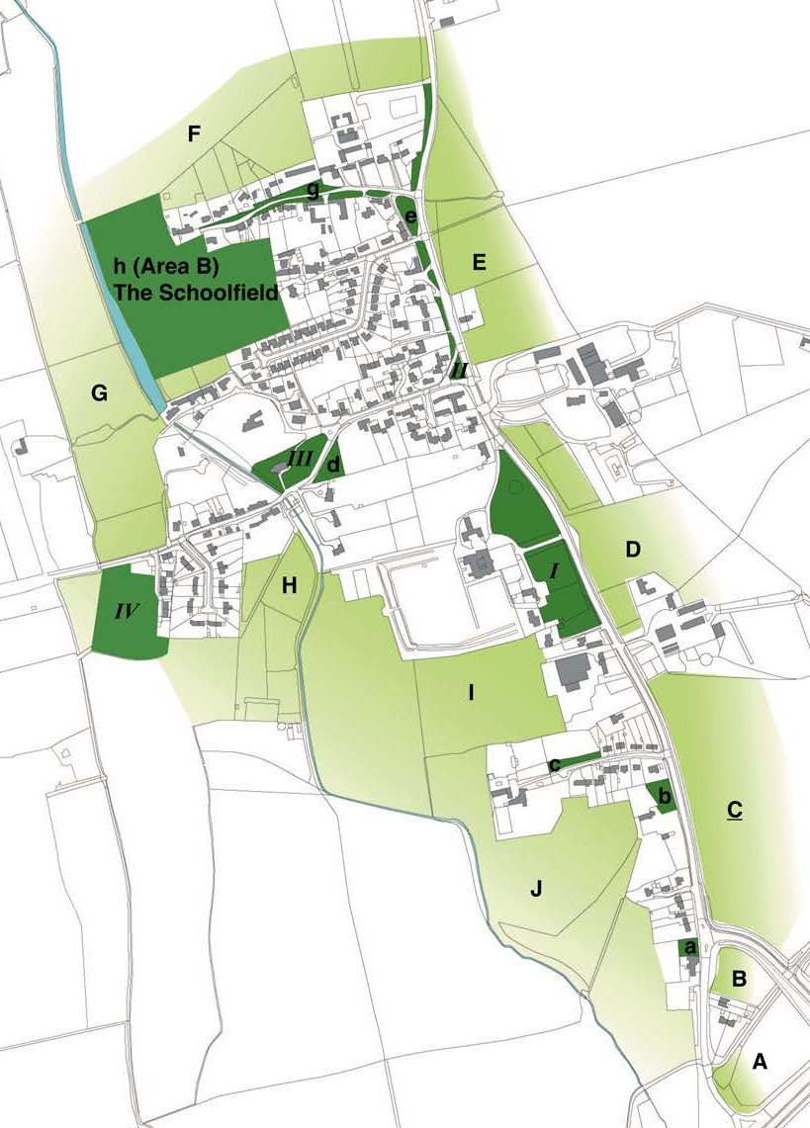

Figure 15: Important green spaces (e-h) and new designated Local Green Spaces in this Neighbourhood Plan (I-IV): A full appraisal is given in Appendix G (Map: Ordnance Survey 2018. All rights reserved)

A key aim of the Neighbourhood Plan is to conserve and increase biodiversity in the parish environment and to support this through our Plan policies. As mentioned, the broader parish area contains and is adjacent to SSSIs and other important habitats. Figure 16a shows the designated habitats bordering the village which lie within the largely agricultural landscape. The importance of connected habitat corridors to maintain biodiversity and support natural species has been highlighted by ecological consultees and can be accessed via data available via Natural England. The habitat corridor which links important sites and traverses Weston-on- the-Green parish north-east to south-west is highlighted with a red boundary marker (see Figure 16)6. This Plan seeks to further support the connection of a north-south habitat corridor (from Weston Fen SSSI to Wendlebury Meads and Mansmoor Closes SSSI, shown bordered in red) by the protection and conservation of important and designated green spaces in the village. Figure 16b illustrates how the village green spaces identified in Appendix G of this Plan will extend and strengthen this corridor.

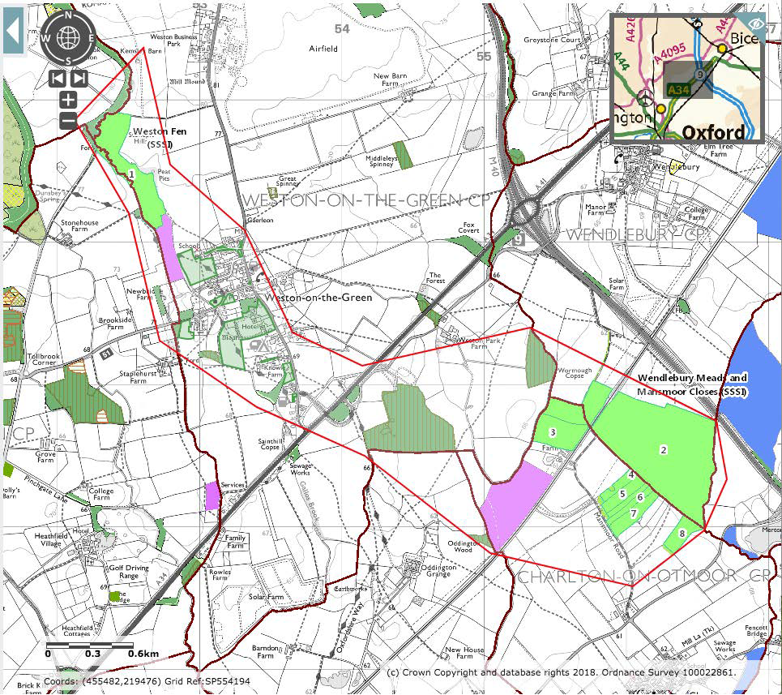
e
6 http://magic.defra.gov.uk/. Crown Copyright and database rights: Ordnance Survey 100022861. Copyright resides with the data suppliers.
Figure 16b: Green spaces as identified in Appendix G of this Plan add continuity to a north-south connected habitat.
Figure 16a: Habitat designations in the Parish of Weston-on-the-Green (MagicMaps, Crown Copyright 2018, all right reserved)
A closer view of the green spaces contributing to the ‘green corridor’ is shown in Figure 16b with th legend to both maps.

Legend to Figure 16: Habitats

Good quality semi-improved grassland (Priority habitat inventory, England) Lowland meadows (Priority habitat inventory (England)
Open spaces within Weston-on-the-Green village that contribute to the habitat corridor Parish administrative boundary

SOCIAL AND ECONOMIC BASELINE
STUDIES 3

- SOCIAL AND ECONOMIC BASELINE STUDIES
The current issues that were considered in producing this Plan included:
. Housing
. Access to/from and around the village
. Environment and sustainability
. Design quality
An overview of these issues, around which consultation was sought, is set out below. The evidence base for Section 3 is presented in Appendix D and E to this Plan (Social and Economic Profile of Weston-on-the-Green and Community survey data).

HOUSING
The parish of Weston-on-the-Green recorded a population of 523 people in the 2011 census and this has changed little since those data were collected. A review of available housing in the parish reported by the Office for National Statistics7 and data collected specifically for this Neighbourhood Plan in 2015 demonstrated:
A high level of home ownership (83%) with low numbers of social and privately rented housing;

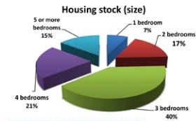
A median residency term approaching 20 years and few properties available for potential purchasers or tenants;
A high proportion (76-82%) of larger dwellings of 3 or more bedrooms, 49% of which are detached houses with gardens;
Figure 17: House sizes in the village

Higher median property value (£344,995) compared with the regional median in Cherwell District (£220,000 recorded in 2011). In 2016, the average house price from sales in the
7 Office of National Statistics www.ons.gov.uk

village was close to £500,000.
Data from the Surveys reported in Appendix E of this document recorded the current occupancy of houses in the village:
Fig A9 (Appendix E) shows that data from Survey 1, confirming data from the 2011 census, recorded the majority of households with 2 occupants (51%). These survey data also showed that 56% of occupants >65 years were living with another in the same age group. Figure 18 shows numbers in each age group living alone, with one other or more than one other. Most
>65s are in the 2 per household category.

1per household
>65
25-65
3 per household
18-24
2 per household
<18
0
5
10
15
20
25
Age distribution per household
Figure 18: Age distribution per household
This points to many older residents occupying larger (31 of 67 (46%) were 4 bedroom) detached houses of high value and 39 of 90 occupants recorded in the survey were >65 years (43%);
- of 90 surveyed occupants were in the 18-24 years range (4.4%) and 38% of survey respondents from all age groups wanted new housing for young families to be part of the Neighbourhood Plan policies.

CALCULATED HOUSING NEED FOR WESTON-ON-THE-GREEN

Based on the information gathered on the current and future populations, the housing needs for the village were calculated as follows:
- An objective of 15% growth in new housing in the period 2017-2031 = 38 new houses needed based on the survey data. This is reasonable to achieve based on the current expected growth in the region and the present housing expectation from Category A villages in the Local Plan.
- The profile of housing needed is stratified as follows:
  - Provide housing for an increased 20-35 age group in the village (9% increase or 46 young residents) = 6x1-2 bed (16%) and 9x2-3 bed houses (24%); housing is required that is attractive and affordable for younger people. The objective is to attract young families to the village and increase the proportion of the residency in the 20-35 age group to 40% by 2025. In the 2011 census, the proportion in this group (for Weston-on-the-Green) was 37% but has since fallen to 31% in 2016. To achieve 40%, we estimate at least 15 new affordable smaller houses need to be built in the village (assuming 2 young occupants per new house);
  - Provide housing for retirees and downsizers = 5x1-2 bed (13%) and 6x2-3 bed (16%); housing suitable for downsizing retirees or those in the >65 years age group who require some care support, is needed. 18 of 50 (36%) survey 1 respondents said they would need assistance to stay in their existing home, and 28% wanted single occupancy homes to be made available. To accommodate the needs of this age group, which is projected to increase within the term of this plan from 32% recorded in the 2011 census to 52% in 2037 (Population Estimates tool, Office of National Statistics 28/4 2016), at least 11 houses meeting these needs are required.
Totals: 1-2 bed = 11 houses (30%); 2-3 bed = 15 houses (40%); 3-4 bed = 5 houses
(25%); 4 bed or larger houses = 1 (5%).

Of these, at least 35% (or such higher figure as is fixed in local policy) shall be
affordable housing as defined in local and national policy.

Of the 20 houses approved on Site A, 7 fall into the affordable smaller homes category. At the moment, 20 houses is sufficient growth for the village given the present issues around lack of public transportation to/from the village.

Other development sites that come forward must fulfil the criteria in this Neighbourhood Plan including, crucially, being well connected with the village. The Parish Council would support development on exception sites in the Green Belt if it could contribute to affordable housing (Policy Villages 3 of the Local Plan). Subject to all planning consents, one site in the village (see HELAA 229 in Appendix F) could provide 18 extra houses if appropriate conditions are met. Windfall housing, which falls within Policy Villages 1 of the Local Plan, may add housing incrementally, but sites will be rigorously measured against the policies in this Plan. Since more than half of the village is included in the Green Belt, this is a significant constraint and development particularly taking account of the policies regarding character and intensification in the part of the village that is outside the Green Belt.

ACCESS TO/FROM AND AROUND THE VILLAGE

Weston is a small compact village which in principle should be easily walkable. However key facilities in the village are disconnected by lanes and roads where heavy traffic dominates narrow road spaces and footways are not available for pedestrians. Church Lane between St Marys Church and the playing field is particularly identified as a pedestrian hazard. Although public footpaths connect areas of the village across the western fields, these are not accessible to all or in poor weather conditions.

The village has a cycleway which is part of the Sustrans National cycle network but this is limited to a short stretch of the B430, is poorly connected to other routes and is badly neglected.

As of July 2016, there is no direct public transport option to/from the village as the only direct bus (Thames Travel 25 service) was withdrawn due to funding cuts from Oxfordshire County Council. At present there is no alternative public service in place except for a bookable and relatively expensive door-to-door service.

EMPLOYMENT

The village has few working farms now and a high proportion of residents commute out of the village for work. There are a number of well established businesses in the village, operating from converted buildings within or on the edge of the village, or from the Weston Business Park, situated approximately one mile north of the village along the B430. In addition, there are many residents who work from home in full or part employment. RAF Weston-on-the-Green maintains its own company of staff which provides adventure and force development training through parachuting.

CURRENT PROFILE OF THE PARISH

Full details of the data recorded for the parish, including data from the 2011 census and information gathered by survey of the villagers in 2015-16 is provided in Appendices D and E.

Population

The 2011 census showed 523 inhabitants of Weston-on-the-Green parish (recorded from 218 households). The age distribution of Weston-on-the-Green is skewed with relation to neighbouring parishes and the larger county areas, with a high proportion of residents aged 60 plus.

The present skew in the parish towards an ageing population exaggerates the national trend in rural areas, while the 0-15 age group is predicted to fall further. This presents a significant challenge in providing adequate community-level support and public services for the village demographic.

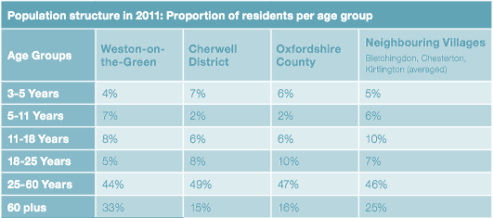

Table B: Population structure of Weston-on-the-Green compared with related regional figures.(2011 UK Census data, Office of National Statistics www.ons.gov.uk)

SOCIAL AND ECONOMIC PROFILE

Weston-on-the-Green is an affluent village with a high level of employment and a high educational profile. The village retains several working farms and businesses that employ local people, and there is a thriving ‘work-from-home’ community. However, the majority of employed residents commute to their workplace outside the village, some considerable distances. The skewed population age range means that the number of retired residents is higher than the Cherwell District average.

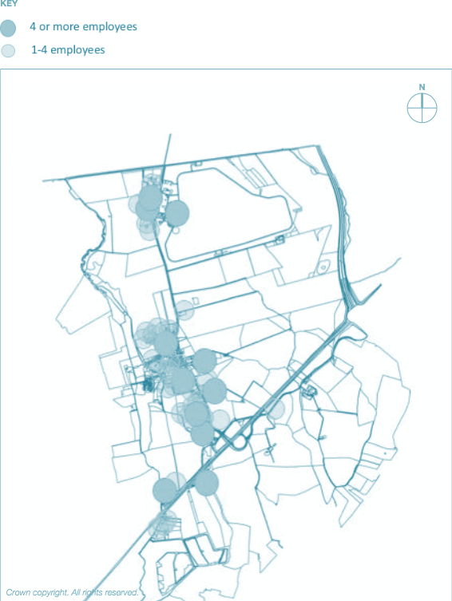
Figure 19: Business sites in the Plan area (Crown copyright. All rights reserved)

HOUSING STYLES

The size of Weston-on-the-Green has fluctuated during the time period 1665 to present when both the number of households and the population was recorded. However, until the 1950s, the number of households was fairly constant at around 100. In the second half of the 1900s, the number of houses increased with the Church Close and Westlands Avenue developments, which together provided about 80 new homes within 15 years. During this time, the population also rose from around 350 in the 1930s to 523 at the 2011 census.

The housing styles visible in the village clearly represent the periods in which they were built

(see Figure 20). There are many 17th-18th century stone and thatch cottages and some grander buildings (the Dower House). More substantial buildings surviving in the village from the early-mid 19th century are less common (Prospect House, the Schoolhouse, Jubilee Cottage), possibly reflecting the drop in population between 1850-1920. More recent styles are the bungalows in Westlands Avenue and the new builds on Gallosbrook Way, both 20- 21st century developments.

The 2011 census recorded a stable resident population with a median residency period of 18 years. With high owner-occupancy, the housing stock in the village has a low turnover providing few opportunities for incoming residents. The recent village survey figures show a predominance of larger houses (most houses are three or more bedrooms) and few rental properties and affordable homes. Almost half of all properties are owned outright and have been in the same ownership for many years.

The average house price in the village is some £120,000 above the Cherwell District regional average recorded in 2015 at about £500,000. This makes the majority of housing unaffordable for younger families and single occupants, even as housing is rarely available to purchase.

In 2011-2012, fewer than 11% of houses built in the South-East region were constructed as part of a Housing Association or Local Authority scheme, representing affordable housing at entry level. The present housing stock in the village clearly is inadequate for the existing population make-up and for a future which aspires to attract new families to the village, and this issue has significantly shaped the objectives and policies in this Neighbourhood Plan.

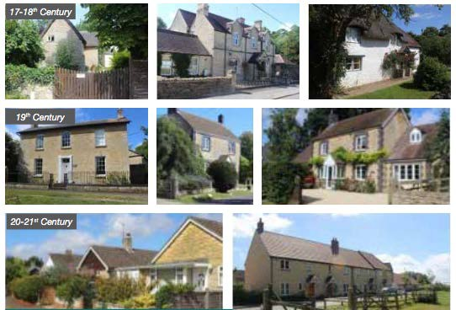

Figure 20: Representative housing styles in the village

EDUCATION

Weston-on-the-Green had a village school from 1855 to 1984 at which time it was closed. There are no educational facilities in the village except for one nursery school on the Weston/Wendlebury parish boundary, 1.5 miles distant from the village centre (see Figure 21). Children of school age attend a number of local schools ranging from 2.5 to 5.5 miles distant, or commute longer distances to schools, for example to Oxford. Of concern is the common over-subscription of local schools where places are in short supply. There are no plans to build a school in the village.

COMMUNITY

As a small village, Weston has limited but well used community facilities. They include the Church, the Memorial Village Hall, the shop and post-office, the playing field, two public houses and a small village green. There is no allotment space.

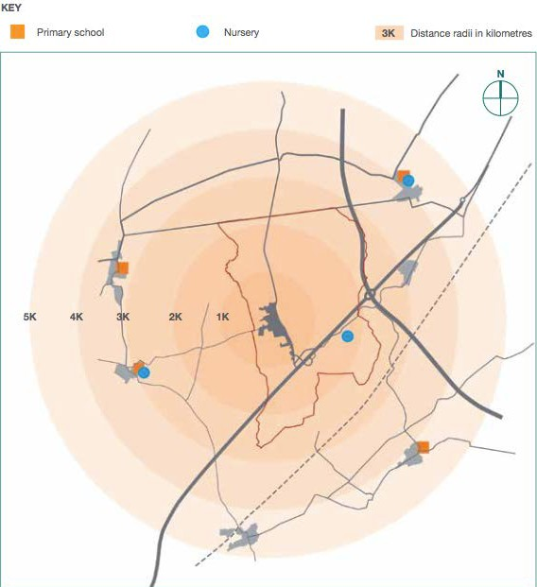

Figure 21: Distances to existing nursery and primary schools within a five kilometre radius.

CONCERNS AND ASPIRATIONS: ISSUES ARISING FROM THE CONSULTATIONS 4

- CONCERNS AND ASPIRATIONS: ISSUES ARISING FROM THE CONSULTATIONS
The consultations associated with the building of this Plan identified key concerns and aspirations for the future of the village. These were developed into objectives and where appropriate, into policies of the Neighbourhood Plan, as presented in Section 5 of this document. The following comments and concerns were noted, and the aspirations (A1-31) listed:

THEME 1: VILLAGE CHARACTER AND ENVIRONMENT

The history of Weston-on-the-Green is a cherished asset that forms an important foundation of the current village form and environment. There is a strong wish to preserve the historic features of the village, namely the vernacular building styles, the Church, Memorial Village Hall, the stocks, the ponds, the Manor, the pubs and the farming heritage. Preservation and conservation are important ideologies that should safeguard the heritage assets in the village. Residents noted the tranquillity of the village at weekends and holiday periods when traffic was less intrusive and its loss during the busy commuting times when traffic noise levels were raised. Some of the important features of the village are being lost, partly because of inappropriate development in the recent past, and while embracing change that will support the future needs of the village, these changes should not be at the expense of its historical legacy. The village should remain as a compact group of related dwellings while continuing also to relate to the open countryside on its boundaries and be attractive for residents and visitors.
A1: Preserve the historic character of the village;
A2: Restore safe access around the village so that the key facilities can be used by all.
Crucially, it is important for the majority of villagers that the existing ‘village confines’ should be maintained to preserve the outlook from the residential spaces into the open vistas bordering the village, thereby maintaining the rural character and charm of the area. ‘Dormitory and linear development’ were major concerns, both of which would detract from

the village centre and the sense of community.
A3: Maintain the existing ‘village confines’ area and resist a linear extension of the village along the B430 and encroachment into the rural boundary areas around the village.

THEME 2: HOUSING AND LAND USE

Weston-on-the-Green has increased in size incrementally and slowly, with only one major development in the 1960s (Westlands Avenue) which added 60 new dwellings, a 30% increase at the time. As a result of data gathered in the Village survey (Appendix D) the Neighbourhood Plan supports a further 15% growth over the period to 2031. 8% growth will be met immediately with Site A (Southfield Farm) which already has planning approval.

Priority would be given to previously developed land that is within the ‘village confines’, delivering homes that meet local needs. A further 12% growth could be supported on two sites in the Green Belt that could meet both the Local Plan policies and the policies and Design Code in this Plan. However these sites are within the Green Belt which bisects the village at Church Road (see Figure 9). The Local Plan policies (BSC2, ESD14 and Policy Villages
1) seek to retain the Green Belt land and protect it where possible unless exceptional circumstances can be demonstrated which may permit development.

The village includes a diversity of building styles spanning the period from the 12th century (Weston Manor), the 17-18th centuries (stone and thatch), the 19th century (e.g. Prospect House and Jubilee Cottage) and through to the 20th and 21st century. Housing has grown incrementally over the years until the 20th century when the first of the uniform estate developments was built (Church Close followed by Westlands Avenue). The consultations revealed a consensus view that new developments should be on a scale that does not impact adversely on the existing character mix of housing. Therefore, developments that present a dominant style on a single site are not favoured. New housing should be of a style and layout and of an appropriate scale to sit easily with the existing local setting. Sites are shown on Figure 22.

Developments on the edge of the village have been deeply unpopular and vigorously

opposed. Development pressure at these sites has been driven by the designation of the south half of the village as Green Belt, which restricts development. The main growth in housing has therefore been concentrated to the north of the Green Belt boundary, which aligns with Church Road, Church Lane and the Bletchingdon Road (see Figure 5). Rather than extend housing beyond the existing ‘village confines’ which will erode the areas bordering the ‘village envelope’, sites within the ‘village confines’ are more consistent with the wishes of the village. In addition, development puts pressure on the existing infrastructure of the parish and previous evidence of flooding and water management issues in the village confirm that it is essential for developers to engage with Thames Water to ensure that the demand for water and sewage treatment infrastructure can be met and surface drainage requirements and flood risk is properly assessed. The National Policy Statement for Waste Water8 states that adequate water and wastewater infrastructure is a requirement for sustainable development.
A4: No large-scale housing developments should be allowed in the village;
A5: No ‘satellite’ or ‘dormitory’ housing development should be supported outside the ‘village confines’, nor ‘ribbon development’ along the B430 ;
A6: Keep new housing to the west of the B430, maintaining the open rural spaces on the eastern side;
A7: New house styles should be in sympathy with the village character e.g. the Gallosbrook Way is considered an acceptable example of new housing which does not jar with the historic environment;
A8: New housing should support young people with limited means, older people and young families e.g. an appropriate mix of housing types should provide for the existing and future population of the village;
A9: The siting of new housing should not increase traffic problems in the village;
A10: New housing should be energy efficient and should adequately plan for the expanded load on water management infrastructure;
A11: New housing should be laid out with a variety in density, layout, building orientation and sizes to reflect the local building styles and materials must also respect and positively contribute to local distinctiveness.

8 National Policy Statement for Waste Water 2012, ISBN: 9780108511486.

THEME 3: COMMUNITY AND ECONOMY

The village grew around a working agricultural community. The latter part of the 20th century saw local employment much diminished and a pattern of commuting established. Today, there are businesses of all sizes and a large number of home-workers which means that the village is populated during the working day again and there is a demand for local shops and services.
A12: Local employment should be encouraged.
Currently, the heart of the village is underused in spite of the fact that Weston-on-the-Green is home to more than 90 businesses and 37% of households have residents who work from home for all or part of the week. Combined with a high proportion of retired people, this means that up to 50% of the population is village-based during the working day. Compared with commuter villages, this is a real asset, which provides an opportunity to promote and expand the use of local shops and services, including the existing shop/post office, focusing these activities at the centre of the village.
A13: Local retail and community services should be expanded to support the local resident population and businesses e.g. ;
A14: Internet and mobile phone access should be improved to bolster businesses;
A15: Access to/from the village to outlying business sites (RAF airfield, Kelberg, the Flight House, Weston Business Park, Bear Necessities Nursery) should be improved.
Enhancement around the village centre and upgrading of village facilities such as the playing field, playground and village ponds would make Weston- on-the-Green a more attractive destination. Improving access to footpath walking routes, the historic village features and making use of nearby formal attractions (Blenheim Palace, Rousham Park, Oxford) would make the village more visitor-friendly and boost village retail and catering businesses, hotel and pubs. Weston Manor, which is both a historic icon in the village and a major employer, can play a valued role in meeting these aspirations. A high priority for families with children is to establish a village recreation area that has a safe access route. The existing playing field

and playground is reached from the vast majority of the village by Church Lane leading onto the Bletchingdon Road. Footpaths connect with Church Lane but the crucial last distance to enter the playing field is by walking on the road surface on a single width section of the road. With parked vehicles and traffic volume and congestion, this is a dangerous stretch of road that deters many families from using the facilities. It is difficult to see a remedy to this as many historic cottages along Church Lane are built up to the road edge, making it impossible to provide a footway for pedestrians. Therefore, the identification of new space in the village that can be made available for recreation is a priority and Area B has been identified that could provide a safe open space that can be used for passive appreciation of the rural setting and its natural habitat. A draft plan for Area B for the establishment and management of an amenity space, has the strong support of the Parish Council. As a matter of principle and policy, all development should seek to provide a net gain for biodiversity in the local area, thereby positively contributing to the network of green spaces that link wildlife corridors county-wide. A separate site will be sought for allotments, for which a previous call for land allocation in 2014 was unsuccessful. Traffic management schemes are also essential to reduce the impact of traffic on residents and users of village facilities.

Cherwell has the largest expected level of population growth in Oxfordshire at 27,240 stated in the Local Plan. The impact of this on health services that also serve the small villages is considerable. The recommendation of the Oxfordshire Primary Care Commissioning Committee is to allow S106 Planning obligations to fund the expansion of existing health facilities as well as fund new ones9. In addition, isolated villages have special needs such as rural loneliness, transport to surgeries, remote health monitoring and other community support facilities. These needs must be taken into account for new development of any scale (e.g. 10 or more houses).
A16: The village centre facilities should be more flexible with improved retail opportunities;
A17: Playground facilities need better access for children and family members and should be improved to include a clubhouse and new features. The designation of a new safely accessible recreational area in the village would be supported for purposes distinct from those already available;

9 Primary Care Estates July 2017: Oxfordshire Primary Care Commissioning Committee Paper No 6, Appendix 1 ‘Health needs associated with Housing need’.

A18: An allotment ground should be sought;
A19: Local expansion of health and social support services for an expanded population should be a condition of planning approval, with consideration of S106 contributions to fund these;
A20: Better information should be provided on the accessible features of the parish (walking trails, cycle paths, historic features, bridle paths and nearby tourist destinations) to encourage healthy transport options;
A21: The ancient open areas bordering the village should be conserved and biodiversity should be protected and enhanced.

THEME 4: TRANSPORT , HIGHWAYS, FOOTPATHS/WAYS

The high volume and speed of traffic through the village, and the loss of public transport options to the village is the issue that unites the villagers as the main concern for the future. The impact of traffic on the entire village is significant and this led to the large number of specific concerns regarding its future management.
A22: B430 speed limit should be reduced to 30mph through the village; A23: Traffic calming measures should be introduced subject to the outcome of the statutory consultation;
A24: Speed on the lanes radiating from the B430 should be reduced to 20mph;
A25: The weight restriction for heavy lorries should include both directions on the B430, except when in use as a diversion route for the A34;
A26: The stocks junction should be remodelled to slow down and manage high volume commuter traffic on Church Road and Church Lane;
A27: Pedestrian crossings are needed across the B430 to allow access to commercial premises on the eastern side;
A28: Footways for pedestrian access around the village need extending and upgrading;
A29: The cycle path needs extending and upgrading (should be extended up to RAF airfield and Weston Business Park);
A30: Parking areas need better management in the village centre, and green verges should be reinstated where existing parking has destroyed their integrity;
A31: Some form of public transport must be reinstated for the village.
The Parish Council is aware that central funding is not available to address the aspirations above and are committed to a long-term plan to make improvements incrementally as funding allows.
Some of the concerns and aspirations listed here and arising from village consultations are outside of the scope of the objectives or the Neighbourhood Plan policies. However, they show the depth of feeling of the community to make improvements to the village and the real concerns for the future. The Parish Council is aware that central funding is not available to address the aspirations above and are committed to a long-term plan to make improvements incrementally as funding allows.

.

A VISION FOR WESTON-ON-THE-GREEN: OBJECTIVES AND POLICIES 5

- A VISION FOR WESTON-ON-THE-GREEN: OBJECTIVES AND POLICIES
Weston-on-the-Green grew slowly over a millennium to become a working village based around four farms by the mid twentieth century. During the closing decades of that century local employment declined and Weston became a largely commuter village. Today, the village economy has come full-circle with over 70 local businesses and many residents working part of the week from home following the internet revolution. As a working village, there is demand for local services, an acceptance that modest growth will bring benefits, but also an insistence that new development shall be appropriate to the character of the village and that intrusive traffic – particularly that which threatens pedestrian safety – shall be calmed.
The overriding principle of the NPPF is that of sustainable development, which is generally taken to mean ‘meeting the needs of the present without compromising the ability of future generations to meet their own needs’.
The NPPF identifies three key elements of sustainable development:
- economic - contributing to building a strong, responsive and competitive economy, supporting growth and innovation;
- social - supporting strong, vibrant and healthy communities, by providing a supply of suitable housing and a high quality built environment;
- environmental - contributing to protecting and enhancing our natural, built and historic environment, providing a biodiversity net gain for the area, minimising waste and mitigating the effects of climate change.
While the Cherwell Local Plan policies set the standards for sustainable development throughout the District, the Weston-on-the-Green Neighbourhood Plan supplements these policies to ensure that specific development conditions that are relevant to the local community overlay more general policies and can be implemented within Planning policy.
The adopted Local Plan requires high standards of design and building methods. Weston-on-

the-Green has a rich history which is reflected in many designs of exemplary quality and with notable vernacular features. This Plan seeks to safeguard the quality of any new developments within the designated Neighbourhood Plan area.

DEVELOPING THE POLICIES

At an early stage of developing the Plan, feedback and opinion received from respondents shaped the objectives and policies presented here. Potential strategic development sites, identified in the Cherwell Housing and Economic Land Availability Assessment (HELAA, 2017) were considered during this process. The full HELAA appraisal of available land in Weston- on-the-Green is provided in Appendix F to this Plan. The assessment is used as an evidence base for the Cherwell Local Plan. The Neighbourhood Plan Steering Group also considered each of these sites in the light of the objectives and policies established and the outcome of these are recorded in Appendix F.

Proposed housing development site and potential exception site :

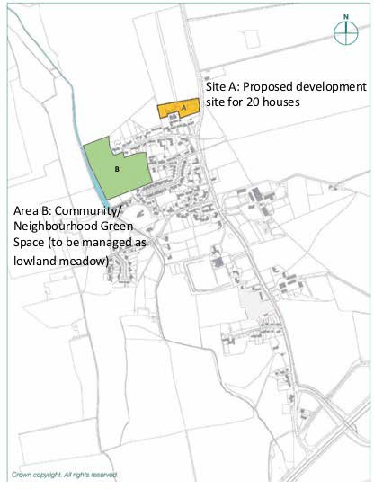

Figure 22: Site A proposed in this Plan (see policy H1) and Area B ().

  - THE NEIGHBOURHOOD PLAN POLICIES

Policies and objectives were established in the four themes to address the main concerns articulated by villagers during the consultation process. In each theme, policies are measured for consistency with policies in the National Planning Policy Framework (NPPF) and the Adopted Cherwell Local Plan (ACLP).

Theme 1 – Village character and environment Objectives:
O1:  To respect and conserve the historic ‘village confines’ within its open countryside setting and preserve open  spaces for the benefit of the whole village. | Small rural villages are surrounded by open areas bordering the ‘village confines’. These fringe areas are important buffers between the built-up village dwellings and the actively farmed agricultural land and support wildlife habitats and local access-ways.
O2:  To maintain the rural character of the village, and its distinction from the more urban developments of Kidlington and Bicester. | We aim to protect the natural and historic boundaries to the village and the remaining green spaces that contribute to village character. New development should maintain the building character and rural context and protect public rights of way.

ENVIRONMENTAL POLICIES

E1

E1: Development should provide a positive contribution to the locally distinctive character of Weston-on-the-Green and conserve important aspects of the setting of the village, in particular it should:
• Recognise the importance of open space, rural character and important views; and
• Achieve a biodiversity net gain for the parish including appropriate maintenance and expansion of green spaces; and
• Implement a biodiversity measure for all development proposals; and
• Avoid development outside the village confines along the B430 unless it is in accordance with policies in this Plan and the adopted Cherwell Local Plan.

The use of biodiversity assessment indicators is explained in ‘The UK Biodiversity Indicators 2017’10

E2: Development should preserve and enhance the green infrastructure and the natural environment of the area, and where appropriate:
    - Provide new footpaths with landscaping to link existing rights of way or other green spaces;
    - Value, preserve, support and enhance green infrastructure within the parish, including open green space, wild green space, allotment space, habitats in or on structures;
    - Preserve hedgerows or create new ones;
    - Create a pond or preserve an existing one;
    - Plant trees characteristic to the local area to make a positive contribution to the local landscape;
    - Use native plants in landscaping to provide nectar and seed sources for wildlife;
    - Incorporate bird and bat boxes into the design of new buildings;
    - Keep exterior lighting levels low to encourage wildlife;
    - Use green roofs or walls to new or existing buildings where allowed;
    - Preserve and manage potential grassland habitats by careful cutting or grazing and monitoring visitor numbers.
E3: Development that makes use of previously developed land will generally be preferred to greenfield locations. Inappropriate development of residential gardens will not be supported where it will detract from the character of the village or will have a negative impact on biodiversity, such as the loss of roosts and nests of bats and birds.

E4: Any lighting proposed should be designed to ensure that it does not cause visual

10 Jncc.defra.gov.uk/ukbi, 2017

intrusion, nor cause adverse effects due to light pollution.

E5: The distinctive wide grass verges between dwelling boundaries and the carriageway should be preserved and protected in the existing village landscape and the same pattern adopted in new developments.

E6: Four sites, the boundaries of which are shown in Figure 15, are designated as Local Green Spaces. They are:
I: Weston Manor grounds fronting the B430;
II: the Stocks situated on a small green at the junction of Church Road and the B430;
III: St. Mary’s Churchyard
IV: the playing field
E7: New development will not be permitted on land designated as Local Green Space except in very special circumstances.
We consider policies E1-E6 are consistent with each of the following:
NPPF – Para 17 “..ways to enhance and improve the places in which people live their lives; contribute to conserving and enhancing the natural environment;

NPPF – Para 57 “..plan positively for…public and private spaces and wider area development schemes.”

NPPF – Para 58 “ ..add to the overall quality of the area; establish a strong sense of place; includ[e] green and other public space as part of developments; respond to local character and history and reflect the identity of local surroundings”

NPPF – Para 70 “plan positively for the provision and use of shared space”

NPPF – Para 109 “..enhance the natural and local environment; protecting and enhancing valued landscapes; minimising impacts on biodiversity and providing

net gains in biodiversity where possible.”

ACLP – A9 “cherish protect and enhance our distinctive natural and built environment and rich historic heritage; maintain rural character where its landscapes, its vast range of natural and built heritage ….. define its distinctiveness.”

ACLP – BSC 10 “Consideration will be given to the need to designate Local Green Spaces in accordance with advice in the NPPF and NPPG.”

ACLP – ESD 10 “Protection and enhancement of biodiversity and the natural environment will be achieved; a net gain in biodiversity will be sought by protecting, managing, enhancing and extending existing resources and by creating new resources.”

ACLP – ESD 11 “Biodiversity enhancements sought in association with development could include the restoration or maintenance of habitats through appropriate management, new habitat creation to link fragmented habitats.”

ACLP – ESD 13 “seek to retain woodlands, trees, hedges, ponds, walls and any other features which are important to the character or appearance of the local landscape as a result of their ecological, historic or amenity value.”

ACLP – ESD 17 “Green infrastructure comprises the network of green spaces and features in both urban and rural areas including the following: …natural and semi- natural green space, green corridors, amenity green space, children’s play space, allotments …. Churchyards, accessible countryside in urban fringe areas,
…woodlands, …. Green roofs and walls.”

Green spaces and priority habitats

Policy ESD10 in the Cherwell Local Plan Part 111 recognises the value of SSSIs, ancient woodland, aged or veteran trees and priority habitats as valuable contributors to biodiversity and the recent report by Wild Oxfordshire12 identifies specific areas of concern where habitats and wildlife are under threat. Areas adjacent to designated sites can form part of an overall ecological unit and provide important linkages. Also landscape features such as hedgerows, woods, trees, rivers and riverbanks, ponds and floodplains can be of importance both in urban and rural areas, and often form wildlife corridors and stepping stones for species mobility.

The NPPF (sections 76 and 77) permits local communities, through Neighbourhood Plans, to identify special protection for Local Green Spaces of particular importance to them, subject to certain conditions. They must be demonstrably special to the local community and hold a particular local significance and character (e.g. their aesthetic value, historic significance, recreational value, tranquillity or richness of wildlife).

Designated Local Green Spaces and Community/Neighbourhood space in this Plan are shown in Figure 15. Marked Sites I-IV are described in more detail in Appendix G. Each site has been evaluated for designation against the pre-conditions set out in the NPPF Paragraph 77 and a summary of how these sites meet the requirements is given in the Appendix. The designation of Local Green Spaces is intended to provide opportunities to implement elements of a wider green infrastructure strategy (see O1 and O2) for the community: for example, restoring neglected environmental features (hedges, ponds); improving the existing public right of way network to connect missing sections; planting additional street trees and sowing wild flower strips. This protection is embodied in policy E7 of this Plan.

Theme 2 – Housing and land use

Survey and census data have confirmed that the housing mix in Weston-on- the-Green is weighted towards larger detached housing and the most recent survey identified a large proportion of the housing with low occupancy. However, the parish population is skewed

11 Adopted Cherwell Local Plan 2011-2031 (Part 1): http://www.cherwell.gov.uk/index.cfm?articleid=11344
12 The State of Nature in Oxfordshire 2017; www.wildoxfordshire.org.uk.

towards the upper age ranges. There is clearly an imbalance with the needs of the community as it stands and the housing stock that makes up the village. Provision has been made in the Housing policies to support an expanded population with health services appropriate for the parish demographic and the isolation of the population (no public transport).

Objectives:

O3:  To deliver a mix of housing that addresses the demonstrable needs of the current and future communities as identified in the housing survey. | Provide small houses for young families, first-time buyers, retirees and single people; those with strong local connections and lower income residents.  Insist on high design quality and limited size of individual developments to allow growth which will support sustainability, but not compromise the character of  the existing environment.

HOUSING AND LAND USE POLICIES

H1: A development of 20 dwellings is supported on Site A (Southfield Farm) as shown on Figure 22 subject to compliance with other policies in this Plan

H2: In addition to the major development set out in Policy H1, sustainable residential development within the village confines will be permitted for conversion, infilling and other development, , provided that they protect the character of the village and are in accord with the other policies in the Neighbourhood Plan and Local Planning Policies.

H3: New developments should contribute to the overall target of 30% 1-2 bedrooms; 40% 2-3 bedrooms; 25% 3-4 bedrooms and 5% 4-5 bedrooms.

H4: New development should place additional emphasis, in addition to the requirements outlined by the NPPF paragraphs 126-141 and especially paragraphs 132 and 139 on the conservation or enhancement of all heritage assets of the parish and ESD15 of the Local

Plan, such that housing type should be appropriate to the local setting e.g. terrace, detached, semi-detached, affordable, design for life, and relate in scale, massing and layout to neighbouring properties. The density of new housing should be consistent and compatible with the existing prevailing density of the locality in which new development is proposed.

H5: All planning applications for development should provide specific detail to show compliance with the Design Code (Appendix A) and all other policies in this Neighbourhood Plan, including proper and full consultation with utility companies with specific regard to building over or close to existing public utility infrastructure.

H6: Developments should provide safe and convenient access to village facilities for pedestrians, cyclists, and users of mobility aids.

H7: New housing should be: clearly designed for the needs of residents at or beyond the state pension age; adaptable for wheelchair access with ground level WC and shower where practicable.
H8: New developments of 10 or more houses should have a corresponding impact on the health care resources available to support the expanded population. Developer contributions should be considered to enable local health facilities to expand and to support ancillary resources that offset the effects of rural isolation.
H9: Developments of 10 or more dwellings (gross), or which would be provided on sites suitable for 10 or more dwellings (gross0, will provide at least 35% of new housing as affordable homes on site. In the event of a lower threshold for affordable housing or a higher percentage for provision becoming local policy, these will apply. Where this would result in a requirement that part of an affordable home should be provided, a financial contribution of equivalent value will be required for that part only. Otherwise, financial contributions in lieu of on-site provision will not be accepted.
We consider policies H1 – H7 are consistent with each of the following:
NPPF – Para 7 “…the need for the planning system to perform a number of roles – contributing to protecting and enhancing our natural, built and historic environment and, as part of this, helping to improve biodiversity ”
NPPF – Para 17 “always seek to secure high design quality and a good standard of amenity to all existing and future occupants of land and buildings; recognising the intrinsic character and beauty of the countryside and supporting thriving rural communities within it.”
NPPF – Para 55 “ …sustainable development in rural areas, housing should be located where it will enhance or maintain the vitality of rural communities.”
NPPF – Para 58 “Neighbourhood Plans should develop robust and comprehensive policies that set out the quality of development that will be expected for the area: respond to local character and history and reflect the identity of local surroundings and materials, while not

preventing or discouraging appropriate innovation.”

ACLP ESD15 “Where development is in the vicinity of any of the District’s distinctive natural or heritage assets, delivering high quality design that complements the asset will be essential” ;

“Conserve, sustain and enhance designated and non-designated ‘heritage assets’ (as defined in the NPPF) including buildings, features, archaeology, conservation areas and their settings, and ensure new development is sensitively sited and integrated in accordance with advice in the NPPF and NPPG. Proposals for development that affect non- designated heritage assets will be considered taking account of the scale of any harm or loss and the significance of the heritage asset as set out in the NPPF and NPPG. Regeneration proposals that make sensitive use of heritage assets, particularly where these bring redundant or under used buildings or areas, especially any on English Heritage’s At Risk Register, into appropriate use will be encouraged.”
ACLP Policy Villages 1 C261 “allows minor development, infilling and conversions with consideration of ESD 15”.
ACLP Policy Villages 2 C272 “in the interests of meeting local housing need in rural areas, an allocation enables development of some new sites (for 10 or more dwellings) in the most sustainable locations.”
ACLP BSC 4 “provide a mix of housing …that reflects the needs of an ageing population, a growth in smaller households”.

Theme 3 – Community and economy Objectives:

O4:  To expand and support the community wellbeing by improving community facilities including support for businesses and home- workers. | Engage with the Village Memorial Hall trustees and Committee and users of community facilities to discuss plans to enhance the centre of the village.  - some restructuring around St Mary’s Church and the Memorial Village Hall providing centralised community space at the heart of the village (see Figure 23);  - expanding facilities for the community  - expanding retail service opportunities  - providing safer pedestrian access to

village facilities (see also Transport Objectives);
- providing nursery facilities in the
village.
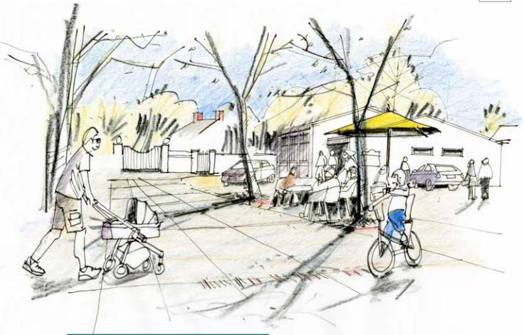

Figure 23: An artist’s impression of the square at the centre of the village (Courtesy R. Evans)

COMMUNITY POLICIES

.

C1: Development proposals should not adversely affect facilities of community benefit. Developments that seek to enhance the facilities in the area bounded by the Church, the Memorial Village Hall and the village shop/post office, including the Memorial Village Hall itself, should not adversely affect the existing character of the area, nor reduce the parking provision for or associated with the Memorial Village Hall.
C2: Developments that enhance the community educational facilities within the designated Plan area, including safe access for all users, will be supported. Proposals that address the provision of children’s nursery facilities and allotments will be supported.
C3: All developments must provide connectivity (virtual services such as broadband, telecoms) to the highest standard available at the time of proposal.
C4: Developments should not harm a heritage asset, character of the village centre, or important space, key street scenes and views such that:
- Development that results in harm to the visual contribution of key views set out in this Plan and in Cherwell District Council’s Weston-on-the-Green Conservation Area Appraisal (2009) shall not be permitted.
- Unless required for sustainable development (and then only to the extent necessary) development will not harm key features of local and heritage character as described in Appendices A, F-H of this Plan and including:
  - views of high positive visual impact, particularly the Parish Church, the green and stocks, the Memorial roundabout at the village centre, the wide verges on North Lane and the B430, the Manor frontage; designated Local Green Spaces;
  - the rural character engendered by all types of amenity and green spaces, particularly the playing field, the spinney, the ponds and the Schoolfield.
We consider policies C1 – C4 are consistent with each of the following:
NPPF – Para 17 “..ways to enhance and improve the places in which people live their lives; contribute to conserving and enhancing the natural environment;

NPPF – Para 42 “The development of high speed broadband technology and other communications networks plays a vital role in enhancing the provision of local community facilities and services.”

NPPF – Para 50 “plan for a mix of housing based on current and future demographic trends; identify the size, type, tenure and range of housing that is required in particular locations, reflecting local demand.”
NPPF – Para 57 “..plan positively for…public and private spaces and wider area development schemes.”

NPPF – Para 58 ““Neighbourhood Plans should develop robust and comprehensive policies that set out the quality of development that will be expected for the area: respond to local character and history and reflect the identity of local surroundings and materials, while not preventing or discouraging appropriate innovation…..add to the overall quality of the area; establish a strong sense of place; includ[e] green and other public space as part of developments; respond to local character and history and reflect the identity of local surroundings”

NPPF – Para 70 “plan positively for the provision and use of shared space”

NPPF – Para 109 “..enhance the natural and local environment; protecting and enhancing valued landscapes; minimising impacts on biodiversity and providing net gains in biodiversity where possible.”

ACLP – ESD 10 “Protection and enhancement of biodiversity and the natural environment will be achieved; a net gain in biodiversity will be sought by protecting, managing, enhancing and extending existing resources and by creating new resources.”

ACLP – ESD 11 “Biodiversity enhancements sought in association with development could include the restoration or maintenance of habitats through appropriate management, new habitat creation to link fragmented habitats.”

ACLP – ESD 13 “seek to retain woodlands, trees, hedges, ponds, walls and any other features which are important to the character or appearance of the local landscape as a result of their ecological, historic or amenity value.”

ACLP – ESD 17 “Green infrastructure comprises the network of green spaces and

features in both urban and rural areas including the following: …natural and semi- natural green space, green corridors, amenity green space, children’s play space, allotments …. Churchyards, accessible countryside in urban fringe areas,
…woodlands, …. Green roofs and walls.”

Theme 4 – Transport, Highways, Footpaths/ways

Alongside the implementation of the Neighbourhood Plan, the Parish Council will work with Oxfordshire County Council and the Highways Authority to achieve the following Transport Objectives:

O5:  Ensure that new developments improve road safety and aim to reduce traffic volume in the parish. Proposals should include measures to limit traffic speeds. | Additional traffic volume, created as a consequence of new housing, is not consistent with the objective to reduce traffic volume in the village. For this reason, O1 led to policy T2, requiring new developments over a minimum size of 10 dwellings to contribute to traffic mitigation measures.
O6:  Developments should not adversely affect public rights of way. Exceptionally, re- routing will be considered only where sustainable development is majorly affected in which case any loss of amenity will be minimised. | Where possible, Public Rights of Way should be enhanced by creating or upgrading link paths, improving maintenance and signage.

TRANSPORT POLICIES

T1: Parking areas and access routes related to new development should be designed in a manner in keeping with the local area with regard to scale, materials, splays and signage, be consistent with the stated Design Code and should not result in a net loss to biodiversity or green space.

T2: Developments of 10 or more dwellings will be expected to promote and improve low- carbon transport connectivity by contributing to improvements in the local footway/ cycleway network to facilitate safe and energy efficient means of transport around and beyond the village limits and enhance links with neighbouring parishes.

T3: In so far as planning permission is required, any proposal to alter or extend an existing dwelling that would reduce the level of off-street parking provision will be resisted unless it can be demonstrated that the overall parking provision retained is satisfactory.
We consider policies T1 – T3 are consistent with each of the following:
NPPF – Para 35 “Plans should protect and exploit opportunities for the use of sustainable transport modes for the movement of goods or people. Therefore, developments should be located and designed where practical to give priority to pedestrian and cycle movements and have access to high quality public transport facilities; create safe and secure layouts which minimise conflicts between traffic and cyclists or pedestrians”.
ACLP SLE 4 “All development where reasonable to do so, should facilitate the use of sustainable modes of transport to make the fullest possible use of public transport, walking and cycling. “

  - DELIVERY OF THE PLAN

Implementation of the adopted Neighbourhood Plan policies over the period to 2031 will be managed by the Weston-on-the-Green Parish Council in close cooperation with Cherwell District Council.

Meeting the objectives within each theme will be the responsibility of the Parish Council, in consultation and close collaboration with other implementing bodies: e.g. Oxfordshire County Council (highways, public rights of way, countryside access) Natural England, infrastructure providers (telephone, broadband providers), utility companies (Thames Water, underground power and telephone cabling), local/regional amenity groups (Memorial Village Hall trustees, Parochial Church Council) and the private sector (energy generation, nursery facilities).

An implementation plan will be drawn up to make the enhancements described in Section
  - alongside the implementation of policies outlined in this Plan. The implementation plan will include: assessing the existing deficiencies in the green spaces and drawing up a list of actions to rectify these; managing existing and new public spaces to be more wildlife friendly (e.g. by creating flower strips, planting trees to improve the streetscape, improving existing public rights of way by cutting back hedges, improving surfaces, repairing gates and fences and clearing unsightly areas and litter. Every effort will be made to improve all public areas to make them richer in biodiversity, ecologically sound and more attractive for residents. The key responsibilities for implementation of the policies in this Plan are given in Table C:

Table C: Plan policies and responsibilities for their implementation
Plan policy | How the policy is delivered  and monitored | Key responsibilities
E1  Development should provide a positive contribution to the locally distinctive character of Weston-on-the-Green and conserve important aspects of the setting of the village | Preserve existing and take every available opportunity to create new areas of open space to help retain the rural character and open areas of community benefit including the reservation and enhancement of important views linking with the rural landscape | Weston-on-the-Green PC Cherwell District Council
 | Achieve a biodiversity net gain for the parish including maintaining and expanding spaces that extend habitat corridors that link designated sites to the north and south of the Parish
 | Implement a biodiversity measure for all development proposals
 | Resist development outside the village confines along the B430.
E2  Development should preserve and enhance the green infrastructure and the natural environment of the area | Provide new footpaths with landscaping to link existing rights of way or other green spaces;  Value, preserve, support and enhance green infrastructure within the Parish, including open green space, wild green  space, allotment space, | Weston-on-the-Green PC

habitats in or on structures
Preserve hedgerows or create new ones;
Create a pond or preserve an existing one;
Plant trees characteristic to the local area to make a positive contribution to the local landscape;
Use native plants in landscaping to provide nectar and seed sources for wildlife;
Incorporate bird and bat boxes into the design of new buildings;
Keep exterior lighting levels low to encourage wildlife;
Use green roofs or walls to new or existing buildings where allowed;
Conserve and manage potential grassland habitats by careful cutting or grazing and monitoring visitor numbers.
E3  Development that makes use of previously developed land will generally be preferred to greenfield locations | Inappropriate development of residential gardens will not be supported where it will detract from the character of the village or will have a negative impact on biodiversity, such as the loss of  roosts and nests of | Weston-on-the-Green PC Cherwell District Council

 | bats and birds.
E4  Any lighting proposed should be designed to ensure that it does not cause visual intrusion, nor cause adverse effects due  to light pollution | Refuse planning applications where lighting is intrusive | Weston-on-the-Green PC Cherwell District Council
E5  The distinctive wide grass verges between dwelling boundaries and the carriageway should be preserved and protected in the existing village landscape and the same pattern  adopted in new developments | Refuse planning applications that do not preserve or protect wide grass verges | Weston-on-the-Green PC Cherwell District Council  Oxfordshire County Council
E6  Four sites (I: Weston Manor grounds fronting the B430; II: the Stocks situated on a small green at the junction of Church Road and the B430; III: St.  Mary’s Churchyard and IV: the playing field) are designated as Local Green Spaces because of their significance to the character of the village and should not be developed. | Refuse planning applications on areas designated as Local Green Space unless exceptional circumstances to mitigate harm are met | Weston-on-the-Green PC Cherwell District Council
E7  New development will not be permitted on land designated as Local Green Space except in very special circumstances. | Refuse planning applications on areas designated as Local Green Space unless exceptional circumstances can be demonstrated | Weston-on-the-Green PC Cherwell District Council

H1  Support the development of 20 dwellings on Site A (Southfield  Farm) subject to compliance with other policies in this Plan | Planning is now approved for this development | Weston-on-the-Green PC Cherwell District Council
H2  In addition to the major development set out in Policy H1, sustainable residential development within the village confines will be permitted for conversion, infilling and other development, provided that they protect the character of the village and are in accord with the other policies in the  Neighbourhood Plan and Local Planning Policies. | Refuse planning applications that negatively impact on the character of the village or contrary to the policies in this Plan. | Weston-on-the-Green PC Cherwell District Council
H3  New developments should contribute to the overall target of 30% 1-2 bedrooms; 40% 2-3  bedrooms; 25% 3-4 bedrooms  and 5% 4-5 bedrooms | Refuse planning applications that do not meet these targets | Weston-on-the-Green PC Cherwell District Council
H4  New development should place additional emphasis, in addition to the requirements outlined by the NPPF paragraphs 126-141 and especially paragraphs 132 and 139 on the conservation or enhancement of all heritage assets of the parish and ESD15 of the Local Plan, such that housing type should be appropriate to the local setting  e.g. terrace, detached, semi- detached, affordable, design for life, and relate in scale, massing and layout to neighbouring  properties. The density of new housing should be consistent | Refuse planning applications that are not compatible with the local setting as set out in the policy | Weston-on-the-Green PC Cherwell District Council

and compatible with the existing prevailing density of the locality in which new development is proposed.
H5  All planning applications should provide specific detail to show compliance with the Design Code (Appendix A) and all other policies in this Neighbourhood Plan, including proper and full consultation with utility companies with specific regard to building over  or close to existing public utility infrastructure. | Refuse planning applications that do not show compliance with the Design Code or utility requirements | Weston-on-the-Green PC Cherwell District Council
H6  Developments should provide safe and convenient access to village facilities for pedestrians, cyclists, and users of mobility aids. | Accessibility plans should be provided by developers | Weston-on-the-Green PC Developers  Oxfordshire County Council (Highways)
H7  New housing should be clearly designed for the needs of residents at or beyond the state age pension and adaptable for wheelchair access with ground  level WC and shower where practicable. | Developers to incorporate these requirements into plans as appropriate | Weston-on-the-Green PC Cherwell District Council
H8  New developments of 10 or more houses should have a corresponding impact on the health care resources available to support the expanded population.  Developer contributions should be considered to enable local health facilities to expand and to support ancillary resources that offset the effects of rural  isolation. | Developer contributions should be considered to enable local GP practices to expand proportionately to an increase in population and to support ancillary resources that offset the effects of rural isolation | Weston-on-the-Green PC  Cherwell District Council Oxford Clinical Commissioning Group
H9  Developments of 10 or more dwellings (gross), or which would be provided on sites suitable for 10 or more dwellings (gross) will provide at least 35% of new housing as affordable homes on site. | Refuse planning applications that do not provide the required level of affordable housing | Weston-on-the-Green PC  Cherwell District Council

C1 | .
C1  Developments should not adversely affect facilities of community benefit.  Developments that seek to enhance the facilities in the area bounded by the Church, the Memorial Village Hall and the village shop/post office, including the Memorial Village Hall itself, should not adversely affect the existing character of the area, nor reduce the parking provision for or associated with the Memorial  Village Hall. | Refuse planning applications that adversely affect community assets or reduce parking in the central village area | Weston-on-the-Green PC Cherwell District Council
C2  Developments that enhance the community educational facilities within the designated Plan area, including safe access for all users, will be supported. Proposals that address the provision of children’s nursery facilities and allotments will be supported. | Weston-on-the-Green Parish Council to liaise with appropriate bodies and local people | Weston-on-the-Green PC
C3  All developments must provide connectivity (virtual services such as broadband, telecoms) to the highest standard available at the time of proposal. | Refuse site briefs that do not include up-to-date connectivity | Weston-on-the-Green PC Cherwell District Council Utility providers
C4 | Refuse planning | Weston-on-the-Green PC

Developments should not harm a heritage asset, character of the village centre, or important space, key street scenes and views. | permission for developments that adversely impact on important spaces street scenes and views. | Cherwell District Council
T1  Parking areas and access routes related to new development should be designed in a manner in keeping with the local area with regard to scale, materials, splays and signage, be consistent with the stated | Planning applications to comply with the Design Code of this Plan | Weston-on-the-Green PC Cherwell District Council  Oxfordshire County Council (Highways)

5.4
Design Code and should not result in a net loss to
biodiversity or green space.
T2  Developments of 10 or more dwellings will be expected to promote and improve low- carbon transport connectivity by contributing to improvements in the local footway/cycleway network to facilitate safe and energy efficient means of transport around and beyond the village limits and enhance links with  neighbouring parishes. | Financial contributions to be sought from new developments | Weston-on-the-Green PC Cherwell District Council  Oxfordshire County Council
T3  In so far as planning permission is required, any proposal to alter or extend an existing dwelling that would reduce the level of off-street parking provision will be resisted unless it can be demonstrated that the overall parking provision retained is satisfactory. | Planning applications where off-street parking is reduced to an unsatisfactory provision will be refused | Weston-on-the-Green PC Cherwell District Council  Oxfordshire County Council

MONITORING

Monitoring delivery of the policies will be the responsibility of different bodies as defined in the Delivery and Monitoring table. Delivering the policies will require an integrated approach involving public sector (Weston-on-the-Green PC, Cherwell District Council, Oxfordshire County Council, utilities), private sector (developers and owners) and voluntary bodies and groups.

The strategic Plan for the Parish will be included as a standing item at each Parish Council meeting and a progress report will be tabled at each Annual Parish Meeting.

The Parish Council website will include updated information on progress during the lifetime

and implementation of the Neighbourhood Plan. At 5-year intervals a review of progress will be undertaken with recommendations and amendments considered as appropriate.

The delivery of new housing as described in policy H1 will be accompanied by implementation of the objectives within the Parish plan guided by the following time-plan:

Years 1-5 (2018-2023):

Improvements to existing village community facilities:
    - Developing an overall Neighbourhood Plan implementation and management programme in consultation with advisory bodies and Stakeholders;
    - First tranche of traffic calming measures completed;
    - Consultation and plan to improve public transport options for residents;
    - Consultation on upgrade to the village centre started;
    - Initiate upgrades to cycle routes and footpaths;
    - Reinstatement and maintenance of grass verges;
    - Defining the grassland management objectives and implementation plan for Area B and initiating first steps.
Years 6-10 (2023-2027):
    - Complete upgrades to cycle routes and footpaths;
    - Public transport solutions implemented;
    - Advanced consultation on the development of a nursery school in the parish;
    - Fundraising for major village objectives;
    - Upgrades to the village centre completed; design for Village Square proposed;
    - Maintaining grassland Management and monitoring progress: reporting to stakeholders.
    - Further traffic measures and monitoring.
Years 11-14 (2027-2031):
    - Enhancement of community facilities (village centre; football field; footpaths; allotments);
    - Appraisal of progress in grassland management and biodiversity on and adjacent to Area B with nearby SSSIs as comparators. Revision of the management plan as appropriate.

WESTON-ON-THE-GREEN
NEIGHBOURHOOD PLAN
2018-1031

APPENDICES
. A Design Code
. B Statement of community engagement and consultation
. C Historical context for the village
. D Social and economic profile of Weston-on-the-Green
. E Community survey data
. F Site appraisal and Environmental Statement for Area B (the Schoolfield)
. G Landscape setting and important internal green spaces
. H Characteristics of village form (morphology)

APPENDIX A

DESIGN CODE

A1 Introduction

The need for a Code
This Code has been prepared as a guide for developers planning to build in Weston-on-the- Green to ensure that new build developments are compatible with the look and feel of the village, particularly if they are within, or adjacent to, the Conservation Area. Many of the recommendations are derived from the 2009 Conservation Area Appraisal report, prepared by Cherwell District Council and also the analysis of the form of the village set out in Appendices H and J. New developments will be expected to reflect the characteristics described in this analysis1. The guidance will also be useful for householders planning renovations or refurbishment.

A2 Public realm

Generally, the village is located to the west of the B430, with a main street leading to the Church, shop and village hall, and then to Bletchingdon. Apart from Westlands Avenue, other roads are ‘lanes’, which traditionally led to the three village farms.
Streets
Streets within new developments should have the characteristics of these’ lanes’, with:
- houses located at different distances from the carriageway
- long straight segments with small angles of deflection between each segment to give a gently meandering appearance (see Appendix H)
- grass verges of varying width from the dwelling boundary to the carriageway, with
these verges including trees and hedgerows

1 Photographs of local features provided with permission by R. Evans 2016.

- a shared surface for pedestrians and vehicles, but with a footway (pavement) where the need is warranted  - traffic calming achieved through design  Footways (pavements)  - Any footway created for new developments should link up with the existing network of pedestrian access to village facilities.  - Footways should, where possible, be set back from the carriageway edge and separated from it by a grass verge. In this circumstance, footways should meet the grass verge without edging.  - Footways should be firm, free from undulations or trip hazards. If laid correctly, suitable materials are tarmacadam, asphalt, brick/block paving and paving slabs. Gravel and cobbles are not suitable. (See BS 8300, 5.5).  - Footways should be a minimum of 1500mm wide, if necessary widened to 1800mm wide for a distance of 2m to create passing places (see BS 8300, 5.2(b) and 5.3).  Cycle paths  - Cycle paths should link with existing official cycle ways.  Verges and greens  - Verges and greens are historically characteristic of the village and should be incorporated into new developments.  - Existing and newly-formed grass verges should not, in principle, be used for car parking.  - Where, in exceptional circumstances, grass verges need to be used for parking cars, they should be reinforced, to maintain a ‘grassy’ appearance.  Kerbs  - Kerbs that separate a footway from the carriageway should be granite or basalt setts laid on their side to match those in Church Road, not precast concrete kerbs. | 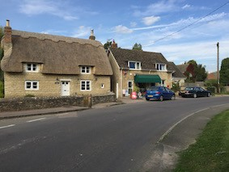  Street from B430 to the shop, church and village hall  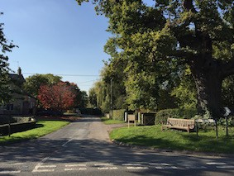  North Lane from the B430  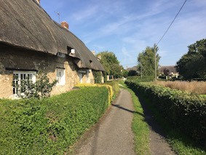  Footway separated from carriageway  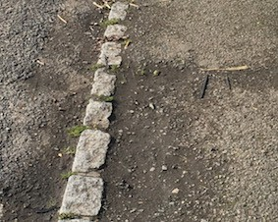  Kerb to footway of granite setts

Shared surfaces
- Shared surfaces should be suitable for pedestrian and vehicular traffic, with priority for pedestrians.
- The choice of surface should respect the needs of blind and partially sighted people and people who use mobility devices, if necessary, by having a portion of the surface with the characteristics of a footway (see above under Footways).

Accessibility
- All pedestrian routes around the village, and access to village facilities, should be accessible to all, including elderly and disabled people (see BS 8300). (see also under Footways
above)
A3 Housing plots

Location of houses within plots
- Houses should be built either directly against a front verge (where appropriate, forming a continuous frontage of terraced houses), or set back from the street with a front garden and a boundary wall delineating the front of the property. The combination of these two typologies gives variety to a development (see Appendix H).

Driveways and hard standings
- 70% of the surface area of entrance driveways and hard standings should be of a porous material, such as gravel, porous brick/block paving or porous asphalt, with pedestrian access complying with Footways.

Waste management
- Storage for refuse bins should be provided where it is not visible from the street.

Cycle storage
- External storage should be provided for cycles.

Boundary features
- Boundary features should be stone walls (coursed rubble limestone or dry stone walls with

cement:sand coping), metal railings, timber post and rail fencing, or hedges of privet or native species.  - To reflect the ‘open’ character of the ‘lanes’, stone boundary walls and post and rail fencing on the public side of house plots should be no more than 1.35m high.  - Boundary features should reflect the materials found in neighbouring properties. | 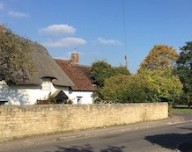  Typical stone boundary wall
A4 Housing form and tenure

Housing form
- Where houses are designed in terraces, a variation in house width, depth, number of storeys and roof form gives an informal rhythm to the elevation, which is characteristic of the village (see Appendix H). Designers should attempt to achieve this in new developments.

Incremental development
- To maintain the character of the village, housing sites of sufficient size should be developed incrementally or be designed to appear so.

Number of storeys
- Dwellings of 1 to 2.5 storeys are acceptable, but care should be taken to consider the relative eaves height of adjacent houses.
Eaves height
- To be compatible with the scale of village houses, the eaves height of new houses should be lower than in common for modern “estate” houses, if necessary by projecting the rafters more than normal beyond the external wall (see Appendix H).

Housing tenure
- As per Cherwell DC and national guidelines, we require a proportion of new housing developments to be ‘affordable’ housing.
- We also encourage a proportion of dwellings to be ‘Shared ownership’ and homes

that are of appropriate size and cost for first time buyers.

Innovative design
- We support Cherwell’s initiative on ‘self- build’ or ‘custom-build’ and are not, in principle, against innovative housing design.
A5 Housing standards

Design quality
- Developments should be compatible with the principles in Building for Life, which is supported by CABE.

Security
- Developments should achieve Secured by Design accreditation.

Accessible and adaptable housing
- We support the concept of accessible and adaptable housing designed to meet the changing needs of the occupants over time (e.g. through accident, old age or disability) (see the Lifetime Homes standard or Requirement M4(2) of Approved Document M of the Building Regulations).

Energy efficiency
- We support forms of construction where the fabric energy efficiency is maximised in line with the Sustainable Construction policy of Cherwell District Council.
A6 Detailed features and materials

Roof pitch and shape
- Roof pitch should be consistent with the chosen roof covering, with steeper pitches being preferred within the Conservation Area. Pitched roofs should have a minimum pitch of 35 degrees.
Dormer windows and Velux rooflights
- Both of these are used throughout the village and are acceptable for new developments, provided the design chosen and

the materials used are compatible with the examples used in the rest of the village. |  | 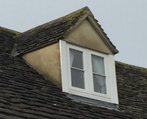
 | 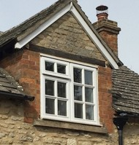 | 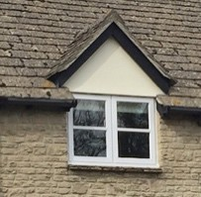
Walls  - Walls should be finished in coursed rubble limestone to match the rest of the village, although the use of red brick quoins, combined with the stonework, is acceptable to give variety.  - Lime mortar should be used as modern mortars can accelerate weathering in stone.  - A traditional style of pointing (not ‘ribbon’ pointing) should be used – this is particularly  important for stonework. | Rubble limestone | 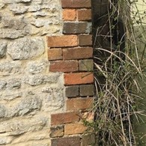  Stone with brick quoins
- The occasional use of render on some walls, coloured to match the tones of natural stone, is also acceptable.  - Weatherboarding is acceptable for outbuildings, e.g. garages, but should be used sparingly. | 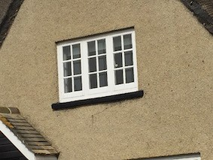  Render coloured as natural stone
Roof coverings  - The following roof coverings are acceptable for pitched roofs:  - Plain clay tiles (not concrete tiles or Pantiles)  - Thatch  - Stonesfield or Welsh slates. | 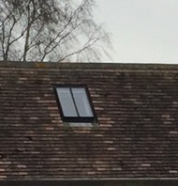  Clay tiles | 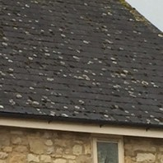  Slates
Eaves design  - The majority of eaves in the village do not have pronounced fascia and soffit boards. To be compatible with traditional village houses, the eaves should be designed either without a fascia board or, if one is proposed, it should be unobtrusive. | 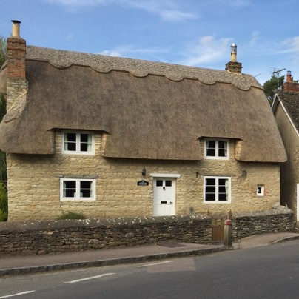  Thatch

Windows and doors  - Side hung timber casement windows of 2 or 3 lights are acceptable. Adjacent casements should be ‘balanced’, i.e. have the same glazed area dimensions.  - The ratio of window area to wall area should following traditional practice, except in exceptional circumstances.  - Windows of uPVC are not acceptable for housing within the Conservation Area, and discouraged outside this area. Very durable windows of timber or timber composite construction, which have much less  environmental impact, are now available. | 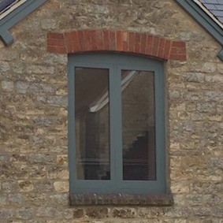  Side-hung casement windows
- Doors should be of timber, either:  - Solid boarded  - Part glazed, or  - Of stable door design. | 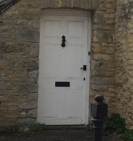  Solid boarded | 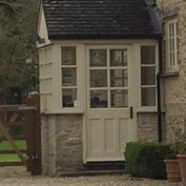  Part glazed door
 | door
Lintels and sills  - Lintels should be of timber (traditional for farm buildings), stone or stone-effect.  - Sills should be of stone or stone-effect. Ceramic tile sills are also acceptable. | 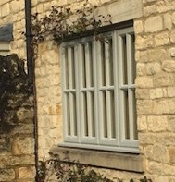  Stone sill | 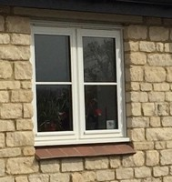  Ceramic tile sill
Garage doors
- Timber boarded side-hung garage doors are preferred to metal or fibreglass up-and-over
doors.

APPENDIX B

STATEMENT OF COMMUNITY ENGAGEMENT AND CONSULTATION

1 - How the Neighbourhood Plan was Developed First Stages:
A small group of villagers met with the PC Chairman and Parish Clerk in November 2014 to explore the idea of creating a Neighbourhood Plan. The Parish Council (PC) called a village meeting in March 20152 to explain what a Neighbourhood Plan is and to see if the village was in favour of one being written for Weston-on-the-Green. As there was a majority vote in favour of this the PC held another meeting in April 2015 where Geoff Botting of Woodcote village, who had successfully completed a Neighbourhood Plan, explained the process. Following a full discussion of the issues within the village, it was agreed at that meeting to encourage the Neighbourhood Plan and specifically to address issues of traffic and development.
A core group of volunteers was established which met several times, during which 4 task groups, Community Engagement, Village Form & Character, Social & Economic Aspects and Transportation & Highways, were formed and team leaders allocated to each.
A village meeting was held in August 2015 for all those interested in volunteering and from this the Steering Group3 was formed, along with people volunteering for each task group. Each volunteer was asked to fill in a data protection form to ensure they were happy with their contact details being circulated to other member of the groups.
The Social & Economic Aspects group prepared a questionnaire to be circulated to every household and business in the parish boundary. It went through several drafts with the Steering Group before being signed off and delivered around the parish. The returned forms’ data were collated before the first Village Event in October 2015.
The Team leaders met several times before the Village Event to finalise the details of the Event.

Meeting 1: 17th and 22nd October 2015

2 Please see section 2 of Appendix A for the full list and dates of all meetings held
3 Please see section 3 of Appendix A for the list of members of each group

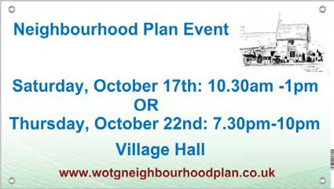
The first Village Meeting was held on Saturday, October 17th and repeated on Thursday, October 22nd 2016 (two events were held so that more villagers could attend). It was advertised through the village newsletter, a leaflet drop and large advertising panels at all entry points
to the village. The format was an exhibition and workshop:
Display panels were prepared on different topics and presentations given of work undertaken to date. Key survey data were presented which provided a basis for discussion e.g. the average age of residents, house size, number of children, form of transport and other matters of key concern. The presentations were followed by a workshop consisting of small group discussions using a prompt question sheet and led by a member of the Steering Group.

The workshop reviewed the context for a Neighbourhood Plan and set the expectations for the tone of discussion. Each table was led by a member of the Steering Group and consultation, together with questionnaires, were used to capture the key concerns and aspirations for the future of the Parish. These identified potential improvements in the parish environment.
Notes were made on a flip chart and then summaries of each group discussion were shared with the meeting.
A large aerial map of the village was located in the centre of the room and the attendees were encouraged to place Post-it™ notes to highlight
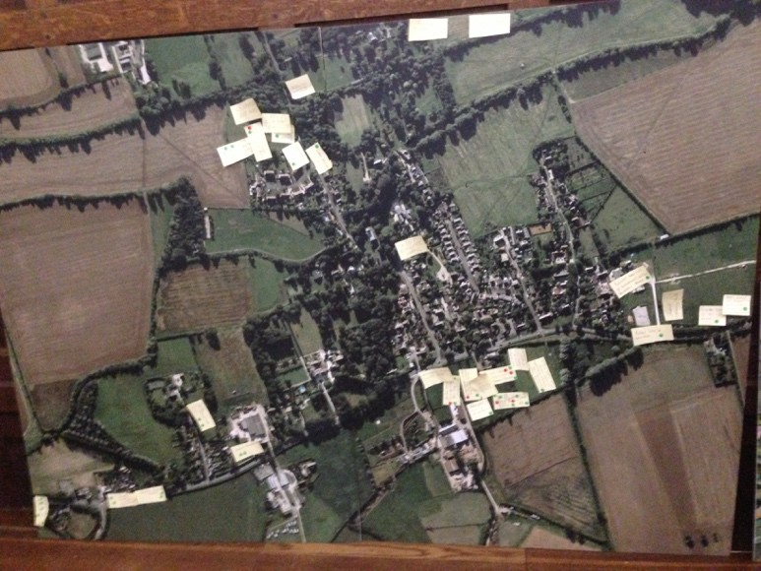
issues and potential sites for development.
The final tally of Post-it™ note suggestions and green (agreement) or red (disagreement) spot stickers recorded on the aerial map was over 70. The attendance at the meetings was between
  - people with landowners evident at the second meeting.

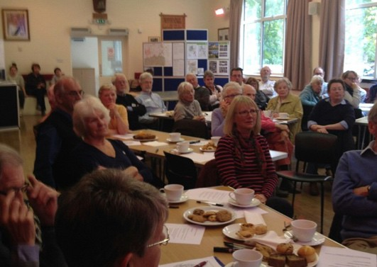
The exhibition was moved to the Church, which is open every day thus enabling people to drop in at
their leisure, read the exhibition panels and add their notes to the aerial photograph. It was displayed for three weeks.
The key points were collated and circulated to the Steering Group which met to discuss the next steps to be taken. From these key issues the preparation of the Neighbourhood Plan policies began to be drawn up.
Second Stages:
The Steering Group began to write a draft proposal of ideas that had emerged from the October meeting. They looked at various options of sites for new development.
Team leaders met with various landowners to discuss whether they were happy with their land being put forward as suggestions for new housing/village green etc.
There was a second village meeting held in February 2016 (again run twice) to display the draft proposals that had emerged from the October meetings. Villagers were given questionnaires listing all these ideas and were asked to tick or cross anything they liked/didn’t like. There were also discussion groups where people could debate issues that had been raised, and put forward further suggestions.
Meeting 2: 6th and 10th February 2016
The second Village Meeting was held on Saturday, February 6th and repeated on Wednesday, February 10th, 2016. The meetings were focused around an exhibition organised by topic.
The topics were:

Community and design | Housing
Environment and Public spaces | Traffic calming, Movement & design
Information was provided to attendees in a booklet where opinions could
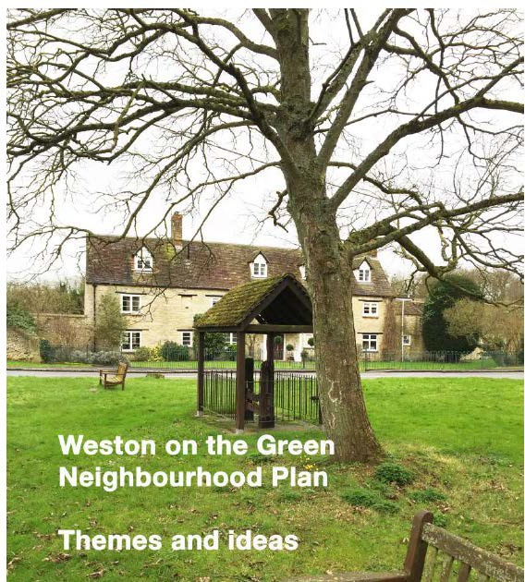
be captured on a response form. The centre of the booklet contained an aerial map of the village with numbers indicating twenty-six key items. These included proposed housing sites, a village square, new village green, site for allotments and a day nursery for children, key views to protect, the village historic boundary, public footpaths both current and needed, National Cycle Network, sites for traffic calming, preserved green spaces and lanes with original verges, the Conservation area and the Greenbelt which runs through half of the village.
Once the majority of the group had had a chance to look at the exhibition, members of the Steering Group led small group discussions. This was an opportunity to enlarge on the proposals, explain in more detail and answer questions. There was a large table with an A0 map with the proposals numbered so the public could have an overview of the village and an awareness of the impact of future development. The results of the questionnaire were tabulated and there was an overwhelming majority support for these proposals to be developed into policies.
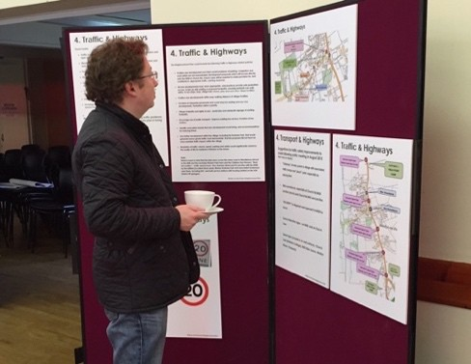
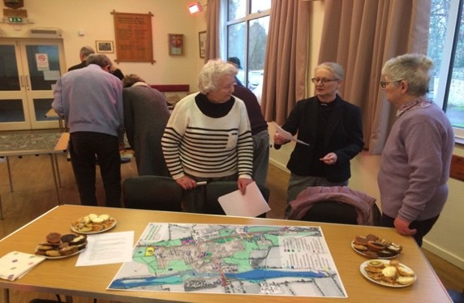

Figure A2 Consultations in Meeting 2

Third Stage
Once the returned questionnaires from the February meetings had been collated, the Steering Group began to form the first draft of the Neighbourhood Plan document. An Editorial Team, consisting of Diane

Bohm, Roger Evans, Susan Daenke, Mike Finbow, Alex Reid and Patsy Parsons, was formed. Members of the Steering Group continued to meet with stakeholders to ensure they were up-to-date with how the plan was developing.

Meeting 3: 20th September 2016
The third Village Meeting was held on Tuesday 20 September 2016 with the aim of consulting with the village on the pre-final draft of the Neighbourhood Plan .. It was a well attended and lively meeting, with over 35 villagers turning out.
The evening was a chance for villagers to hear an explanation of the contents of the final Neighbourhood Plan , how the central planning process works and how a NP fits into this; a description of the proposals put forward at the original village consultation meetings and how they were chosen and thus to discover what the Neighbourhood Plan means for the village. It was also an opportunity for any feedback to be given and questions to be asked. Diane Bohm, the Chair of the Steering Group (SG), led the presentation with support from Susan Davis and Bob Hessian.
It was agreed that the next steps would be:
- All feedback from this meeting would be considered based on the information in the Executive Summary;
- The final draft would be presented for approval to the Parish Council and then submitted to Cherwell District Council for review;
- After consideration of CDC’s comments, the Parish Council, which is the legal body for submitting the Neighbourhood Plan, would formally submit the Plan to CDC;
- It would go to the Planning body and either be agreed and comments/ suggestions made or be rejected;
- If agreed with suggested amendments, the Steering Group would make changes as advised by the CDC.
The Steering Group continued to work on amendments to the draft throughout October. In November 2016 there was a meeting with Cherwell District Council and they encouraged us to continue to look at policies on topics ranging from protection of the Conservation Area, to improved digital communication and encouragement for small

businesses, provision of allotments and recreation facilities including a new site and a biodiversity policy. Their report was thorough and it took us several months to digest and address it.
Communications: A website was created along with a Facebook page so the village could be continually updated with the process and progress of the NP. Each edition of the Village News also ran an article explaining what had happened and what the next stage of the process was.
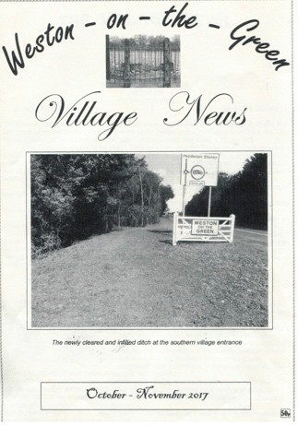
The dates of all Steering Group meetings, plus the Village Events, were advertised on the website and in the Village News and posters were put round the village before each meeting reminding people the Steering Group meetings were open to everybody and they were welcome to attend.
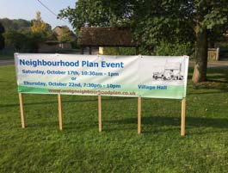
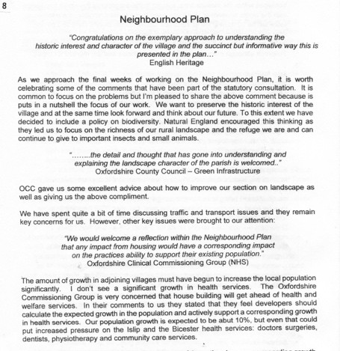
Four banners were put up in prominent positions around the village advertising each
village event, as well as leaflet drops and posters around the village.
The community engagement team was responsible for delivering two Social and

Economic surveys as well as organising three leaflet drops that reached every household and business in Weston-on-the-Green. Every Steering Group meeting was advertised in the Village News and by posters throughout the village during the week before each meeting.
To ensure that the Steering Group had the maximum number of responses to the ideas and proposals put forward at the second Village Event in February 2016, door-to-door
conversations were held so that those who hadn’t attended the event had the chance to add their voice to the responses. Once the ideas of policies and possible options had been developed, the team spoke to landowners

who would be affected and met with young mothers to discuss their concerns about traffic and access to the playground.
After the October event, people were encouraged to visit the Church and view information on the website. Before the February event, volunteers conducted a door-to-door questionnaire to try to engage the whole village with the process. Following that event the SG felt it important to reach the households who had not so far engaged in the consultation process. An email was distributed asking for volunteers to talk with neighbours; another leaflet drop was organised directing people to the website showing the results of the survey.
There was agreement to form a group to investigate: the history of the field, any protection of the field and to plan for the future of the field. Two members of the Neighbourhood Plan group, both Parish Councillors volunteered for the group. Over the next five months the Neighbourhood Plan was amended to include a deeper look at the issues of biodiversity, connection to a wildlife corridor status and use of the Schoolfield. There was consultation with Cherwell District Council who in turn consulted the Environment Agency and Thames Valley Environments Records (TVERC) in order to understand how our concerns regards the Schoolfield, plus our biodiversity statement, would affect the Strategic Environmental Assessment Screening Option. Agreement on the wording occurred after consultation with the WF2 group.
A second village meeting occurred on January 24th, 2018 with 100-120 people present. This was an information sharing meeting regarding the research the ~WF2 group had done on the history of the Schoolfield and the present challenge of a potential housing application. Villagers were reassured that the Neighbourhood Plan had amended the plan to include a specific policy on the meadow.

Consultation has been wide and varied throughout the process of writing the Neighbourhood Plan. Writing the NP has been an iterative process and as such had asked much of the volunteers who have worked tirelessly throughout the process.

APPENDIX C

HISTORICAL CONTEXT FOR THE VILLAGE
The earliest map of the village, dated early 18th century and showing individual buildings, is in the County records office. Apart from the sequential issues of OS maps, the next most informative maps are those drawn up at the time of the sale of the village in 1918. The sale catalogue worked with two maps – one of the whole parish, showing fields, woodlands etc. and one showing the centre of the village and detailing properties in their different sale lots.
Comparison of the 1800 map with that of 1918 shows that there was very little change in the scale of the village during the 19th century. In fact when Jubilee Cottage (Church Lane) and the School House (North Lane) were built in 1887, it was reported in the local paper that these two buildings represented the only new properties built in the village ‘within living memory’. Given that this phrase usually represents about 60-80 years and also that the 1800 map so closely resembles that of 1918 it is clear that the village did not grow during the Victorian era.
From records of the Manor during the 19th century, it is fairly clear that the owners, the Norris Berties, were not in the top echelons of the landed gentry and most of the mid-19th century was characterised by an empty Manor House undergoing modernisation. The family were probably unable to spend money on property for their tenants and it is likely there wasn’t a great call for new buildings in the village anyway. In the Victorian age, many of the children of village families moved away because mechanisation was beginning to improve agriculture and reduce the number of people required in the workforce. Many men and women moved away to either Birmingham, West London or places further afield such as Australia and Canada and local women left to find work in service all over the country.
The most significant developments of the village in the 20th century was the building of Church Close and Westlands Avenue in the 1950’s and 1960’s. This provided approximately 50 bungalows and 18 semi-detached houses in a very conventional layout on land adjacent to the Ben Jonson public house and on the Bletchingdon Road. Extension of the Westlands Avenue development to Shepherd’s Close added a further six semi- detached houses in the 1970’s. These housing areas remain incongruous with the rest of the village pattern which exemplifies small incremental additions to housing over centuries, demonstrating different styles. This has built an interesting mix of housing which adds to the essential character and history of the village.
Certain areas of the village have remained undeveloped and are now valued as important open and green spaces: the wetland areas around North Lane, Gallosbrook and the Millpond, the ridge and furrow field near

the old School (the Schoolfield), the Manor moat, and areas to the west of Knowle Lane. Some of these areas are in danger of loss or damage if action is not taken to safeguard them from neglect or inappropriate development. In addition, although some commercial development of the farmland on the eastern side of the B430 has occurred, only very few dwellings are located on this side of the road. This is consistent with the historic origins of Weston-on-the-Green and its descriptive name.
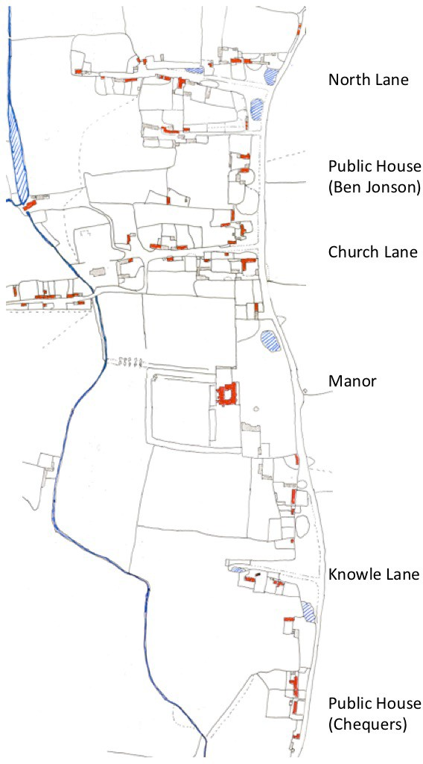

Fig A3: Weston-on-the-Green late 18th Century showing dwellings (red)

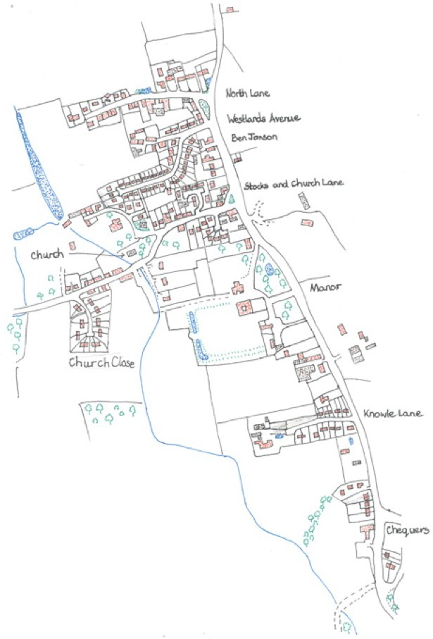
Fig A4: Weston-on-the-Green 2000

APPENDIX D
SOCIAL AND ECONOMIC PROFILE OF WESTON-ON-THE-GREEN

Current profile of the parish. Parish population:
The 2011 census showed 523 inhabitants of Weston-on-the-Green parish (recorded from 218 households).
The population of the parish represents 0.37% of the total Cherwell District population and 0.08% of the total Oxfordshire county population. The age distribution of Weston is skewed in relation to neighbouring parishes and the larger county areas with a high proportion of 60 plus residents.

 | Age structure Number of Persons
 | nursery 3-5 | 20
 | primary 5-11 | 37
 | secondary 11-18 | 41
 | University 18-25 | 25
 | working age 25-60 | 230
 | retired & 60plus | 170
Fig A5: Population numbers per age group. The median age of the parish in 2011 was 48.5 years compared with
40.5 years in 2001: the median for the UK population at large in 2011 was 40 years (ONS census data).

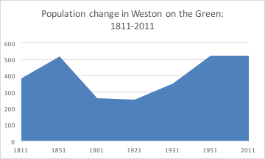
Historic population data (1811 to present) indicate that the village population has not increased significantly over 150 years, with a notable loss of residents between 1851
and 1901.

Fig A6: Population change 1811 to 2011 based on historical accounts of village occupation and census data from 1841.

This may have been a combination of low registration of births (documented in the Constables’ Book 1797-18434) and slow recovery of the population as a result of the 1914-18 war. At best, there has been an

4 The ‘Constables Book for the Parish of Weston’ is a handwritten record of public expenditure kept by a series of parish constables from 1797 to 1843. The record ceased following the County Police Act of 1839.

overall small increase in population since 1811 to date, although the population age distribution has changed significantly in that time.

The present skew in the parish towards an ageing population exaggerates the national trend in rural areas which is predicted to rise from 24% 65+ people recorded in 2013 to 29% 65+ people in 20215.
Equivalent predictors show significant expansion of the 65+ age group in Weston-on-the-Green to 2037 which could see this group exceeding 32% of the total parish population. By comparison, the 0-15 age group represented 19% of the total parish population in 2011 and is predicted to fall to 16% in 2037.

Fig A7: Age distribution for Weston-on-the-Green at 2011 and projected to 2037 (calculated using Population
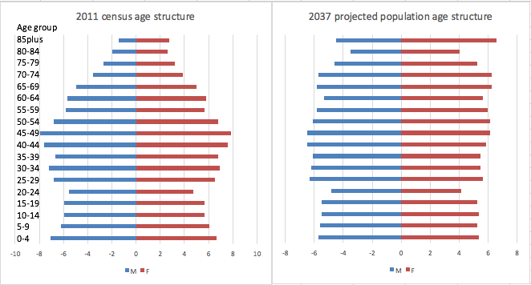
Estimates Analysis Tool released 28/4/16, Office for National Statistics).

5 2013 Rural Ageing Research Summary Report of Findings, Department for Environment Food and Rural Affairs, 2013: www.tns-bmrb.co.uk.

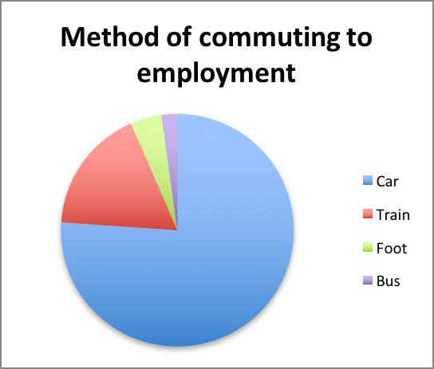
Social and economic considerations
Weston-on-the-Green has a high level of employment closely linked with work opportunities in Oxford, Bicester and London. In 2011, 71% of adult residents were in some form of economic activity, 1% were declared unemployed. Average gross incomes for the parish were in the highest category at £980 average per week or more6 with minor flanking areas in Kidlington and Bicester falling below that level.
Fig A8: Method of commuting to employment for residents of Weston-on-the-Green

The adult population in Weston-on-the-Green is therefore relatively advantaged with 40% having degree or higher qualifications, a low index of deprivation and better than average health (http://www.neighbourhood.statistics.gov.uk). However, this apparent advantaged picture can mask pockets of deprivation which may put an extra burden on community and local services.

Employment
In 2011, the census recorded a total of 324 residents (62% of the total population of the parish) in some kind of employment, of which 54% were in full-time employment, 22% in part-time employment and 24% were self- employed. In 2015, the proportions recorded (Survey 2) from village residents were largely unchanged from these with the added information that 37% of households had residents who regularly worked from home.
Weston-on-the-Green supports a number of businesses in the village. The Cherwell area 016 is rich in businesses in the Professional, Scientific and Technical sector (19%), agriculture (16%) and building /engineering (11%). Survey 1 in the parish recorded more than 90 businesses, many located at the Weston Business Park, the Manor Farm retail development and within the village. Most of these employ 0-4 people with some notable exceptions (Kel-Berg Trailers and Trucks Limited, David Beecroft Limited, Axicon Limited, The Manor Weston) each of which employs in excess of 10 people. Many businesses are situated outside the village settlement area although there are a large number of residents and small businesses working from home in the village (Figure 19).

6 Data from the Super-output area 016, of which Weston-on-the-Green is a subcategory area, 2007/2008

Of the villagers in employment, most (79%) commute from the village to their place of employment by private vehicle.
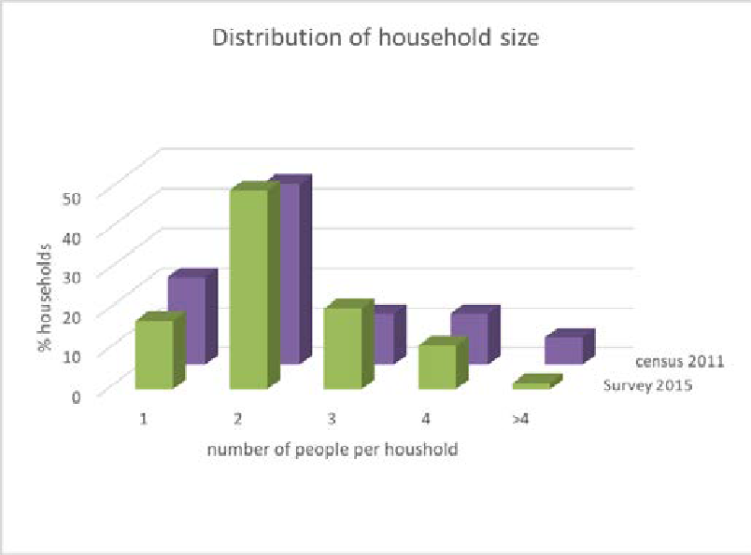
Similarly, the majority of workers employed by businesses in the parish commute from outside the parish boundary to their workplace.

Housing
Of the 218 households identified in the 2011 census in Weston-on-the-Green, a high percentage (83%) were owner-occupied.
Fig A9: Distribution of household size in Weston-on-the-Green.

The median residency period
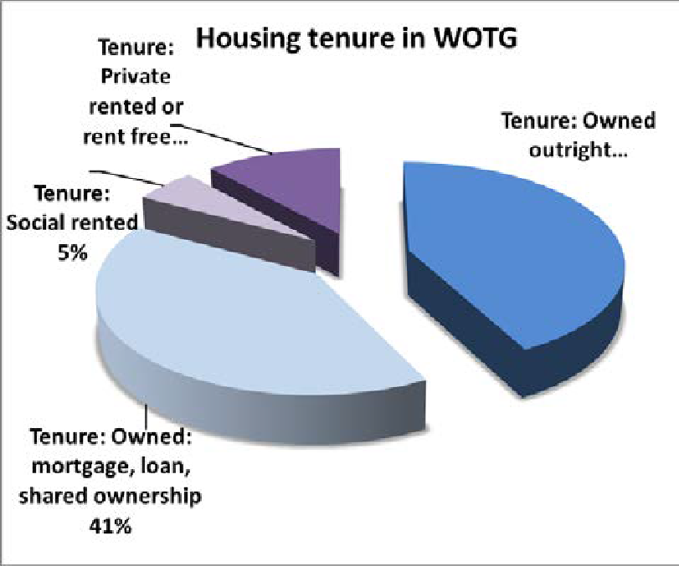
in the village is 18 years, with one resident having lived in the village for 69 years. Weston-on-the-Green therefore has a core of relatively long-term residents of which 96% are owner-occupiers. Between 76% (census 2011 data) and 82% (survey 2015) of
households had 3 or more bedrooms and most were detached.
Data collected over the last five years showed that the majority of households had two residents, despite the predominance of larger housing in the village.
Figure A9 shows consistency in this trend comparing the 2011 census data (purple) with village survey data (green) collected in 2015.
Fig A10: Ownership/rental status for housing in the village.
Rental properties were in the minority, with only 5% being shared/social rental and 10% being private rentals.

In 2011-2012, fewer than 11% of houses built in the South-East region were constructed as part of a Housing Association or Local Authority scheme, representing affordable housing at entry level. In Weston-on-the-Green, the recent development of Gallosbrook provided seven houses close to the village centre, three of which were part of a shared ownership scheme. However, 47% of residents of Weston-on-the-Green wanted new

housing to fall into one of “affordable, retirement/sheltered, shared ownership or Council/Housing Association” categories.
70% of village residents (Survey 1) agreed that more housing should be built in the village, identifying the need to attract young people to the village as being the main motivation (33% of respondents wanted young people), closely followed by the need to accommodate retirees (26% of respondents) who wish to stay in the village but may need alternative accommodation types. However, the median value of properties in the village in 2013 was £344,995, significantly above the regional median (Cherwell District) of £220,000 and local people have concerns about the affordability of housing in Weston-on-the-Green, particularly for young people and families. In particular, there are a number of young adults who were raised in the village and would like to return as homeowners, but are unable to do so because of the lack of affordable, available housing.

Fig A11: Average house prices (in £1000s) sold between 2011 and 2015 shows a rising trend from £300,000 in 2011 towards £500,000 in 2015
Overwhelmingly, given the current average price of real estate in the village and surrounding area, the need for affordable houses was highlighted in the survey responses (20% of all responses included this as a priority need). The average price of real estate in the OX25 postcode was almost £500,000 in April 2016 and despite the economic constraints of the last 7 years, has risen steadily over that time (Housing Market trends for
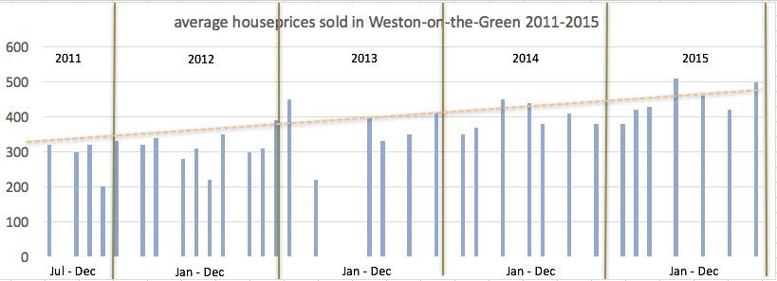
OX25). Firstly, most housing prices are beyond the means of many younger people and first-time buyers. Secondly, there is little available housing that comes to market in the village and sales tend to be quickly completed.

Nurseries and Schools
The village has one private pre-school/nursery within the parish boundary, Bear Necessities (near Wendlebury, 1.5 miles). Others are more distant:
    - Willow Cottage (Bletchingdon, 2.2. miles)

    - Chesterton Play Group (Chesterton, 3.4 miles)
The village survey of 2015 identified that, despite the low number of resident children of pre-school and school age in the village, a much larger number of children were regularly cared for/supervised in the village by grandparents or other relatives/friends. This brought into focus a need for more nursery facilities in or close to the village and other community services for young children.
Weston-on-the-Green has no school in the village. The original school, founded in 1855, closed in 1984. Children in the village are served by five primary schools within a radius of 5.5miles from the village centre:
    - Chesterton VA C of E: 3.4 miles
    - Kirtlington VA C of E: 4.9 miles
    - Bletchingdon Parochial VA C of E: 2.5 miles
    - Dr South’s VA C of E, Islip: 4 miles
    - Heyford Park Free School: 5.5 miles
Three of these schools are full to quota or oversubscribed for 2016 and two (Bletchingdon and Heyford Park) are filling rapidly. Children attending secondary schools and sixth form colleges travel further afield to Bicester, Woodstock, Heyford Park, Oxford, Banbury, Abingdon, Witney and Headington. Compared with the national average, a higher proportion of children from the village attend independent schools. There are currently no plans to build a school in the village.
Community facilities and services
Weston-on-the-Green has a lively social life and the available facilities are well used. The village survey provided an indicator of the use and popularity with residents. Many residents use the village shop/post office on a daily basis and there was a clear emphasis on the importance of maintaining this service for the village. The Memorial Village Hall, which is run as a charity governed by a Board of Trustees, also provides facilities that support activities for both the village and external users.
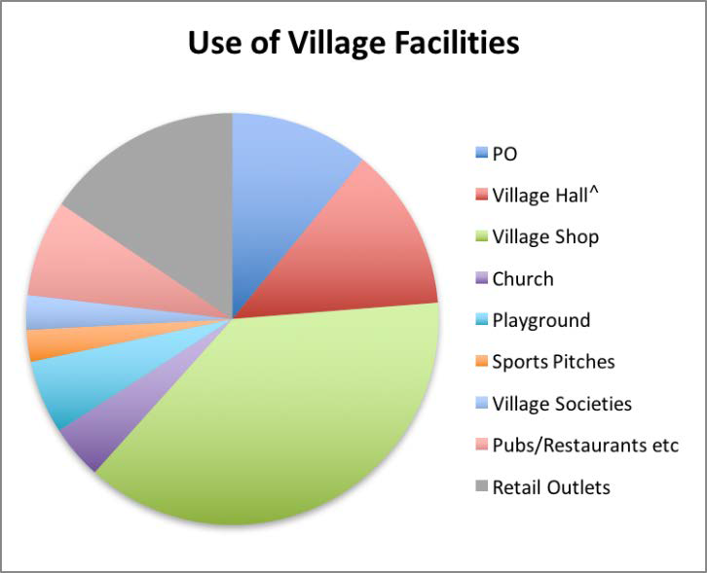
Frequent users from the village are the Women’s Institute, Parish Council, Garden Club, Weston Walkers, Weston Society, Painting and Art group, and various fitness groups. In all, the Memorial Village Hall recorded more than 2000 local users in 2015 with a further 1000 external users from commercial bookings.

Fig A12: Use of village facilities as captured in the Neighbourhood Plan survey 1.

The playing field and playground are the main space for recreation on the community green. Situated on the edge of the historic heart of the village, it is poorly connected to the rest of the village, relying on the main Bletchingdon road as the primary access route from elsewhere. The road has no verge or footpath and is a serious barrier for users of the playing field and playground as children and families find access difficult and dangerous.
At the heart of the village is the Church of St Mary the Virgin in the Akeman Benefice, which is still well attended. The Church bells have recently been restored and a new bell-ringing group has convened. The village has actively supported the upkeep and improvement of the Church for many years and is looking at supporting some secular activities in the Church.
Informal social life focuses on the two public houses and the Milk Shed, a popular café and ice cream parlour on Manor Farm.
Although a small village, Weston makes the most of its limited community services and facilities. The recent village surveys conducted as part of the Neighbourhood Plan consultation identified the significant number of residents who undertake at least some regular work from home. This has been largely unrecognised until now, and brings into focus areas where community facilities can be upgraded to support this economic activity and help to rebuild vibrancy in the village.
Weston has strong links to surrounding villages and facilities in Oxford and Bicester. The parish is keen to protect its historic assets (e.g. the moat, the village ponds, the broad grass verges, the spinney and nature trail, the footpath network and the scheduled SSSIs) from unsympathetic development.

Transport and highway considerations
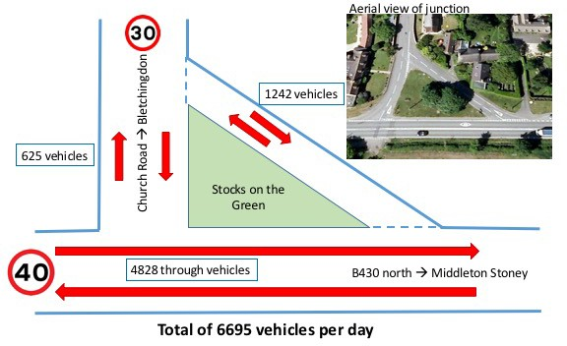
Primary access to the village is via the B430 on a north/south axis. There is a secondary route to the village from the Bletchingdon Road using Church Lane and Church Road to join the B430.
Fig A13: Traffic volume recorded in one day of April 2016 (school holiday period).

The B430 is subject to high traffic volumes often at speeds above the 40 mph limit currently in force. Traffic surveys have been undertaken in the last five years to monitor traffic volume and speed.
Survey 1, 2011: Speed survey B430
Survey 2, 2015: Vehicle volume B430 and Church Road
Survey 3, 2016: Vehicle volume and speed, B430 and Church Road

A survey undertaken in April 2016 recorded more than 6,500 vehicles per day using the B430, including over 200 lorries and HGVs. There is a weight restriction on the south flyover access to the A34 which is poorly observed. High traffic volumes were also observed on the partly single lane width Church Road/Church Lane route (more than 1750 vehicles per day) again often at speeds in excess of the 30 mph limit. At peak periods, over 150 vehicles per hour use this narrow lane to avoid congestion on the A34.
B430/Church
Lane turns
B430 B430
northbound Southbound
Vehicle type

Car | 2232 | 1511 | 1577
Motorcycle | 19 | 21 | 13
Light van | 166 | 128 | 109
Large van | 267 | 172 | 124
Lorry | 65 | 52 | 29
HGV/articulated  lorry | 151 | 21 | 5
Bus/coach | 10 | 8 | 1
Farm vehicle | 3 | 2 | 9
Totals | 2913 | 1915 | 1867

Fig A14: Number of vehicles recorded in a 14 hr period (0500-1900) April 2015
A vehicle speed survey undertaken in 2011 showed that 33% of vehicles exceeded the 30mph limit between 07.00 and 09.00 during the morning peak period; 64% exceed the speed limit between 09.00 and 16.00 and 42% exceed the speed limit between 16.00 and 19.00 during the evening peak.
Speed more than 30mph
Speed less than 30mph
2011 (9am-4pm) 2011 (4-7pm) 2016 (24hr period)
2011 (7-9am)
100%
90%
80%
70%
60%
50%
40%
30%
20%
10%
0%
Speed survey data 2011 and 2016

Fig A15: Recorded speed groups of vehicles using Church Road during the time periods shown (Surveys 1 and 3)

Noise is a significant factor at peak commuter times due to the traffic volumes, and the noise of heavy vehicles travelling through the village at night is particularly disruptive for residences close to the B430. The junction

of the B430 with the Bletchingdon Road creates an element of hazard for commuters as well as pedestrians as the road layout here is confusing for users. The lack of pavements on Church Road/Lane restrict the ability to safely access the village shop, Hall, Church and the playing field which are the “core” of the village.
There are no pedestrian crossing points on the B430 that would allow easy access from the residential part of the village to the west of the B430 to the businesses and facilities to the east, even though the Milk Shed café is well used by villagers and accessed regularly by foot. The sweeping curve of the B430 and the 40mph speed restriction make vehicular access from the side streets a cause for concern.
Public transport is almost non-existent. The only bus service through the village was discontinued in July 2016. There is therefore a high reliance on cars for employment commuting and daily activities such as shopping and attending appointments (e.g. doctor, dentist etc).
The public footpaths and bicycle paths lack co-ordination to allow access through and around the village.

APPENDIX E
COMMUNITY SURVEY DATA (see Figure 3 of the Plan)

Survey 1a – Basic householder profile: Householder responses
The village survey conducted in October 2015 sought to establish key drivers for identifying the type of housing and facilities that residents felt were important for the future. The identification of valued facilities helped to prioritise new housing sites in the village. The survey responses were collated; volunteers helped with personal visits to residents where necessary.

Neighbourhood Planning – WG S&E survey questionnaire – 31/07/15

People:
    - age profile:
      - which age range do you belong to? <21; 22-39; 40-59; 60-74; 75+
      - how many people are in your household?
        - Will this number change: in 5 years; 10 years; >10 years?
    - How long have you lived in the village?

Housing:
    - Households:
      - What type of dwelling do you live in?: detached, semi detached/terraced, flat/maisonette, bungalow, caravan/mobile home/temp structure/ other
      - How many bedrooms: bedsit/1, 2,3,4 or more
      - Housing tenure: is your dwelling owner occupied; housing association/council rent; private rent; 2nd home + duration of residence/ tied to employment
      - Unoccupied housing (this is probably not for the questionnaire but we need to know the number in the village (if any))
    - Suitability of your housing:
      - Is your home: Too small; too large
        - What features affect your answer above: garden/ stairs/access/repair/upkeep/parking/ other
      - Ideally would you like to: remain in own home; move to other premises?
      - What assistance would you require to remain in your home: home repair/handyman, adaptation (eg stairlift, disabled access), equity release, sheltered support
      - In selecting a new home to move to, what are the important factors in selection
        - Single level living
        - Purchase/rental cost of property
        - Running costs
        - Public transport
        - Close to support services: health facilities, post office, bank, other
        - close to schools/nursery
        - close to shops/leisure facilities
        - close to centre of village (church and social focus)
        - close to countryside
        - close to friends and family
    - Is there a need for more housing in the Parish?
      - Yes – in 5 yrs/ >5 yrs; No

      - What reasons are there for new housing? (how do we write this to get 1) personal reasons that relate to their own circumstance and 2) general reasons that might relate to others coming to the village e.g. a younger population):
        - Family members wishing to move back to village
        - Living with parents
        - Family expanding
        - Retirement/downsizing/equity release/lower cost
        - Health issues/support needed
        - Closer to amenities
    - Affordability:
      - Annual incomes of those with village housing need:
        - < 10Kpa; 10-25K; 25-40K; >40K (how does this align with housing association shared ownership rules)
    - What kind of new housing do you think should be built in the village:
      - Affordable housing (definition?)
      - Open market development
        - What type of development (flats, terrace/semi det, 1-2 bed, 2-3 bed, 3-4 bed, 5-6 bed, detached, bungalows, courtyard development (shared areas)
  - Shared ownership schemes
  - Council and/or Housing Association housing

Business in the Parish:
    - Do you work in a business within the village?
      - Do you work from home (all the time/part of the time)
      - If you are an owner/manager of a business, how many people do you employ at this location (how many from the village?)
8.2.1. | 1
8.2.2. | 2-5
8.2.3. | 6-10
8.2.4. | 10+
8.3. | Are there any facilities that would make working from Weston
better? (e.g. availability of meeting rooms, shared facilities, faster broadband)
  - If you travel to work, what is the distance of your commute?
    - Within the Village/Parish
    - Oxford/Oxfordshire
    - London
    - Elsewhere
  - How do you travel to work
    - Car
    - Bus
    - Train

8.5.4. cycle

Use of Village and neighbouring amenities
- Do you have nursery and school-age children in your household?
  - Number of children (and ages)?
  - Do you use a nursery in the Parish?
  - Other nursery facilities used – distance from home?
  - Which schools do your children attend – distance from home?
    - How do your children travel to school: bus; car; bicycle; other?
- Users of Village facilities: -how often do you use:
  - Post office
  - Village Hall
  - Village Shop
  - Church
  - Playground
  - Sports pitches
  - Village societies
  - Pubs and restaurants
  - Retail outlets (e.g. Godwins Farm)
- Which existing village amenities do you most value (e.g. 1=unimportant to me; 5 = essential)
  - Post office
  - Village hall
  - Village shop
  - Church
  - Playground
  - Sports pitches
  - Village societies
  - Pubs and restaurants
12. Are there other or better amenities which you would like to see in the village(e.g. nursery school, community meeting rooms, improved bus service etc)

Survey1b- feedback on current village profile: Householder responses

How many people are in your household?
Count of Replies | 65
Average | 2.28
Median | 2
Household Size:
Single Person | 12

2 People | 32
3 People | 11
4 People | 7
5 People | 1

How many residents of your household are in the age range:
Age | <18 |  | 18-24 | 25-65 | >65
1 per household | 5 | 3 | 12 |  | 16
2 per household | 6 | 1 | 21 |  | 23
3 per household |  |  | 3

How long have you lived in the Village (years)?
Average 21.22
Min moved this year
Max 69 years

What type of dwelling do you live in?
Dwelling Style | Count
Detached | 35
Semi/Terrace | 22
Flat | 0
Bungalow | 14

How many bedrooms in your dwelling?
Bedrooms | Count
1 Bedroom | 2
2 Bedrooms | 10
3 Bedrooms | 24
4 Bedrooms | 31

Housing Tenure:
Owner Occupied | 68
Housing association | 2
Private Rent | 1

Is your home:
Too Small | 1
Too Large | 4
Right Size | 57

Factors affecting home size reply:

Garden | 6
Stairs | 1
Access | 1
Repairs/upkeep | 1
Parking | 1
Other | 3

Ideally, would you like to move to other premises in the next 10 years?
Yes 13

What assistance would you require to stay in your home?
None | 50
Home Repair/Handyman | 8
Adaptations | 3
Care support | 7

In selecting a new home to move to, what are the important factors?

Single Level Living | 16
Cost of Property | 26
Running/Repair costs | 21
Public Transport | 30
Close to: Support Services | 23
School | 9
Shops/Leisure | 31
Village centre | 29
Countryside | 35
Family and friends | 25
Do you think there is a need for more housing in the Parish?
Yes - in 5 years | 32
Yes - in over 5 years | 15
No | 21

What reasons are there for new housing?
Proximity to family | 15
Young families moving to the village | 38
Family expanding | 7
Retirement/downsizing/equity release/lower cost | 31

Health issues/support needed | 7
More single occupancy | 14
Other | 3

What kind of new housing do you think should be built in the village?
Affordable housing | 43
Flats | 6
Terrace/semi detached | 20
1-2 bed | 31
2-4 bed | 31
5+ bed | 5
Detached | 15
Bungalow | 23
Retirement/sheltered housing | 32
Shared ownership schemes | 22
Council/Housing Association | 19

Are you employed at present?
Employed | Full time | 32
 | Part time | 14
Self Employed | Full time | 8
 | Part time | 9
Student |  | 4
Other | (sometimes "retired" | 39
pencilled in)

How often do you use the Village facilities?
Daily Weekly

Monthly

Rarely

Never
Post Office | 20 | 20 | 13 | 15 | 3
Memorial Village Hall | 6 | 23 | 36 | 6 | 0
Village Shop | 21 | 19 | 5 | 8 | 20
Church | 14 | 35 | 13 | 10 | 0
Playground | 32 | 23 | 3 | 6 | 2
Sports pitches | 50 | 12 | 0 | 2 | 1
Village Societies | 15 | 22 | 32 | 1 | 0
Pubs Restaurants etc. | 1 | 33 | 27 | 6 | 2
Village Retail | 0 | 17 | 25 | 28 | 3

Are there other or better facilities which you would like to see in the village?
Schools | 19
Community meeting rooms | 7
Other educational services | 13
Better connectivity (broadband, mobile signal) | 51
Allotments | 30
"Other" Suggestions for improvements:
Group for Pre-school Street Light, Vet
Traffic Calming Bus Service Hourly
Better Public Transport Bus
Tennis, Bowling

B: Survey feedback on current village profile: Business Related Results. How many people do you employ at this location, and do they reside in the parish?
Number of Residing in Parish Employees
1 3 1

2-5 | 4 | 2
6-10 | 1
10+ | 1

Are there any facilities that would make working from Weston better for your business?
Facilities
Availability of Meeting rooms | 1
Shared Facilities | 1
Faster Broadband | 7
Better Mobile Connectivity | 5
Better Visitor/staff Access | 1
Other | 1

How do your employees travel to work?
Car | 26
Bus
Train
Cycle | 2
Foot | 4

Number of employees and distance travelled:
Number Employees |  | Distance
Within the  Village/parish | 2 | 0
Oxfordshire | 28 | Ave 10 miles
London | 0 | 0
Elsewhere | 2 | 30

Survey outcomes:
- A total of 77 survey responses were received out of 218 households which had the opportunity to make a return (35.3% of total) and including 73 total attendees of the two village meetings held on Feb. 6th and 10th 2016.
- The survey questions were based on the inputs from villagers who attended the meetings of Oct 17th and 22nd 2015 and were designed to collect more in-depth views on focused issues.
- Outcomes for each section of the survey are summarised as the percentage of votes for or against each idea put forward.
The results to the sections of the survey were as follows:
Community & Economy

Ideas:
- Create a village square between St. Mary’s Church and the Memorial Village Hall
- Improve mobile phone reception, Wi-Fi hot spot at village square
- Promote a pop-up café on the square
- Upgrade the Memorial Village Hall and add a conference room and an auxiliary room
- Retain village shop and post office in its current location
- Retain some of the non-residential building stock to accommodate community businesses (e.g. A3 use class: restaurant / café)
- Identify a site for a nursery school within a 10-minute walk of 80% of homes
- Investigate the demand for allotments and possible provision

Results:
Abstain
Against For
100%
80%
60%
40%
20%
0%
Community & Economy

Housing Ideas
V. Square
Hot Spot
Café
Upgrade VH
Shop & PO
Businesses
Nursery
Allotments
    - Priority for young people, families and elderly long-term villagers wanting to down-size
    - Maintain settlement pattern of winding lanes to the west of B430
    - Work with land-owners willing to offer sites for affordable housing, self-build and custom-build
    - Sites identified for small clusters of housing – see Proposals Plan exhibition panel
    - Produce a general Design Code for new developments in the village – see Design exhibition panel
    - Produce Site Development Briefs for each potential site to guide development

Open Skies
Countryside
R&F Fie d
Green Spaces
Verges
Water Courses
Dark Skies
l

Results:
Abstain Against
For
100%
80%
60%
40%
20%
0%
Housing

Environment & Public Spaces Ideas
Younger
Lanes
Landowners
Clusters
Design Code
Site Briefs
    - Retain the open nature and big skies east of the B430
    - Retain the countryside setting to the north of North Lane
    - Retain the ridge and furrow field
    - Identify the remaining green spaces in the village that should not be built on
– see Proposals Plan exhibition panel
    - Protect broad verges: aim for off-road and off-verge parking where possible
    - Protect ancient water courses
    - Preserve dark skies and tranquillity

Results
Abstain
Against For
100%
80%
60%
40%
20%
0%
Environment & Public Spaces

Traffic Calming & Movement Ideas:
B43
30mph
Control@Church…
CL Pedestrian…
Home Zones
CL/MS Crossing
Public rights of way
Bus Stops
0@
    - Reduce the speed limit on the B430 to 30mph by agreement with Oxfordshire County Council
    - Create a traffic-calming feature at the northern and western entrances to the village (B430 and Church Lane)
    - A special scheme in Church Lane to be designed to ensure pedestrian safety between the post office and the play ground
    - Establish ‘Home Zones’ on all other streets within the village, with a 20mph speed limit and priority for pedestrians (requires agreement with the County Council)
    - Provide pedestrian crossings giving access to the east side of the B430 both at the junction with Church Road and at the Milk Shed
      - Establish new public rights of way to improve the pedestrian network
      - Create new bus stops and shelters on the B430, close to Chequers, for an hourly Stagecoach S5 (Bicester / Oxford) service.

Results:
Abstain
Against For
0%
10%
20%
30%
40%
50%
60%
70%
80%
90%
100%
Traffic Calming & Movement

Design Ideas:
    - Produce a general Design Code (Appendix E) to ensure developers design housing that is compatible with the existing village.

Results:

Design Code Site Briefs
Abstain
Against For
100%
80%
60%
40%
20%
0%
Design

APPENDIX F
SITE APPRAISAL FOR HOUSING DEVELOPMENT AND ENVIRONMENTAL STATEMENT –
This section shows the sites in the CDC Housing and Economic Land Availability Assessment (HELAA) 2018. In the left column, the overall assessment by CDC is stated; the site description relates to the map below; the right column records the assessment in the context of this Neighbourhood Plan objectives and policies.

Sites considered for housing development (maps reproduced from the HELAA 2018: © Crown Copyright and database right 2017. Ordnance Survey 100018504)

Sites identified in the HELAA 2018 | Site description | Reason for non-allocation under this Plan
HELAA 228  OVERALL ASSESSMENT: NOT SUITABLE | Land to the east of B430, part of Weston  Grounds Farm | The site is located to the east of the B430 and has poor connectivity to the village. The site provides a valuable open rural vista to the east. It is contrary to Objective O5 (Transport) and Policies E1, E2, H5 of the Neighbourhood Plan.
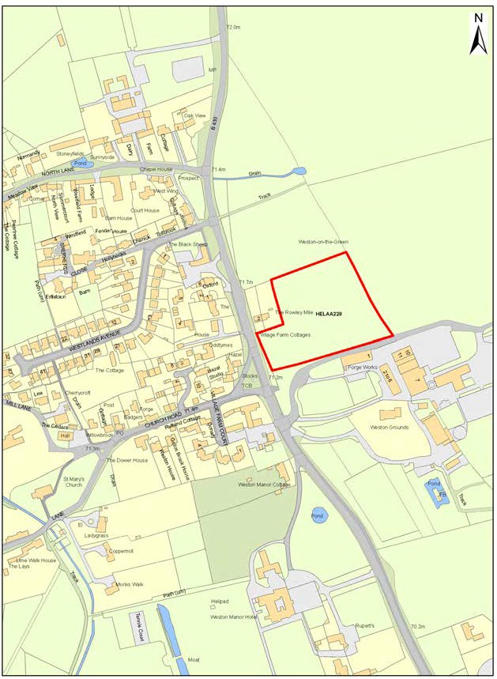

HELAA 229  OVERALL ASSESSMENT: SUITABLE, AVAILABLE AND ACHIEVABLE | Land at Fir Tree Farm and North of The Knowle, Weston on the Green | This site is centrally located for access to the village core and is currently used for agricultural and business purposes. The site lies within the Green Belt and would need to satisfy the requirements of an exceptional site in order to be considered for development. This site would be supported for development by the Parish Council if it could meet planning conditions.
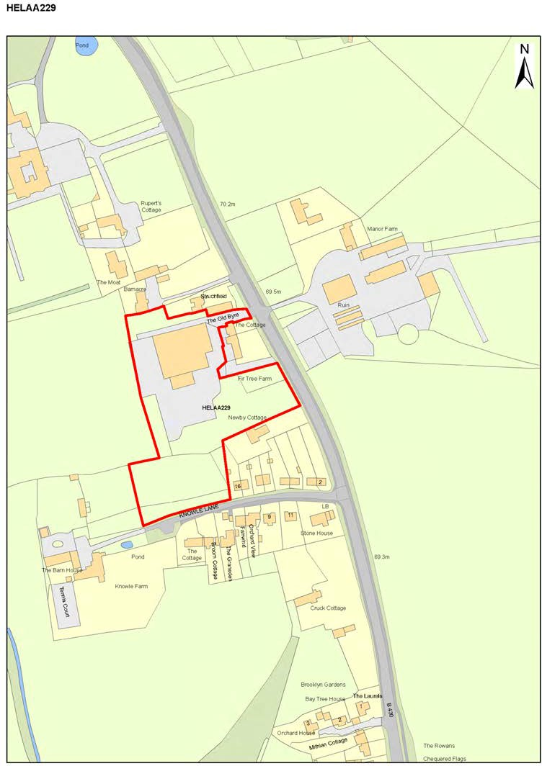

HELAA 230  OVERALL ASSESSMENT: NOT SUITABLE | Land at Weston on the Green, Weston on  the Green | Land on the eastern side of the B430 with poor connectivity to the village. The site extends over the site of the original Green and provides valued views to the east from the village boundary. It is contrary to Policies E1, E2, H5 of the Neighbourhood Plan.
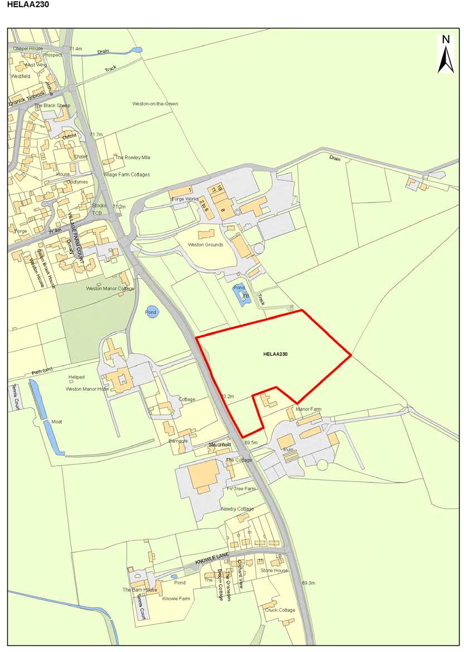

HELAA 231  OVERALL ASSESSMENT: NOT SUITABLE | Field known as Baby Ben, adjoining Northampton Road | This site lies to the east of the B430 and is subject to flooding. Access from the site is on a bend in the road where the carriageway is already narrowed. It is contrary to Objective O5 (Transport) and Policies E1, E2, H5 of the Neighbourhood Plan.
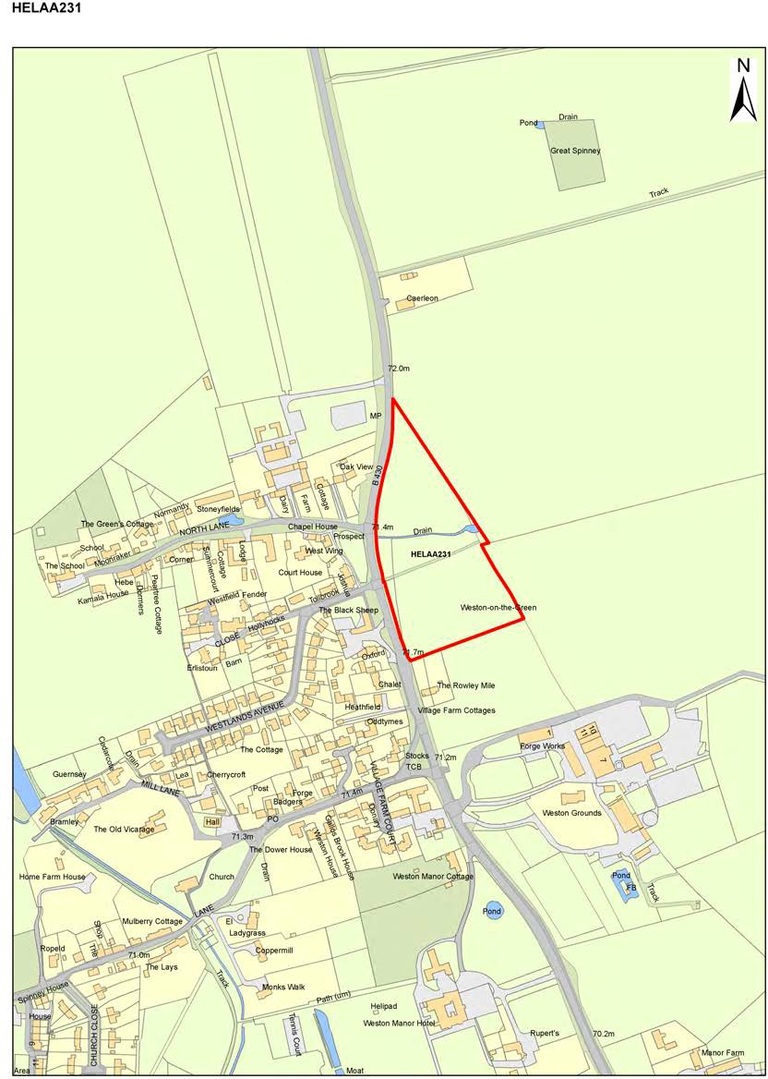

HELAA 232  OVERALL ASSESSMENT: NOT SUITABLE | Land adjoining Caerleon, Northampton Road | This site lies immediately adjacent to PR82 to the east of the B430. Access from the site is on a bend in the road where the carriageway is already narrowed. It is contrary to Objective O5 (Transport) and Policies E1, E2 and H5 of the Neighbourhood Plan.
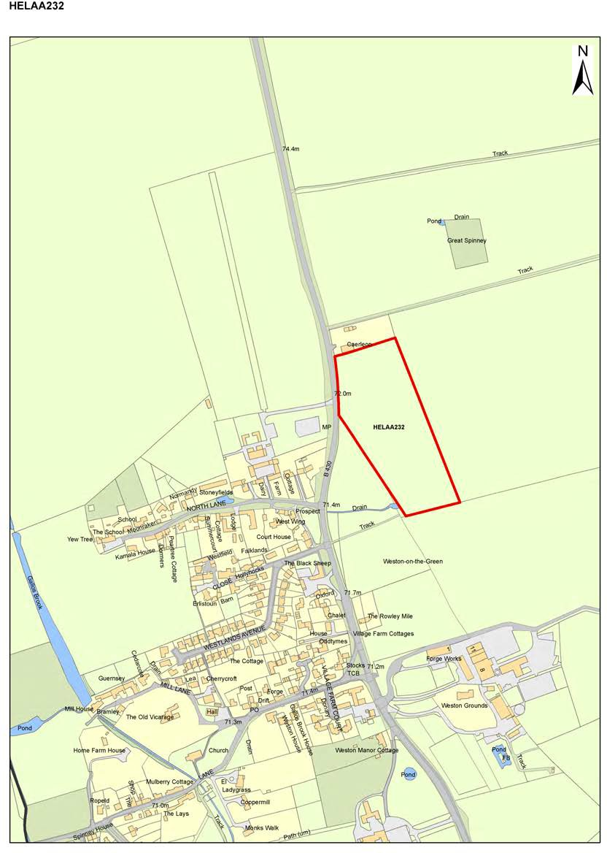

HELAA 233  OVERALL ASSESSMENT: NOT SUITABLE | Land opposite Staplehurst Farm, Church Road | This site is outside the Parish Boundary and therefore not applicable to this Plan. However, since it has immediate adjacency to Weston-on-the-Green on the Bletchingdon Road, concerns about access onto the very narrow and already busy single track lane through the village have been raised. The lack of public transport to the village compromises a development of this size where it would increase private car use and numbers (car journeys and parking).
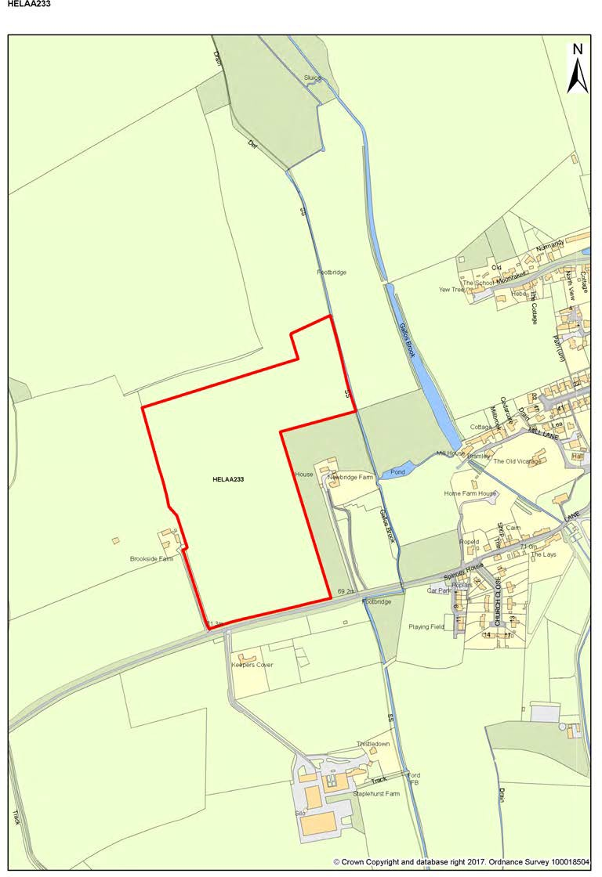

HELAA 234  OVERALL ASSESSMENT: NOT SUITABLE | Land east of B430  opposite Weston Manor | Greenfield site outside the built-up limits. Weston on the Green is a Category A village in the adopted Local Plan Part 1, the category of the most sustainable villages in the district. The adopted Local Plan makes provision for some development (10 or more homes and small scale employment) at Category A villages. The site overlaps with HELAA230 - see separate assessment. It is contrary  to Policies E1, E2, H5 of the Neighbourhood Plan.
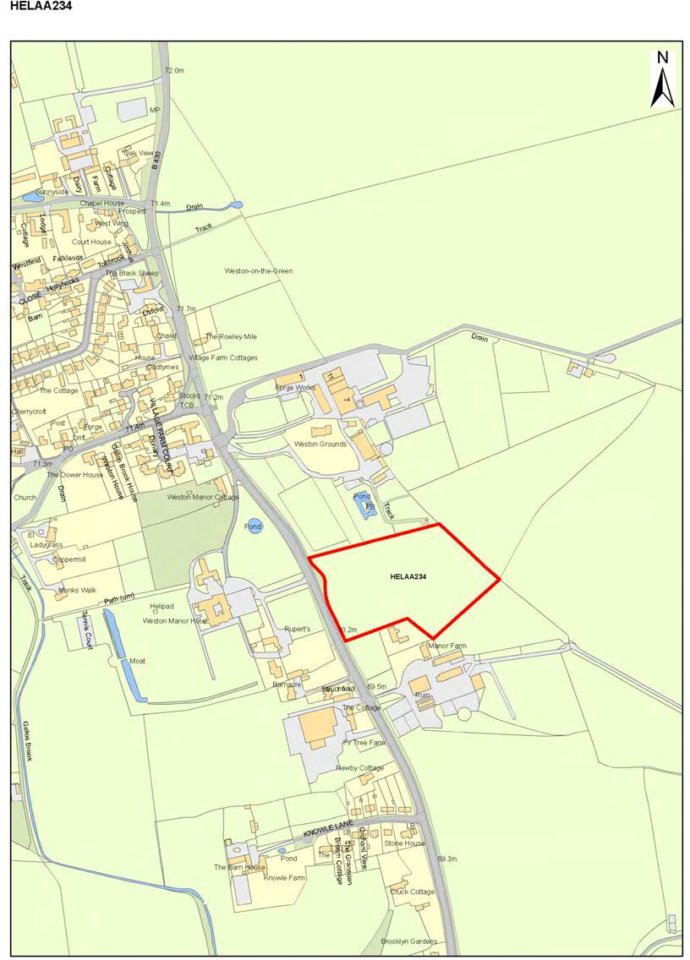

HELAA 235  OVERALL ASSESSMENT: NOT SUITABLE | Land near the B430, Weston on the Green | This land lies immediately adjacent to the A34 and is contained within the flyover and slip roads making the junction between the B430 and the A34. It is contrary to Objective O5 (Transport) and Policies E1, E2, H5 of the Neighbourhood Plan.
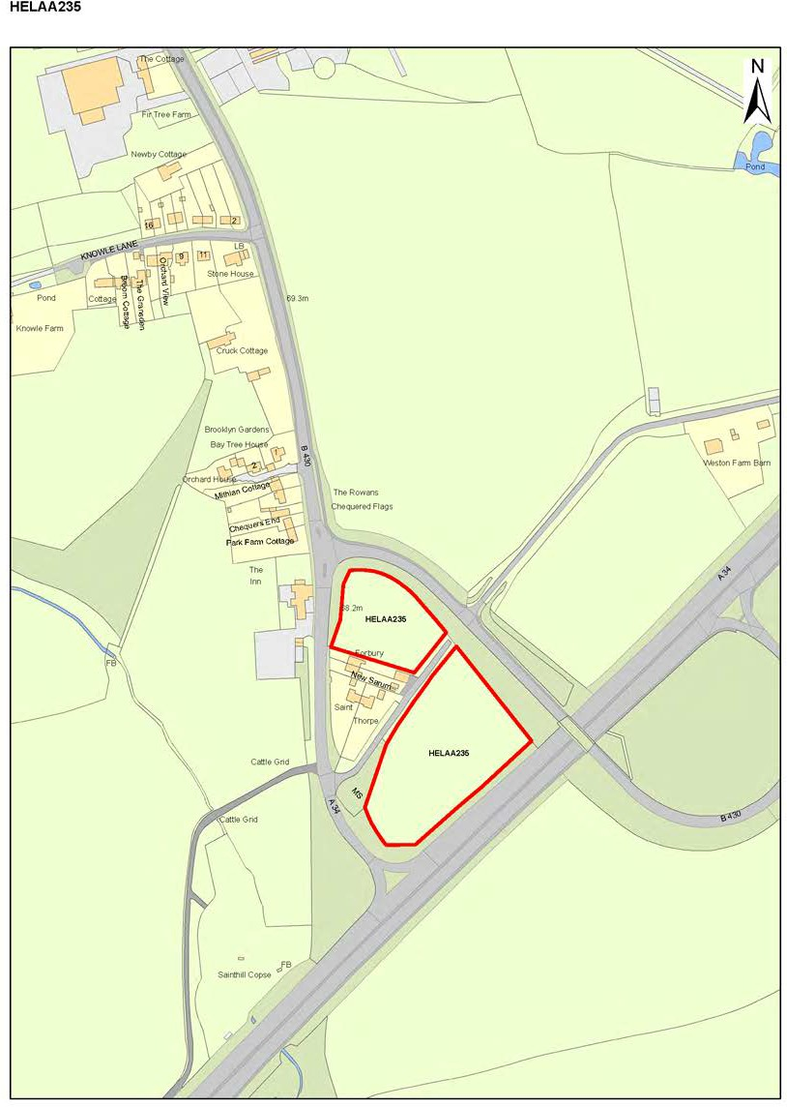

HELAA 236  OVERALL ASSESSMENT: NOT SUITABLE | Land to the Rear of Kelberg Trailers, | This site is well outside the ‘village confines’ and would be isolated from the village by way of pedestrian or cycle routes.  Development of this site would be unsustainable on transport grounds. It is also adjacent to land which has evidence of bronze age settlement and SSSI designated areas (along Gallosbrook). Development would produce a satellite estate in a region of the Parish which currently is confined to business, light industrial and RAF activities. It is contrary to Policy H5 of the Neighbourhood Plan.
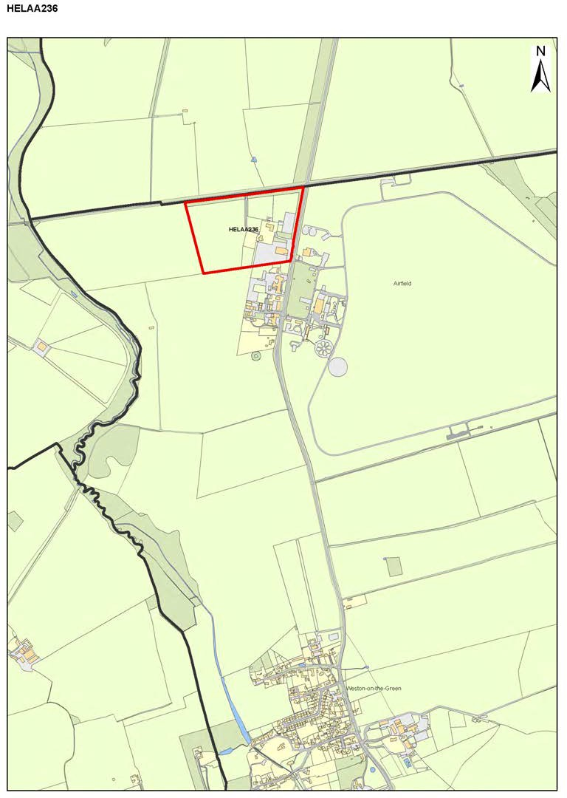

Site A: Southfield Farm – see Neighbourhood Plan Policy H1. This site is HELAA 284 and has permission for 20 houses.
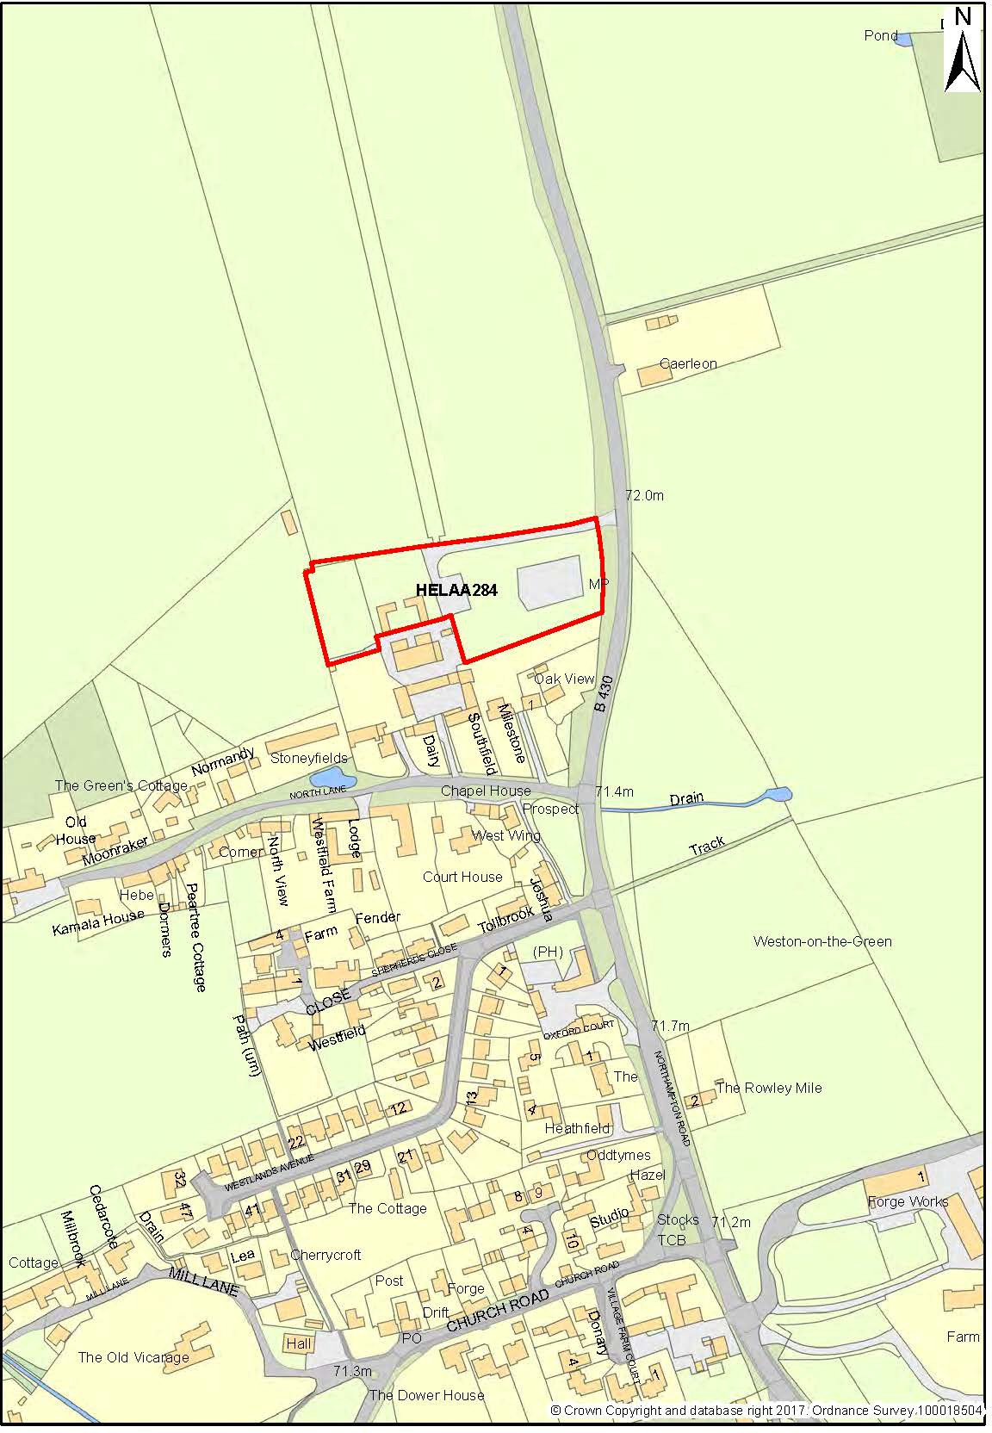

Communal space for recreation – the present case

Weston-on-the-Green, while being set in a rural landscape, has very little open land available for community use. For 13 years, the Parish Council has leased land from the Duchy of Cornwall to use as a playing field and part of this area has been established as a playground for young children. Management of the land is in partnership with the Duchy and in 2012 part of the land was sold by the Duchy for affordable housing and the area available for recreation was reduced.
The playing field lies on the edge of the village to the south of the Bletchingdon Road. A section of the playing field is fenced off as a car parking area, and another section is reserved for a playground area. This space is useful for organised events.
Other communal areas include the village green on which the stocks are located, and the village duck pond on North Lane and the pond by the Oak Tree. The Memorial Village Hall, which provides valuable indoor recreational resources, has little outside land which can be used even for small events.
Each of these available communal areas are small and distributed around the village, so there is no single site that can accommodate all recreational needs of village residents, nor a tranquil space that embodies the beauty and value of our rural heritage and in part reinstates the properties of the Weston village green which was lost to the village sometime during the enclosure period.
A valuable part of village life is the appreciation of the open spaces conferred by the rural countryside. One of the objectives stated in the Neighbourhood Plan is to attract new families to the village to ensure its sustainability for the future. The village is well served by public footpaths, however, accessible community open space is limited. An important objective of the Neighbourhood Plan is to provide amenity space which is accessible without the use of a car.
Currently, to get children to nurseries, schools and recreational activities outside the village with no public transport solutions to/from the village means using private car transport, which is contrary to the objectives of sustainability in the NPPF and the adopted Cherwell Local Plan.
Communal space for recreation – future plan

The Neighbourhood Plan identified a number of aspirations (see A2, A17, A18, A21, A28 in section 4 of the Plan) to improve community facilities, including access to open spaces for unstructured recreation and passive appreciation of the countryside setting. This need is in addition to retaining the existing playing field which will continue to provide structured facilities for games and events.
Key to identifying a suitable site was good access routes in the village via public footpaths and roads with footways so that the space or spaces could be reached safely on foot.

The aspirations aim for the preservation and enhancement of quality green space which has a positive impact on the village environment. Green or open space can provide tangible social benefits such as promoting healthier lifestyles and encouraging social interaction within a community. As well as the recreational benefits, green spaces also provide opportunities to preserve, reclaim and enhance biodiversity, and help alleviate and mitigate against flooding. It provides opportunities for learning and appreciation of the natural world, especially for children, and a chance to understand some of the history and heritage of their village. The social function of the Schoolfield has been diminished over the last 20 years and it is intended to reclaim that use compatible with the maintenance of a lowland meadow. The Neighbourhood Plan policies recognise the value that green spaces have on the lives of people in the village (see Appendices F & G) and propose the designation of Area B as a green space dedicated to this purpose.

The Parish Council’s Aspirations in terms of The Schoolfield

Area B (The Schoolfield) will be preserved and managed as a grassland habitat with access for passive recreational open space commensurate with the maintenance of a lowland meadow. The site will be carefully managed to enhance natural grassland and wildlife biodiversity (see also policy E2).

Area B shown on the map below is an area of 4 hectares. It lies within the Weston-on-the-Green Conservation area but is outside the Green Belt. It was originally part of Westfield Farm which also included houses and cottages (some of which are Grade II listed) on North Lane and the area now known as Shepherds Close. There is pedestrian access to the site through North Lane (two public footpaths with access from North Lane cross the site), Shepherds Close and Westlands Avenue (the Oxfordshire Way footpath crosses The Schoolfield south to north providing the route from Weston to Kirtlington).
This land was evaluated in the Cherwell District Council Strategic Housing Land Availability Assessment Report of 2013 (site WG010) and considered unsuitable for housing development, stating: “The Conservation Area Appraisal highlights the importance of this parcel of land in providing views into the Conservation area and providing an interface with the surrounding lowland landscape that gives the wider area its distinctive character. Although the site is well related to the village it is an important open space in establishing the setting of the Conservation Area and in providing for recreation (the public footpaths which cross the site are well used).” The site was not included in the HELAA 2018.

Area B: The Schoolfield –
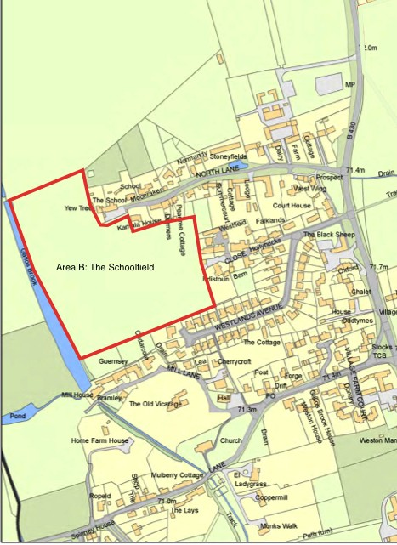
© Crown Copyright and database right 2017. Ordnance Survey 100018504

Area B has been in private ownership for many years and was managed as grazing land for horses and more recently cattle and sheep. The land has not been ploughed or cultivated in living memory and still bears a striking ridge and furrow pattern.
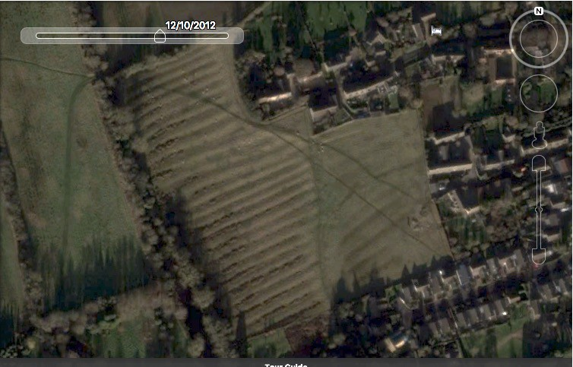
The Schoolfield (Area B) in 2012 showing marked ridge and furrow pattern (GoogleGB Camera 676m; 51o51’55oN, 1o13’43oW)
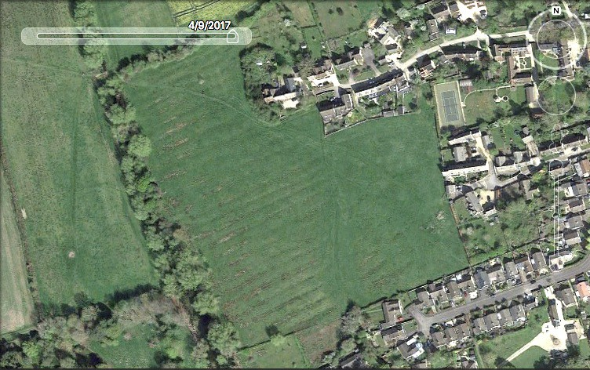
The Schoolfield (Area B) in 2017. The field pattern is still in evidence. Footpaths crossing the site are evident. (GoogleGB )
The site is identified as a possible NERC Act S41 grassland habitat approximately 300 metres south east of the Weston Fen SSSI and is considered to be part of a biodiversity corridor linking important habitats to the north/northwest of the site

(Weston Fen SSSI, Kirtlington and Bletchington Parks and Woods CTA) with others to the south/southeast (Weston Wood and Otmoor CTA and Wendelbury Meads and Mansmoor Closes SSSIs). Such grasslands are a habitat for newts, bats, orchids and rare butterflies (possibly the Brown Hairstreak butterfly which was recorded south of the site in 2017 (Dave Wilton, Upper Thames Branch butterfly sightings http://upperthames-butterflies.org.uk/butterfly_sightings.html). In the summer of 2018, the following species with lowland meadow associations were recorded on the Schoolfield: marsh marigold, brown sedge, water horsetail, common sedge, meadowsweet and angelica (Sam Watson, Ecologist). This area has been described as the ‘lungs’ of the village, reaching into the most populous northern half of the village and extending directly to the agricultural landscape beyond. The field is bounded on the western side by the Mill stream with the Mill situated at the south western corner of the field and cottages on Mill Lane form part of the south boundary. A narrow strip of land at the southern boundary of the field was purchased by the cottages on Mill Lane in the 1970’s to extend their properties. The purchased land was subject to a Section 52 covenant preventing the new owners from developing the properties on the land.
The field has recently changed ownership and its future is undetermined. There is concern in the village that the natural grassland habitat may be degraded by neglect and the land is under threat from weed invasion with some woody overgrowth and perennial weeds already present.
The Parish Council desire is to keep this field as a community/amenity space, an open area of natural tranquillity where wildlife can be observed and appreciated. The plan will retain the field as open space which will be managed to preserve and enhance the wildlife habitats which appear to be in decline. The proposal includes an option to set up a Community Interest Company or Trustee Group to manage the area, funded through donations and operating in the interests of the village. The ownership and management would be external to the Parish Council but include one Councillor on its Management body. The aim is to manage cutting and grazing that will conserve the habitat structure according to the principles outlined in the Lowland Grassland Management Handbook 2007. This would be based on a mixture of limited grazing (3-4 sheep) and grass cutting at different time of the year as well as monitoring the use of the field to manage trampling, litter and dog fouling. The expectation is that over a period of 10 years, significant reparation can be made to the natural habitat to sustain wildlife species that are native to the area and currently under pressure.
Area B is one of the last remaining open fields which has been retained as pasture in the village. Its location for recreation, education and passive use as an open space of natural tranquillity is unique. It is remote from the busy roads surrounding the village (A34, B430 and more distant but audible from parts of the village, the M40). It has several safe access routes approaching from the north,

east and south of the village. It is an enclave of peace that could replace the long lost Green from which the village takes its name. If it can be secured now, this important environmental resource can be preserved and looked after as a valuable wildlife habitat for the foreseeable future and to the great benefit of the parish.

Map showing the position of Area B (the Schoolfield) which relates to Neighbourhood Policy C1.

APPENDIX G
LANDSCAPE SETTING AND IMPORTANT INTERNAL GREEN SPACES

Weston-on-the-Green is characterised by its setting within an agricultural countryside and also by retained green spaces within the village. Those aspects that are important to the character of the village have their key characteristics noted below. *Green spaces i, ii, iii, iv and ix are all with the greenbelt.

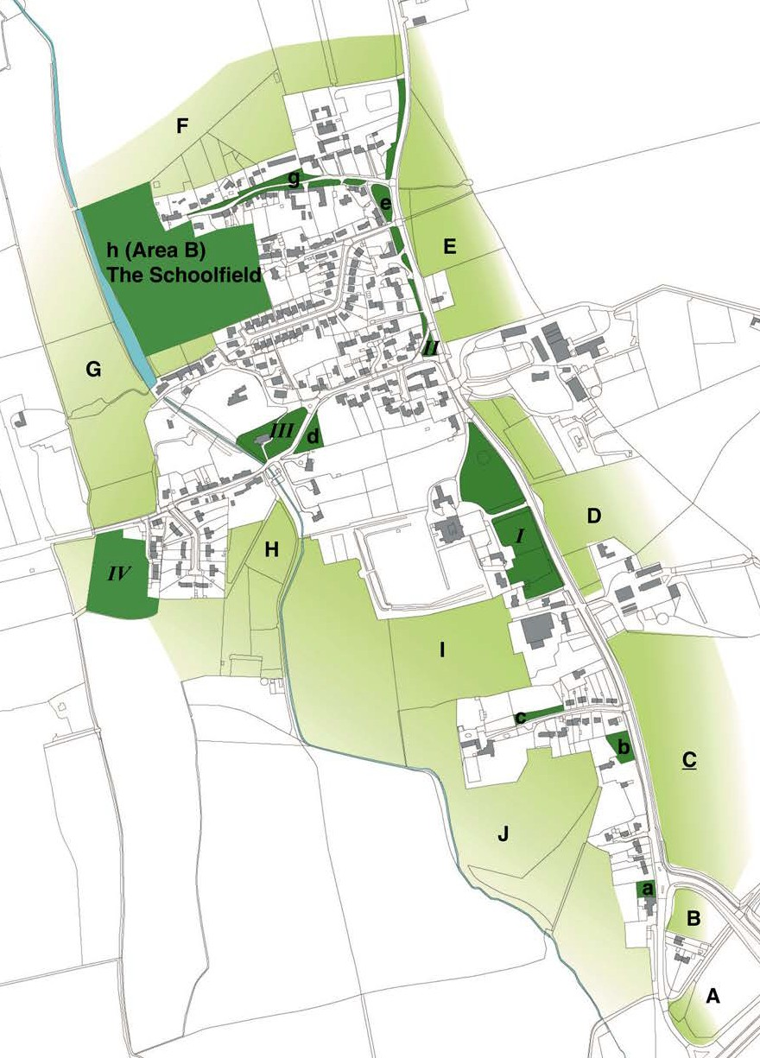

Landscape setting and important internal green spaces

Sites A-J (light green):
Landscape setting and open views

Sites a-h (dark green): important green spaces in the village

Sites I – IV (dark green): Designated Local Green Spaces (policy E6 and E7)

(Map: Ordnance Survey 2018. All rights

Landscape setting
The following sites are associated with open views from the built-up village area to the rural countryside and enhance the character of the village within its broader landscape.

A | LAND BOUNDED BY B430, A34 AND CONNECTING FLYOVER
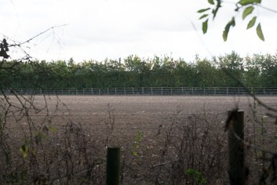
This is arable land that largely screened by mature hedgerows and provides visual screening and some noise reduction from the A34. This landscape would have once connected to Weston Wood (ancient woodland) to the east of the A34. The hedgerows extend north screening dwellings sitting between fields A and B.

B | LAND BETWEEN B430 AND FLYOVER
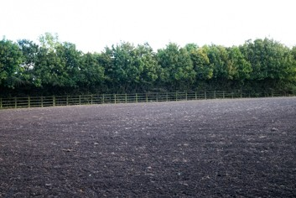
Arable land partly screened by hedgerows but with glimpses from the B430. It lies opposite to the Chequers public house which marks the southern entrance to the village.

C |PART OF FIR TREE DAIRY

Photo shows view from south. The low hedgerow along the B430 and open landscape afford dramatic views of big skies east of the B430. Footpaths 404/8 and 404/11 cross the field. The original ‘green’ stretched from these fields northwards across fields D and E.

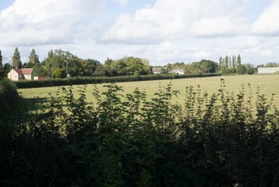
D | LAND BETWEEN MANOR FARM AND WESTON GROUNDS FARM
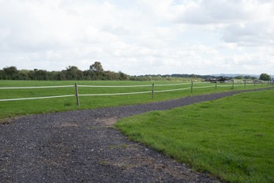
These fields lie opposite Weston Manor Hotel grounds. This is a largely open landscape and affords views to the more recent industrial buildings developed on the Weston Farm Grounds. Together with land parcels E, C, B and A it establishes the

open countryside setting to the east of the village and is crossed by footpath 404/12.

E |LAND OPPOSITE THE VILLAGE CORE
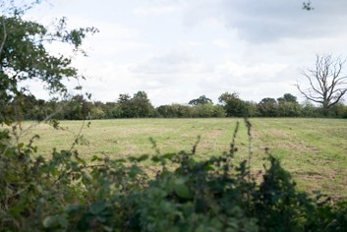
This land is bounded by a mature hedgerow so is less open than the land to the south. It still establishes the eastern edge to village development. Footpath 404/14 leads eastwards from the Ben Jonson public house.

F | LAND TO THE NORTH OF NORTH LANE
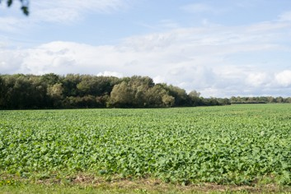
This arable landscape lies just above North Lane and contains the northernmost part of the village. Northwards the land forms a plain and is utilised as an airfield to the north-east before being bounded by Akeman Street (Roman Road). In this landscape lies the Weston Fen SSSI and a Bronze Age Ring Ditch.

G | GALLOS BROOK FLOOD PLAIN
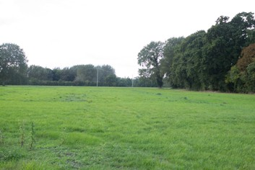
The flood plain marks the western edge of the village with Gallos Brook signalled by a spine of trees. Newbridge Farm (pictured), Brookside Farm and Staplehurst Farm, while all outside the parish boundary, maintain an open countryside setting with the floodplain creating a threshold to the village.

H |LAND SOUTH OF CHURCH LANE
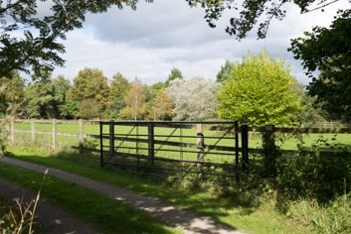
The village development south of Church Lane – GallosBrook Way, Church Close and Weston Manor. The approach to the village along the Oxfordshire Way from the south passes through a paddock which maintains a green ‘wedge’ into the village at this point.

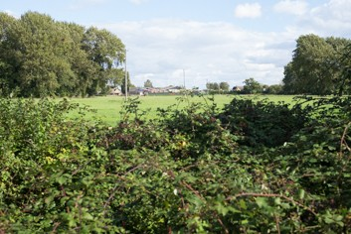
- | LAND SOUTH OF WESTON MANOR
This is part of Fir Tree Farm and while the western boundary of the Manor is screened by large trees there is a clear view of the industrial buildings of Fir Tree Farm.

J | KNOWLE FARM

Knowle Farm extends around the southern tip of the village to enclose the Chequers public House.

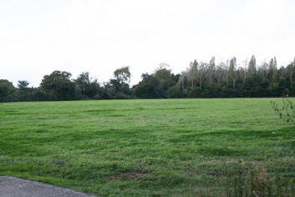
Parcels A, B, C, G, H, I, J and part of D all lie in the Greenbelt.

Important green spaces within the village
There are a number of important green spaces still remaining within the village.
a| CHEQUERS PUBLIC HOUSE GARDEN
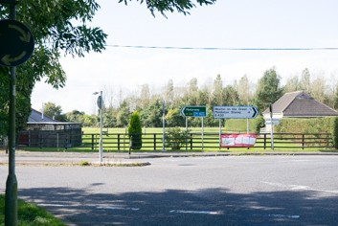
This open and sunny garden faces the eastern entrance to the village from the flyover and is a pleasant introduction to Weston-on-the-Green.

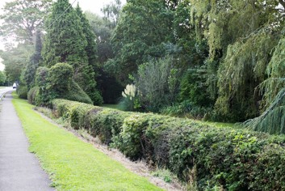
b| PRIVATE GARDEN ON B430

Lying just below the B430, the low hedge affords a view into a private garden. Many of the traditional low walls and hedges to the fronts of village houses have been replaced by tall screens so it is a delight to see a private garden that allows passers-by to share the view.

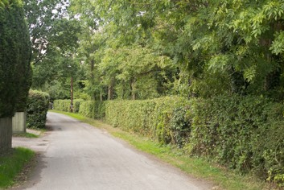
c | GREEN EDGE TO NORTH SIDE OF KNOWLE LANE
This is a distinctive green edge to the lane and hides what was once an orchard.
Some management of the trees and scrub is needed but it does make a strong contribution to the character of Knowle Lane.

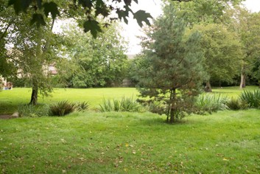
d | PRIVATE GARDEN TO DOWER HOUSE
This large garden complements the greenery of the churchyard environs. It was an orchard from Victorian times and is now laid to lawn, open to view over a low stone wall.

e | VERGES FROM WESTON MANOR TO AND INCLUDING NORTH LANE
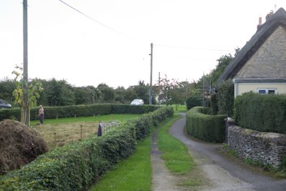
These broad verges include the private garden to Bramble Cottage, bounded by a low hedge, the verge and pond adjacent to the Great Oak tree and the green outside the Ben Jonson which was used for village fairs until the 1960’s. The Conservation Area Appraisal notes that grassed verges in the village play a key role in retaining a rural feel. The Bramble
Cottage garden was wholly taken over for the cultivation of vegetables between the wars and has only recently been grassed with a wildflower area managed by the owner.

f| THE GREAT OAK AND VERGE
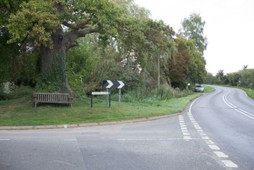
The great oak stands at the entrance to North Lane and historically marked the northern end of the village. The verge on which the oak stands and the adjacent pond, forms a tidy apron at this northern gateway into Weston on the Green. This is one of the oaks that has a connection to fertility in the village according to local folk-lore. The tree is on the special interest
list at OCC and is a notable icon for the village. The public bench was donated by villagers and is a popular place to sit.

g| NORTH LANE VERGES
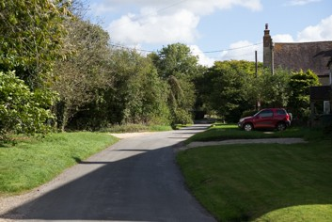
The Conservation Area Appraisal states that verges should be retained ‘without the use of a kerb, where appropriate’. Where some verges have been appropriated as front gardens, the County Council keeps a definitive record of the verges and ensures that all verges are kept in public ownership, protected, and available for public usage such as paths and recreation. These verges
are progressively being eroded for parking and heavy construction vehicles have carved up the edges badly. This area also includes the North Lane duck pond – part of which is registered as a village green, but the surrounding grassed area is unprotected. This area needs regeneration as it was once a charming local attraction with ducks and duckhouse.

h | THE SCHOOLFIELD

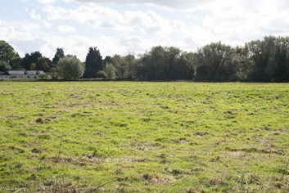

This open tract of land forms the western boundary of the village and has the Oxfordshire Way and two other footpaths running across it. It provides a valuable connection between North Lane and the village centre. Evidence of a ridge and furrow ploughing pattern suggests this site was once an important part of the manorial field use, running alongside the

mill stream and close to the Mill. Now known as the Schoolfield, it was used as a recreational area when the school was in occupation and is currently a valued open space, in private ownership. The Conservation Area Appraisal notes that the relationship of this medieval ridge and furrow field to the village is considered of importance ‘because of the two way views both into and out of the Conservation Area and due to the heavily vegetated boundary which separates the land from the surrounding landscape, while remaining open to the village’. It is a rich habitat which connects other protected sites (the SSSI 400m to the north with the Weston Wood and Otmoor borderlands to the south.

Designated Local green Spaces in the Neighbourhood Plan* (see Policy E6 and E7, Figure 15 and section 2.4):

Green spaces which are considered of particular importance to the local community are designated as ‘Local Green Spaces’ where the green space is:
    - in reasonably close proximity to the community services;
    - special to the village and holds a particular local significance, and
local in character and not forming an extensive tract of land.

The NPPF states that to be considered for designation in the NPPF as a Local Green Space, an area should be demonstrably special to a local community and hold a particular local significance. Significant factors are:
    - Beauty
    - Historic significance
    - Recreational value
    - Tranquillity
    - Richness in wildlife

Based on the assessments of Local Green Space undertaken by other local authorities, the Neighbourhood Plan Steering Group has applied the following criteria when considering candidates for designation as Local Green Space:
    - Proximity to the community it serves - the measurement usually applied is the walking distance or distance in metres e.g. within 300m or 5 minutes walking (as set out in Natural England’s Accessible Natural Greenspace Guidance7) is the guide taken as a measure in this case. Area B is less than 5 minutes walk from the centre of the village and at most 10 minutes from the extreme south or north boundaries.
    - Beauty - The Steering Group assessed the visual attractiveness of the proposed areas and their contribution to the landscape, character and setting of the village settlement including views to and from the settlement (see Figure 10 in the NP). Local Green Spaces will typically contribute to local identity and character of the area and a sense of place.
    - Historic significance – Consideration was given to the proposed areas and whether they have historical significance. The areas may reflect an archaeological site or other historical feature, provide the setting to a statutory listed building or scheduled monument or be within a Conservation Area. Designated areas I to III all have historic significance to the village: sites ! and III are Grade II* listed and site III includes the old stocks which are located on a registered village green.
    - Recreational value – Site IV is the only open recreational area in the village and is used for football, including training groups for young players

7 Nature Nearby – Accessible Natural Greenspace Guidance (NE265) Jan 2010, www.naturalengland.org

and general outdoor activities by families. The field is used periodically for small fetes and local events and annually hosts the Guy Faulks bonfire and firework display. The adjoining spinney provides a nature trail which has access from the playing field and is popular with various groups and families.
    - Tranquillity – The Campaign for the Protection of Rural England’s (CPREs) Tranquillity Map identifies Weston-on-the-Green in the mid-tranquillity range. The village has audible pollution from the major roads bordering the parish, namely the A34 to the south, the M40 to the east and the B430 which runs through the village south to north. All sites have audible gains in birdsong and Site IV has running water from Gallosbrook which runs along the spinney to the Manor moat. Visual pollution arises from the night-sky glows from Bicester, Kidlington and distantly, Oxford. Positive visual tranquillity factors in the designated areas include trees in the landscape (Site IV), open green areas (Site I and II), quiet contemplative space (Site I).

All the sites designated in this Plan (policy E6) and subject to protection under policy E7 are local in character and not extensive tracts of land. The largest is Site IV which is approximately 2 hectares area. All sites are self-contained.

I| WESTON MANOR GROUNDS
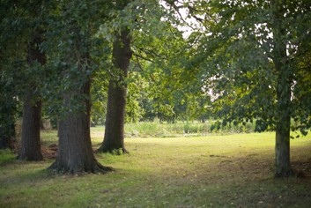
This is a memorable space as seen from the B430 over a low stone wall. The lime avenue to the main entrance of Weston Manor is a highly distinctive historical feature of Weston-on-the-Green. Weston Manor has a rich history at the centre of the village and the Manor building is Grade II* listed. The grounds surround the
Manor House and echo the original Manorial layout when the village was tithed. This open area is one of that last examples of undisturbed land in its original form at the heart of the village.
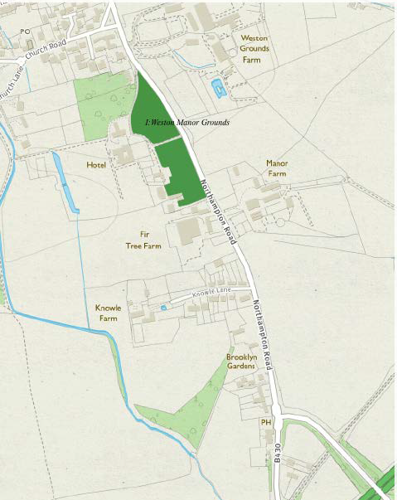
© Crown Copyright and database right 2017. Ordnance Survey 100018504

- | THE STOCKS
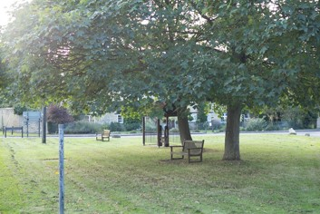
green.

This is a focal point at the junction of Church Road with the B430 and is sometimes mistaken as the ‘Green’ in Weston. It is the site of the village stocks, now fenced off for protection. The stocks are particular to Weston-on-the-Green and historical accounts provide evidence of their use. This area is a registered village

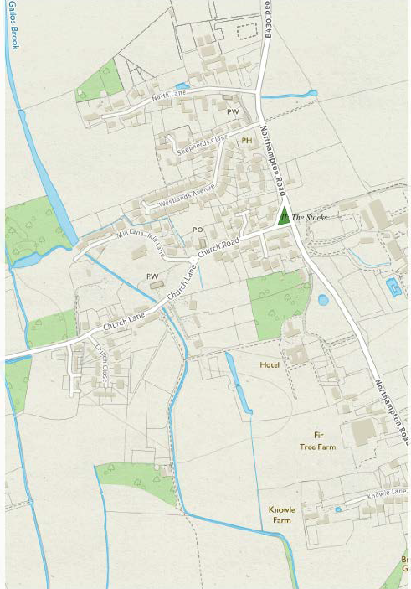
© Crown Copyright and database right 2017. Ordnance Survey 100018504

III| ST. MARY’S CHURCHYARD
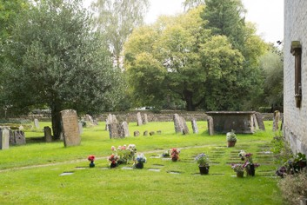
for villagers.

The churchyard functions as an important green space at the heart of the village. The trees are protected by tree preservation orders. It is used as a pedestrian route from Church Lane to the Memorial Village Hall and shop. In recent years, the Church has diversified to accommodate a variety of social events and acts as a meeting place

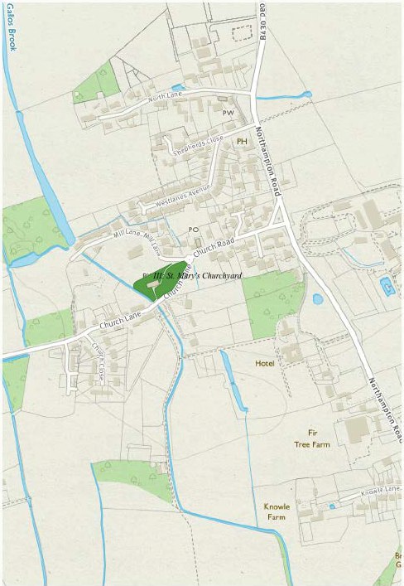
© Crown Copyright and database right 2017. Ordnance Survey 100018504

IV | THE PLAYING FIELD

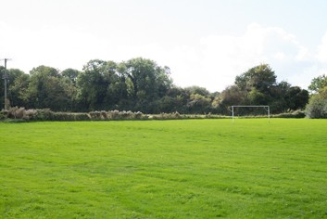

The only recreational area of the village is bounded by a small spinney and stream feeding the Manor moat. This area is in constant use and includes a playground for small children. The Playing field is overlooked by the Gallosbrook Way housing which establishes the western edge of the village confines. The field sits within floodplain zones 2 and 3 and is

maintained by the Parish Council. A small carpark is located on the northern boundary by Church Lane. The land is leased by the Parish Council from the Duchy of Cornwall.
© Crown Copyright and database right 2017. Ordnance Survey 100018504
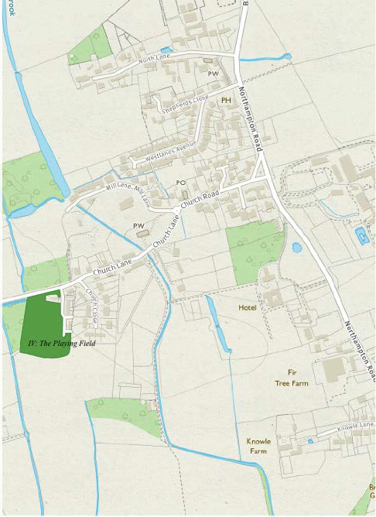
© Crown Copyright and database right 2017. Ordnance Survey 100018504

APPENDIX H:

CHARACTERISTICS OF VILLAGE FORM (MORPHOLOGY)
The following analysis highlights the key elements to consider for new designs but the arrangement of buildings, lanes and landscapes should always be such that the whole is greater than the sum of the parts. This analysis should inform the design of new development (see Appendix E – Design Code and Appendix J – Village Character).

Street pattern and alignment
Lanes run east-west to the western side of the Northampton Road. The historic lanes are made up of long, straight segments with small angles of deflection between each segment, typically 10 to 20 degrees but always less than 45 degrees. This gives a gently meandering appearance where the small deflections hide the long distance views which are revealed as the viewer passes the point of deflection.
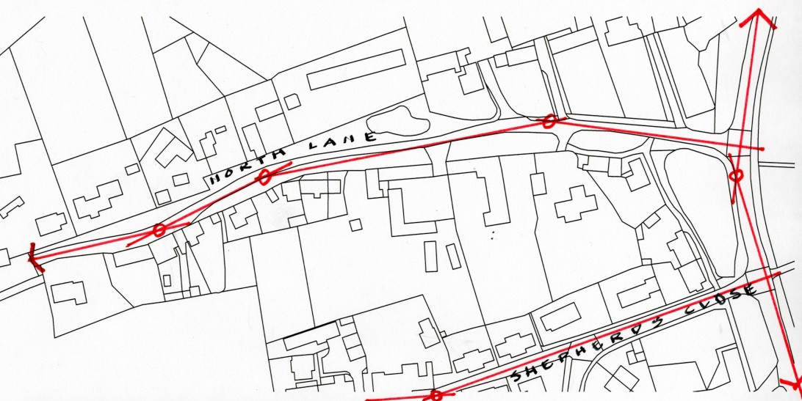
North Lane comprises four ‘segments’ (red line) with small deflections in the alignment of the lane just screening each segment

Virtually all dwellings are located no more than one or two turns (right angled junctions) off the Northampton Road creating a highly ‘legible’ layout.

Focal points
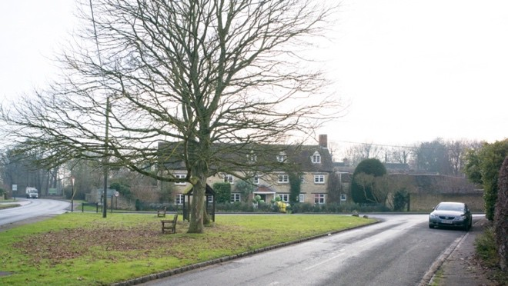
Focal points or nodes are memorable places at the junctions of streets or lanes and may take the form of a small square or green. The junction of Church Road and Northampton Road is one and the junction of Church Road / Church Lane / Mill Lane another.

The junction of Church Road and the B430 creates a memorable place

Enclaves
Some buildings are grouped around a public or private space which is set behind a street or lane. Historically, many of these would have been farmyards and some have been converted into residential or business use where they create ‘enclaves’ which reference their historical context.
Such developments include Village Farm Court, Blacksmith’s Close, Oxford Court and Shepherd’s Close and are generally good design solutions to infill sites.

Gateways
Gateways signify the visual entry points into the village: from the south at The Chequers public house, from the north at the Great Oak on the junction of North Lane and the Northampton Road, and from the west on crossing the flood plain at the end of Church Lane.

Tree canopy and important hedgerows
The principle tree canopies and hedgerows also give form to the village and are shown on the survey drawing (Appendix J).

Verges and greens
The verges and greens are a historic remnant and form an important part of the public realm. It is proposed that some of these be designated formally as Local Green Spaces and that any future development incorporates new greens. A more detailed assessment of green spaces is provided at Appendix G.

Edges to the countryside
There is a clear visual edge between the built-form of the village and the surrounding countryside which generally follows the ‘character areas’ defined in the CDC Conservation Area Appraisal (the boundaries to these are also indicated in Appendix J).

Key building frontages and important front boundary walls
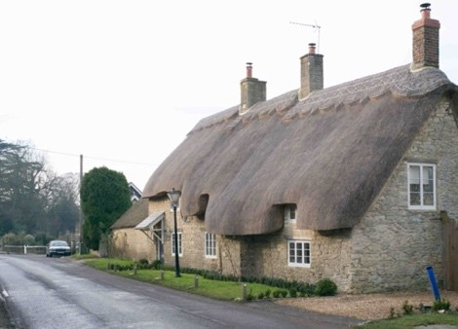
Most of the village housing is either:
    - built directly against the back of footpath / lane or against a verge and often forming a continuous building frontage.
    - Or set back from the street with a stone front boundary wall delineating the edge of the property. This is typical of larger detached properties.

Example of building frontage set directly against public grass verge

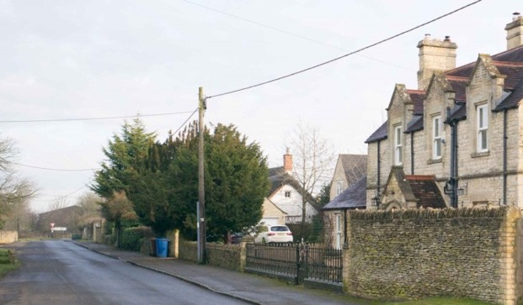
This combination of continuous frontages and buildings set back behind boundary walls is a key characteristic of the village. Where 20th century development has arranged houses around standard estate roads without following either precedent, the typology is not characteristic of the village.

Example of building set behind front boundary stone wall

Landmarks and ‘marker’ buildings
The principal landmark buildings are the Church of St Mary the Virgin and Weston Manor Hotel. There is also a large number of what might be termed ‘marker buildings’, lesser buildings which because of their siting, perhaps on a corner, or perhaps because of a prominent gable which can be seen from a distance, create memorable places within the village.
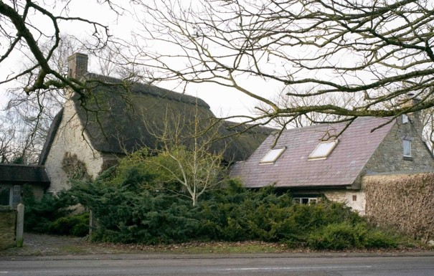
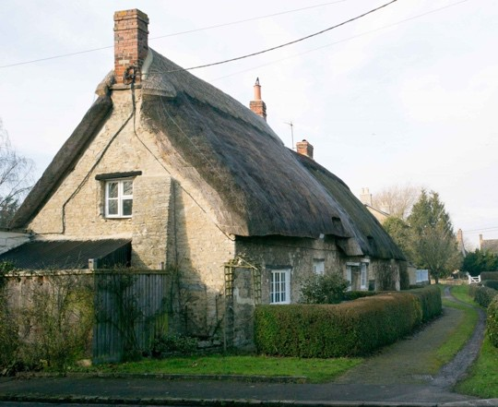
Small landmarks or ‘marker’ buildings are created where gables front the street (Hazel Cottage and Bramble Cottage, above)

Key views and open vistas
The historic lanes are rich in landmarks and marker buildings and their distinctive gables or elevations frequently terminate long views. There are a number of memorable vistas across the surrounding countryside; every lane emerging onto the Northampton Road affords such a vista over farmland to the east.

Vista needing screening
The industrial areas at Fir Tree Farm and on the eastern side of the Northampton Road require screen planting. There is a real risk that unplanned industrial development on the eastern side of the road could severely damage the setting of the village.

Area of weak orientation
There are several areas where the building typology is uncharacteristic of the village and does not define public spaces by either a continuous frontage or a consistent boundary wall treatment. They are instead typical of prevailing standards at the time of construction and include the Memorial Village Hall site, Church Close and Westlands Avenue.

Variation in plot widths
Terraces with a continuous building frontage typically have a variation in plot widths which leads to an informal street frontage which expresses the character of the individual homes.
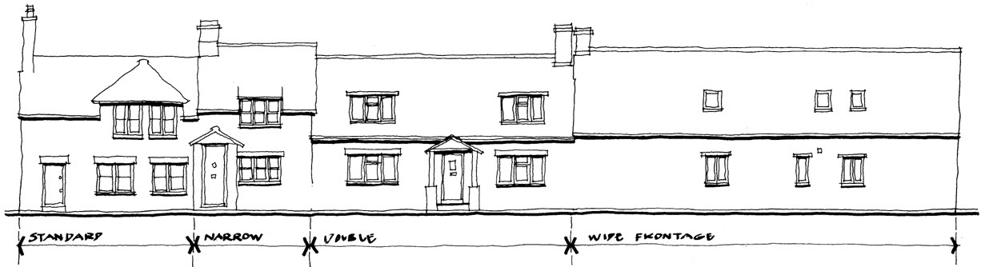
Four cottages| A continuous building line and consistent use of natural stone unifies this group of differing architectural styles. The informal rhythm of the elevations results from a variety in plot widths (North Lane).

Shallow building depths
The vernacular buildings typically have stone walls and are a single timber beam span in depth, usually 4.5 metres maximum span. For a given roof pitch, the ridge is therefore lower than on deep-plan buildings.

Roof pitches
Roof pitches in the village reflect the original roof covering: 50+ degrees - thatch
40+ degrees- clay tile or stone slates 35 degrees - slate

Most roofs are therefore more steeply pitched than modern houses with typical building depths of 8 metres and corresponding shallower roof pitches.

Low eaves heights
Not only do most of the vernacular houses and cottages have lower ceiling heights than modern houses, the thick outer walls and steep roof pitches mean that eaves heights are notably lower than in modern buildings. The eaves height is more important than the ridge in giving scale to the street and a modern house can unintentionally stand out where the eaves height is higher – something that could easily be remedied though attention to construction detailing.

Materials
The predominant materials are local stone walls, tile, slate or that roofs and granite streetscape details. A more comprehensive list is provided in Appendix E - Design Code.

The following figure (also shown as Figure 10 in the main NP) shows the key characteristics of the village, including positive (blue) and adverse (red) vistas from viewpoints shown; the open and green spaces within the village confines and the main hedgerows, verges and greens.
Development Site A is shown in yellow. The compass entry points to the village are shown.
The wetland area associated with Gallosbrook and the Millstream is shown on the western edge of the village.
Key characteristics of the village showing positive and adverse vistas from viewpoints; village entry points; open spaces within the village envelope; hedgerows, verges and greens. (Map Crown copyright, all rights reserved; annotations courtesy R. Evans and S. Daenke)

