Water Scarcity in California
Justin R. Bingham
GCH 360-002
02 May 2016

Introduction
Imagine being told what to do on a daily basis by regulating how much water can come out of your faucet, showerhead, or hose because of the fear that the region may run out of water. Picture acres of farmland and flora and fauna all dead and brown, because of a drought and water shortage. Many areas of the country struggle to reach normal average rainfall, and California in particular is struggling to get anywhere near close to an ample amount of rainfall to be able to accommodate for their millions of residents. It is even more daunting that California is short on water to be able to harvest and take care of their farmland, which is a huge supplier for fruits, vegetables, and nuts that we see on store shelves all over the country. California has suffered from below-average rainfall for years, and due to the falling levels of water of the Colorado River basin, the problem is not only affecting California itself. Due to the water shortage and the massive drought, California has had to take action and implement policies that have affected the multi-billion dollar agricultural industry as well as many communities that have led to adverse health affects.
Background
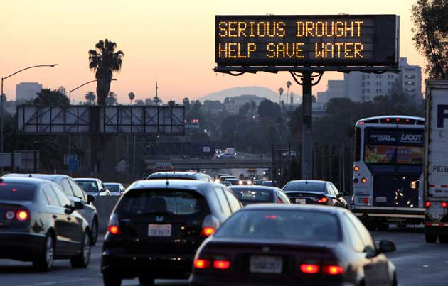 A massive drought and a shortage of melting snow are contributors to California’s water shortage. California is on its fourth year of a major drought that is affecting the lives of millions of residents, especially those who work in agriculture and fishery. When the drought initially began, California governor Jerry Brown had to declare statewide, mandatory water restrictions in order to respond to the state’s worst drought in all of history. As a result, many cities and towns were informed to cut their total water usage by 25%, and it is said that this is the first intervention that is going to be implemented in order to deal with this crisis. Due to the below-normal snowfall in the Cascades and Sierra Nevada mountain ranges, there has been less snowmelt to resupply surface waters such as streams and lakes. Since California relies heavily on water from the Colorado River to supply water to their state for millions of residents and many acres of farmland, the demand is exceeding the supply since the water from this particular river has to supply major cities in the Southwest such as Phoenix, Las Vegas, San Diego, and Los Angeles. (Dimick, 2015)
According to Zamora, Kirchner, and Lustgarten (2015), most of California is experiencing “extreme to exceptional drought” and the state announced its first cutback to farmers’ water rights since 1977. Many towns are going to be forced to cut water by as much as 36%. Recent studies showed that the projected cost of the drought in 2015 would be $2.7 billion just in that year. The shortage of water has hurt the $46 billion agricultural industry and infuriated many farmers, who chose to fight the laws regarding the cutback of water on farms. Farming and agriculture relies on more than 70% of the water supply from the Colorado River basin to keep the major agricultural industry afloat. (Zamora, Kirchner, and Lustgarten, 2015)
Methodology
California is simply undergoing one major issue right now. The issue pertains to there not being enough water for the millions of people who demand it. According to Dimick (2015) of The National Geographic, when California faced a major drought back in the 1970s, fewer than twenty million people were living in the state at the time. However, there are currently more than forty million people living in California and yet again there is another water problem. This time, there is nearly double the amount of people than there was back in the 1970s, and now the California governor is demanding for new regulations to put in place. Residents will have to cope with the new regulations in order to address the water crisis. (Dimick, 2015)
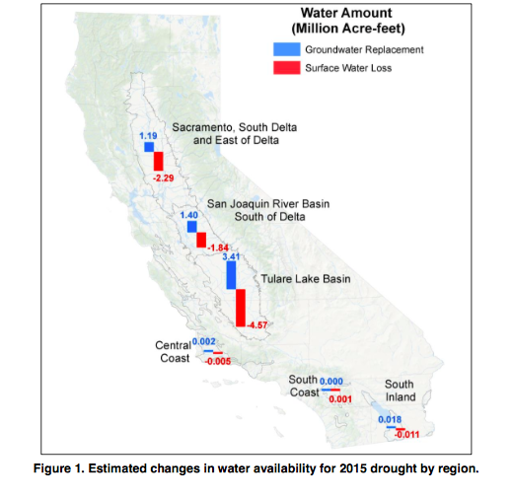 As shown in the figure below representing the water amount (Million Acre-Feet), the amount of surface water available has been on the decline due to the lack of snowmelt and rainfall. As a result, the dependence of groundwater pumping has risen in order to replace all of the lost surface water and availability of water for agriculture has gone down. Howitt, et al. (2015) stated “it’s estimated that the 2015 drought has reduced surface water by 8.7 million acre-feet statewide” (p. 2). Many of the hidden water supplies below the surface from aquifers and groundwater are constantly drilled to replenish the lost surface water. According to Dimick (2015) of The National Geographic, “a 2011 study indicated that the Central Valley Aquifer is losing an amount of water each year equivalent to the nearly 29 million acre-feet of water found in Lake Mead, the nation’s largest surface reservoir on the Colorado River.”

The Adverse Effects on Fishing
It is obviously important that there is enough water for fish to survive in order to keep the fishing industry afloat. Many individuals in California (especially in the San Francisco Bay Area) rely on fishery to make a good living. The Chinook salmon and Delta smelt have suffered the most, making them more endangered as the water levels continue to decrease. According to Kasler and Reese (2015), “the state’s monthly surveys of the Delta smelt population found just one of the diminutive fish in April 2015 and just eight in May. Almost all of the juvenile winter-run Chinook salmon died last year, due to a shortage of cool water in the Sacramento River Valley.” Additionally, the diminishing Chinook population creates lots of issues for California’s $1.4 billion dollar-a-year salmon fishing industry. There have been legal issues evolving that have gotten the fishing and agricultural industries in arguments on where the water should be going. More water is needed to keep the fish alive, however water is needed to harvest crops to supply food to the rest of the nation. The Delta smelt species has been listed as “threatened” and efforts to keep the species alive such as water re-routing and temperature regulation are necessary to respond to water levels reaching a record low. (Kasler, Reese, 2015)
The Effect of Water Scarcity on the Agricultural Industry
Water scarcity plays a major role in the agricultural industry in California, because it not only feeds the residents living in there, but a lot of the produce and nuts we find on shelves on the east coast come from California. California has had of history of dry spells in the past, especially when the state experienced the driest winter in five hundred years back in 2013. Due to the drought and shortage of water, many consequences associated with the agricultural industry have been found. According to Comer (2015), “California’s typical production of roughly fifty percent of the country’s fruits and vegetables has been steadily falling, leading to a rise in food prices.” Not only are farmers letting their farms fallow, but cattle ranchers have also had to thin out their herds as the price of hay and feed has increased due to the water shortage. The U.S. will have to begin importing more food in order to avoid a drastic increase of food prices, as demand is exceeding supply. California produces more than 11% of all of the food produced in America and is the largest agricultural producer. (Comer, 2015)
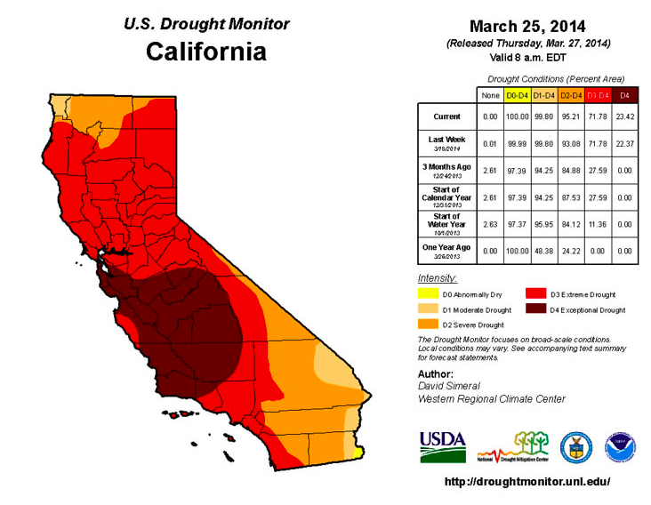
(The figure above examines the drought conditions over certain periods of time)
A study was conducted that examined the acreage, revenue, and employment numbers over a fourteen-year period from 2000-2014. According to Cooley, et al. (2015) of the Pacific Institute, “the drought brought record-high crop revenue and employment”. Despite having to constantly rely on groundwater sources, farms have been able to adopt ways to manage consumption levels, such as drip irrigation and by using higher-value crops which helps increase revenue.
Analysis
While California is a major food supplier for the entire country, it is important to develop interventions and ways to manage the levels of water consumption. Steps should be taken to monitor the habitats of the endangered fish in order to save the fishing industry. According to Howitt, et al. (2015), “the Sacramento River Water Temperature Management Plan monitors water temperatures at Shasta Reservoir to ensure flows are cool enough to support fish habitat” (p. 4). Irrigation districts are also in charge of diverting water if the water temperature exceeds certain levels.
To respond to the water shortage and to be able to accommodate other important industries such as fishing, efforts to harvest crops that require less water are ideal. According to Ackerman, Stanton (2011), “California agriculture should focus on the growing scarcity of water by shifting to a higher-value, less water-intensive crop (p. 11). This accounts for the increased employment numbers and revenue since California is producing crops that are more valuable.
Conclusion
While the California water crisis is not going to be ending anytime soon, the state has a lot of work to do to create ways to conserve water. It will start by educating the community in order to cut back on water consumption in residential areas, such as refraining from using potable water to clean hard surfaces or for watering the lawn. Emphasis should be made on ensuring that there is an adequate supply of water for important industries like the fishing and agricultural industries, which plays one of the biggest roles in America’s economy. Whether it is rerouting water flow or by reducing the amount of groundwater sources extracted from beneath the surface, simple interventions can make a difference in order to contain California’s water scarcity issue.

References

Ackerman, F., Stanton, E. A. (2011, February). Stockholm Environment Institute. Retrieved 30 April 2016 from: http://sei-us.org/Publications_PDF/SEI-WesternWater-0211.pdf

Comer, V. (2014, August 1). Auburn Univerity. Retrieved 30 April 2016 from: http://cla.auburn.edu/ces/climate/california-case-study/

Cooley, H., Donnelly, K., Phurisamban, R., & Subramanian, M. (2015, August 26). The Pacific Institute. Retrieved 30 April 2016 from: http://pacinst.org/publication/impacts-of-californias-ongoing-drought-agriculture/

Dimick, D. (2015, April 6). The National Geographic. 5 Things you should know about California’s water crisis. Retrieved 30 April 2016 from: http://news.nationalgeographic.com/2015/04/150406-california-drought-snowpack-map-water-science/

Howitt, R., MacEwan, D., Medellín-Azuara, J. Lund, J. Sumner, D. (2015, August 17) Economic analysis of the 2015 drought for California agriculture. Retrieved 30 April 2016 from: https://watershed.ucdavis.edu/files/biblio/Final_Drought%20Report_08182015_Full_Report_WithAppendices.pdf

Kasler, D., Reese, P. (2015, June 8). Governing. Retrieved 30 April from: http://www.governing.com/news/headlines/california-drought-is-killing-fish.html

Zamora, A., Kirchner, L., & Lustgarten, A. (2015, June 25). ProPublica. Retrieved 30 April, 2016 from: https://www.propublica.org/article/california-drought-colorado-river-water-crisis-explained

