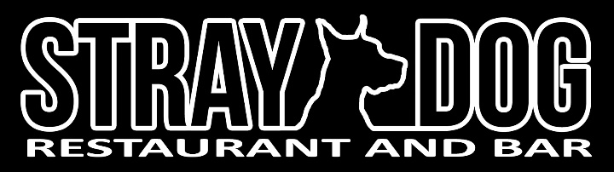
Brunch
Sunday 12pm-5pm

Sausage Griddle 13
Mini cornbread pancake, American cheese, applewood bacon, bacon and thyme infused Wood’s Maple Syrup (WI), with salad and parmesan potatoes
Breakfast Sandwich 10
English muffin, ham, fried egg, American cheese, and Sriracha mayo, with salad and parmesan potatoes
American Breakfast 13
Two eggs to order, applewood bacon, toast and jam, with salad and parmesan potatoes
Chilaquiles 15
Braised brisket chili, radishes, cotija, pickled red onion, pico de gallo, avocado, corn tortilla, fried, Cholula, and salsa verde
Chicken and Waffle 17
Buttermilk-fried chicken breast and thigh/drummy with bacon and thyme infused Wood’s maple syrup and sourdough waffle
Waffle 5
whipped cream, strawberries, Wood’s Maple Syrup (WI)
Corn Cakes 9
Cornbread pancakes with Wood’s Maple Syrup (WI)
Sin Roll 8
Deep-fried caramel roll with bacon and caramel syrup and whipped cream

