TODD TITUS WINS GRIT CRATE SPORTSMAN SEASON OPENER AT FIVE MILE POINT SPEEDWAY. VICTORY WORTH $1,000 FOR KIRKWOOD DRIVER.
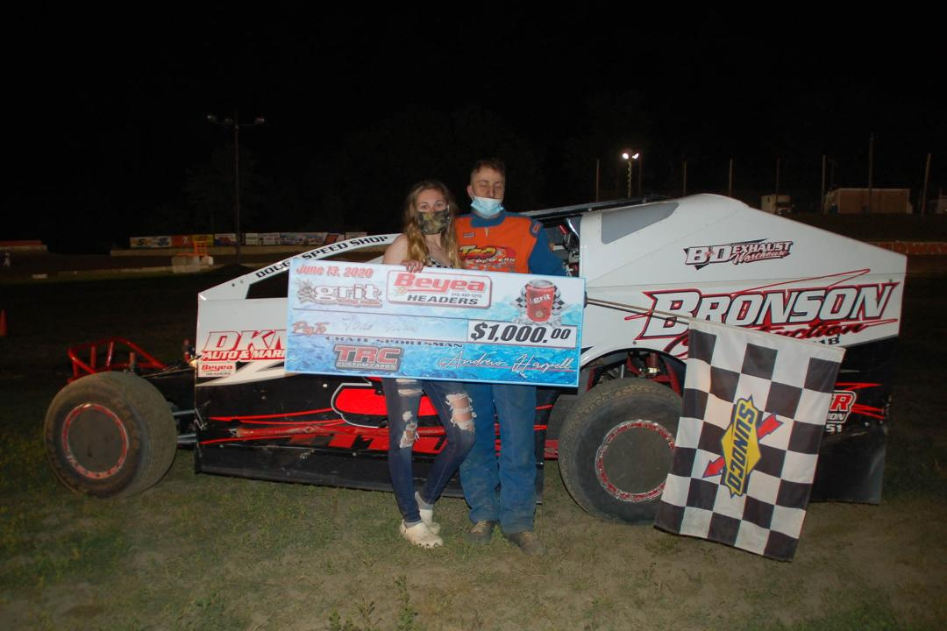
Todd Titus - GRIT Crate Sportsman Feature Winner.
KIRKWOOD, NY…Todd Titus opened the 70th Anniversary Five Mile Point Speedway race season with a victory in the 30 lap GRIT Crate Sportsman series race on Saturday. Steve Babicek collected the victory in the Binghamton Truck & Tire Center Modified “Dash for Cash”. Other winners were: Adam Mudge (600 Modifieds), Ray Lindquist (Factory Stock), Matt Bowman (Street Stock), Nick Kennedy (FWD Four Cylinder Expert), Owen Clark (FWD Four Cylinder Novice), Josh Landers (Juniors) with the three Nostalgia racer divisional wins going to Mike Houghtaling, Chip Gauthier and Scott Gauthier. Racing continues this Saturday at 7 p.m.
The GRIT Crate Sportsman 30 lap feature event was led to the green by Tyler Stoddard and Brian Franko. Stoddard, a rookie in the Sportsman division raced out to the early advantage. Several cautions slowed the action during the early going as the racing was intense. Fourth place starter Todd Titus quickly emerged as the first challenger to Stoddard for the race lead. By lap two Titus had already moved into the second slot and set his sites on the Freshman Sportsman driver.
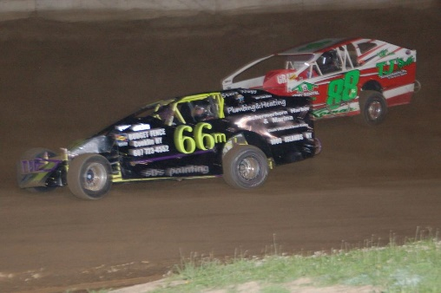
Sportsman feature action was intense.
The third early caution of the race flew on lap number four. On the restart Titus charged past Stoddard into the race lead. Stoddard now had to contend with Franko and Gary Smith for the runner-up battle intensified. Smith had charged eighth starting slot and was on the move early. Six cautions slowed the first half of the race but the second half went with only one yellow. Lap 18 the caution flew for the final time. On the restart Stoddard remained in second as Titus saw his big lead evaporate. This was the best opportunity Stoddard would have to make a bid for the lead. Titus was flawless on the restart and quickly opened back up his race lead.
A number of intense battles took place throughout the field but two drivers Randy Fox and Blaine Klinger were putting on a show after starting in the tenth and eleventh slots respectively. As the laps wound down Titus maintained his sizeable lead. Stoddard and Smith were now joined by Klinger and Randy Fox. Joining the party up front was also Randy Brokaw, who had started in the fifteenth slot. At the finish Titus went on for the popular victory. Stoddard was impressive with his runner-up tally and Klinger charged all the way to third. Fox was fourth with Smith completing the top five. Brokaw captured sixth with Sean Beardsley making his first appearance a success in finishing seventh after starting twenty-first. Tom Hampton had a solid drive finishing eighth with Franko ninth and Nick Plumstead completing the top ten after starting nineteenth.
Several Modified drivers were on hand for a special “Dash for Cash” initiated by Scott Landers a weekly Modified driver and owner of Binghamton Truck & Tire Center. The dash saw nine drivers take the green for the 15 lap event. Brad Weaver and Steve Babicek brought the field to the green flag.
At the start Babicek utilized the outside to move past Weaver for the immediate lead. Babicek held the point while several great battles materialized. All eyes were on Justin Holland as charged from the sixth starting spot. A caution on lap 7 reset the field with Babicek and Weaver still one and two. Holland was up to third place at this point with Matt Cole and Scott Landers in the top five. On the restart Babicek again took the lead but now Holland had made his way to second place. The final laps Holland tried all routes but could not work past Babicek as the two had a spirited battle for the win. Babicek went on for his first FMP win with Holland, Weaver, Scott Landers and Cole completing the top five.

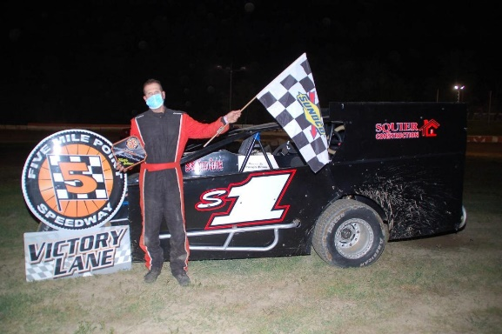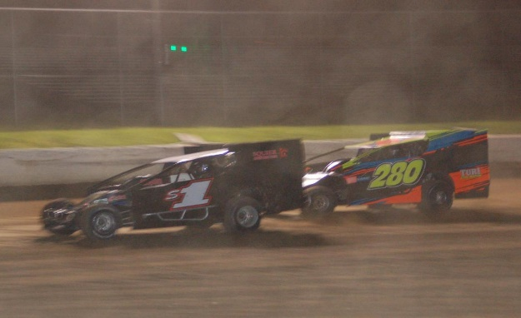

The annual Tommy Boy 20 for Factory Stocks saw Ray Lindquist capture the victory. Lindquist took the lead from Todd Sutliff on lap 3 and he never looked back. Charlie Towner and Justin Slezak had a terrific battle for the second slot during the late stages with Slezak taking the runner-up honors. Adam Gilbert, Tommy Groover and Towner completed the top five.
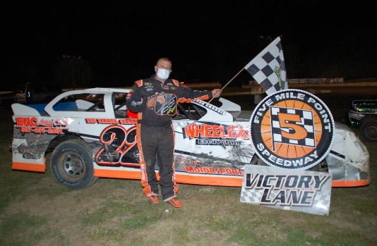
Ray Lindquist was the "Tommy Boy 20" Factory Stock winner.
The Four Cylinder Expert feature was won by Nick Kennedy. Kennedy started fifth and took over the race lead on lap 7 on his way to the victory. Walter Decker, Tim Vandermark, Randy Lane and Dave Simms completed the top five.
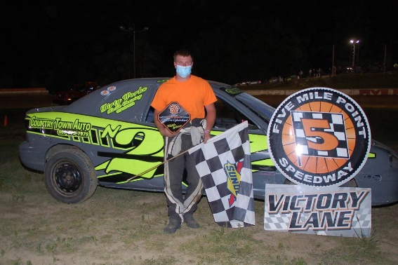
Nick Kennedy - FWD Four Cylinder Expert Winner.
Adam Mudge took the lead from Zack Mills on lap 12 and went on for the opening season win in the 20 lap Schneider’s Market 600 Modified feature event. Mudge started third in the field. Nolan Smith finished second after starting sixth with Dominick Amato, Tyler Smith and Bob Hamm, Jr. completing the top five.
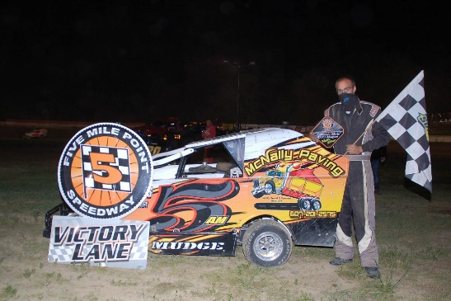
Adam Mudge - 600 Modified Winner.
The Trackside Products Street Stock feature saw Mike Bowman lead wire to wire in the 20 lap event. Joshua Landers was the Juniors Inner Loop race winner. Three divisional nostalgia feature winners were: Mike Houghtaling, Chip Gauthier and Scott Gauthier.
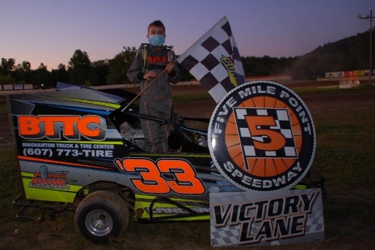
Inner Loop Juniors Winner Joshua Landers
COUNTER POINTS…It was the most unusual season opener at Five Mile Point Speedway in the 70 years of operation…Spectators were not allowed in the grandstand area due to current New York State Covid-19 restrictions…Local drivers shined on Saturday as seven of the nine feature event winners were either from the town of Kirkwood or neighboring Windsor, New York…Several area businesses stepped up to support the racing events on Saturday whether sponsoring a racing division or as part of the Modified “Dash for Cash”…They are: Schneider’s Market, Big R & J Exterminating, Suburban Septic and Excavating, Lasher’s Construction, Trackside Products, The Longstreet Family, Judy Wood and Dave and Gary Nixon, Gary Allen, In Memory of Jim Randall from his family.
OFFICIAL GRIT CRATE SPORTSMAN FEATURE FINISH (30 LAPS): TODD TITUS, Tyler Stoddard, Blaine Klinger, Randy Fox, Gary Smith, Randy Brokaw, Sean Beardsley, Tom Hampton, Brian Franko, Nick Plumstead, Matt Brewer, Mike Nagel Jr., Joe Guastella, Matt Sobieck, Joe Wilous, Alan Komar, Mark Longstreet, Set Zacharias, Brandon Fritsch, Brandon McGill, Brandon Loucks, Russell Benke, Mike Ward, Derek McGrew, Jr., MecKenzie Marsh, Jason Feinberg, Tyler Peet, Marty Bunker.
OFFICIAL BINGHAMTON TRUCK TIRE MODIFIED DASH FOR CASH (15 LAPS): STEVE BABICEK, Justin Holland, Brad Weaver, Scott Landers, Matt Cole, Glenn Knapp, Alissa Cody, Nick Rochinski, Brian Malcolm.
600 MODIFIED OFFICAL FEATURE FINISH (20 LAPS): ADAM MUDGE, Nolan Smith, Dominick Amato, Tyler Smith, Bob Hamm, Samantha Mills, Devon Green, Sharon Sealy, Zack Mills, David Brown.
TOMMY BOY 20 FACTORY STOCK OFFICIAL FEATURE FINISH (20 LAPS): RAY LINDQUIST, Justin Slezak, Adam Gilbert, Tommy Groover, Charlie Towner, Bob Mills, Kurtis Stickle, Ned Fitch, Todd Sutliff, Matt Millard, Philip Clapper, Josh Dumas.
LIGHNTING CAT EXPERT OFFICIAL FEATURE FINISH (15 LAPS): NICK KENNEDY, Walter Decker, Tim Vandermark, Randy Lane, Dave Simms, Josh Wilder, Steve Lunn, Caleb Lacey, Brian Salmini, Jeff Sterling, Jason Colwell Jr. DNS – Ken Underwood.
LIGHTNING CAT NOVICE OFFICAL FEATURE FINISH (12 LAPS): OWEN CLARK, Billy Colwell, Bethany Bertram, Zack Hayward, Cheyenne Bump, Ashley Slater, Austin Slater, Mike Abbott, Doug Newbigging, Greg Slater.
STREET STOCK OFFICIAL FEATURE FINISH (20 LAPS): MATT BOWMAN, Shane Wolf Jr., Doug Polhamus, Shawn Stalker. DQ – Mike Stoddard.
JR. 600 MODIFIED/SLINGSHOT OFFICIAL FEATURE FINISH (10 LAPS): JOSH LANDERS, Avery Decker.

