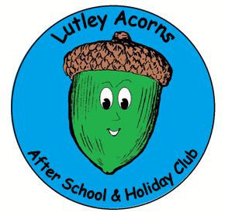
Lutley Acorns Newsletter

SUN CREAM
Please ensure that if you have stated that you wish for your child to use their own sun cream that this is sent to club with them. If we do not have sun cream for your child their outdoor play will have be limited whilst they are at club. Sun hats are also strongly advised.
Changes in circumstances
Please can you ensure that we are kept up to date with any changes in circumstances. This may be contact information, address details or medical conditions.
If you would like to check the information we hold for you and your child, please ask a member of staff.

May 2018

Dear Parents / Carers,
As the summer term is now upon us, we are going to be planning lots of new fun activities!! We will be looking at the topic ‘Under the sea’ as well as preparing lots of exciting summer activities. If you would like to see what your child has been doing at after school club then you are welcome to view our planning on the information board in the mini hall.
We hope that all the children enjoyed the visits from Angie’s Animal Antics. We have some lovely photographs of the children getting to meet the animals and we will be displaying these for parents to see in the next few days. We are hoping to arrange more visitors and entertainers for the children in the future and any suggestions are welcomed. We will also be looking to arrange a special summer party for the children towards the end of term. More details will be sent out closer to the date.
Acorns Preschool provisions
We are proud to announce the opening of our preschool provisions! Both are based in Halesowen and offer safe, fun and educational day-care for children aged 2-4 years. For more information please call 07866 264499.
We are pleased to announce that we have appointed Maria as deputy manager. Maria will be aiding Beckii with the running of club and will be on hand to answer any queries.
At the end of the half term we will be bidding farewell to one of our playworkers. Josh has been with us since September and will be missed by staff and children alike. We would like to wish him lots of luck for the future.

Useful numbers for parents and carers
Dudley Family Information Service – 01384 814398 Tax Credit Information Line -0845 300 3900
Ofsted Complaints Line - 0300 123 4666 Dudley Mental Health & Wellbeing - 01384 816284
If you are worried about a child you can telephone the Children and Young People's MASH Team for advice and consultation on 0300 555 0050 9am - 5pm or 0300 555 8574 after 5pm / weekends and Bank Holidays

