References
American Counseling Association
American Telemedicine Association
Center for Connected Health Policy
Tele-health Resource Centers
www.telehealth.org/ for video and info@ for email

If you send billing electronically, you are considered a “covered entity” with HIPPA.

HHS.gov (free resources) Documents/Solved Cases for HIPPA HHS.gov (free resources)
ACA Document by Ann Marie Nancy Wheeler (attorney) Feed the HIPPA clock

BCBSIL https://www.bcbsil.com/newsroom/news-releases/2020/covid-19-expanded-telehealth?fbclid=IwAR0krSsduiuIxSLu47Q7LojAL2JyAynObBP7_lHBWP9RIjfroCKiggStkc4

Transitioning to Remote Sessions from ZenCare https://blog.zencare.co/remote-therapy-coronavirus/?utm_source=email&utm_campaign=newsletter-march-13&utm_term=cta&fbclid=IwAR1Cmjc-DFFvHq9lW62Ccwb4dIAYVdIEPSmVcgAcIsbeMNyuwBZ1AfYjbj4

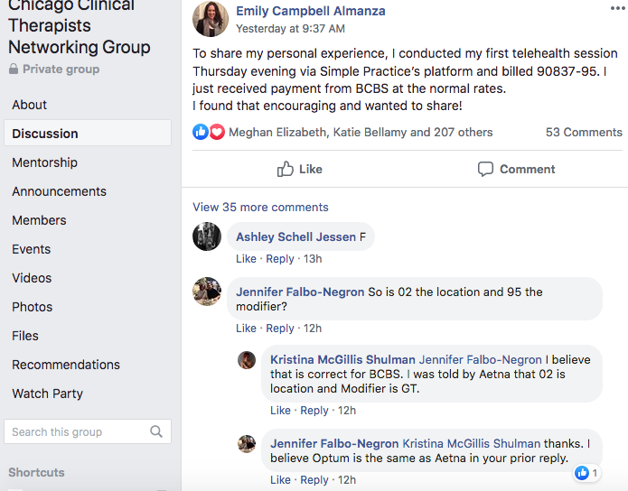

SAMPLE

INFORMED CONSENT FOR TELEPSYCHOLOGY
Colleen Duffy Cira·Friday, March 13, 2020·
INFORMED CONSENT FOR TELEPSYCHOLOGY
This Informed Consent for Telepsychology contains important information focusing on doing psychotherapy using the phone or the Internet. Please read this carefully, and let me know if you have any questions. When you sign this document, it will represent an agreement between us.
Benefits and Risks of Telepsychology
Telepsychology refers to providing psychotherapy services remotely using telecommunications technologies, such as video conferencing or telephone. One of the benefits of telepsychology is that the client and clinician can engage in services without being in the same physical location. This can be helpful in ensuring continuity of care if the client or clinician moves to a different location, takes an extended vacation, or is otherwise unable to continue to meet in person. It is also more convenient and takes less time. Telepsychology, however, requires technical competence on both our parts to be helpful. Although there are benefits of telepsychology, there are some differences between in-person psychotherapy and telepsychology, as well as some risks. For example:
- Risks to confidentiality. Because telepsychology sessions take place outside of the therapist’s private office, there is potential for other people to overhear sessions if you are not in a private place during the session. On my end I will take reasonable steps to ensure your privacy. But it is important for you to make sure you find a private place for our session where you will not be interrupted. It is also important for you to protect the privacy of our session on your cell phone or other device. You should participate in therapy only while in a room or area where other people are not present and cannot overhear the conversation.
- Issues related to technology. There are many ways that technology issues might impact telepsychology. For example, technology may stop working during a session, other people might be able to get access to our private conversation, or stored data could be accessed by unauthorized people or companies.
- Crisis management and intervention. Usually, I will not engage in telepsychology with clients who are currently in a crisis situation requiring high levels of support and intervention. Before engaging in telepsychology, we will develop an emergency response plan to address potential crisis situations that may arise during the course of our telepsychology work.
- Efficacy. Most research shows that telepsychology is about as effective as in-person psychotherapy. However, some therapists believe that something is lost by not being in the same room. For example, there is debate about a therapist’s ability to fully understand non-verbal information when working remotely.
Electronic Communications
We will decide together which kind of telepsychology service to use. You may have to have certain computer or cell phone systems to use telepsychology services. You are solely responsible for any cost to you to obtain any necessary equipment, accessories, or software to take part in telepsychology.
Confidentiality
I have a legal and ethical responsibility to make my best efforts to protect all communications that are a part of our telepsychology. However, the nature of electronic communications technologies is such that I cannot guarantee that our communications will be kept confidential or that other people may not gain access to our communications. I will try to use updated encryption methods, firewalls, and back-up systems to help keep your information private, but there is a risk that our electronic communications may be compromised, unsecured, or accessed by others. You should also take reasonable steps to ensure the security of our communications (for example, only using secure networks for telepsychology sessions and having passwords to protect the device you use for telepsychology).
The extent of confidentiality and the exceptions to confidentiality that we outlined in our Outpatient Agreement still apply in telepsychology. Please let me know if you have any questions about exceptions to confidentiality.
Emergencies and Technology
Assessing and evaluating threats and other emergencies can be more difficult when conducting telepsychology than in traditional in-person therapy. To address some of these difficulties, we will create an emergency plan before engaging in telepsychology services. I will ask you to identify an emergency contact person who is near your location and who I will contact in the event of a crisis or emergency to assist in addressing the situation. I will ask that you name that person along with their contact information at the bottom of this forms, which will allow me to contact your emergency contact person as needed during such a crisis or emergency.
If the session is interrupted for any reason, such as the technological connection fails, and you are having an emergency, do not call me back; instead, call 911, andy/or any other hotlines local resources that we will identify in our emergency plan or go to your nearest emergency room. Call me back after you have called or obtained emergency services.
If the session is interrupted and you are not having an emergency, disconnect from the session and I will wait two (2) minutes and then re-contact you via the telepsychology platform on which we agreed to conduct therapy.
If there is a technological failure and we are unable to resume the connection, you will only be charged the prorated amount of actual session time.
Fees
The same fee rates will apply for telepsychology as apply for in-person psychotherapy. However, insurance or other managed care providers may not cover sessions that are conducted via telecommunication. If your insurance, HMO, third-party payor, or other managed care provider does not cover electronic psychotherapy sessions, you will be solely responsible for the entire fee of the session. Please contact your insurance company prior to our engaging in telepsychology sessions in order to determine whether these sessions will be covered.
Records
The telepsychology sessions shall not be recorded in any way unless agreed to in writing by mutual consent. I will maintain a record of our session in the same way I maintain records of in-person sessions in accordance with my policies.
Informed Consent
This agreement is intended as a supplement to the general informed consent that we agreed to at the outset of our clinical work together and does not amend any of the terms of that agreement.
Your signature below indicates agreement with its terms and conditions.
_________________________ _________________________
Client Date
_________________________ _________________________
Therapist Date
Emergency Contact
________________________ _________________________
Name of Emergency Contact Date
________________________
Phone Number

℠

