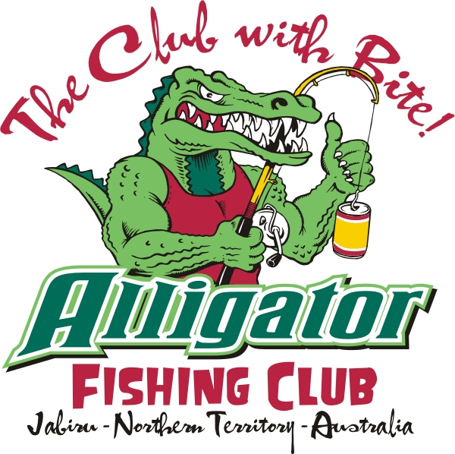
Alligator Fishing Club Challenge
7-8th September 2012
This is a catch and release competition proudly brought to you by the Alligator Fishing Club Inc. This competition includes Barramundi, Snapper, Jew Fish & Saratoga. Teams of four
The cost of entry per competitor is $120 for adults and $80 for children (under16). The entry fee includes a long sleeve fishing shirt, hat, stubby cooler, lures, stickers, and a measuring stick for each boat, breakfast, dinner and live entertainment from Doctor Elephant on the Saturday.
Prizes will be awarded for Biggest catch (Male/Female/Junior), best team & boat name, best costume, mystery prizes & many more.
The “Grog Monster” will be providing a BBQ breakfast on Saturday morning at the Jabiru Lake starting at 4:30am going through till 7:00am then at the South boat ramp at 8.30am. A dinner will be provided at the JSSC on the Saturday night Presentations for competitors and prepaid guests.
Extra shirts $50 & dinner vouchers for Saturday night are available at the time of registrations for non-competitors – Please advise Katrina when registering. (Non competitor’s $25 adults & Children under 12 - $10).
MEAL VOUCHERS MUST BE PRE PURCHASED FOR NON COMPETITORS
Open to members of the Alligator Fishing Club ONLY. Feel free to join!
If you are not a member of the AFC you will need to join for insurance purposes.
Family - $50 Single - $20. Membership forms available from Committee Members & JSSC
For any queries or questions please contact Katrina Bangay 0421 814 462
NOMINATIONS CLOSE 26/06/2012 - No Late Nominations Excepted
NOMINATION FORM
Team Name: …………………………………….. Boat Name: ………………………………
 | FULL NAME | T-Shirt Size | Junior | Email Address
Captain
First Mate
Deck Hand
Deck Hand

Emergency Contact Person: ………………………………………………………………… Phone: …………………………………………………….
Captains Phone No: ………………………………………
Captains Postal Address: ………………………………………………………………………………………………………………………………………….
Boat Length………………………………………… Make……………………………………………………..
Extra Meals: Adult ($25) …………… Child ($10) …………….
Extra Shirts :( $50) ………………………………………………………………………………………………………………………………………………
Return with full payment, no later the 26/06/2012to Katrina Bangay or Jenna Gollan- 2 Sergison St Jabiru (Including payment for extra shirts or meals)

