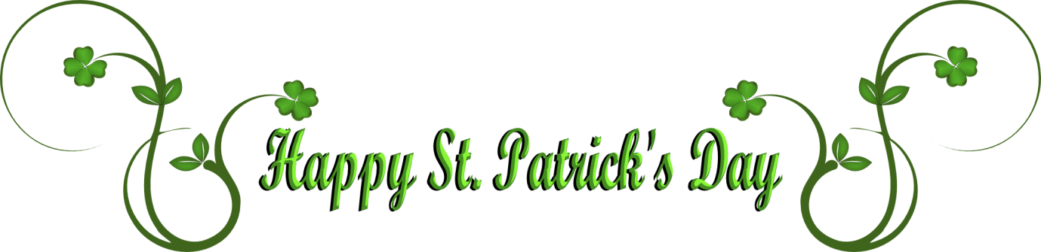

Friday 13th and Saturday 14th March 2020
Starters
Homemade Irish onion soup topped with toasted blue cheese soda bread (v)

Potato pancake topped with a fried egg

Guinness battered Dublin bay prawns with chive and garlic mayonnaise

Flat mushroom filled with black pudding, leek and bacon lardons topped with Irish cheese

Mains
Slow cooked Irish stew

Pork chop on braised red cabbage with apple, bacon and a balsamic glaze

Poached smoked haddock on colcannon with poached egg and chive butter

Flat field mushroom rarebit with mashed potato and thyme gravy (v)

Desserts
Homemade Irish cream chocolate mousse

Homemade marmalade bread and butter pudding with Irish whiskey cream

Homemade Irish apple tart with Chantilly cream

Irish Cheese Selection

Two Courses £17.95 Three Courses £20.95
