Marsha L Hickey, DDS
“Providing Professional and Friendly Dental Care in Knoxville”

Welcome to Downtown Dental, and thank you for choosing us to serve your dental care needs! You can relax in knowing that you have chosen professionals with a sincere interest in your dental health.
We want your dentistry to be a gentle, positive experience. That’s why we strive to provide you with comprehensive, comfortable dentistry. We take all the time necessary to answer your every question and concern. At Downtown Dental, you are more than just a patient or client. Our goal is to serve you as a friend, in a professional, yet caring and comfortable environment.
We offer a variety of services, all designed to give you a beautiful smile and great dental health to last a lifetime. From basic restorative and preventative care, to the latest in cosmetic procedures, we are committed to quality dental care and a positive experience.

Dr. Hickey: Dr. Marsha Hickey studied at Indiana University/Purdue University Indianapolis, and attended the Indiana University School of Dentistry where she graduated with clinical honors. She is a member of the Tennessee Dental Association, American Dental Association, and the International Association for Orthodontics. Dr. Hickey volunteers her time in the Knoxville community and is involved in programs such as Donated Dental Services and Give Kids A Smile. She has extensive post-graduate education in cosmetic dentistry, including Orthodontics (Invisalign ™ and Clear Correct ™ clear aligners, as well as traditional wire braces).
Our Staff: Each member of our team plays an important role in your care. All staff members regularly attend continuing education courses in order to provide the best up-to-date care for our patients.
Making an Appointment: To schedule an appointment, call 865-524-1655. If for any reason you are unable to keep your appointment, please call our office at least 24 hours in advance. This makes it possible to fill your spot with another patient. We reserve the right to charge for no shows.
Your First Visit: For your first visit, please plan to arrive at least 15 minutes early to provide information about your medical history. Please bring any medication information with you so we can enter the information into your records. We also need information about your insurance coverage. Please bring your insurance information with you.
Insurance: Your dental insurance is a contract between you and your insurance provider. As a courtesy to our patients, we will complete and submit necessary paperwork. Please keep in mind that your insurance may pay all, some, or none of your bill. You are responsible for paying any charges not covered by your insurance. Should you have any questions, concerns, or complaints regarding your coverage, please contact your insurance carrier directly.
Confidentiality: Dental Information is confidential and only released with your consent. All of the information that we obtain is important for accurately assessing your dental needs.
Payment: Payment is due at each visit. We accept cash, checks, and most major credit cards. We also offer payment plans at very affordable rates.
Office Hours: Office hours are Monday through Thursday 7:30 am – 4:30 pm.
Parking: Free parking is available right at our front door, and all around the Cherokee Mills business complex.
Satisfaction: We hope this information helps. Keep this brochure handy, and refer to it when necessary. Of you have any questions or concerns, please don’t hesitate to contact us. Your suggestions and comments are always welcome, as your satisfaction is our goal. We look forward to welcoming you to our dental family!
Downtown Dental – Knoxville
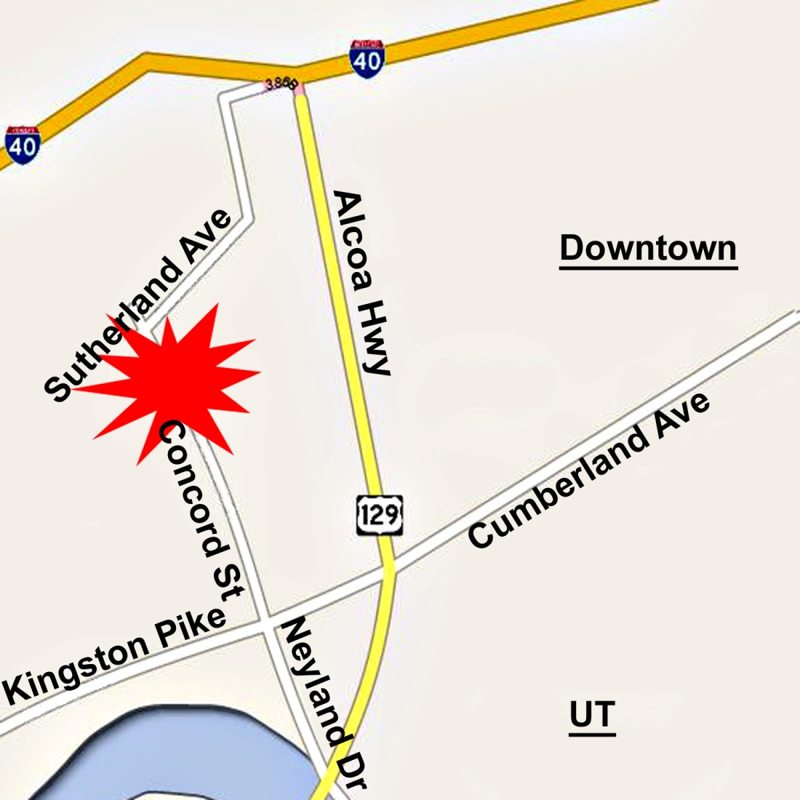
123 N Concord Street
Knoxville, TN 37919
865-524-1655
www.DowntownDentalKnoxville.com
Office@DowntownDentalKnoxville.com

We are located on the backside of the Cherokee Mills business complex, which is at the corner of Sutherland Avenue and Concord Street. Downtown Dental is just north of the railroad tracks.
PATIENT REGISTRATION
PLEASE COMPLETE THE FOLLOWING CONFIDENTIAL INFORMATION

Patient’s Name _______________________________________________________ Date ______________
Patient’s Birthday ________________________ _____ Social Security Number ______-______-______
SINGLE MARRIED SEPARATED WIDOWED DIVORCED
Email______________________________________________________
Home Address _________________________________________________________________________________
Home phone__ _____________ Cell Phone _____________ Text notifications from our office OK? __________
Employer _____________________________________________ Occupation _____________________________
Work Address _____________________________________________________ Work phone _________________
Spouse Name ________________________________________________________________________________
Spouse Birthday ________________________ __ Social Security Number _______-_______-_______
Spouse Email ________________________________________________
Spouse Employer _________________________________________ Occupation ________________________
Work Address ______________________________________________Work Phone _______________________
SECONDARY COVERAGE
Employee Name _________________________________
Insurance Company ______________________________
Policy No. ______________________________________
Group No. ______________________________________
Insurance Co. Phone No. __________________________
Coverage: Family Individual
PRIMARY COVERAGE
Employee Name _____________________________
Insurance Company __________________________
Policy No. __________________________________
Group No. __________________________________
Insurance Co. Phone No. ______________________
Coverage: Family Individual
In case of an emergency please contact: Name: ______________________________________________________
Home phone ____________________ Cell Phone ____________________ Work phone ______________________
Who recommended you to Downtown Dental, Marsha L Hickey, DDS ? _____________________________________
Who is responsible for this account? _________________________________________________________________
The information I have provided is complete and accurate to the best of my knowledge. I consent to whatever procedures are deemed necessary to diagnose my oral condition. I agree to be responsible for payment of all services rendered. I authorize a credit check, should I ask for credit.
Patient Signature _______________________________________________ Today’s Date ________________
MEDICAL DENTAL HISTORY
Date __________________ Physician’s Name __________________________________________________
Patient’s Name ________________________________________________________________________________
Premed Required? Yes No Reason ____________________________________________________
Premed type:____________________ Dosage ___________________________
Allergy to: Latex Medications _________________________________
Other _______________________________________________

Current medications: Prescription, over-the-counter, herbal
Medication | Dosage | Frequency
Attach a list if more medications are taken

Previous Dentist: _____________________
Last cleaning: _____________________
Last visit, if not cleaning: ______________
Primary source of drinking water: (circle)
City water At-home filtration
Bottled water Well water
How many soft drinks do you drink in a day?
Frequency of brushing:
What are some typical foods you eat between meals?
What type of beverages do you typically drink between meals?

Past and Current Medical Conditions,
mark all that apply YES
YES
Under physician’s care
Details:

Hospitalization/operation in last 5 years
Details:

Head/Neck/Mouth Injuries
Women: Pregnant
Women: Nursing
Women: Oral contraceptives
Heart trouble / Disease
Rheumatic Fever
Mitral valve Prolapse
Heart Surgery
Artificial Heart Valves
Pacemaker
Indwelling Defibrillator
Artificial Joints
History Of Organ Transplant
High Blood Pressure
BP:
Stroke
Bleeding Problem
Hemophilia
Anemia
Leukemia
Lung Disease
Emphysema
Shortness of Breath
Asthma
Sleep Apnea
Tuberculosis
Sinus Trouble
Cancer
Radiation Treatment to head/neck
Chemotherapy
Kidney Disease
Dialysis
Eating Disorder
Stomach: Reflux or Ulcer

Arthritis or Joint Disorder
Diabetes: Type_____________
Controlled? Yes No
Headaches
Depression:
Diagnosed? Yes No
Other Psychiatric Disorders
Neurological Disease
Convulsions/Epilepsy/Seizures
Fainting/Dizziness
Cerebral Palsy
AIDS/HIV positive
Alcohol or Chemical Dependency
Hepatitis: Type: A B C
Thyroid Disease
Glaucoma
Immunology Disease
Sjogren’s Disease
Fibromyalgia
Other Autoimmune Disease
(Lupus, Pemphigus, etc.)
Tobacco use:
Type: ___________________________
Amount: ________________________
If quit, what year? _________
Mouth Odors/Bad Taste
Dry Mouth/Excessive Thirst
Sensitive Teeth? Hot or cold or pressure or sweets
Cold Sores/Blisters/Oral Lesions
Are you aware of any lumps or swelling?
Frequency of Flossing:
Sore/Bleeding Gums
Use Fluoridated Toothpaste
One or more Fillings in the last three years
Family History of Extensive Decay
Have you had Orthodontics (braces/aligners)
Have you had Oral Surgery
Have you had any dental Implants placed
Treatment for Temporomandibular disorder
(TMD or TMJ)
Do you wear a Denture or Partial

Signature:________________________
Date: _______________________________

Acknowledgement of Receipt of
Notice Of Privacy Practices

* You may refuse to sign this Acknowledgement *

I, ___________________________________________________, have received a copy of this office’s Notice Of Privacy Practices.

Print Name ________________________________________________________________________________
Signature ________________________________________________________________________________
Date __________________

For Office use Only
_____________________________________________________________________________________

We attempted to obtain written acknowledgement of receipt of our Notice of Privacy Practices, but
Acknowledgement could not be obtained because:

Individual refused to sign

Communications barriers prohibited obtaining the acknowledgement

An emergency situation prevented us from obtaining the acknowledgement

Other (please specify)
_______________________________________________________________________________________________________________________________________________________________________________________________________________________________________________________________________________________

Financial Policy For our Patients
I authorize the Dentist to release any information including the diagnosis and the records of any treatment or examination rendered to me during the period of such dental care to third party payers and/or health practitioners.
I authorize and herby request my insurance company to pay directly to the dentist, insurance benefits otherwise payable to me.
I understand that my dental insurance carrier may pay less than the actual bill for services. I agree to be responsible for payment of all services rendered on my behalf or on behalf of my dependents.
I realize that failure to keep this account current may result in this office being unable to provide additional dental services and may require pre-payment for additional services. In the case of default on payment of this account, I agree to pay collection costs and reasonable attorney fees incurred in attempting to collect on this amount, or any future outstanding account balances.
Signature _____________________________________________________________________________
Date ___________________________
Our office wants all of our patients to be able to comfortable afford dental care. We proudly offer the following financial policy so that our patients can have the opportunity to decide which payment option best suits their needs.
Insurance: Our office will gladly work with you to help get the maximum benefit available to you. Most dental insurance plans do not cover 100% of your cost of treatment. Because of this, you will be asked to pay your deductible and co-payment for charges on the day service is rendered. We will estimate as closely as possible your coverage, but we can make no guarantee of any estimated coverage. Because your insurance is an agreement between you and your insurance company, the ultimate responsibility for all charges lies with you. If after 60 days the insurance company has not paid on the claim, you will be responsible for the total balance.
Payment Options:
1. Cash, Check, or Debit
2. Credit Card – Visa, Mastercard, Discover, and American Express
3. Care Credit – This is a medical credit card with an outside financing company that can be applied for, through our office or website. The application is filled out and within minutes we will know if it is approved or not. They offer interest-free payments for up to 18 months.
Notice of Privacy Practices
THIS NOTICE DESCRIBES HOW HEALTH INFORMATION ABOUT YOU MAY BE USED AND DISCLOSED AND HOW YOU CAN GET ACCESS TO THIS INFORMATION. PLEASE REVIEW IT CAREFULLY. THE PRIVACY OF YOUR HEALTH INFORMATION IS IMPORTANT TO US.

Our Legal Duty

We are required by applicable federal and state law to maintain the privacy of your protected health information. We are also required to give you this Notice about our privacy practices, our legal duties, and your rights concerning your protected health information. We must follow the privacy practices that are described in this Notice while it is in effect. This Notice takes effect April 1, 2011, and will remain in effect until we replace it.

We reserve the right to change our privacy practices and the terms of this Notice at any time, provided such changes are permitted by applicable law. We reserve the right to make the changes in our privacy practices and the new terms of our Notice effective for all health information that we maintain, including health information we created or received before we made the changes. Before we make a significant change in our privacy practices, we will change this Notice and provide the new Notice at our practice location, and we will distribute it upon request.

You may request a copy of our Notice at any time. For more information about our privacy practices, or for additional copies of this Notice, please contact us using the information listed at the end of this notice.
Your Authorization: In addition to our use of your health information for the following purposes, you may give us written authorization to use your health information or to disclose it to anyone for any purpose. If you give us an authorization, you may revoke it in writing at any time. Your revocation will not affect any use or disclosures permitted by your authorization while it was in effect. Unless you give us a written authorization, we cannot use or disclose your health information for any reason except those described in this Notice.
___________________________________________________________________

Uses and Disclosures of Health Information
We use and disclose health information about you without authorization for the following purposes.

Treatment: We may use or disclose your health information for your treatment. For example, we may disclose your health information to a physician or other healthcare provider providing treatment to you.

Payment: We may use and disclose your health information to obtain payment for services we provide to you. For example, we may send claims to your dental health plan containing certain health information.

Healthcare Operations: We may use and disclose your health information in connection with our healthcare operations. For example, healthcare operations include quality assessment and improvement activities, reviewing the competence or qualifications of healthcare professionals, evaluating practitioner and provider performance, conducting training programs, accreditation, certification, licensing or credentialing activities.

To You Or Your Personal Representative: We must disclose your health information to you, as described in the Patient Rights section of this Notice. We may disclose your health information to your personal representative, but only if you agree that we may do so.

Persons Involved In Care: We may use or disclose health information to notify, or assist in the notification of (including identifying or locating) a family member, your personal representative or another person responsible for your care, of your location, your general condition, or death. If you are present, then prior to use or disclosure of your health information, we will provide you with an opportunity to object to such uses or disclosures. In the event of your absence or incapacity or in emergency circumstances, we will disclose health information based on a determination using our professional judgment disclosing only health information that is directly relevant to the person’s involvement in your healthcare. We will also use our professional judgment and our experience with common practice to make reasonable inferences of your best interest in allowing a person to pick up filled prescriptions, medical supplies, x-rays, or other similar forms of health information.

Disaster Relief: We may use or disclose your health information to assist in disaster relief efforts.

Marketing Health-Related Services: We will not use your health information for marketing communications without your written authorization.

Required by Law: We may use or disclose your health information when we are required to do so by law.

Public Health and Public Benefit: We may use or disclose your health information to report abuse, neglect, or domestic violence; to report disease, injury, and vital statistics; to report certain information to the Food and Drug Administration (FDA); to alert someone who may be at risk of contracting or spreading a disease; for health oversight activities; for certain judicial and administrative proceedings; for certain law enforcement purposes; to avert a serious threat to health or safety; and to comply with workers’ compensation or similar programs.

Decedents: We may disclose health information about a decedent as authorized or required by law.

National Security: We may disclose to military authorities the health information of Armed Forces personnel under certain circumstances. We may disclose to authorized federal officials health information required for lawful intelligence, counterintelligence, and other national security activities. We may disclose to correctional institution or law enforcement official having lawful custody the protected health information of an inmate or patient under certain circumstances.

Appointment Reminders: We may use or disclose your health information to provide you with appointment reminders (such as voicemail messages, postcards, or letters).
______________________________________________________________________________

Access: You have the right to look at or get copies of your health information, with limited exceptions. You may request that we provide copies in a format other than photocopies. We will use the format you request unless we cannot practicably do so. You must make a request in writing to obtain access to your health information. You may obtain a form to request access by using the contact information listed at the end of this Notice. You may also request access by sending us a letter to the address at the end of this Notice. We will charge you a reasonable cost-based fee for the cost of supplies and labor of copying. If you request copies, we will charge you $2 for each page, $10 per hour for staff time to copy your health information, and postage if you want the copies mailed to you. If you request an alternative format, we will charge a cost-based fee for providing your health information in that format. If you prefer, we will prepare a summary or an explanation of your health information for a fee. Contact us using the information listed at the end of this Notice for a full explanation of our fee structure.

Disclosure Accounting: You have the right to receive a list of instances in which we or our business associates disclosed your health information for purposes other than treatment, payment, healthcare operations, and certain other activities, for the last 6 years, but not before April 14, 2003. If you request this accounting more than once in a 12-month period, we may charge you a reasonable, cost-based fee for responding to these additional requests.

Restriction: You have the right to request that we place additional restrictions on our use or disclosure of your health information. In most cases we are not required to agree to these additional restrictions, but if we do, we will abide by our agreement (except in certain circumstances where disclosure is required or permitted, such as an emergency, for public health activities, or when disclosure is required by law). We must comply with a request to restrict the disclosure of protected health information to a health plan for purposes of carrying out payment or health care operations (as defined by HIPAA) if the protected health information pertains solely to a health care item or service for which we have been paid out of pocket in full.

Alternative Communication: You have the right to request that we communicate with you about your health information by alternative means or at alternative locations. (You must make your request in writing.) Your request must specify the alternative means or location, and provide satisfactory explanation of how payments will be handled under the alternative means or location you request.

Amendment: You have the right to request that we amend your health information. Your request must be in writing, and it must explain why the information should be amended. We may deny your request under certain circumstances.

Electronic Notice: You may receive a paper copy of this notice upon request, even if you have agreed to receive this notice electronically on our Web site or by electronic mail (e-mail).

Questions and Complaints
If you want more information about our privacy practices or have questions or concerns, please contact us.

If you are concerned that we may have violated your privacy rights, or you disagree with a decision we made about access to your health information or in response to a request you made to amend or restrict the use or disclosure of your health information or to have us communicate with you by alternative means or at alternative locations, you may complain to us using the contact information listed at the end of this Notice. You also may submit a written complaint to the U.S. Department of Health and Human Services. We will provide you with the address to file your complaint with the U.S. Department of Health and Human Services upon request.

We support your right to the privacy of your health information. We will not retaliate in any way if you choose to file a complaint with us or with the U.S. Department of Health and Human Services.

Contact Officer: Susan Keith
Telephone: 524-1655
Fax: 546-3797
Address: 123 N Concord Street Knoxville, TN 37919

