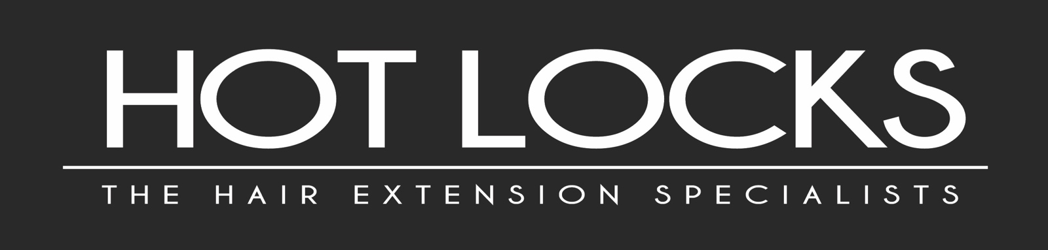
GDPR CONSENT FORM
Name
Address
Postcode
Mobile
Email

Due to changes in data protection regulation known as GDPR, we would like to review how we contact you with about special offers, news and updates, appointments and contact with you. Choose how you would like to be contacted below.
- You will still receive your messages and emails regarding your appointments
- You can change your settings any time
- We wont pass your details to any third parties

Everything listed below | Yes | No
Mailchimp – Newsletter with info, special offers, latest offers and updates about Hot Locks. | Yes | No
Booking System Reminders via text and email | Yes | No
Urgent Updates | Yes | No
Text Messages | Yes | No
Post | Yes | No
Emails | Yes | No
Social Media | Yes | No
Telephone | Yes | No
Before and After Pictures (back shots only) | Yes | No

Important
By selecting ‘YES’ you consent for us to contact you using the above methods and you can withdraw consent at any time.

Signed
Dated

