Press Kit for
Molten Blues Band
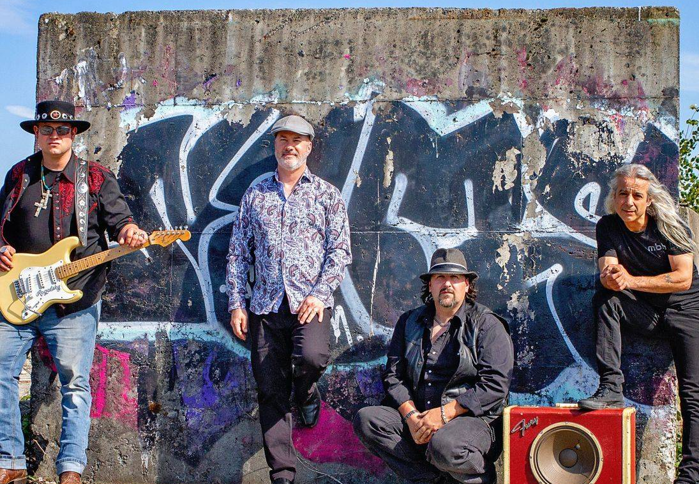

Highlights:
- Recipient of CIVL Radio’s Fraser Valley Music Award’s competition as “2017’s Best performing artist of the year”.
- Recipient of MNet Radio’s “2018 Best upcoming blues artist award”.

Video:
The Molten Blues Sampler: https://m.youtube.com/watch?v=QJEWWQ97lAE
Short Band BIO:
One of the West Coast’s “Hottest” and “Coolest” blues bands, these four very talented and professional performers blend their individual past accomplishments from various regions of Canada, with some driving southern Texas Shuffle rhythms and inspirations from New York’s Popa Chubby as well as Stevie Ray Vaughn, to create unique, interactive, energetic and entertaining shows.

Medium Band BIO:
One of the ‘hottest and coolest’ blues electric dance bands to come out of the Fraser Valley. It is not surprising that they received CIVL Radio’s Fraser Valley Music Award’s “2017’s best performing artist of the year” as well as MNet Radio’s “2018’s Best upcoming blues artist award”.
Molten Blues Band
They deliver a driving Texas-shuffle beat, supported with intricate bass lines, dazzling guitar work, and phenomenal keys and sax, all topped off with powerhouse vocals and some sweet harmonies.

Long Band BIO:
The Molten Blues Band is an electric blues band that was formed in Mission BC in early 2017. Later that same year, they won their first award, from CIVL Radio’s Fraser Valley Music Award’s competition as “2017’s best performing artist of the year”. They were honored again the following year as recipients of Mnet Radio’s “2018’s Best upcoming blues artist award”.

One of the West Coast’s “Hottest” and “Coolest” Fraser Valley blues bands, these four very talented and professional performers blend their individual past accomplishments from various regions across Canada, with some driving southern Texas Shuffle percussion and inspirations from New York’s Popa Chubby as well as Stevie Ray Vaughn, to create unique, interactive, energetic and entertaining shows.
Consummate crowd pleasers, their musicality, presentation, energy and enthusiasm infuse all their audiences’ live music experience.
Band Photos:
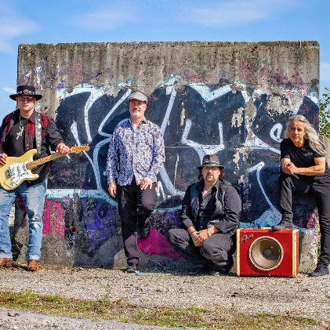 | 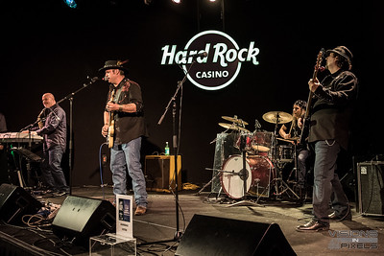 | 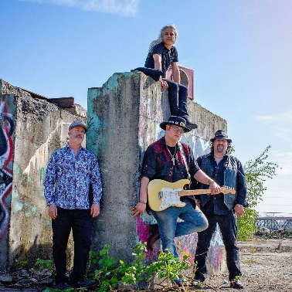 | 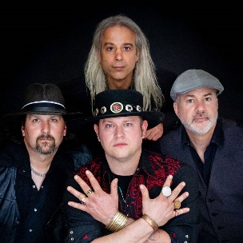
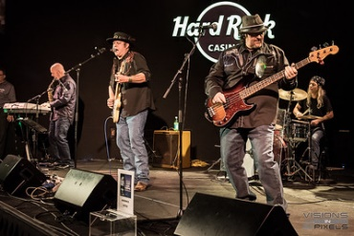 | 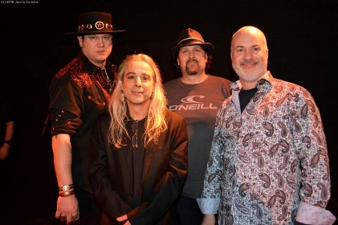 | 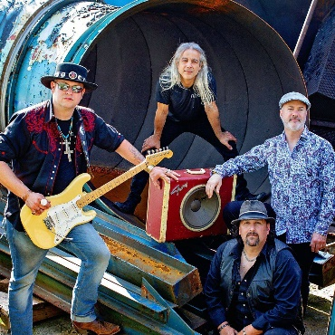 | 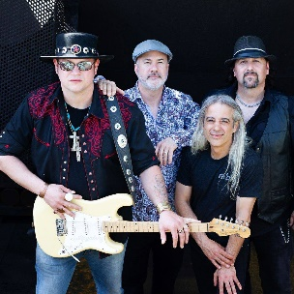

Social Media:
Facebook: https://www.facebook.com/themoltenbluesband
Website: https://themoltenbluesband.com/

Molten Blues Band
Member’s BIOs:

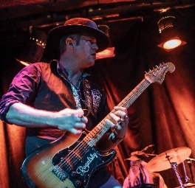 | Mike Rogalsky (guitar & vocals)  Born and raised in Vancouver BC, Mike is the band’s founder and brings a diverse skillset that combines traditional style rock of Brian May, with the driving Texas Blues Shuffle stylings of Stevie Ray Vaughan. He serves up electrifying lead guitar solos with his powerful vocals and a gregarious demeaner that mesmerizes audiences where-ever he performs.
Chuck Cave (keys & sax)
Steeped in the richness of Winnipeg’s music mecca, Chuck infuses intricate keyboards and emotive saxophone as well as creative embellishments to deliver some good old southern spice to keep everything cooking hot.

George Ringas (drums)
George hails from Toronto and has spent most of his adult life ‘sitting in the pocket’ right beside a selection of great bass players. This is where the Texas Shuffle engine sits that keeps driving you forward.

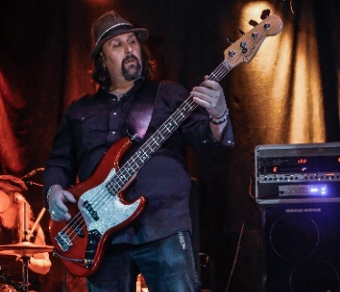 | Charles Mauviel (bass & harmonies)  From Canada’s capital city of Ottawa ONT, Charles weaves sophistication, finesse and energy throughout his soulful bass renditions. Even though he is busy helping George create a powerful foundation, his bass moves the shuffle along and he even has some spectacular riffs that will make you feel like you are flying.

Molten Blues Band
Member Photos:
Mike Rogalsky – Guitar & Lead Vocals:
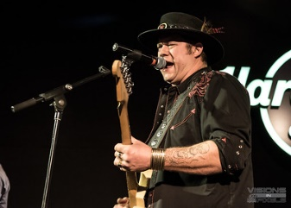 | 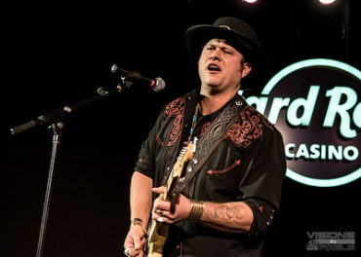 | 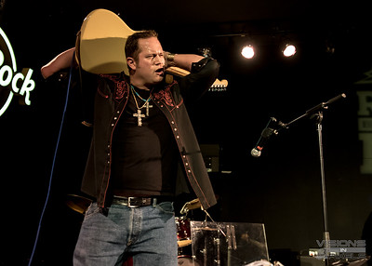 | 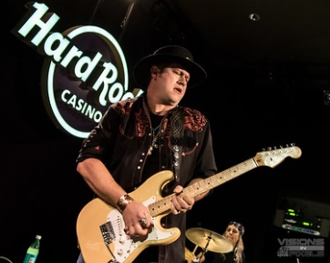
Chuck Cave – Keyboards and Saxaphone:
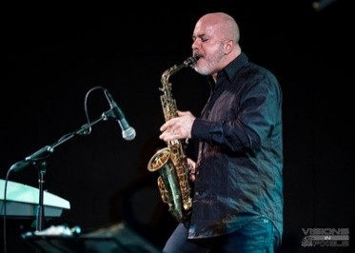 | 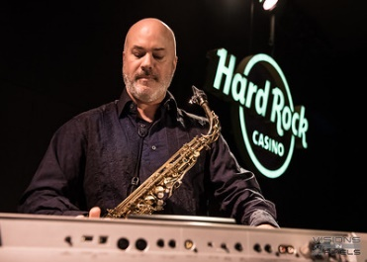 | 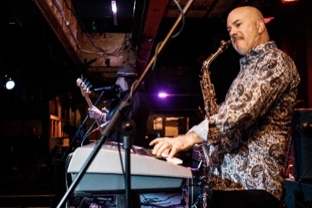 | 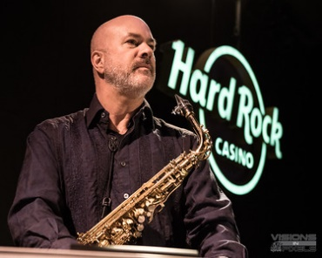
Charles Mauviel – Bass & Background Vocals:
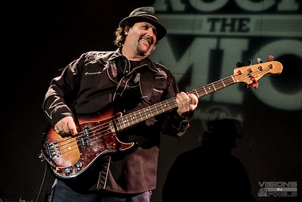 | 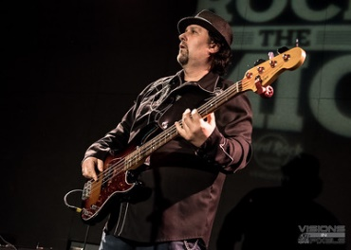 | 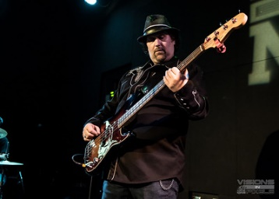 | 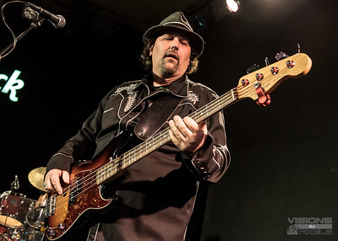
George Ringas – Drums:
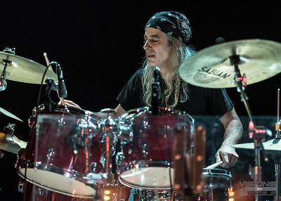 | 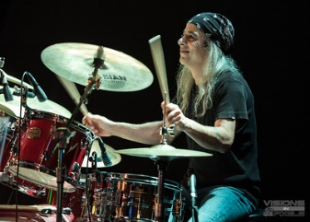 | 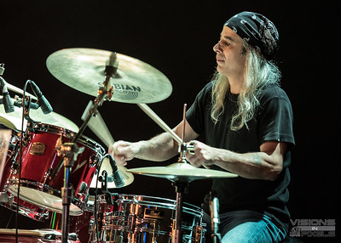 | 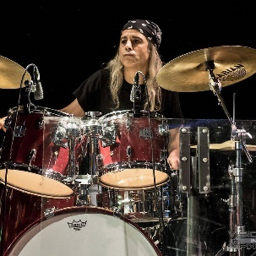

Molten Blues Band
Past Performances:

Festivals | Facilities
Aldergrove Fair  Fraser Valley Music Awards  Hatzic Music Festival  Hatzic Lake Weekend Bash  Heritage Park in Mission  Envision Concert Series  Mill Lake Concert Series at the Kariton Art Gallery  Mnet Radio Music Fest | The Backstage Lounge  Bob’s Steakhouse  Brothers Bowling & Billiards  Country Tire Car Show  Dewdney Pub (aka Church of the Blues)  Donegal’s Irish Pub  The Flamingo – Black Bird Room  Fraser Valley Blues Society  Hard Rock Casino Vancouver Asylum Lounge  Hole in the Sky Tour  Kennedy’s Pub  The Railyard  Silverdale Concert Hall  The Stage Sunshine Bowling Lanes  Private Events

Contact:
Mark Ardley  Band Representative  LittleHorse Entertainment  www.LittleHorseEntertainment.ca  cell: 1-604-996-8188 phone: 1-604-532-9637  eMail: Mark-Ardley@shaw.ca | The Molten Blues Band  https://themoltenbluesband.com/  cell: 1-604-897-0884  eMail: theMoltenBluesBand@hotmail.com

Stage Plot

Guitar amp Drums bass amp keys amp
Monitor

Guitar/lead vocal bass/vocal keys and sax

Monitor Mic monitor monitor Mic Monitor Mic on sax

