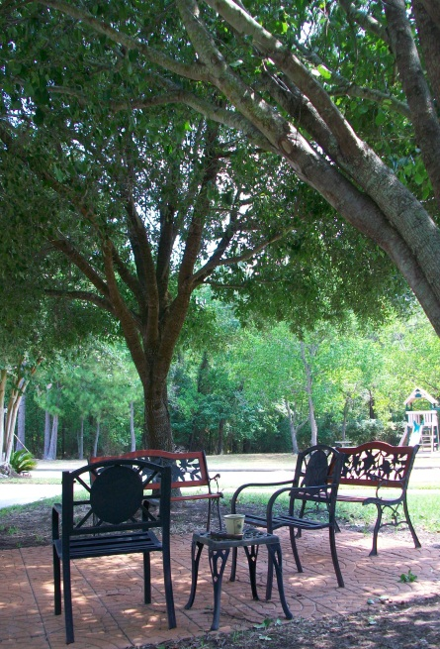

**Lakeview Pointe Offers a unique setting on Lake Conroe with quality and affordable one and two bedroom homes.**

**Come visit with us, see why you will choose to make this ~ Your New Home ~**

Showings are by appointment only.

Evening and Saturday appointments are available

Call today, to schedule your viewing.

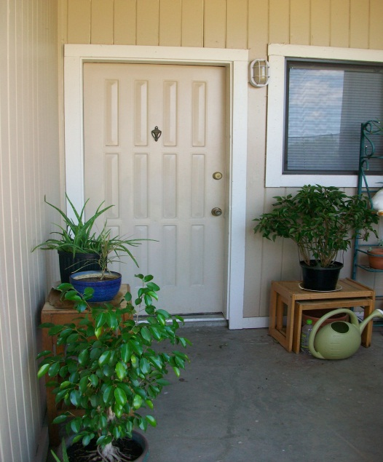

***The management and owners at Lakeview Pointe take pride in providing an enjoyable community for all our tenants.***

**936-588-6096**

Lakeviewpointe3@aol.com

**14949 Hwy 105 West**  
**Montgomery TX 77356**

**WWW.LakeviewPointeApartmentHomes.com**

Condo Style Living ~ At Apartment Prices

LAKEVIEW POINTE APARTMENT HOMES

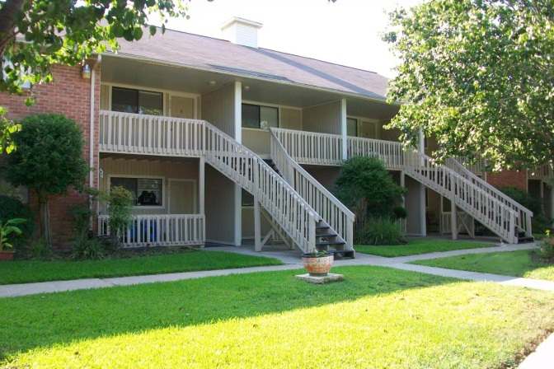

.

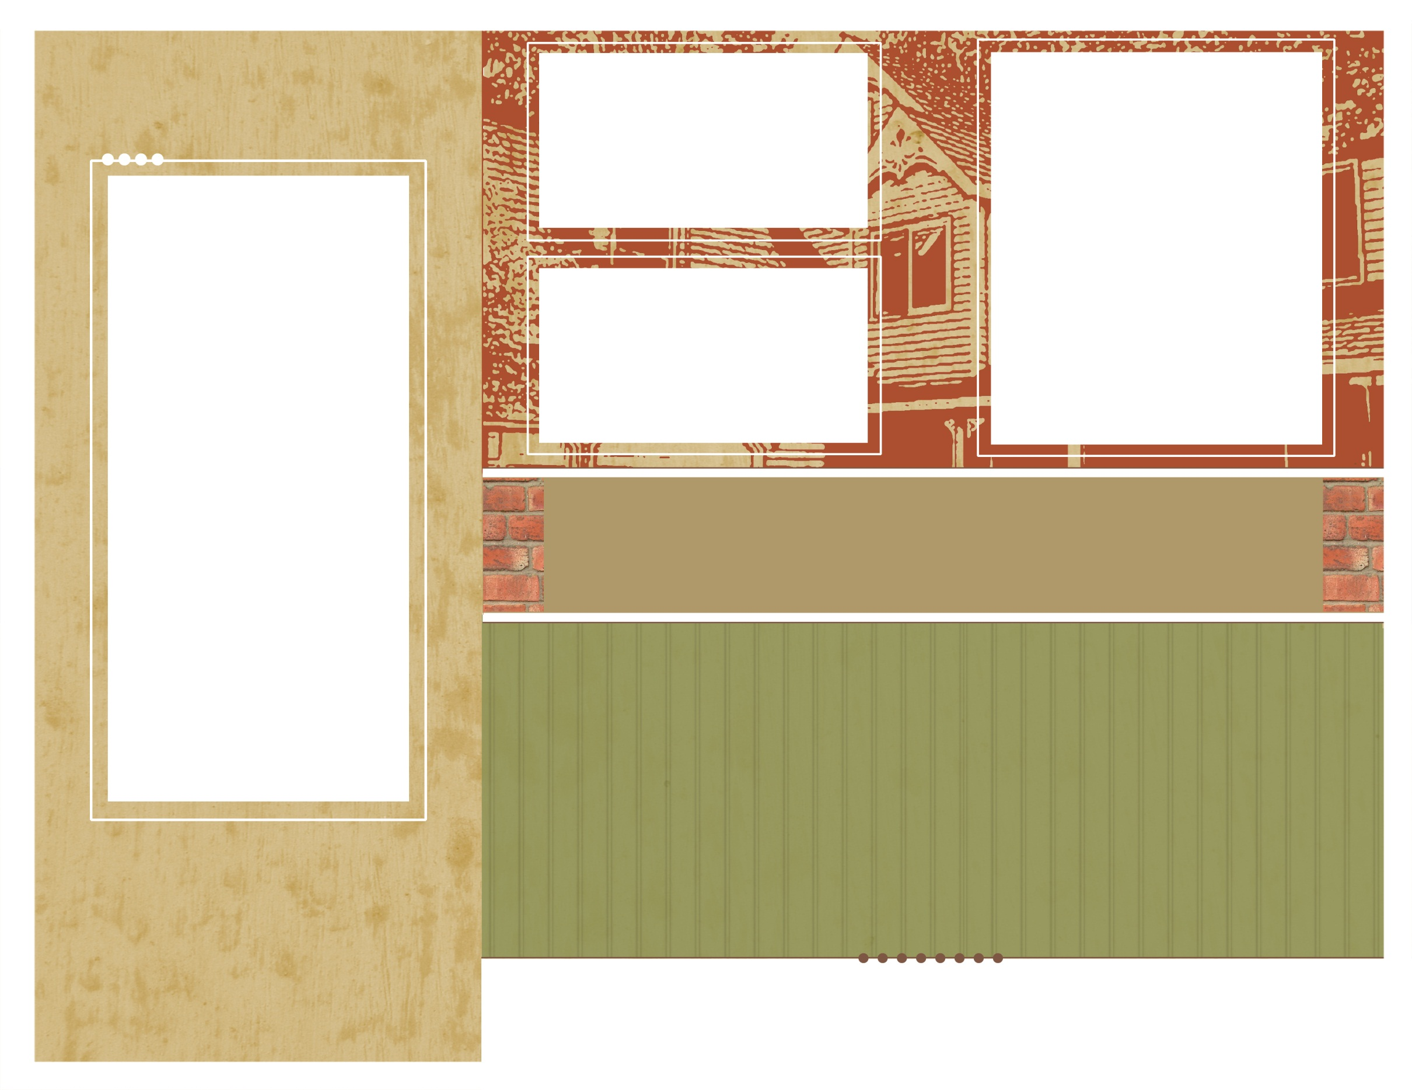

Exceptionally maintained and continually updated.

One Bedroom - One Bath

Two Bedrooms - Two Bath

#### We are located on Highway 105 West between the historic town of Montgomery and the city of Conroe.

#### Easy access to Interstate 45 will take you to The Woodlands or Houston.

#### Big City close, but you’re

#### “Living County”

**Lakeview Pointe is the alternative to “cookie-cutter” apartment living.**

**Our apartments are priced competitively for the quiet, relaxing home you want without paying for amenities you will never use.**

**Our small community of 28 units makes for an enjoyable living experience with attentive management and great neighbors**

**You will feel like you are in your own private condo. Each unit has its own covered, private patio with views of Lake Conroe, the meadows and acres of trees.**

**There are marinas, shopping and live music nearby.**

**Living here at LakeView Pointe is like being on vacation every day!**

* **Relaxing patios, with lake and park views.**
* **New carpet, new flooring\***
* **Warm colors, new two-tone paint.\***
* **15 ft. vaulted ceilings - chair rails and picture rails.\***
* **Washer / dryer hook-ups in every unit.**
* **Large shaded park and two BBQ areas.**
* **Some bills paid.**
* **His & hers closets in the master.**
* **Wood grain flooring and cabinets.**
* **Designated parking**
* **Conroe schools**
* **Great management**

**\*Most units**

wwwLakeviewPointeApartmentHome.com

Leave the city behind - come to Lakeview Pointe Apartments,

a unique setting offering affordable and quality one and two bedroom apartment homes.



.



Place real estate logos here