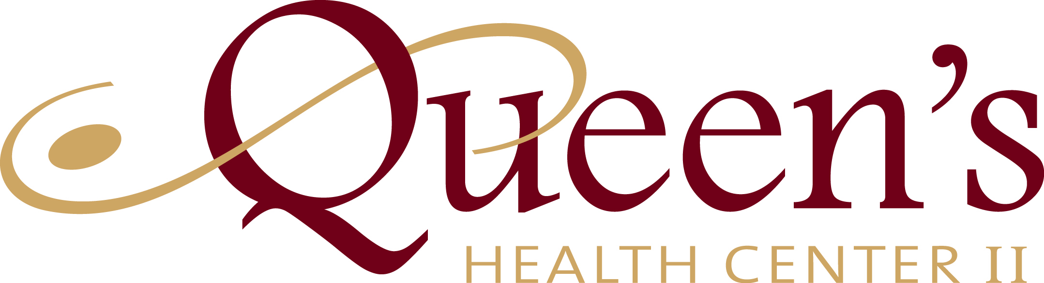

HOLD HARMLESS AGREEMENT

I understand that is an Independent Contractor and not an employee of Queen’s Health Center II (QHC II.)

I further understand and agree to hold harmless Queen’s Health Center II, their staff, and employees, from any and all liability, loss, damages, costs, or expenses which may be sustained, incurred, or required arising out of the actions performed by in the course of my therapeutic massage (shiatsu, reflexology or adjustment) while at QHC II.

Client Name: PRINT

Client Signature:

Date:

Independent Contractors:

Alexis Christy
Tina Caperelli
Joanna Barnes
Laura Midgley

