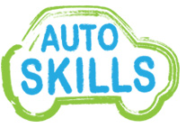 | 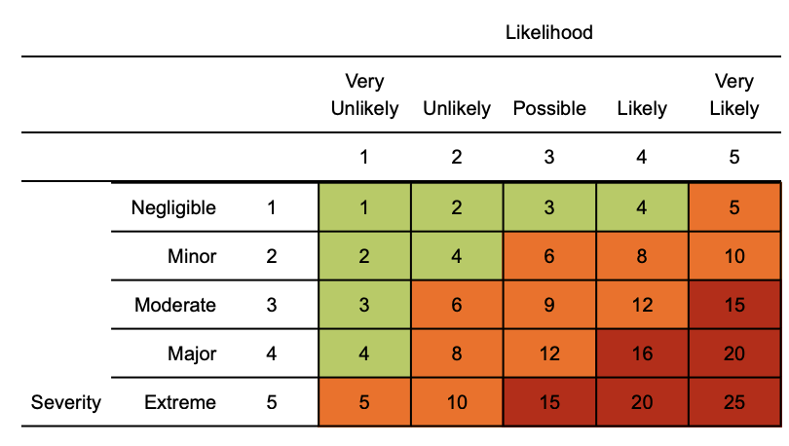  Risk matrix used in risk assessment below  RR = residual risk

Coronavirus (COVID-19) Risk Assessment

Contents:
Exposure risk
Travel
Access & egress
Welfare / Hygiene
Social distancing (2m and working within 2m of workers)
Manual Handling
First aid

Assessment date: 14th May 2020
Review date: 14th June 2020
Version: 1.0

Hazard | Risk | Control measures | RR | Persons at risk
Exposure from others due to:  1) Living with someone with a confirmed case of COVID-19.  2) Have come into close contact (within 2 metres for 15 minutes or more) with a confirmed case of COVID-19.  3) Being advised by a public health agency that contact with a diagnosed case has occurred. | 4  x  3  =  12 | - Continue following government action of self isolation and only to leave house on the following circumstances: for medical reasons; to shop for necessary food supplies; for exercise;; and for work where you cannot do this at home  - Any existing individual risk assessments (disability, young persons or new / expectant mothers) to be reviewed  - Maintain contact with line management and Human Resources (HR) and to follow company policy / guidance.  - Travel is only required where you cannot work from home. Use private transportation, cycle or walk. As a last resort public transport to be used as a minimum and to implement social distancing where possible.  - To continue following ongoing government guidance  - Stay at home and only attend hospital in an emergency. Do not attend GP surgery and phone NHS line (111) if further advice is required  - Company to ensure extremely clinically vulnerable persons do not come to work and continue to shield themselves whilst following their specific medical advice issued to them  - Follow good NHS hygiene measures at all times  - Avoid all visitors to your home unless they are providing a medical requirement  - Do not approach delivery staff, allow packages to be left on the doorstep  - Do not take any antibiotics as they do not work against viruses. | 4  x  1  =  4 | All staff and students
Suspected case whilst working on site | 4  x  4  =  16 | If any member of staff or a student develops a high temperature or a persistent cough while at Auto Skills, they should:  - Return home immediately  - Avoid touching anything  - Cough or sneeze into a tissue and put it in a bin, or if they do not have tissues, cough and sneeze into the crook of their elbow.  - They must then follow the guidance on self-isolation and not return until their period of self-isolation has been completed.  - The work area should receive deep cleaning and social distancing must be maintained | 4  x  1  =  4 | All staff & students
General travel | 4  x  4  =  16 | - Do not travel unless you cannot work from home or deemed a key worker – implement teleconferencing for meetings.  - Where an individual has recently travelled abroad, they must self isolate for 14 days.  - Continue to follow any further national government advice provided  - All persons to limit their use of public transport. Where travel is essential, use private single occupancy where possible, cycle or walk. | 4  x  1  =  4 | All staff & students
Access / egress to site | 4  x  4  =  16 | - Ensure no extremely clinically vulnerable persons attend site.  - Stop all non-essential visitors  - Log all visitors to site.  - Introduce staggered start and finish times where possible to reduce congestion and contact at all times.  - Monitor site access points to enable social distancing.  - Remove or disable entry systems that require skin contact e.g. fingerprint scanners and look to increase cleaning or removal of common ‘touch points’ on site  - Require all staff and students to wash their hands before entering or leaving the site.  - Regularly clean common contact surfaces in reception, office, and workshop. | 4  x  1  =  4 | All staff & students
Poor hygiene | 4  x  4  =  16 | - Hands must be washed thoroughly and regularly, using soap and water for at least 20 seconds.  - All persons reminded to avoid touching face/eyes/nose/mouth with unwashed hands and to cover any cough or sneeze with a tissue then throw it in the bin.  - Hand washing facilities to be checked and cleaned regularly.  - Suitable and sufficient rubbish bins for hand towels to be provided, with regular removal and disposal.  - Toilet facilities to be cleaned and sanitised periodically throughout the day. | 4  x  1  =  4 | All staff and students
Canteen - exposure from large numbers of persons | 4  x  4  =  16 | - All persons to stay on site once they have entered it and not use local shops to limit contact with others.  - Dedicated eating areas will be identified on site.  - Hand cleaning facilities will be available at the entrance of any room where people eat and should be used by all persons when entering and leaving the area.  - All persons will be asked to bring pre-prepared meals and refillable drinking bottles from home.  - All persons should sit 2 metres apart from each other whilst eating and avoid all contact.  - Drinking water will continue to be provided and there will be enhanced cleaning measures of the dispenser.  - All rubbish must be put straight in the bin and not left for someone else to clear up  - All areas used for eating must be thoroughly cleaned at the end of each break and shift, including chairs, door handles, vending machines and payment devices. | 4  x  1  =  4 | All staff & students
Manual handling - dual lifting | 4x4 = 16 | - Always consider if the task can be performed with one person using mechanical aid  - Ensure the individual(s) are fit for work prior to commencing task  - Break down the load where possible so that one person can comfortably carry  - Assess route so 2 metre social distance can be maintained whilst moving the load  - Where dual lifts cannot be avoided, lift facing away from each each or side by side rather than face to face where possible  - Where teams are used, try to keep to fixed teams / partnering to prevent cross over of workers.  - Where PPE is to be used, this is on an individual issue and items should not be shared. | 1x4 = 4 | All staff and students
Taking / accepting deliveries - contact with materials and persons (driver) | 4x4 = 16 | - Maintain 2m social distancing when accepting deliveries.  - Deliveries to be placed outside main door to reduce exposure to drivers  - Hand washing and sanitizer measures available to maintain good hygiene | 4x1 = 4 | All staff / students
Working in local vicinity of other persons (maintaining 2m distancing) | 4  x  4  =  16 | - Starting and finishing times are to be staggered and reviewed to ensure no build up of staff / teams in areas.  - Any person who is unwell with symptoms of Covid-19 should not attend Auto Skills.  - Work design to be reviewed regularly to identify any safer ways to move around site.  - Work programme to be reviewed to identify any work reordering that would limit exposure to others.  - Tasks are to be rearranged to enable them to be done by one person or as small number of persons without compromising safety measures.  - Maintain social distancing measure of 2 metres from each other as much as possible with supervision in place to monitor compliance  - Avoid skin to skin and face to face contact.  - Above hygiene measures and additional cleaning schedules to remain (regularly washing hands for at least 20 seconds with soap and warm water).  - Any health concern to be raised immediately to senior staff. | 4  x  1  =  4 | All staff / students
Working within 2 metres of other people | 4  x  4  =  16 | - Always consider if the task can be performed differently without having to breach the 2m social distancing rule  - Workers are to limit face to face working and work facing away from each other when possible  - Limit the frequency of working within 2m to an absolute minimum and ensure it is for strictly low intensity, sporadic work where exposure to this distance is less than 15 mins.  - All persons encouraged to conduct dynamic risk assessments whilst completing the work and speak up if there is a safer way of completing the task.  - All equipment to be thoroughly cleaned prior and after using it.  - Increased ventilation will be provided within enclosed spaces.  - Reusable PPE should be thoroughly cleaned after use and not shared between workers. These should be stored in suitable places.  - Single use PPE should be disposed of so that it cannot be reused and to control potential contamination is controlled (waste removed by a responsible, approved contractor).  - Any persons deemed clinically vulnerable should never work within 2m of persons and preference should be given to whether any change in task can allow an individual to work from home where possible. | 4  x  2  =  8 | All staff & Students
First aid - including mental health | 4x4 = 16 | - First aid contents to be monitored to ensure adequate supplies remain  - First aid and cover arrangements to be reviewed  - First aider certificates to be checked for validity and understand amended practices in regards to attending a casualty during COVID (such as revised CPR methodology).  - Emergency plans on site and communicated so all staff understand what action to take in the event of a suspected or confirmed case of COVID 19.  - considered | 4x1 = 4 | All staff & students

If in England call NHS on 111, if in Scotland call your GP or NHS 24, If in Wales call 0845 46 47 or 111 or if in Northern Ireland contact 0300 200 7885 where you will be assessed by an appropriate specialist. NHS guidance is that you do not go directly to your GP surgery, community pharmacy or hospital unless an emergency occurs

