Zika and the Dramatic Increase of Abortion in Countries of South America, Especially Brazil
Jeison Castro Amurrio
George Mason University
May 2017

Introduction
Zika Virus is a disease caused by the bite of an infected Aedes species mosquito like the Ae. aegypti and Ae. Albopictus (“About Zika,” 2017). Also, one of the biggest problem about Zika virus is that “[t]here is no vaccine or medicine for Zika” (“About Zika,” 2017). Zika virus can be transmitted by many ways: mosquito bites, sex, and “[f]rom a pregnant woman to her fetus” (“About Zika,” 2017). According to CDC, Zika virus may also be transmitted by blood transfusion, but it is not 100% confirmed (“Overview,” 2017). In addition, infected mosquitoes with zika cannot stand the environmental conditions in places with elevations above 2,000 meters ("Zika Virus in Brazil,” 2017).
According to The World Factbook, Brazil is the largest country in South America, and has around 205 million people, of which 85% of the population are urban ("South America: Brazil,” 2017). Moreover, the birth rate has been declining since 1960s, which will cause the elderly to “compose an increasing share of the total population” by 2025 ("South America: Brazil,” 2017). In addition, the World Bank said that the fertility rate of Brazil in 2015 was 1.79 births per woman (“Fertility rate, total (births per woman),” 2017). Brazil has a climate that is mostly tropical, and a land that is mostly flat ("South America: Brazil,” 2017). However, the highest elevation is Pico da Neblina, which is around 2,994 meters ("South America: Brazil,” 2017).
Background
In Uganda, 1947, Zika virus was first identified in rhesus monkeys, but it was first reported in humans in Africa and Asia in 2007 (Jaenisch, Rosenberger, Brito, Brady, Brasil, & Marques, 2017, p.191). Also, it was called Zika virus, because the virus originated in the Zika Forest area of Uganda (Yun, 2017, p. 204). Then, the epidemic of Zika virus reach French Polynesia, and was present from 2014 to 2015 (Jaenisch et al., 2017, p.191). Lastly, the Zika virus emerged in Brazil and other countries in South America in 2015 (Jaenisch et al., 2017, p.191).
In addition, Zika virus came to Brazil (Northeast region) most likely during the World Cup in 2014 (Diniz, 2016, p.22). As a result, many cases of babies born with microcephaly have increased since October 2015 (Jaenisch et al., 2017, p.191). For example, by the end of April 2016, 1,912 cases of microcephaly were reported in Recife, Brazil (Jaenisch et al., 2017, p.191). Also, 14 states in Brazil had reported between 444,000 and 1,300,000 suspected Zika cases by December 2015 (Yun, 2017, p. 205).
Since the emerging of Zika virus in Brazil, it “has spread explosively across South and Central America and the Caribbean Islands” (Yun, 2017, p. 205). As a result, many cases of neonatal malformations and neurological disorders have increased in those places (Yun, 2017, p. 205). The increase of Zika cases in those places forced the World Health Organization (WHO) to announce “a ‘Public Health Emergency of International Concern’ for the nine months beginning in February 2016 (Yun, 2017, p. 205). Then, Zika cases reached North America, and by July 2016, the first case of Zika was confirmed in southern Florida (Yun, 2017, p. 205).
Later, by January 2017, 211 cases of Zika were confirmed in Florida (Yun, 2017, p. 205). The second of the United States affected by Zika virus was Texas, with the first Zika case reported in November 2016 (Yun, 2017, p. 205). In January 12, 2017, 48 Pan-American countries and territories reported more than 170,000 cases of Zika and 150,000 suspected cases of Zika (Yun, 2017, p. 205).
The following picture shows the historical timeline of Zika from Uganda (1947) to the emergence of Zika in Brazil (2015), which was explained above (“Countries and territories,” 2016).
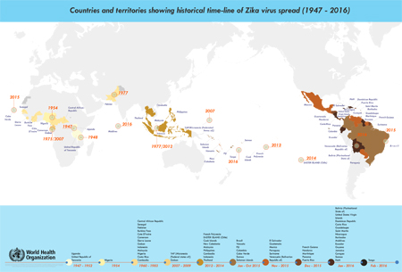
In south America, Zika is affecting pregnant women greatly. In Brazil, since the outbreak, there are “1,845 confirmed cases of congenital Zika syndrome in babies” (“More than half of women,” 2017). As a result, most of the women don’t want to get pregnant (“More than half of women,” 2017). Also, women in north-eastern Brazil have more cases of Zika than any other regions in Brazil (“More than half of women,” 2017). In Brazil, abortion is common and ranges from 100,000 to over a million every year (Hennigan, 2016, p. 3). For example, there were between 684,000 and 860,000 abortions in 2013 (Hennigan, 2016, p. 3).

Health implications
People who have Zika virus don’t show symptoms or may only show mild symptoms (“Overview,” 2017). However, only one in five people will develop symptoms, which will take between three to 12 days after the bite of the infected mosquito (Diniz, 2016, p. 22). The symptoms are fever, rash, joint pain, red eyes, muscle pain, and headache (“Overview,” 2017). Moreover, Zika virus is difficult to diagnose in people, because “[t]hese symptoms are similar (although milder) to those of other viral infections transmitted by this mosquito, such as dengue and chikungunya” (Diniz, 2016, p. 22).
Zika virus can only be founded in the blood of the infected person for a short period of time, such as a week or more depending on the person, since the bite of the infected mosquito (Diniz, 2016, p. 22). In addition, people who have Zika virus hardly die from the Zika symptoms, and don’t need to be hospitalize (Diniz, 2016, p. 22). In pregnant woman, Zika can cause birth defects like neurological malformations (microcephaly) and some pregnancy issues like miscarry and stillbirth (“Overview,” 2017). Microcephaly is when the baby’s head is smaller than usual because the “baby’s brain has not developed properly during pregnancy or has stopped growing after birth” (“Facts about Microcephaly,” 2017).
According to the Center for Disease Control and Prevention (CDC), it suggests that Guillain-Barré Syndrome (GBS) can be caused by Zika (“Zika and Guillain-Barré Syndrome,” 2017). GBS causes nerves cells of people to be destroyed by their own immune system, which will cause “muscle weakness, and sometimes, paralysis” (“Zika and Guillain-Barré Syndrome,” 2017). However, CDC is still investigating more about the relationship between Zika and GBS, and much research has already shown that many countries who experience outbreaks of Zika also have an increase of GBS in people (“Zika and Guillain-Barré Syndrome,” 2017).
Methodology
The first case was published by Debora Diniz, Marcelo Medeiros, and Alberto Madeiro. In June 2016, they conducted a national survey, which used many different methods (Diniz, Medeiros, & Madeiro, 2017, para. 1). One method was a face-to-face questionnaire, which helped “to collect sociodemographic and opinion and practices data about reproductive health and pregnancy” (Diniz et al., 2017, para. 1). Another method was a secret ballot box, which helped “to gather information related to abortion experiences” (Diniz et al., 2017, para. 1). They also gathered information of literate urban Brazilian woman between the ages of 18 to 39 years from a nationally representative sample of the year 2002, which was equivalent to 83% of the total female population (Diniz et al., 2017, para. 1).
The second case is a case series conducted by the Infectious Diseases Pathology Branch at the US Centers for Disease Control and Prevention in Atlanta and Georgia, which consist in the examination of tissues samples (formalin-fixed paraffin-embedded) from five cases in Brazil (Martines, Bhatnagar, Davi, Iglezias, Kanamura, & Zaki, 2016, p. 898). For example, those specimens were analyzed by histopathological examination, and immunohistochemical and reverse transcription polymerase chain reaction (RT-PCR) assays (Martines et al., 2016, p. 898).
These five cases are the following: the first and second case were from two newborn babies with microcephaly and arthrogryposis, who died after birth, the third case was a two-month-old baby, the fourth case was a placenta from a spontaneous abortion, and the fifth case was another placenta from a spontaneous abortion (Martines et al., 2016, p. 898). Arthrogryposis is disorder that is congenital and non-progressive, but involves many pathologies that affect many parts of the body causing joint stiffness and contractures (Ferguson, 2013, p.171).

First supporting case/example
The goal for the first case was to make people aware of the “pregnancy intentions among women in Brazil” (Diniz et al., 2017, para. 2). The results of the case were the following: 56% of women said that they tried or had avoided pregnancy because of the epidemic of Zika, 27% of the women said that they tried or had avoided pregnancy not because of the epidemic of Zika, but for other reasons, and 16% of the women said that they didn’t plan to get pregnant, despite the prevalence of the Zika epidemic in Brazil (Diniz et al., 2017, para. 2). The following picture shows the results in a graphic as group A (56%), group B (27%), and group C (16%) for different pregnancy intentions of women in Brazil that was explain early in this paragraph (Diniz et al., 2017).
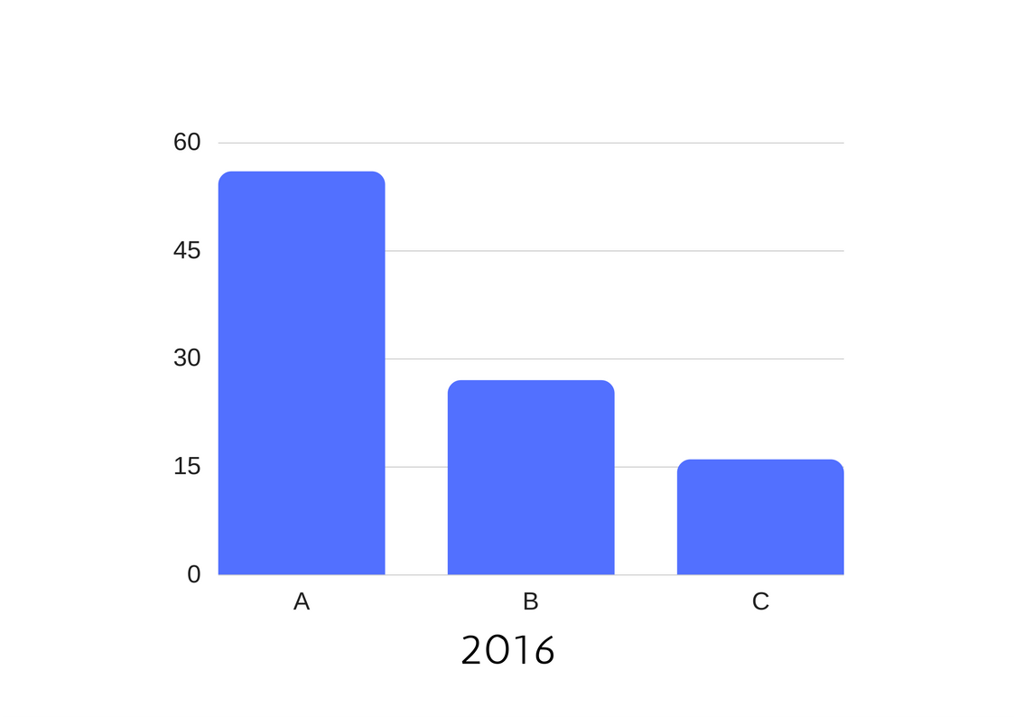
This case shows that Northeastern women have a higher percentage in avoiding pregnancy than Southern women; 66% of women in Northeastern and 46% of women in Southern regions (Diniz et al., 2017, para. 2). Moreover, there was not a significant difference between main religions like Catholic with 58%, and Evangelic with 55% of women who avoid pregnancy because of Zika (Diniz et al., 2017, para. 2). On the other hand, the case shows a great difference among racial groups like black with 64%, brown with 56%, and white with 51% of women who avoid pregnancy because of Zika (Diniz et al., 2017, para. 2). The research suggests that the government of Brazil should re-evaluate the policies that affect the accessibility of contraception information and methods, and criminalization of abortion (Diniz et al., 2017, para. 3).
Second supporting case/example
The goal for the second case is to prove the relationship “between Zika virus infection and different congenital central nervous system malformations, including microcephaly as well as arthrogryposis and spontaneous abortions” (Martines et al., 2016, p. 898). The result of these five cases in Brazil, in 2015, showed that all those congenital malformations and pregnancy complications were caused by the Zika virus (Martines et al., 2016, p. 902). Also, these findings show evidence “that maternal Zika virus infection during the first trimester of pregnancy can result in placental and fetal damage and loss” (Martines et al., 2016, p. 903).
In addition, the report of these cases provides information about the identification of the viral RNA and antigens of the Zika virus in the brain tissues, which were localized in the glial cells and neurons in all microcephaly cases (Martines et al., 2016, p. 898). Also, one of the placenta cases presented antigens located in the chorionic villi, and “[t]issues from all five cases were positive for Zika virus RNA by RT-PCR” (Martines et al., 2016, p. 898).
The following picture shows the autopsy of the babies who had microcephaly and arthrogryposis (case 1 and 2). We can see the congenital malformations and the underdeveloped hemispheres of the lateral ventricle of the brain in the babies (Martines et al., 2016, p. 901).

The following pictures show the histopathological and immunohistochemical findings in case 3. We can see many degenerating neural cells (big black dots) in the brain tissues (Martines et al., 2016, p. 902).
The next picture shows the histopathological and immunohistochemical findings in case 4 (left picture) and 5 (right picture). We can see massive chronic intervillositis (black dots) and fibrin depositions (light red areas) in case 4, and Hofbauer cells (macrophages) where Zika virus was found (red dots) (Martines et al., 2016, p. 903).

Analysis
The abortion rate in Brazil has double this past year as many other Latin American countries (Rettner, Rachael, 2016, para. 1). The second case gives us an idea of how much Zika is affecting pregnant woman and their future babies in Brazil, which usually end in miscarriages and malformations. Also, it helps us to have a better understanding about the causes and increase of abortion in different Latin American countries like Brazil. In Latin American, Peru, Brazil, Costa Rica, Colombia, Ecuador, Honduras, El Salvador, Venezuela, and Argentina have all had an increase in the request for abortion, where access of abortion is limited with the exception of Argentina and Peru (Rettner, Rachael, 2016, para. 4). In Brazil, abortion is considered a crime and they penalize it with time in jail. For example, woman who have illegal abortions can face jail from one to three years, and doctors can face jail up to four years (Hennigan, 2016, p. 3).
On the other hand, there are some exceptions when abortion is legal like rape, anencephaly, and risk of mothers’ lives (Hennigan, 2016, p. 3). However, a pregnant woman with a baby affected by Zika is not considered an exception when abortion is legal (Hennigan, 2016, p. 3). For that reason, most of the women in the first case choose not to get pregnant. Moreover, women, especially in Brazil, won’t want to get pregnant, or/and they will resort to illegal abortions, which can also put women’s lives at risk.
The Minister of Health and the government of Brazil suggest women avoid pregnancy, and advise pregnant woman to use repellents most of the time (Triunfol, 2016, p. 157). However, they can’t stop becoming pregnant, because they don’t have access to contraceptives, education, and money (Alter, 2016, para.1). All these problems will lead to the increase of illegal abortions, which will also increase maternal mortality rates. Also, the increase of abortions and women who don’t plan to have babies will decrease the fertility rates in Brazil. As a result, the older population will increase, and provide more problems to the government like shortage of workers, and more demand in health services and retirement facilities.
Solutions
The government of Brazil is still working on solutions that are related to abortion and Zika, and so far, the congress only increases the penalties for illegal abortion (Hennigan, 2016, p. 3). One solution can be that the government does not limit the access and methods of contraceptives so women will have less probability to get pregnant. In addition, those contraceptive options should be cheap and efficient, otherwise most of the Brazilians won’t buy them. The government should also add microcephaly and other neurological malformations caused by Zika as exceptions for legal abortion so women cannot resort to illegal abortions, which can endanger their lives.
Another solution can be prevention and economic support for women, especially pregnant woman, from the government. This solution can be done through programs and plans, which can help some women in particular (pregnant women or women who plan to have babies) to get products to help to prevent Zika virus like repellents for free or low prices. As a result, the government of Brazil will prevent more illegal and legal abortions, and decrease maternal mortality rate. However, these solutions should be done fast, because the epidemic of Zika is spreading more with the pass of the time.
Conclusion
In South America, Zika cases keep increasing with the pass of time, and Zika virus is causing many health issues, especially in pregnant women. In Brazil, Zika virus is increasing the rate of birth defects like microcephaly, and pregnancy complications like miscarriages. As a result, most of the women avoid pregnancy, and resort to abortions, which are illegal in Brazil with the exception of rape, anencephaly, and risk of mothers’ lives. Moreover, other women don’t plan to have babies at all, because of the Zika epidemic.
Overall, Zika is affecting women, especially pregnant women, physically (side effects of abortion) and mentally (loss of a baby). In Brazil, the government should change the policies about abortion, and create more programs to help people to prevent Zika, especially pregnant women or women that are planning to have babies, as soon as possible. As a result, the government will decrease illegal and legal abortions, maternal mortality rate, and population aging.

References
“About Zika.” (2017). CDC. Retrieved from https://www.cdc.gov/zika/about/index.html
Alter, Charlotte (2016). Why Latin American Women Can't Follow the Zika Advice to Avoid Pregnancy. TIME. Retrieved from http://time.com/4197318/zika-virus-latin-america-avoid-pregnancy/
“Countries and territories showing historical time-line of Zika virus spread (1947 - 2016).” (2016). WHO. Retrieved from http://www.who.int/emergencies/zika-virus/zika_timeline.pdf
Diniz, Simone Grilo. (2016). Zika virus and pregnancy: A perspective from Brazil. Midwifery, p. 22 – 23 doi: 10.1016/j.midw.2016.02.011
Diniz D, Medeiros M, Madeiro. (2017). Brazilian women avoiding pregnancy during Zika epidemic. Journal of Family Planning and Reproductive Health Care. Retrieved from http://dx.doi.org/10.1136/jfprhc-2016-101678
“Facts about Microcephaly.” (2017). CDC. Retrieved from https://www.cdc.gov/ncbddd/birthdefects/microcephaly.html
Ferguson, Jamie (2013). Arthrogryposis. Orthopaedics and trauma, 27 (3), p. 171 – 180 Retrieved from https://doi-org.mutex.gmu.edu/10.1016/j.mporth.2013.03.004
“Fertility rate, total (births per woman).” (2017). World Bank. Retrieved from http://data.worldbank.org/indicator/SP.DYN.TFRT.IN
Jaenisch, T., Rosenberger, K. D., Brito, C., Brady, O., Brasil, P., & Marques, E. T. (2017). Risk of microcephaly after Zika virus infection in Brazil, 2015 to 2016. Bulletin of the World Health Organization, 95(3), 191–198. http://doi.org/10.2471/BLT.16.178608
Hennigan, T. (2016). Brazil struggles to cope with Zika epidemic. BMJ : British Medical Journal (Online), 352,1-3 doi:http://dx.doi.org.mutex.gmu.edu/10.1136/bmj.i1226
Martines, R. B., Bhatnagar, J., de, O. R., Davi, H. P. F., Iglezias, S. D., Kanamura, C. T., . . . Zaki, S. R. (2016). Pathology of congenital Zika syndrome in Brazil: A case series. The Lancet, 388(10047), 898-904. doi:http://dx.doi.org.mutex.gmu.edu/10.1016/S0140-6736(16)30883-2
“More than half of women in Brazil avoiding pregnancy due to Zika virus.” (2017). Nursing Standard (2014+), 31(22), 17. doi:http://dx.doi.org.mutex.gmu.edu/10.7748/ns.31.22.17.s21
“Overview.” (2017). CDC. Retrieved from https://www.cdc.gov/zika/about/overview.html
Rettner, Rachael. (2016). Abortion Requests Double After Zika Warnings in Brazil. Live Science. Retrieved from http://www.livescience.com/55165-zika-virus-abortion-requests.html
“South America: Brazil.” (2017). The World Factbook — Central Intelligence Agency. Retrieved from https://www.cia.gov/library/publications/the-world-factbook/geos/br.html
Triunfol, M. (2016). A new mosquito-borne threat to pregnant women in Brazil. The Lancet Infectious Diseases, 16(2), 156-157. doi:http://dx.doi.org.mutex.gmu.edu/10.1016/S1473-3099(15)00548-4
Yun, Sang-Im. (2017). Zika virus: An emerging flavivirus. The journal of microbiology, 55 (3), 204 – 219. doi:10.1007/s12275-017-7063-6
“Zika and Guillain-Barré Syndrome.” (2017). CDC. Retrieved from https://www.cdc.gov/zika/healtheffects/gbs-qa.html
"Zika Virus in Brazil.” (2017). CDC. Retrieved from https://wwwnc.cdc.gov/travel/notices/alert/zika-virus-brazil

