WWW.Strategic-Social-Marketing.Org

Open Analysis Approach to Selecting Models and Theories of Behaviour Change

The following four domains of influence appear to be key when selecting theory and models of behaviour:

- Bio-physical e.g. Biology
- Psychological e.g. Psychology
- Social e.g. Sociology
- Environmental and Economic e.g. Environmental Studies and Economics

Step One:
Recognise the Multiple Influences on Behaviour

For each of these four domains there are a range of disciplines that inform or are grounded in that perspective. Each of these disciplines has their own range of theories and ideas about what influences behaviour and often each feeder discipline has a number of competing or antagonistic theories. The first step in the process is to accept the influences from these four domains and begin a review of potential influences on behaviour from this perspective. Using this frame of reference potential models and theories can be sought that inform understanding about the impact of each of these four domains on behaviour.

This first stage should be as unrestricted as possible; theory should be sought not just from each domain but also from fields of behavioral influence outside public health. Valuable models and lessons can be learnt from fields such as environmental behavioural influence, transport use, financial decision making and planning and from areas outside the immunisation and pandemic preparedness fields; for example for the fields of smoking, obesity and accident prevention.

Step Two:
Assemble a Multi-Disciplinary Team

There is also a need to be pragmatic and recognise that it is impossible for practitioners to be expected to have detailed understanding of so many disciplines and theories and to conduct exhaustive reviews of theory prior to any strategy or action being delivered. One way to reduce the effort required and to increase the theoretical frame of reference that can be applied to understanding particular issues is the tactic of bringing together multi-disciplinary teams from different backgrounds. This approach will increase the range of theoretical models that will be applied in any given situation.

Each profession within the public sector has its own assumptions about how behaviour is best changed and how best it can be built into their policies, be it through information giving; education; regulation; service provision, or ‘enabling’ measures. Some professions assume that the public make rational choices based on evidence, while others recognize that users are often troubled, or emotional. For example trading standards works through regulation and enforcement, while planners may try to ‘design in’ behaviour change (e.g. building flats without car parking spaces to discourage car use), while children’s services may put more emphasis on talking, interaction, support and advice. Recognising and understanding these different approaches is a first step to making good choices about which approach to use in each situation.

Step Three:
Apply an Open Analysis rather than a start from Fixed Ideas or a Fixed Theory

As discussed above and recommended in the 2008 GSR review if theory is to be used to inform practice it is necessary first to start by trying to get a clear understanding of ‘what’ behaviour is occurring, and what different people know, think and feel about it. Before then going on to ‘pull-down’ theory to consider what might help inform or develop insight into why people are adopting a behaviour and the potential insights that might provide ways for effectively intervening. In this way a focus on the behaviour drives the development of a theoretical perspective rather than the other way round.

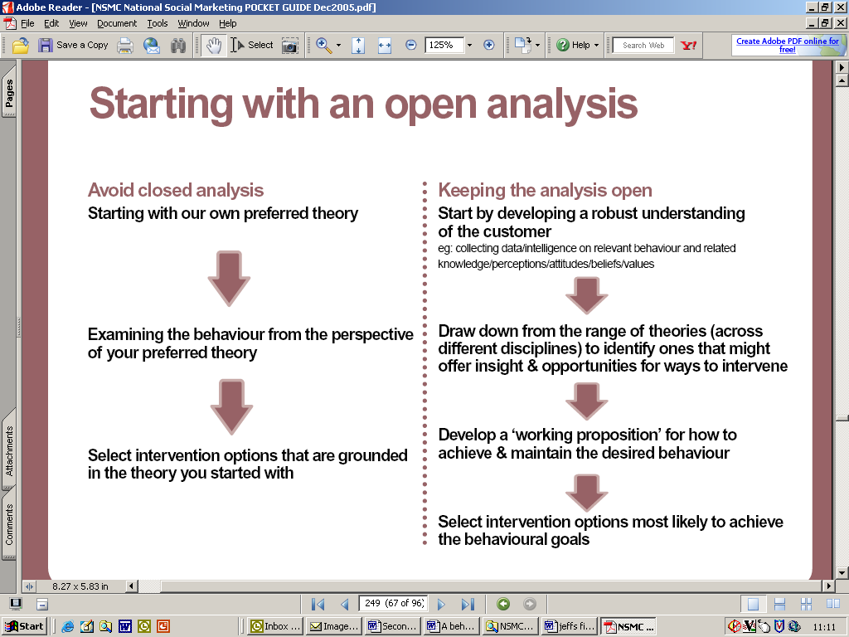

The final stages of step three should involve the development of ‘working propositions' for how to achieve and or maintain the desired behaviour that is being focused on. These propositions will be based on existing and possible newly devised models of behaviour drawn from the literature but also form what is understood about the target audience and what influences the behaviour in question. Interventions can then be developed based on these propositions and tested in pilots and field trials to see if they deliver the anticipated impact on behaviour.

