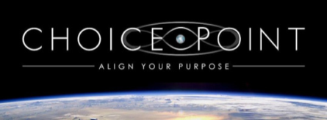

The Choice Point Align Your Purpose Course
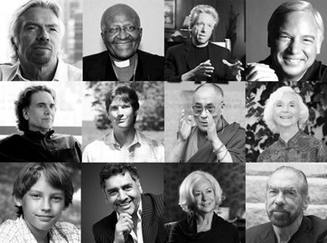
Learn the Secrets Sir Richard Branson, Archbishop Desmond Tutu, Jack Canfield and many other Global Leaders, Billionaires and Visionaries have used to create wiser Choices both for their own lives and others.
Ultimately there is virtually no universal difference between the top billionaires, leaders and visionaries of our world... and all of us. Many of these leaders and visionaries failed in school, possess learning disabilities, came from humble beginnings or suffered horrific circumstances or decisions in their past...
Yet for each and every one, you can see in their life when, nearly overnight, they leapt forward into new ways of being and new almost miraculous circumstances that compelled them forward into their dreams and desires.
The key difference is they learned how to identify and make different choices in the moments that mattered the most in their lives, in other words their Choice Points. They simply choose to align with external forces that served them, rather than hurt them.

The Choice Point course helps to:
- Accurately predict ideal conditions for your business, idea or financial goals to succeed…
- Maintain confidence, calm and clarity for important decisions… even when you’re in the chaos of crisis or a whirlwind of emotions.
- Identify your core purpose and understand how to begin living it immediately…
- Experience a renewed vitality and zest for life because you’re doing what you love on a daily basis…
- Dramatically alter the course of your life
- Spark change and inspire others so that the ripples you create can affect greater and greater amounts of people… whether you consider yourself a leader right now or not.

This requires a specific set of skills and knowledge that Harry Massey and Choice Point’s Visionaries teach in our 18-Step Align Your Purpose Program.
The program moves you through two key phases of alignment and transformation that nearly everyone misses – and yet all the visionaries figured out…
First, you develop the ability to forecast and identify your greatest moments of opportunity. This involves understanding patterns and the nature of cycles – from the very large global or universal cycles down to the smallest. Because whether you realize it or not, these patterns and cycles affect your life direction and ability to fulfill your purpose as much as your own personal cycles and patterns (though we’ll address those too!).
Second, you discover your core purpose (which can evolve and change over time) and then identify the larger natural and social patterns that best support that purpose, so that you can then align with those patterns. This way they work for you, rather than against you. It’s like hitching yourself to a shooting star that will land you in the new world and life experience you desire.
When you harness your choice points by intentionally engaging these two phases of alignment, you can truly unlock the energy and wisdom you need to create and attain everything you have ever wanted in your life – success, happiness, wealth, spiritual awakening, transformation, and even global change through your own hands…

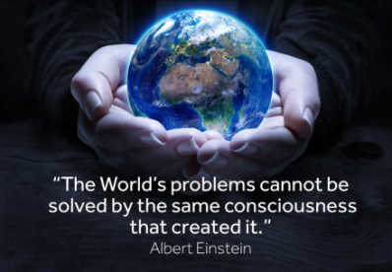
Understand Your World
First, you develop the ability to forecast and identify your greatest moments of opportunity. This involves understanding patterns and the nature of cycles – from the very large global or universal cycles down to the smallest. Because whether you realize it or not, these patterns and cycles affect your life direction and ability to fulfill your purpose as much as your own personal cycles and patterns (though we’ll address those too!).

The Align Your Purpose (AYP) Program
Choice Point helps your client on their life journey to make wiser and more informed choices. Our Scanning Software helps identify where they are on their life journey and what specific wisdom from 18 global leaders in the online video, exercises and beautiful pdf documents will help them most. When your client engages in the program, you’ll journey deeper with Richard Branson, Gregg Braden, Jack Canfield, Barbara Marx Hubbard, and all of our visionaries as each one helps you to activate the key steps in the process. As their choices improve through Understanding their World better and helping them to shift limiting mind-body patterns, their stress levels reduce, health enhances, and is invigorated with new found purpose.

810-584-5241
yourpathforwardholistics@gmail.com

